The software system only stores and retrieves students’ partial information in the current semester and other basic information including **student’s name**, **student’s ID**, **registered courses in the current semester**, **each exam’s score in one course**, **GPA calculation in the current semester**

**-NOUN EXTRACTION-**

Initial Entity Classes: Student Class, Course Class, and Exam Class.

Initial Boundary Classes: User Interface Class, Student Database Class.

Initial Control Classes: Calculate GPA Class.

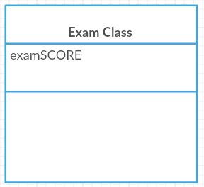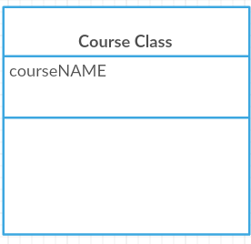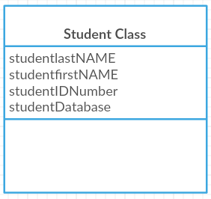

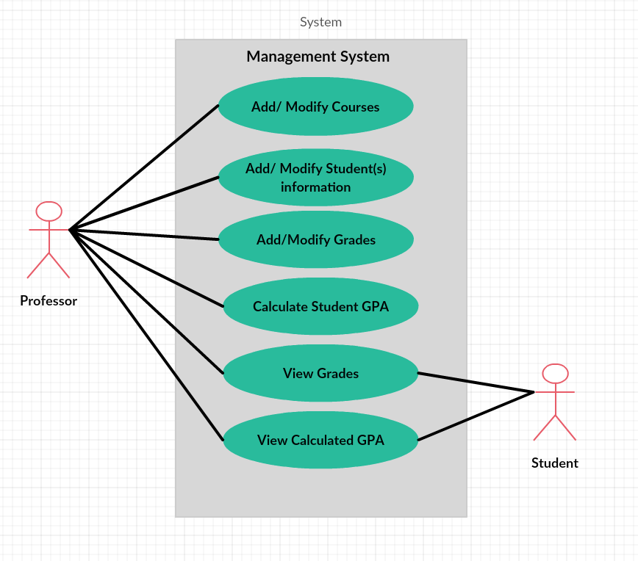

Class diagram showing the classes that realize the Calculate GPA from use case.

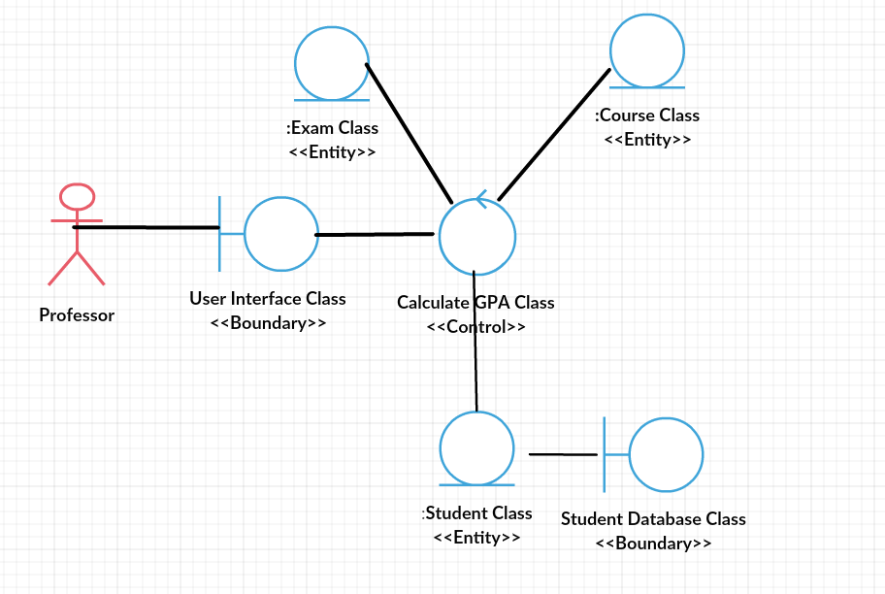

Class diagram showing the classes that realize the Add/Modify Courses.

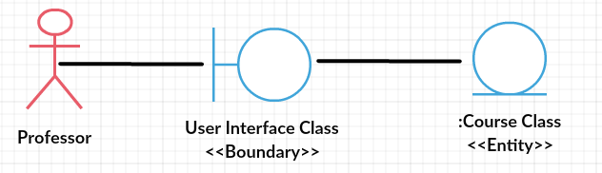

Class diagram showing the classes that realize the Add/Modify Student(s) information.

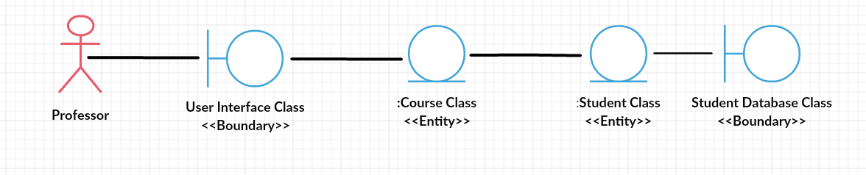

Class diagram showing the classes that realize the Add/Modify Grades.

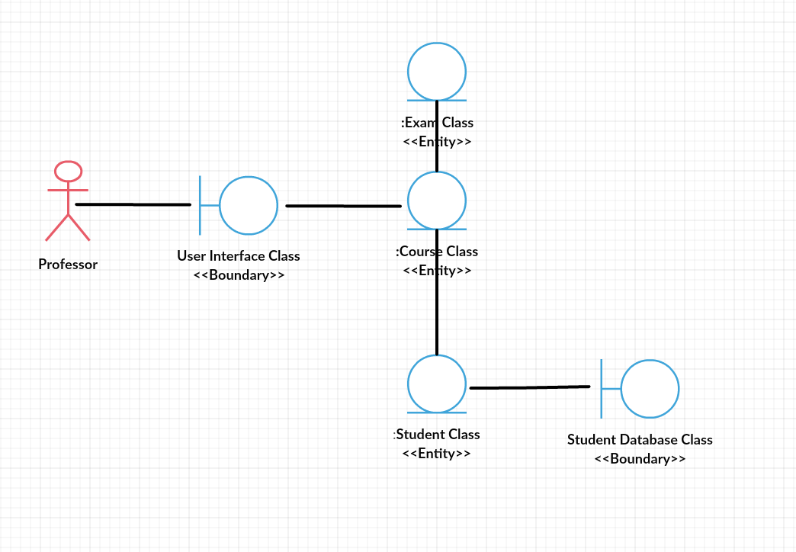

Class diagram showing the classes that realize the View Grade.

