BITCOIN PRICE MODELING AND FORECAST

Bitcoin is a digital currency/network that was invented 12 years ago. In this time it has climbed in value from $0 to above $50,000 per bitcoin, valuing the bitcoin network at around 1 trillion USD. The price of bitcoin has increased along the growth in its usage (users, transactions, etc) and its intrinsic monetary properties (decreasing supply of new bitcoins, decentralization, censorship-resistant, etc).

In this context it has become relevant to develop valuation and prediction models for the price of Bitcoin. As bitcoin has increased in popularity, use, adoption and as an investment/store of value vehicle, a model that can explain and predict its price becomes more useful.

The objective of this capstone project is to build a model that can determine what fundamental variables have the most impact on the bitcoin price, and that can forecast the bitcoin price within a 90%+ accuracy.

DATA SOURCE

Our Data source is coinmetrics.io, which is a company that collects and publishes information about bitcoin prices and bitcoin network statistics. Coin metrics makes the free version of its data available as a .csv file. We import this file to a pandas DataFrames via a URL.

DATA CLEANING

We had the fortune that Coin Metrics allows to download its bitcoin network and price data in a very clean presentation. Most of our data cleaning and wrangling included:
- Removing missing data. Coin Metrics includes data of bitcon’s network statistics before there was a bitcoin price. This data was removed from the dataset. We only ended up with observations that included price data.
- Aggregating data. Coin Metrics data is presented on a daily basis. We aggregated the data to a weekly, monthly and annual basis. Some features were aggregated by averaging, and others by latest datapoint.

EXPLORATORY DATA ANALYSIS (EDA)

For EDA we were interested to determine which features have a high correlation with the price of bitcoin.

We identified the variables that have a higher correlation with the bitcoin price. Some of these variables are in the network usage category: number of addresses (AdrActCnt, a proxy of network users), number of transactions (TxTfrCnt, TxCnt) and block size (BlkSizeByte, BlkSizeMeanByte). Other variables are in the supply category: IssTotNtv (total new bitcoins issued time period), IssContNtv and IssContPctAnn (annual growth of new bitcoin issued). Finally, variables related to bitcoin mining with high correlation are hash rate (HashRate) and average difficulty (DiffMean).

See the correlation heatmaps below, which are sorted for highest positive correlation to highest negative correlation with respect to the price of bitcoin (PriceUSD).

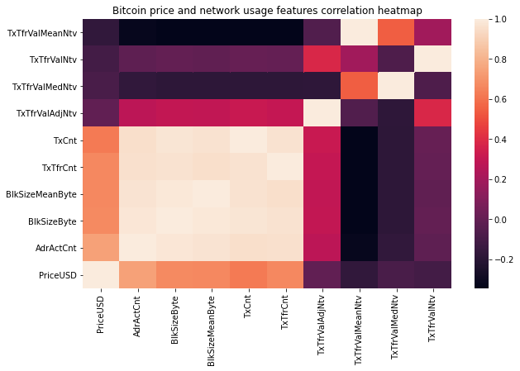
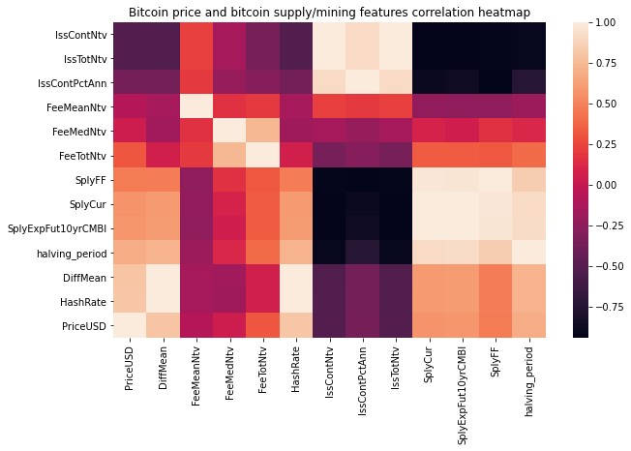

We have also identified that the price seems to cluster as the number of bitcoins being issued (IssContNtv) decreases over time. This coincides with data showing a high negative correlation between price and issuance.

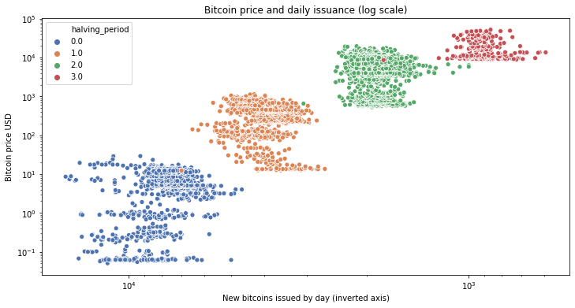

TIME SERIES ANALYSIS AND STATISTICAL TESTS

Time series models need data series to be stationary (constant mean and standard deviation over time).
However, most of our data series are non-stationary.

To make the series stationary we performed a series of transformations to the dataset:
- Calculating first differences.
- Scaling the data (using sklearn StandardScaler) and calculating first differences.
- Calculating 4-year % change.

Under all transformations, price and most features series of interest resulted stationary. Stationarity was tested using Statsmodels’ Augmented Dickie-Fuller test.

FEATURE ENGINEERING

The most important feature engineering that were performed were:
- Converting the number of active addresses (AdrActCnt) to the squared of it (AdrActCnt2), to test if the price of bitcoin could be modeled using Metcalfe law (the value of a network is directly proportional to the square of its users).
- Calculating bitcoin’s stock-to-flow ratio (S2F), the number of bitcoins in existence divided by the annualized issuance of new bitcoins (SplyCur / IssCntNtv). This feature captures bitcoin’s scarcity, measuring how big the current stock is compared to the growth in the supply of bitcoin.

These features also resulted to be stationary after the data transformations mentioned above.

MODELING AND MODEL SELECTION

We used a Vector Autoregressions model (VAR) to model the relationship between the bitcoin price and the features.

The best model according to the test set scores only included AdrActCnt2 (a proxy for users of the bitcoin network) and the bitcoin price (PriceUSD) as the explanatory variables. This model used the 4-year % change weekly data.

Test set scores
r2: 0.9059687205845488
Explained variance: 0.9088195691520202
MAE: 50.76040780251836
MSE: 5262.289196479054
RMSE: 72.5416376743664
However, scores worsened significantly when predicting with the holdout set.

Holdout set scores
r2: -0.2441584162843058
Explained variance: -0.09766692779781416
MAE: 495.3427528413425
MSE: 336857.4098293986
RMSE: 580.3941848686965

Is worth to note that using data sets other than the 4-year % change weekly data gave poor test set scores.

FUTURE ANALYSIS

1. Data granularity. We used the free version of Coin Metrics’ bitcoin network data. This data only give access to bitcoin’s network data on a high level. Future work could be done by having access to more granular data of the network. For example, the number of active address (AdrActCnt) aggregates all addresses, however, not all addresses are equal, as different addresses contain different quantities of bitcoin. Having access to the different distribution of addresses by bitcoins they hold could change model performance. The same is true for other network statistics as transactions.

2. Use other types of features to explain bitcoin price. In this study, we only used features related to bitcoins’ network. As bitcoin has become a major financial asset, price movements could now be more influenced by variables outside the network (financial flows, global monetary conditions, overall market sentiment towards bitcoin, etc).

3. Test other types of models. Other types of time series models could be tested to see if they perform better, specially on the holdout test. These models may include ARMA, ARIMA, Non-linear models, etc. Other option is also to try classification models for time series.

