BITCOIN PRICE CLASSIFICATION

Model metrics.

This project used a KMeans unsupervised learning algorithm to search for clusters regarding the daily minute-to-minute bitcoin price movements and daily price technical indicators (Relative Strength Index, Money Flow Index, Rate of Change, Stochastic and Moving Average Convergence Divergence).

The model metrics suggest that 5 clusters using scaled minute-to-minute daily close data statistics and indicators is the best model specification.

The model metrics used were inertia and silhouette.

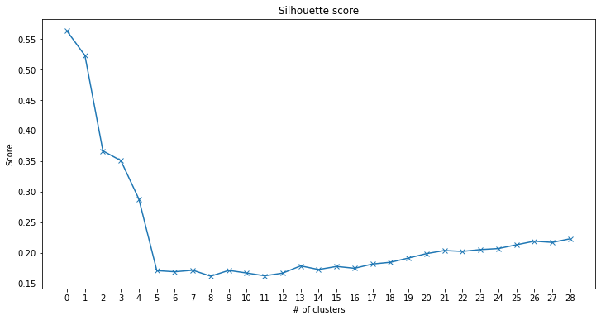

Silhouette score is 0.35 for 5 clusters (number 3 in the chart). We chose 5 clusters as silhouette score drops significantly after this.

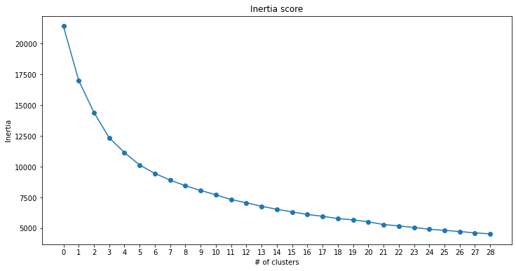

For 5 clusters (number 3 in the chart) the inertia score is 12,352. Inertia drops significantly from 2 to 5 clusters and then its decrease starts to slowdown as more clusters are considered.

