BITCOIN PRICE CLASSIFICATION

Bitcoin is a digital currency/network that was invented 12 years ago. In this time it has climbed in value from $0 to above $57,000 per bitcoin at the time of writing, valuing the bitcoin network above 1 trillion USD. The price of bitcoin has increased along the growth in its usage (users, transactions, etc) and its intrinsic monetary properties (decreasing supply of new bitcoins, decentralization, censorship-resistant, etc).

In this context it has become relevant to develop valuation and prediction models for the price of Bitcoin. As bitcoin has increased in popularity, use, adoption and as an investment/store of value vehicle, a model that can explain and predict its price becomes more useful.

In this project we will try to classify daily bitcoin price movements by finding patterns in the data. The data consists of bitcoin prices each minute from August 2010 to February 2021.

For classification purposes, every sample consist of the change in the bitcoin price every minute of a given day.
We extract features from each sample (mean, median, standard deviation, minimum, maximum, z-score, min-max range, etc, exchange volume, technical indicators, etc)
We then use unsupervised machine learning algorithms to find clusters of the samples.
The hypothesis is that certain clusters could be associated with or used to predict important movements in the bitcoin price.

DATA SOURCE

Our Data source is the minute-to-minute bitcoin price and exchange volume from Bitstamp’s API. Bitstamp is a cryptocurrency exchange company. We import the data from Bitstamp’s API to a .cvs file and to a pandas DataFrames. The API can be accessed at https://www.bitstamp.net/api/v2/ohlc/btcusd.

DATA CLEANING AND WRANGLING

Bitstamp price data was in a very clean presentation. Most of our data cleaning and wrangling included:
- Transforming timestamp data to date format and use the date as our index.
- Transforming price data to % change.
- Grouping and Aggregating data. We downloaded bitstamp price data on a minute-to-minute basis. We grouped the data by day and aggregated it to extract statistics from the price movement of each day (mean, standard deviation, maximum, minimum, and % changes of price open-close, open-max, open-min, min-close, min-max, max-close).

FEATURE ENGINEERING

The most important feature engineering that were performed were:

- Building bitcoin price technical indicators and encoding them. These are indicators that traders and investors use to asses if a given asset is expensive/cheap, overbought/oversold. These technical indicators are: MACD, RSI, stochastic, ROC, Money flow Index. The indicators are oscillators, which can help us in the classification and clustering of daily price data.
  - The technical indicator data wasn’t used in numeric form, but converted to categorical data. For example, the Money Flow Index oscillates between 0 and 100, so categories of 'above_80', 'below_20', 'between_2080' were given to the indicator.
  - Encoding technical indicators. The categorical data of technical indicators were encoded using sklearn’s OneHotEncoder.
- Scaling data. We scaled the numerical data about price movements using StandardScaler.

EXPLORATORY DATA ANALYSIS (EDA)

The charts below are an example of one sample, a day of minute-to-minute bitcoin price % change and the total volume. From this kind of data of each day we extracted the features used for modeling.

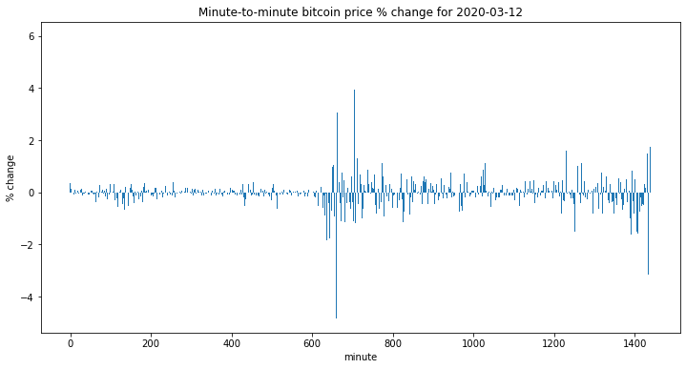

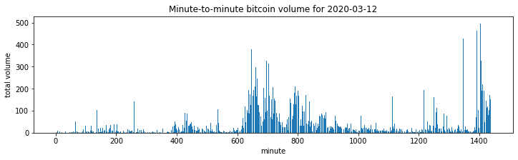

The EDA was mostly focused on finding possible clusters of the given daily price movement statistics and technical indicators. We construct scatter plots to look for possible clusters.

The chart below shows a scatter plot of the % change from the daily open to the daily close (open-close in the y-axis) price and the daily open to the daily high (open-high). The color of the dots represent the level at which the Rate of Change (roc) technical indicator was in that day. We can see that the different colors (categories of the roc) seem to form clusters.

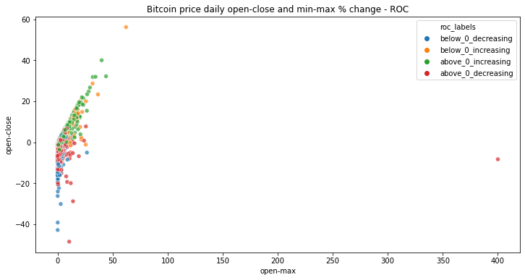

Plotting the same data using different technical indicators shows similar outcomes (see charts below).

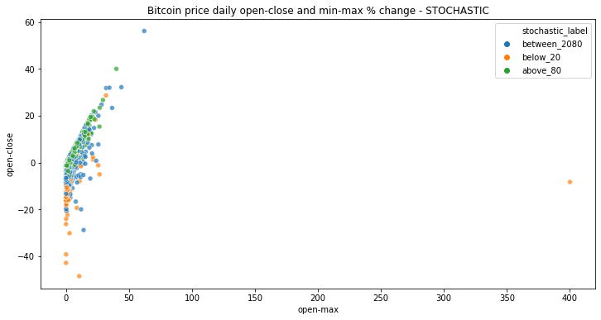

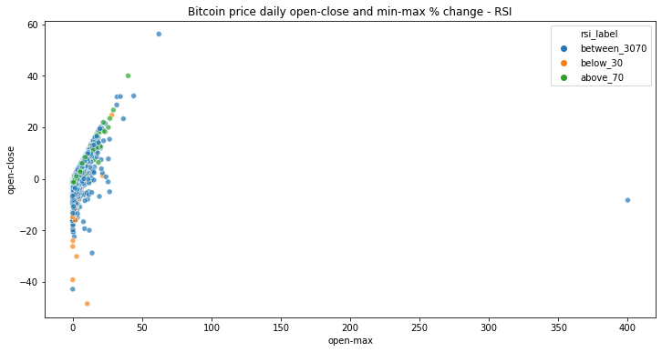

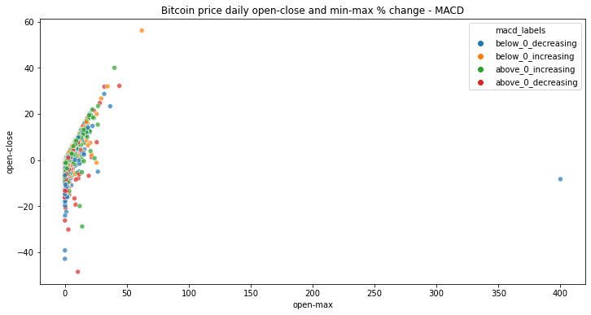

MODELING AND MODEL SELECTION

We used a kmeans algorithm to find clusters in the data.
Three different data sets were used:
1. Statistics of minute-to-minute % change in the bitcoin price + technical indicators.
2. Z-score statistics of minute-to-minute % change in the bitcoin price + technical indicators.
3. Intraday % price movements (open-close, open-high, etc.) + technical indicators.

For each dataset we ran kmeans with k from 2 to 30, and calculated the inertia and silhouette score.
Dataset #3 gave the best results, the lowest inertia and the highest silhouette score for the same k (see charts below).

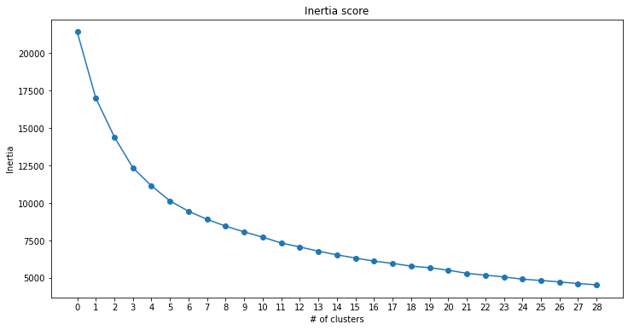

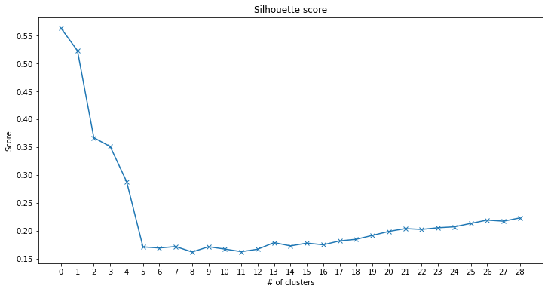

According to inertia and average silhouette score, the best number of clusters is 5 (number 3 in the chart), where the decrease in inertia begins to slowdown, but the silhouette continues to be relatively high.

Mapping cluster data to bitcoin price time series

Next we map the bitcoin price time series with the resulting cluster for each day to see if certain clusters could be associated with or used to predict important movements in the bitcoin price.

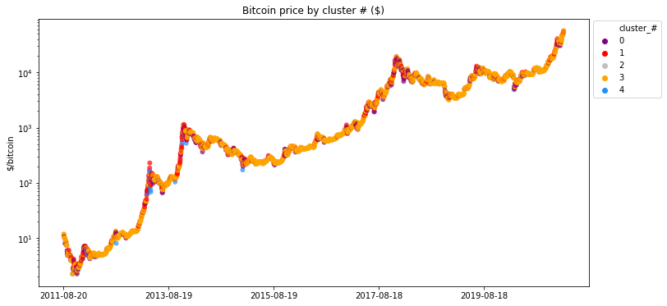

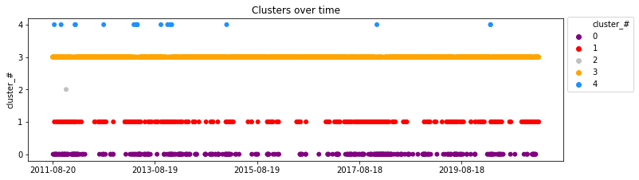

Regarding the clusters, the most important findings were:
- The majority of the days correspond to cluster #3. Days in this cluster could be thought as the "normal days", where the price of bitcoin has low variability, and as it corresponds to the most common cluster.
- Cluster #1 shows the times when the bitcoin price has increased sharply (during, and, or at the end of bull cycles).
- Days in clusters #0 and #4 are typically seen after a correction in prices and/or at the end of bear cycles. Cluster #4 is less common than #0 and seems to show only after sharp corrections and/or to signal market bottoms. Of course, there are also false positives. Cluster #4 includes days 2020-03-12 and 2020-03-13, the two days of the big market sell-off related to the COVID-19 pandemic.
- Cluster #2 has only one day (2011-11-25) which must be seen as an outlier. In this day, there was a sharp intraday price increase (open to high) and then a reversal (big move from high to low).

Cluster’s features and categorization

The charts below show intraday price movements in % terms by cluster.

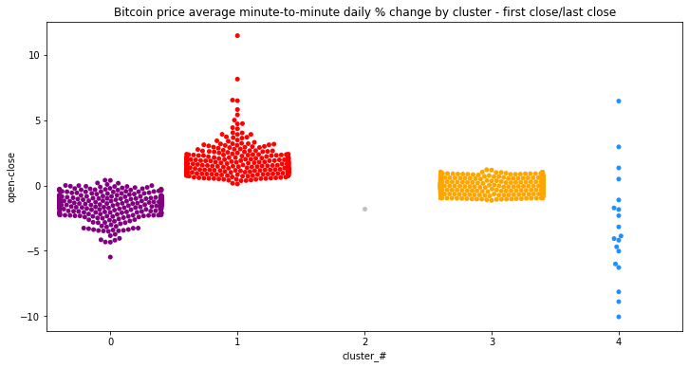
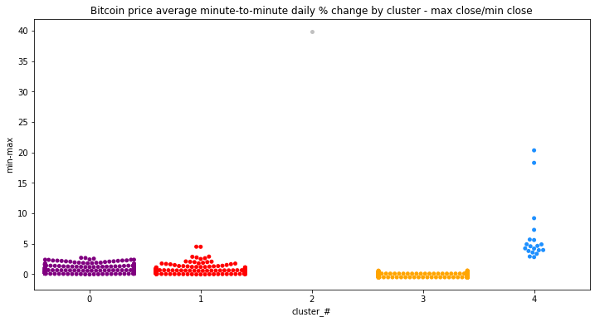

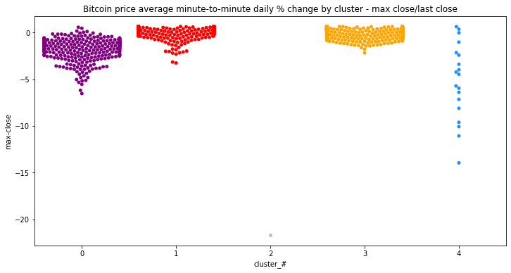
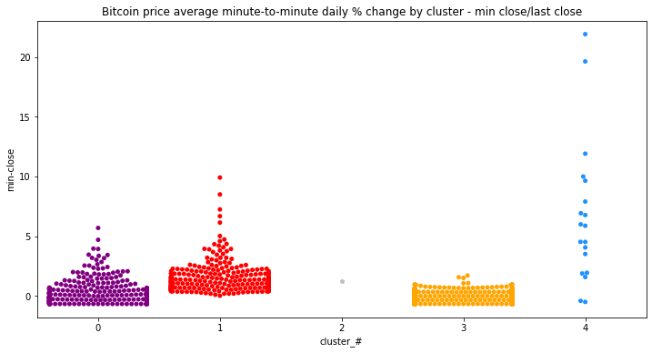

Using these charts we categorize the clusters as follow:
- Cluster #3, “normal days”, low volatility, small price movements.
- Cluster #1, “bull days”, volatility to the upside. This cluster also seems to signal market tops.
- Clusters #0 and #4, “reversal days”, higher volatility, price reverses almost all the daily gains/losses. These type of days also seem to be also associated with correction/market bottoms.
- Cluster #2, “the outlier”.

We can also plot the bitcoin price time series divided by epoch (the time elapsed between halvings), to better appreciate the cluster information.

The chart below shows the price from July 2016 (after the 2nd halving) to May 2020 (just before the 3rd halving). The patterns are the same, most days are “normal days” (cluster #3), “bull days” (cluster #1) coincide with the bull market in full swing and with market tops, “reversal days” (clusters #0 and #4) pop-up after price corrections or signaling market bottoms. Again, note that the “reversal days” (Cluster #4) include days 2020-03-12 and 2020-03-13, the two days of the big market sell-off related to the COVID-19 pandemic (the only 2 blue dots in the chart).

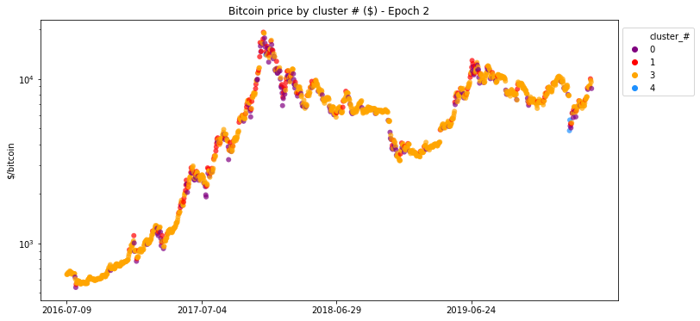

FUTURE ANALYSIS

1. Test additional algorithms. We could do the same analysis using other unsupervised learning algorithms like DBSCAN, BIRCH, etc.

2. Include other types of features related to the bitcoin network. We could add information about the bitcoin network to the dataset. This could include, daily data of active addresses, transactions, mining difficulty, issuance, etc.

3. Include technical indicators specifically related to bitcoin. We used technical price indicators used to analyze the price of any asset in general. However, technical indicators specifically related to bitcoin have also been developed (SOPR, S2F, Coin Days Destroyed, Puell Multiple, Realized HODL ratio, Realized profit, MVRV, etc).

