**Adding Jenkins Slave**

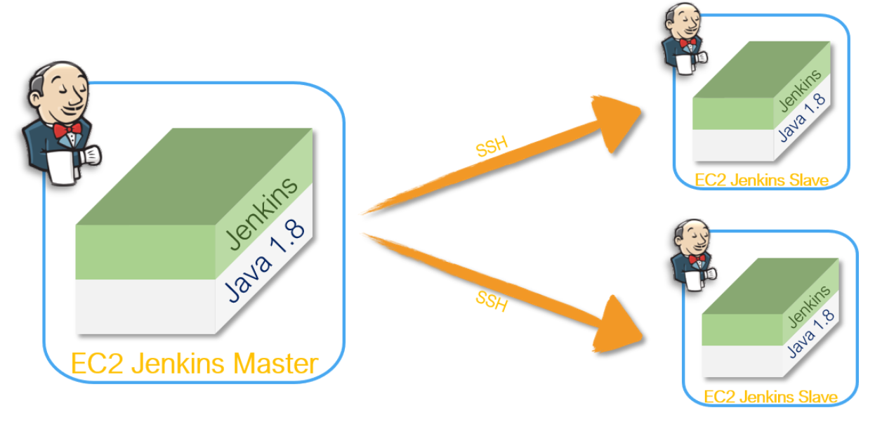

Step 1: Crete A EC2 as Jenkins Slave

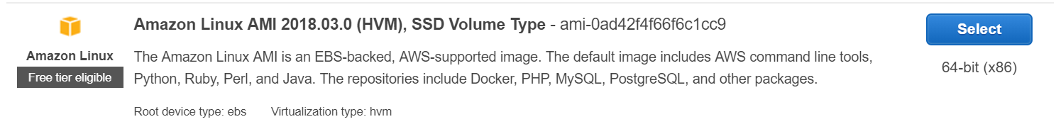

Allow All traffic for this EC2 instance.



Step 2: Install Java Maven Git on Jenkins Slave node as well .

yum update -y

yum install git -y

sudo dnf install java-17-amazon-corretto

sudo dnf install java-17-amazon-corretto-devel

cd /opt

sudo wget https://dlcdn.apache.org/maven/maven-3/3.9.4/binaries/apache-maven-3.9.4-bin.tar.gz

sudo tar xvf apache-maven-3.9.4-bin.tar.gz

ls -ltr

cd

echo "export M2_HOME=/opt/apache-maven-3.9.4" >> .bash_profile

echo "export M2=$M2_HOME/bin" >> .bash_profile

echo "export PATH=$M2:$PATH" >> .bash_profile

source ~/.bash_profile

echo $M2_HOME

Step 3 : Login to Jenkins EC2 Slave machine



Run below command on Jenkins Slave

Create user and add the user to wheel group

#useradd jenkins-slave-01

# Create SSH Keys

#sudo su - jenkins-slave-01

#ssh-keygen -t rsa -N "" -f /home/jenkins-slave-01/.ssh/id_rsa

cd .ssh

cat id_rsa.pub > authorized_keys

chmod 700 authorized_keys

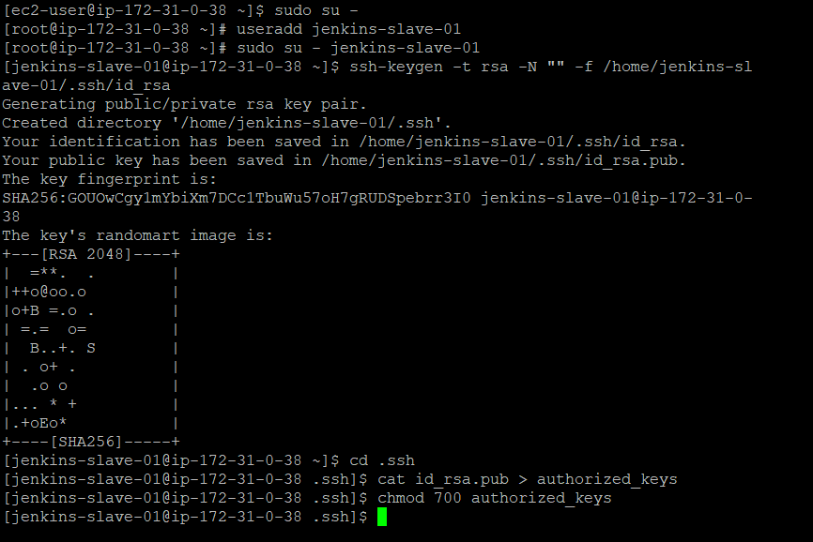

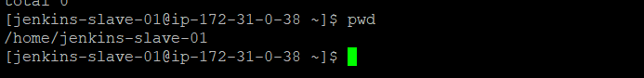

Step 5: Login to Jenkinsmaster and scan the key for jenkinsS

mkdir -p /var/lib/jenkins/.ssh

cd /var/lib/jenkins/.ssh

ssh-keyscan -H 172.31.45.2 >> /var/lib/jenkins/.ssh/known_hosts

chown jenkins:jenkins known_hosts

chmod 700 known_hosts

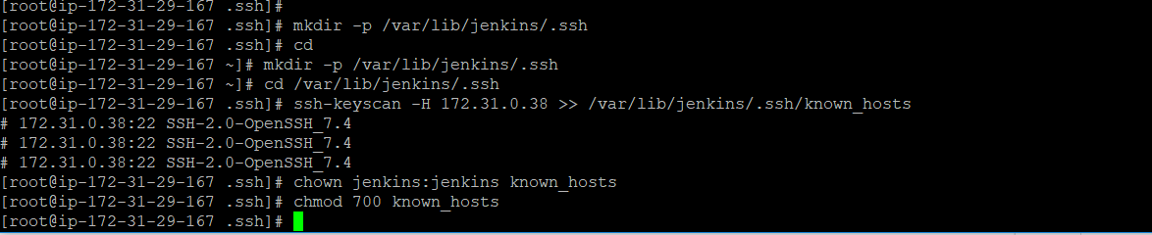

Step 6: Configure the Slave using Manage Jenkins

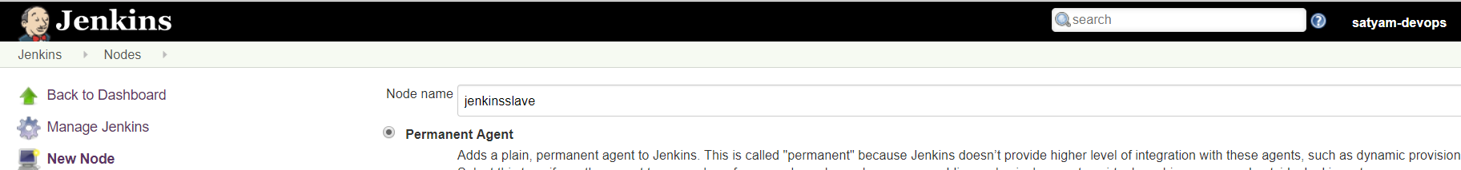

Step 7: Start filling the details

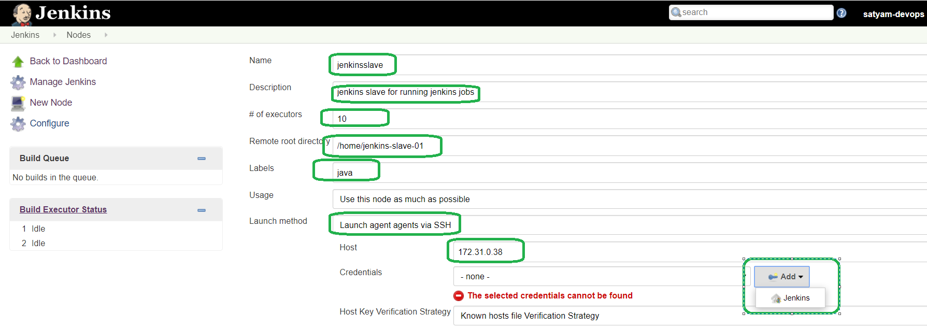

Step 8 : Add the credential’s , Find the key on Jenkins

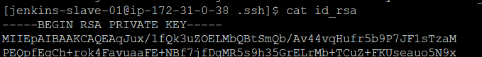

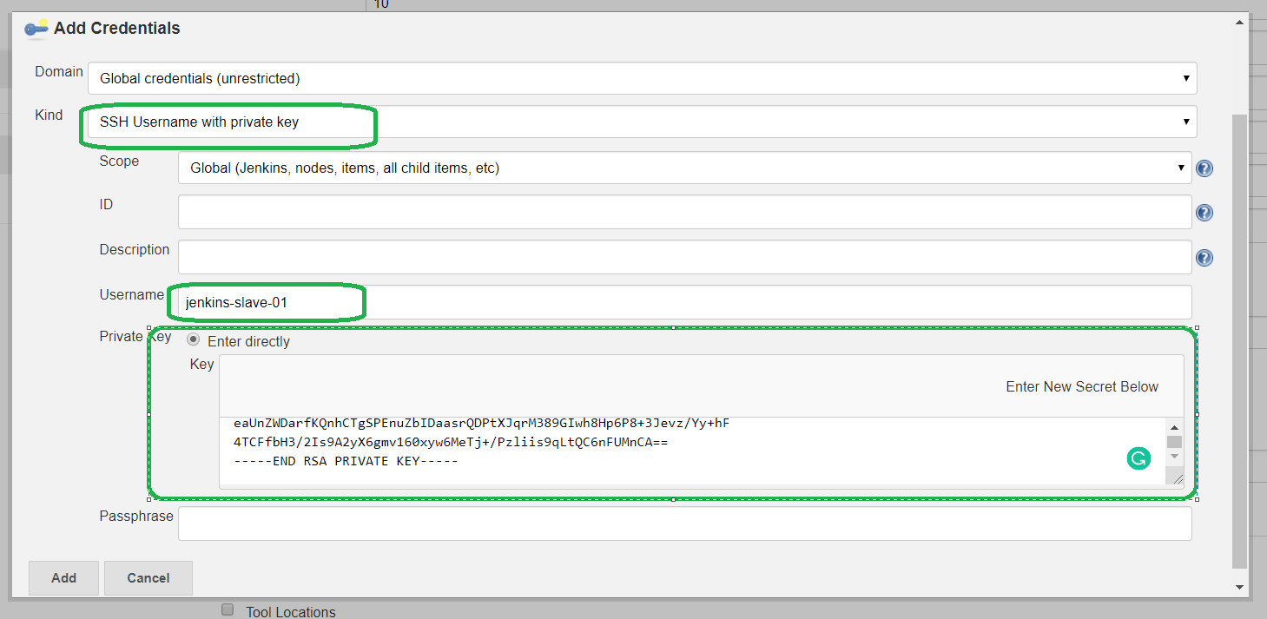

Step 9 : Select the User Id and for password we are using key then save it

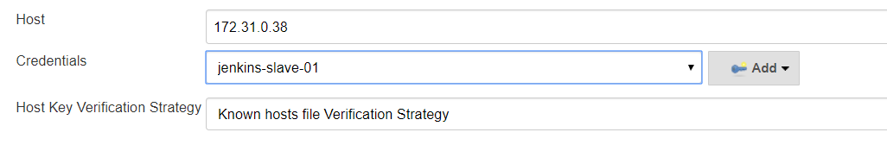

Step 10: Once you save it Jenkins Master will start taking to Jenkins Slave if everything is ohk, he will add

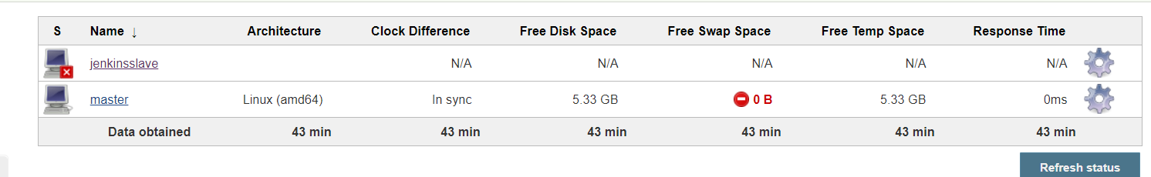

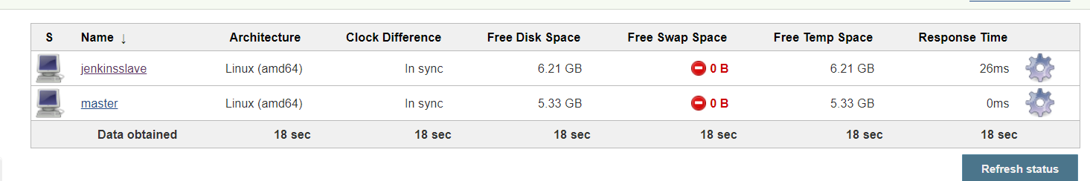

**Create a hello world jobs that run on our slave Node.**

Step 1 : Create Jobs in Jenkins use free style project .

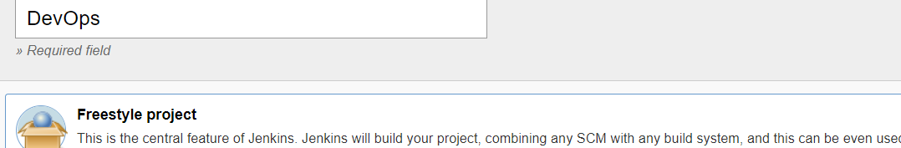

Step 2: Under General tab of jenkins select

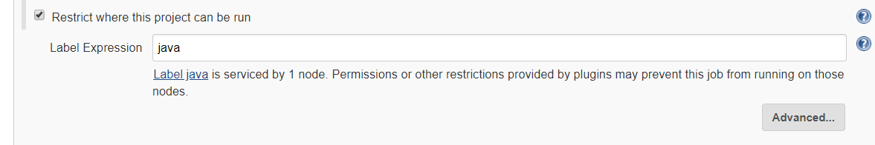

Step 3: Under build tab

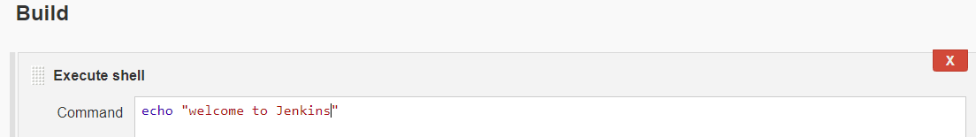

Step 4 : Save apply and click on build now.

