MLB Batting Average
(COMP3125 Individual Project)
*Note: Do not used sub-title

Ewdi Moreta
dept. name of organization

Abstract—This project analyzes how Major League Baseball (MLB) batting averages have lowered over time and whether increased pitch velocity is the cause. After collecting data of league batting average from the years 2000-2025 and average pitch velocity from 2008-2025, it shows that there is a correlation between the two subjects. Using trends, and correlations graphs results show that as pitch velocity increases, batting average decreases.
Keywords— MLB, batting average, pitch velocity, strikeout, time-series analysis

Introduction (Heading 1)
Major League Baseball has had a shift in performance over the past few decades, in particular how batters perform at the plate. One of the most noticeable trends is the decline in league wide batting averages, which has reached one of the lowest avenges in MLB history. This decline in batting averages has raised conversations about how pitching strategy, training, and technology have created an unbalanced skillset between offense and defense. Research suggests that the improvements of pitching like velocity, increased reliance on breaking balls, and advanced analytics guiding pitch selection have played a role in the drop of offensive output. Pitch velocities have increased since the early 2000s, making it more difficult for hitters to make consistent contact. At the same time, strikeouts rates have risen to historic highs while earned run averages (ERA) have shifted in ways that reflect pitching dominance. These different stats are important for understanding the difference between pitching skills increasing and batting averages dropping.
This report will investigate the relationship between these trends by examining pitch-level velocity over time, evaluating how strikeouts per game and ERA have changed in recent years, and analyzing how MLB’s overall batting average has evolved.

Datasets

Baseball-Reference, Baseball-Savant (Heading 2)
The dataset used for this analysis is from Baseball-Reference, a recognized and credible sports statistics provider frequently referenced by analysts, and MLB organizations. The dataset is updated and compiled from official MLB game records. The dataset is provided in tabular format and includes yearly aggregated statistics for all major league teams combined. I also used Baseball-Savant to get the average pitch velocity for the last couple pf years. Baseball-Savant is directly affiliated with the MLB and is also used by Teams, players, and analysts. Which shows that it is a credible source for data.

Character of the datasets
Year | MLB season year | Integer
BA | Batting average (Whole League) | Decimal
SO | Strikeouts per game | integer
ERA | Earned Runs | Integer
TB | Total bases | Integer
HR | Home Runs | Integer
H | Hits | Integer

For data cleaning, I removed nonnumeric rows such as headers repeated within the table. I also handled the missing values by removing incomplete years. I also removed the columns that were not needed for the project.

Methodology
I am going to use descriptive methods and basic trend analysis to explore how MLB batting performance has changed in recent years in relation to pitching improvements.

Time-Series Trend Analysis
Time series analysis is used to observe changes in variables like batting average, strikeouts per game, ERA, and pitch velocity across multiple years. This method identifies upward or downward trends and shows periods of change. Some advantages of using a time series is that it is easy to interpret visually and statistically. It is also useful for identifying long-term changes. Some disadvantages are that it is sensitive to missing or inconsistent data points. I chose a time-series because this project focuses on how the statistics change over multiple years. I will use matplotlib and seaborn for line charts.

Correlation Analysis
Pearson correlation shows the relationship between pitch velocity, strikeouts, ERA, and batting average. Some advantages are that it expresses relationships between variables and is simple to compute and interpret. I chose a correlation analysis to help determine whether increasing pitch velocity or rising strikeouts correspond with decreases in batting average.

Scatterplot Visualization
Scatterplots provide a graphical representation of the relationship between two numeric variables. They were used here to visualize how batting average changes with respect to pitch velocity.

Results

Result A – Time-Series Trends
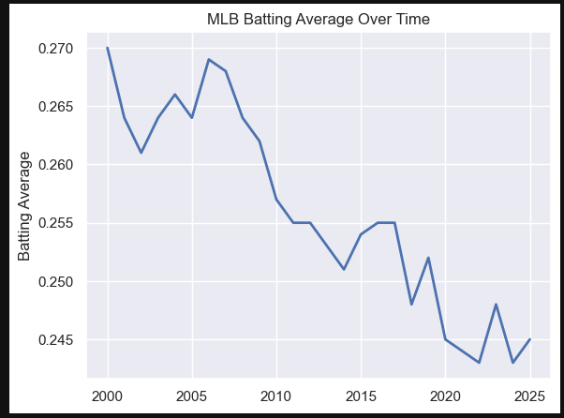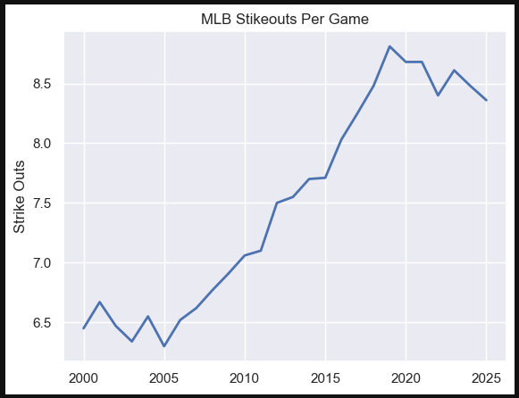

This time-series graph shows that the MLB batting average has slowly decreased over the years. From as early as 2000 the league batting average was .270 and by as recent as 2025 the league batting average was .245. At the same time, strikeouts per game have increased. This shows that over the years the MLB has been in a pitcher-dominant environment.

Results B – Correlation Analysis
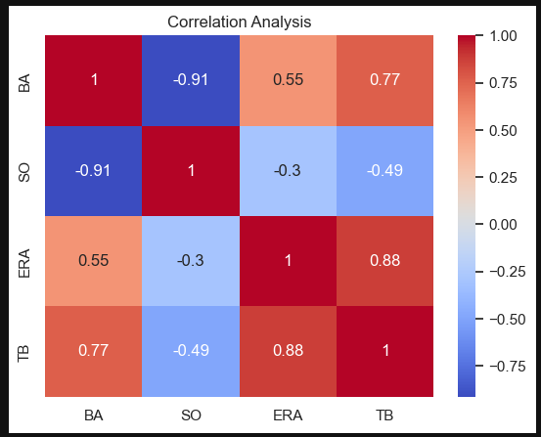

Correlation testing on batting average (BA), strikeouts per game (SO), earned runs (ERA), and total bases (TB) shows that there is a correlation between stakeouts per game and batting average as it is -.91, which shows a negative correlation. There was not much other correlation from the graph, but that can be because of the limited data calculated. If the data was from the last 50-75 years, there would most likely be more correlations between these topics.

Results C - Scatterplot Visualization
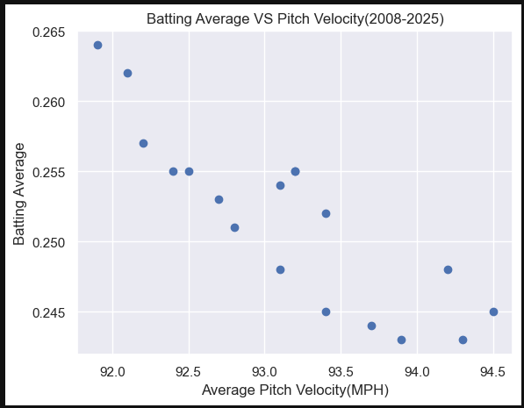

The scatterplot of the average velocity vs batting average shows points trending downward, meaning as velocity increases, batting average tends to decrease. Since
the data for velocity was only from 2008 instead of 2000. There had to be a merge to create the scatterplot. The data does not show a perfect line, which indicates that there are more influences that lead to a decrease in batting average. These influences can be defensives shifts and pitching strategies.

Discussion
While these graphs and data show a clear relationship between the rise of pitching skill contributing to the decline in league batting average, there are still more limitations to the study. The velocity dataset only covers years after 2008, restricting the merged dataset to a smaller time window. There are also other factors which lead to a decreasing batting average, like pitch type distribution. This data also does not take into consideration the rule changes over the past couple of years like pitch clock and shift restrictions which can impact batting average. For future work there can be a study on pitch type trends and a deeper look into the increase of pitching skill. Since the MLB has been here for over 100 years, there is more data available.

Conclusion
This study finds strong evidence that rising pitch velocity and improved pitching performance have contributed to a decrease in batting average throughout the league. Time-series analysis clearly shows opposing trends that strikeout per game has increased while batting average decreased. The Scatterplot shows that there is a visible trend between pitch velocity and batting average. These findings support the discussion that there has been an increase in pitchers' dominating games, and hitters cannot keep up with the evolution of the game.

Acknowledgment (Heading 5)
Thank you, Professor Pang, for providing guidance and resources for the methods used to complete this project.

References
- Baseball-Reference. “Major League Batting Averages by Year.”
- Baseball Savant / Statcast. “Pitch Tracking Data and League Averages.”

