RoadToSmartBaking Visual Style Reference
Foundation for the mobile app and marketing backoffice
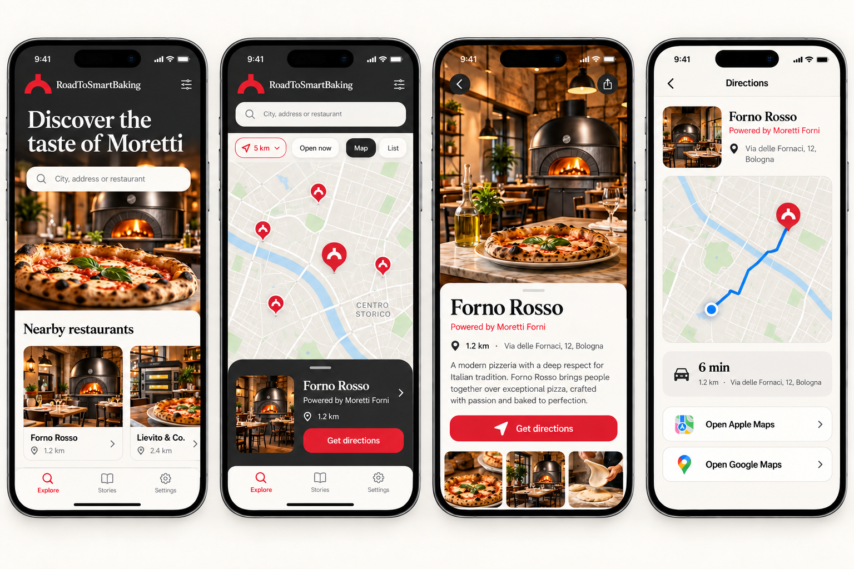
Version 1.0 | October 2026

Purpose and design direction
This document defines the first shared visual standard for RoadToSmartBaking. It aligns the consumer mobile app and the internal marketing backoffice with the approved concept screens. The system should feel premium, warm and distinctly Moretti while remaining simple enough for everyday use.

Core principles
- Product first. Real Moretti ovens and authentic food environments remain the visual centre of the experience.
- Warm editorial character. Large serif headlines and rich photography create emotion without reducing usability.
- Clear actions. Search, directions, saving and publishing use direct labels and one obvious primary action.
- One system, two contexts. Mobile feels immersive and customer facing. Backoffice feels structured and operational.
- Controlled consistency. Shared tokens govern colour, typography, spacing, radius, iconography and status feedback.
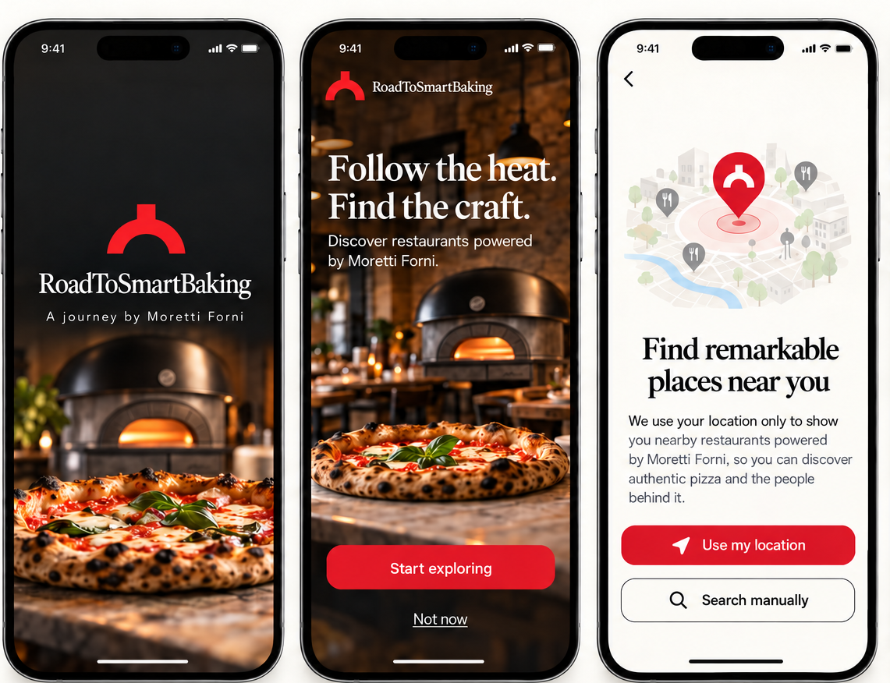
Reference direction for the mobile experience

Colour palette
Use the palette by role rather than by personal preference. Moretti red signals brand and action. Graphite and warm neutrals create the premium editorial atmosphere seen in the approved screens.
Colour | Hex | Primary use | Sample
Moretti Red | #D62839 | Primary actions, active navigation, highlights
Moretti Red Dark | #A91F2D | Pressed states and dark-background emphasis
Graphite | #20201E | Dark surfaces, hero panels and navigation
Ink | #171715 | Primary text on light backgrounds
Warm Cream | #F7F4EE | Main light background
Warm White | #FFFEFB | Cards, forms and elevated surfaces
Stone | #DEDAD3 | Borders, dividers and inactive controls
Muted | #6F6B65 | Secondary text and metadata

Functional colours
Role | Colour | Usage
Success | #168A4A | Published, open, complete
Warning | #C98512 | Draft, pending review, scheduled
Information | #2563B8 | Location, selected map state, neutral guidance
Error | #B3261E | Validation failure, destructive confirmation

Typography
The interface combines an editorial display face with a neutral sans serif. This pairing is visible across the approved mobile screens and should remain consistent in product, presentation and campaign work.
Role | Preferred family | Fallback | Use
Display | DM Serif Display | Georgia | Hero messages, screen titles, editorial stories
Interface | Inter | Aptos or Arial | Navigation, forms, buttons, labels and metadata
Numeric | Inter | Aptos or Arial | Distance, dates, status and map information

Type scale
Token | Mobile | Backoffice | Recommended use
Display XL | 42 px | 40 px | Launch and campaign hero
Heading 1 | 32 px | 32 px | Primary page title
Heading 2 | 24 px | 24 px | Section and card group title
Body | 16 px | 15 px | Descriptions and form content
Label | 14 px | 14 px | Controls, navigation and buttons
Caption | 12 px | 12 px | Metadata and supporting status
Use sentence case. Reserve all caps for short category labels. Avoid long centred paragraphs and avoid using the display serif in forms, buttons or dense operational tables.

Layout spacing and surfaces
Build every screen from an 8 point spacing system. Use generous vertical rhythm on mobile and a tighter but still readable rhythm in the backoffice.
Token | Value | Usage
Space 1 | 4 px | Icon and text micro spacing
Space 2 | 8 px | Related labels and compact controls
Space 3 | 12 px | Field internals and compact card gaps
Space 4 | 16 px | Default component spacing
Space 6 | 24 px | Section spacing and page padding
Space 8 | 32 px | Major content separation
Space 12 | 48 px | Hero and editorial separation

Shape rules
- Mobile cards and sheets use 16 to 20 px corner radius. Buttons use 14 to 16 px.
- Backoffice cards and fields use 10 to 12 px corner radius. Dense tables may use 8 px.
- Use subtle borders before shadows. Shadows should separate layers, not decorate them.
- Use one dominant primary button per view. Secondary actions use neutral fills or outlines.
- Keep mobile side padding at 20 to 24 px. Keep backoffice content gutters at 24 to 32 px.

Mobile application style
The customer app should feel immersive and editorial. Photography leads, while controls remain simple and native in behaviour.
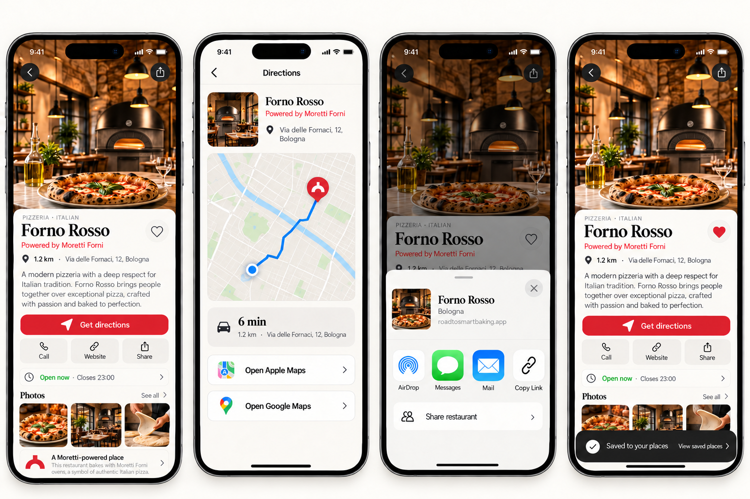
Location detail, directions, sharing and saving

Mobile rules
- Use full-width photography for hero areas and location detail headers.
- Keep search and map controls visually light so locations remain the focus.
- Place the primary action near the bottom of the active content area and label it directly.
- Use the Moretti relationship as a clear supporting label, not as an unsupported certification claim.
- Request location permission only when the benefit is visible. Always provide manual search.

Backoffice style
The backoffice belongs to the same brand but prioritises clarity, speed and content control. Warm neutral surfaces connect it to the mobile app without copying the immersive consumer layout.
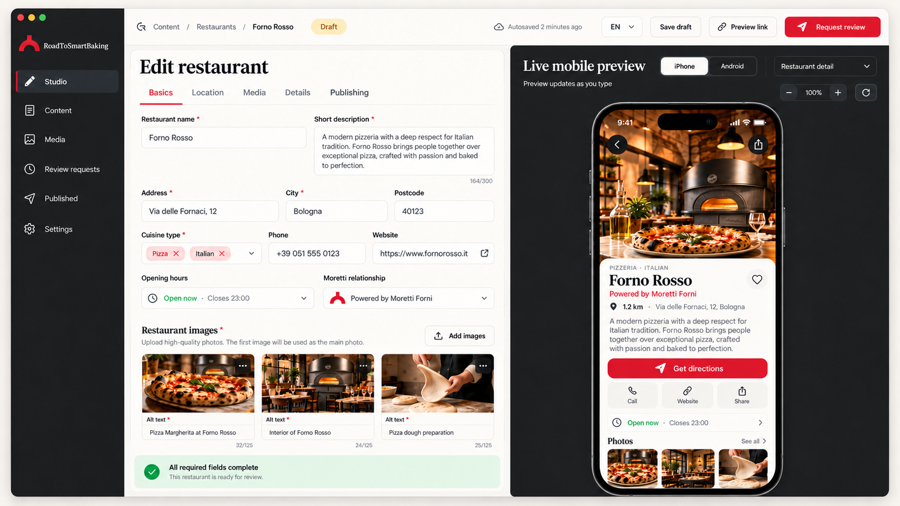
Editor on the left and live mobile preview on the right

Backoffice rules
- Use a dark graphite navigation rail with a red active marker.
- Keep editing fields on the left and the live mobile simulator on the right.
- Show status with text and colour. Never rely on colour alone.
- Use structured templates for locations and events instead of unrestricted page building.
- Keep review and publish actions persistent and visually distinct from save draft.

Component standards
Component | Default | Interaction | Notes
Primary button | Moretti Red, white text | Dark red pressed state | One main action per view
Secondary button | Warm White, graphite text | Stone fill on press | Use for alternatives and utilities
Text field | Warm White, stone border | Red focus ring | Label remains visible above the value
Card | Warm White | Subtle elevation or border | Image, title and essential metadata only
Bottom sheet | Warm White, 20 px radius | Drag handle and native motion | Use for filters and contextual detail
Navigation | Graphite or warm white | Red active state | Maximum five primary mobile destinations
Status | Text plus functional colour | No hover dependency | Published, draft, review and scheduled
Map marker | Moretti Red | Selected marker grows | Cluster dense results

Iconography and motion
- Use simple outlined icons with rounded joins and consistent 2 px visual weight.
- Use familiar platform icons for location, directions, sharing, saving and settings.
- Keep motion short and functional. Use 180 to 240 ms for control feedback and 280 to 360 ms for sheets.
- Respect reduced motion preferences and never animate critical text continuously.

Photography and product imagery
Photography should make the Moretti ecosystem tangible. Use authentic locations, people and food while ensuring the oven model remains accurate.
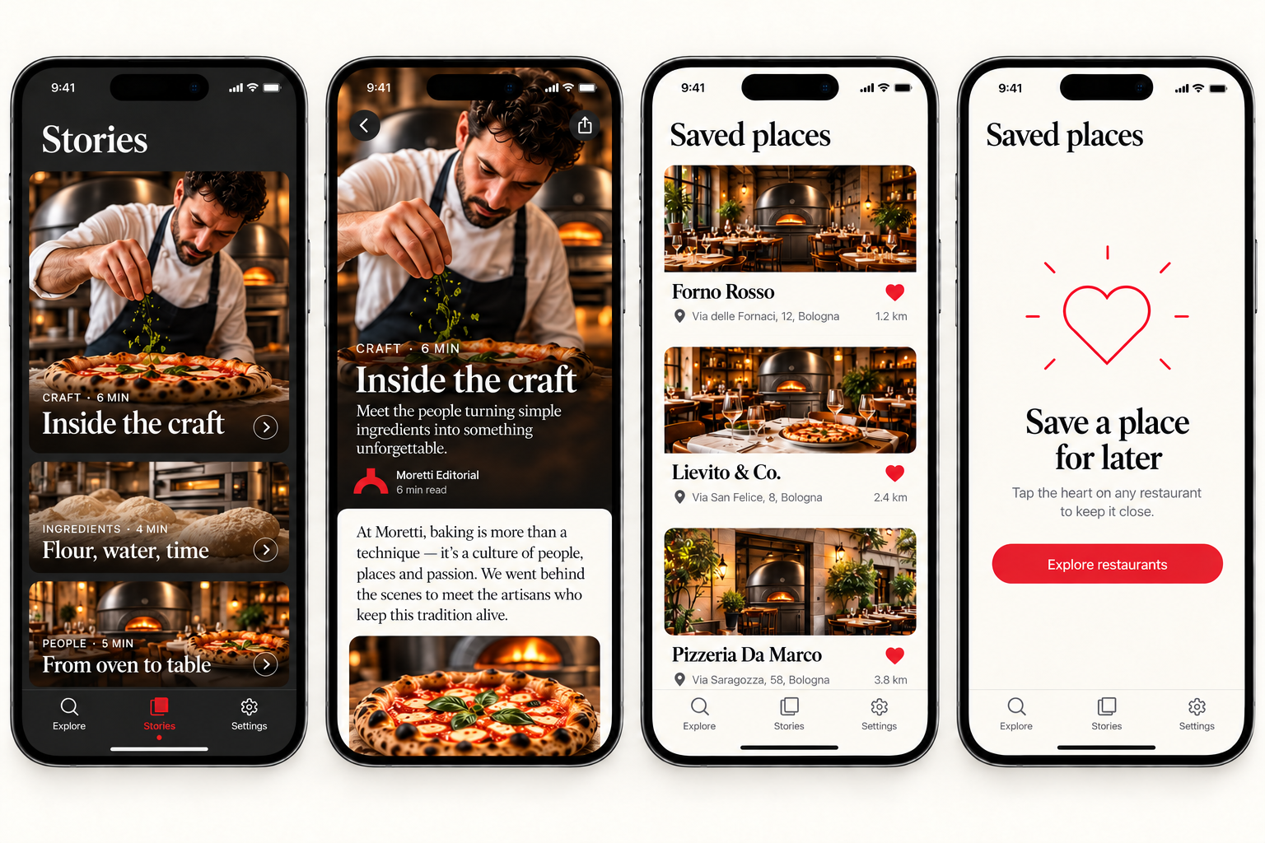
Approved editorial and location photography direction

Image rules
- Use official Moretti Neapolis imagery for restaurant and pizzeria scenes.
- Use Serie S and Serie X for bakery, production, training and exhibition contexts.
- Do not use generic brick domes, rustic masonry ovens or invented product designs.
- Prefer warm natural light, visible craft and real food. Avoid overly staged stock photography.
- Keep the oven identifiable when it supports the story. Do not crop out defining product features.
- Use descriptive alt text that explains the location, activity and relevant oven context.

Content style and implementation checklist

Interface language
- Write short labels that describe the action: Cerca, Indicazioni, Salva, Pubblica.
- Use a warm and informed tone without exaggeration or unsupported quality claims.
- Lead with the customer task. Put brand context and editorial detail second.
- Keep error messages specific and tell the user how to recover.
- Support Italian and English from the start. Avoid text embedded inside images.

Accessibility baseline
- Meet WCAG AA contrast for text and interactive controls.
- Use at least 44 by 44 px touch targets on mobile.
- Keep body text at 16 px on mobile and never below 14 px for essential content.
- Provide visible focus states, screen reader labels and logical reading order.
- Do not communicate status with colour alone.

Start standard
Area | Decision | Status
Colour tokens | Use the palette and roles in this document | Approved foundation
Typography | DM Serif Display plus Inter | Adopt for product UI
Spacing | 8 point system | Adopt for all screens
Mobile components | Use approved reference screens | Foundation ready
Backoffice components | Structured editor plus live simulator | Foundation ready
Photography | Official Moretti oven references only | Mandatory
Accessibility | WCAG AA and native platform patterns | Mandatory
This version establishes the common starting point. The next design phase should convert these decisions into reusable design tokens and a component library for mobile and backoffice implementation.

