1. Install Visual studio code and node js
2. Add HomePage.html file
3. Insert bootstrap and js libraries in header

<link href="https://cdn.jsdelivr.net/npm/bootstrap@5.0.2/dist/css/bootstrap.min.css" rel="stylesheet" integrity="sha384-EVSTQN3/azprG1Anm3QDgpJLIm9Nao0Yz1ztcQTwFspd3yD65VohhpuuCOmLASjC" crossorigin="anonymous">

    <script src="https://cdn.jsdelivr.net/npm/jquery@3.6.0/dist/jquery.slim.min.js"></script>

    <script src="https://cdn.jsdelivr.net/npm/popper.js@1.16.1/dist/umd/popper.min.js"></script>

    <script src="https://cdn.jsdelivr.net/npm/bootstrap@4.6.1/dist/js/bootstrap.bundle.min.js"></script>

4.design Homepage using Navbar, carousel slide, accordion, modal fade classes.

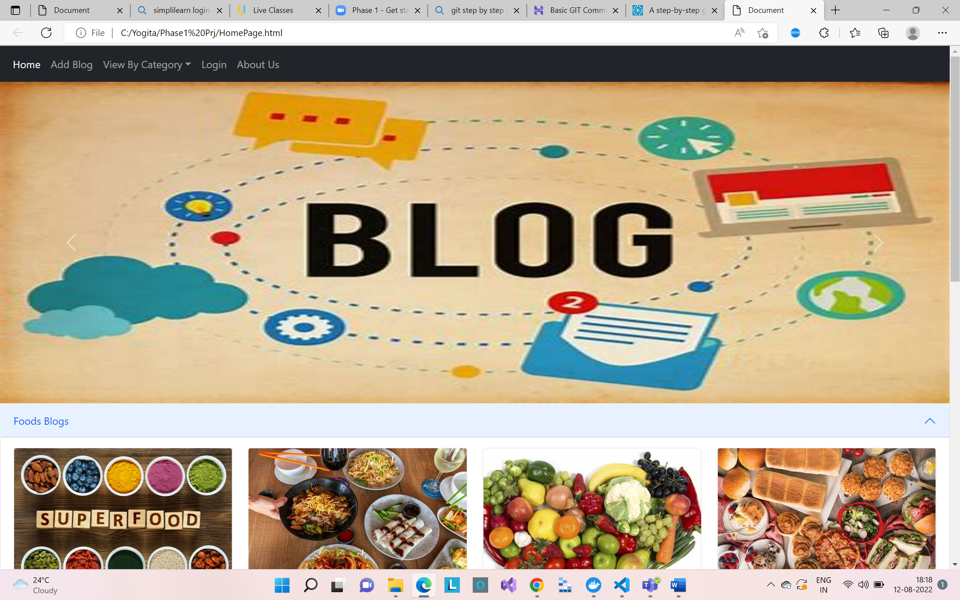

Menu behaviour:

Home: move to Home page

Add Blog: navigate to Insertblog page to add new Blog.

View By Category:Food

Sport

Travel

Login: open model form for login set username and password required fields.

On Submit button click giving “Login Successfully” alert.

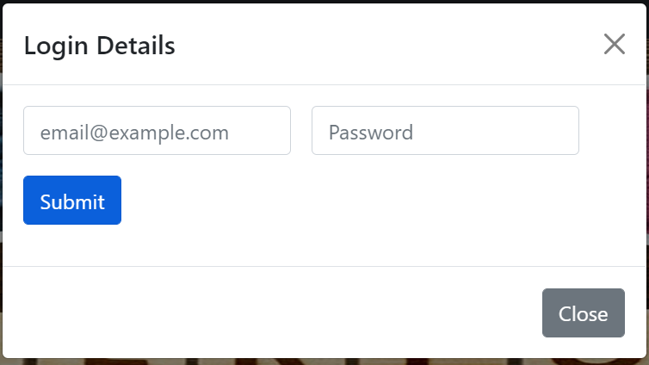

6. Insert “InsertBlog.html” and SubmitForm.js

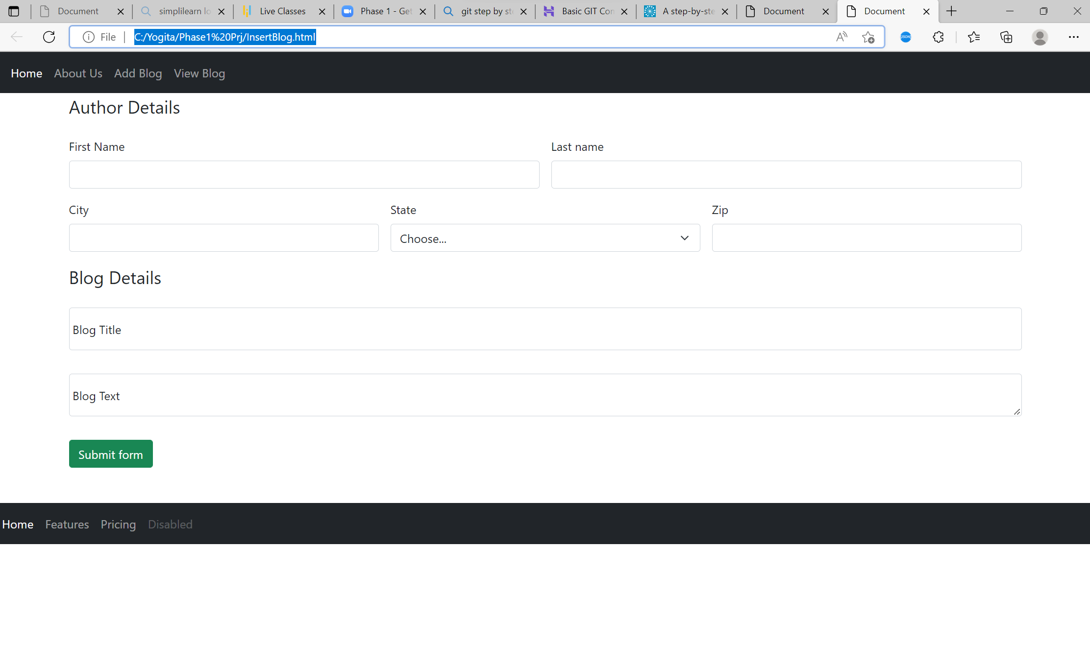

All fields are required, on Submit form click blogs written on UI will get added in array and give alert “"Thank you for submitting a blog. We will review it and upload it"