Algorithmic Report
1.0 Introduction 2
1.1 General Description of Benchmark Methodology 2
2.0 Construction Methods 3
2.1 Nearest Neighbour (DS) 3
2.1.1 Benchmark Results 3
2.1.1.1 Table Of Nearest Neighbour 3
2.2 Insertion Methods 4
2.2.1 Initialisation Methods 4
2.2.1.1 Random (DS) 4
2.2.1.2 Closest (SS) 4
2.2.1.3 Furthest (SS) 4
2.2.2 Operation Methods 4
2.2.2.1 Random Insertion (DS) 4
2.2.2.2 Cheapest Insertion (SS) 4
2.2.2.3 Dearest Insertion (SS) 4
2.2.2.4 Nearest Insertion (SS) 5
2.2.2.6 Nearest II Insertion (SS) 5
2.2.2.7 Furthest II Insertion (SS) 5
2.2.3 Benchmark Results 6
2.2.3.1 Table for Random Initialisation 6
2.2.3.2 Table for Closest Initialisation 6
2.2.3.3 Table for Furthest Initialisation 6
2.3 Discussion On Insertion Techniques 7
3.0 Modification Methods 8
3.1 K-Opt 8
3.1.1 ‘1-Opt’ Single City Move (SS) 9
3.1.2 ‘2-Opt’ Single Segment Reversal (SS) 10
3.1.3 ‘3-Opt’ Triple Segment Reversal (SS) 11
3.2 Benchmark Results 12
3.2.1 Table Of Iteration Methods 12
3.3 Discussion of Iteration Techniques 12
4.0 Simulated Annealing (DS) 14
4.1 Benchmark Results 15
4.1.1 Table Of Annealing Methods 15
5.0 Comparison of TSP techniques. 16

Introduction

The Travelling Salesman Problem (TSP) has the following description.
“You are a travelling salesperson in America. Your boss has given you a requirement for your next sales run. You must visit every capital city in America. You must visit each city once and only once. The route you choose must be the best possible route. Hence the distance you travel must be the smallest possible distance that it is possible to travel while fulfilling the above conditions.”

Upon applying your problem solving skills for a fifty (50) city problem, you find that there are fifty factorial (50!) combinations which is 3.041409320171e+64. Working out all these possible combinations takes about 20,000 years, which you did not have. Realising that although the brute force method will work, it is temporally impossible, so you set about working out quicker methods for finding the solution. You fully realise that since the TSP is an NP-Complete problem, solving the TSP will mean solving all NP-Complete problems – Scheduling, Timetabling, Work rosters, courier routes, Data-communications packet routing, etc. Hence you come to a conclusion – If you solve the TSP there is no way you will remain a salesperson.

General Description of Benchmark Methodology

Benchmarking involves the comparison of solutions (optimal vs resultant) for a given TSP method.
This means running the method on a number of problems – say ten, and averaging the results.
The greater the number of problems the higher is the accuracy of our results. The result for a given problem is calculated as (the resultant path length / the optimal path length), hence a result of 1.1 indicates that the resultant path is 10% worse than the optimal path. Due to my project coordinator (Dr. Raymond Lister) having a student working on distributed systems I had access to a method he implemented which works very well for problems of size 30 cities or less. Thus upon giving him ten 30 city problems he returned to me their optimal solutions.

Each method also has a solution indicator symbol. The solution is for a particular problem the algorithms are running on. The SS means that the solution will be the same no matter how many times it is run while DS means that different solutions can be gained by running this method multiple times.

2.0 Construction Methods

Construction methods involve starting off with no path at all, just the cities, and by use of various methods, construct a path through these cities.

2.1 Nearest Neighbour (DS)

This method randomises its start city. At each stage it chooses as the next city to run the path to as the city which is closest to the last city it chose. When all cities are in the path the first and last cities are joined to complete the path.

2.1.1 Benchmark Results

2.1.1.1 Table Of Nearest Neighbour

File | NearN
30city_0.TSP | 1.30263
30city_1.TSP | 1.21852
30city_2.TSP | 1.25907
30city_3.TSP | 1.25770
30city_4.TSP | 1.08349
30city_5.TSP | 1.16767
30city_6.TSP | 1.35583
30city_7.TSP | 1.24478
30city_8.TSP | 1.16975
30city_9.TSP | 1.16158
Average | 1.2221

2.2 Insertion Methods

Insertion methods involve inserting cities into a path. This path usually starts off at a small length and successively has cities inserted into it until all cities are in the path. These small length paths are usually generated from an initialisation method.

2.2.1 Initialisation Methods

Initialisation methods choose a start path as a small number of points. The path is closed. That is, the first city in the path is joined to the last city in the path.

2.2.1.1 Random (DS)

Random Initialisation chooses two points at random as the start path.

2.2.1.2 Closest (SS)

Closest Initialisation chooses the two points which are closest to each other as the start path.

2.2.1.3 Furthest (SS)

Furthest Initialisation chooses the two points which are furthest from each other as the start path.

2.2.2 Operation Methods

All operation methods choose a city to be inserted into the path and insert it into its best place – that is, between the two cities which minimise its increase to path length.

2.2.2.1 Random Insertion (DS)

The next city to be inserted is chosen at random from amongst the cities not yet in the path.

2.2.2.2 Cheapest Insertion (SS)

The next city to be inserted is chosen as the city not yet in the path which if inserted will minimise the increase to path length.

2.2.2.3 Dearest Insertion (SS)

The next city to be inserted is chosen as the city not yet in the path which if inserted will maximise
the increase to path length (minimax). Note that the particular city chosen for insertion is inserted in the place that minimises the increase to path length.

2.2.2.4 Nearest Insertion (SS)

The nearest city to each city in the path is found. The nearest of these is chosen as the city to be inserted.

2.2.2.5 Furthest Insertion (SS)

The nearest city to each city in the path is found. The furthest of these is chosen as the city to be inserted.

2.2.2.6 Nearest II Insertion (SS)

The furthest city from each city in the path is found. The nearest of these is chosen as the city to be inserted.

2.2.2.7 Furthest II Insertion (SS)

The furthest city from each city in the path is found. The furthest of these is chosen as the city to be inserted.

2.2.3 Benchmark Results

2.2.3.1 Table for Random Initialisation

File/Insert-> | Random | Cheapest | Dearest | Nearest | Furthest | Nearest II | Furthest II
30city_0.TSP | 1.04427 | 1.03297 | 1.01440 | 1.11754 | 1.08142 | 1.06278 | 1.07149
30city_1.TSP | 1.10240 | 1.12429 | 1.04158 | 1.15825 | 1.13575 | 1.02648 | 1.04158
30city_2.TSP | 1.05423 | 1.09287 | 1.00856 | 1.04054 | 1.10955 | 1.07050 | 1.00856
30city_3.TSP | 1.12987 | 1.11112 | 1.01714 | 1.13051 | 1.19765 | 1.03193 | 1.03025
30city_4.TSP | 1.00881 | 1.13661 | 1.01566 | 1.08445 | 1.08166 | 1.01755 | 1.01755
30city_5.TSP | 1.12785 | 1.09987 | 1.03955 | 1.18393 | 1.12194 | 1.05665 | 1.14129
30city_6.TSP | 1.17106 | 1.14997 | 1.01890 | 1.21311 | 1.13364 | 1.06594 | 1.14922
30city_7.TSP | 1.01093 | 1.24361 | 1.06668 | 1.24361 | 1.17880 | 1.00000 | 1.00096
30city_8.TSP | 1.15500 | 1.04613 | 1.01254 | 1.12819 | 1.18329 | 1.01254 | 1.10619
30city_9.TSP | 1.05819 | 1.07046 | 1.05545 | 1.09705 | 1.12560 | 1.03632 | 1.04904
Average | 1.08626 | 1.11079 | 1.02905 | 1.13972 | 1.13493 | 1.03807 | 1.06161

2.2.3.2 Table for Closest Initialisation

File/Insert-> | Random | Cheapest | Dearest | Nearest | Furthest | Nearest II | Furthest II
30city_0.TSP | 1.03576 | 1.12789 | 1.01440 | 1.16921 | 1.18019 | 1.02021 | 1.01440
30city_1.TSP | 1.15038 | 1.20081 | 1.04158 | 1.19206 | 1.29712 | 1.00447 | 1.04158
30city_2.TSP | 1.04313 | 1.06058 | 1.00856 | 1.14947 | 1.12885 | 1.02818 | 1.00856
30city_3.TSP | 1.00501 | 1.11204 | 1.01714 | 1.25344 | 1.10207 | 1.02163 | 1.01714
30city_4.TSP | 1.08704 | 1.11210 | 1.01566 | 1.19927 | 1.21973 | 1.06153 | 1.02636
30city_5.TSP | 1.03818 | 1.10865 | 1.03679 | 1.13531 | 1.24948 | 1.02778 | 1.07377
30city_6.TSP | 1.04444 | 1.19678 | 1.17089 | 1.19678 | 1.25348 | 1.05422 | 1.08568
30city_7.TSP | 1.01093 | 1.21041 | 1.06764 | 1.22047 | 1.18839 | 1.06299 | 1.06668
30city_8.TSP | 1.07159 | 1.06456 | 1.13347 | 1.15981 | 1.01254 | 1.01499 | 1.04544
30city_9.TSP | 1.02574 | 1.10003 | 1.05545 | 1.06517 | 1.10865 | 1.03236 | 1.04904
Average | 1.05122 | 1.12939 | 1.05616 | 1.1741 | 1.17405 | 1.03284 | 1.04287

2.2.3.3 Table for Furthest Initialisation

File/Insert-> | Random | Cheapest | Dearest | Nearest | Furthest | Nearest II | Furthest II
30city_0.TSP | 1.07792 | 1.04274 | 1.02272 | 1.17656 | 1.11377 | 1.02021 | 1.01440
30city_1.TSP | 1.07869 | 1.04204 | 1.03114 | 1.04204 | 1.10615 | 1.02648 | 1.04158
30city_2.TSP | 1.03481 | 1.10620 | 1.00856 | 1.02357 | 1.12693 | 1.02652 | 1.00513
30city_3.TSP | 1.02112 | 1.05942 | 1.01714 | 1.05942 | 1.13067 | 1.03618 | 1.01714
30city_4.TSP | 1.02373 | 1.08399 | 1.01566 | 1.10339 | 1.10581 | 1.01297 | 1.02636
30city_5.TSP | 1.03321 | 1.06566 | 1.03955 | 1.06073 | 1.11339 | 1.07911 | 1.07377
30city_6.TSP | 1.06571 | 1.07703 | 1.01890 | 1.05837 | 1.08366 | 1.01890 | 1.08568
30city_7.TSP | 1.00199 | 1.08765 | 1.00096 | 1.04694 | 1.08906 | 1.00000 | 1.00000
30city_8.TSP | 1.11949 | 1.03389 | 1.02372 | 1.02052 | 1.07080 | 1.01900 | 1.01254
30city_9.TSP | 1.03129 | 1.02175 | 1.05886 | 1.00772 | 1.01974 | 1.05222 | 1.04904
Average | 1.0488 | 1.06204 | 1.02372 | 1.05993 | 1.096 | 1.02916 | 1.03256

2.3 Discussion On Insertion Techniques
Nearest Neighbour is the quickest algorithm.

Nearest II is the best insertion algorithm

Furthest is the best initialisation technique.

It is always possible to solve a TSP with the insertion method if the insertion order used is correct. In some insertion orders, inserting A before B or B before A makes no difference at all to the outcome, e.g. if the points A and B lie in areas of the make which have no effect on each other their order of insertion is irrelevant. Due to there being n! combinations of insertion order, using a brute force method for insertion order as opposed to the brute force method for possible paths (also n!), is pointless. Insertion methods have an inherent advantage over other algorithms – if a new city is added to the run it can simply be inserted, though its effect of insertion would have to be studied to ensure that is insertion will still keep the path optimal. One tiny little change like a new insertion can change the overall optimal path significantly. Hence a global view of the problem is required to ensure an optimal solution.

3.0 Modification Methods

Modification methods convert paths from what they are to something which is better. Usually this means applying a method until no more applications of that method lead to a decrease in path length.

3.1 K-Opt

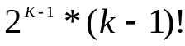K-opt is a modification method which changes the path by breaking the path into sections and reforming the path from these sections. In general, K-opt can be described as ‘make K breaks in the path (where a break is between two neighbouring cities) and choose the change to make as one of the possible combinations of reforming the path’.
The number of possible combinations is

As a result of this 1-Opt is totally pointless: making one break and reforming the path equals no change. As a result 1-Opt is different from the other versions of K-Opt, and hence is not really a member of the K-Opt family. The break is still made to the path but instead of simply reforming it, a single city from the path is entered into the break instead. Due to the constraint of visiting each city once and only once this city must be removed from the section of path at which it originally resided.

3.1.1 ‘1-Opt’ Single City Move (SS)

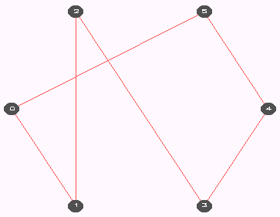
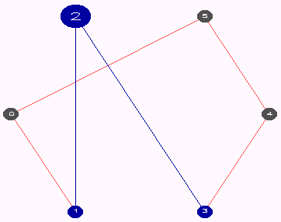
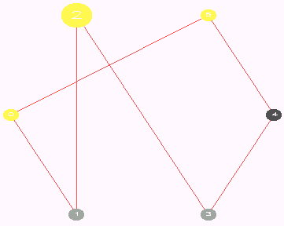
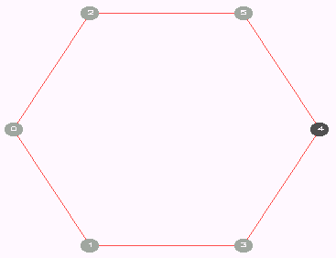
Single city move moves a single city from its place in the path to a place in the path which decreases the path length. To choose which city to apply this to it finds all possible moves including those which increase the path length and makes the best one. If all increase the path length none are made and the method is complete – O(N²).

(Fig_3.1.1.A) (Fig_3.1.1.B)

(Fig_3.1.1.C) (Fig_3.1.1.D)

3.1.2 ‘2-Opt’ Single Segment Reversal (SS)

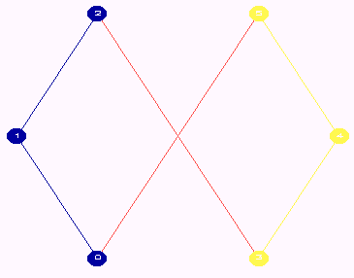
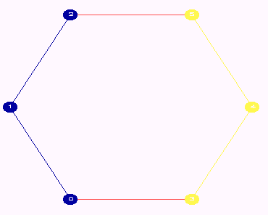
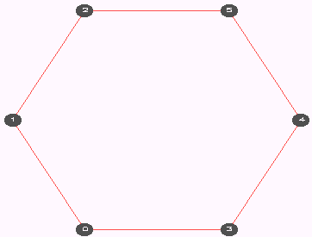
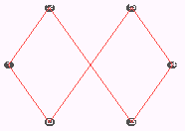
Single segment reversal reverses a single segment in the path which results in a decrease to path length. It chooses the segment to reverse by working out the decreases to path length of all possible segment reversals and makes the best one. If all increase the path length none are made and the method is complete. One feature of this method is that all path crossovers are removed – O(N²).

- (B)

(C) (D)

3.1.3 ‘3-Opt’ Triple Segment Reversal (SS)

Triple segment reversal reverses a combination of three consecutive segments in the path to decrease the path length. The segments include all the cities in the path. Due to there being 3 segments and 2 possibilities with each segment (reverse, don’t reverse) there are 8 possible combinations to check, (don’t) (don’t) (don’t) being no change. The method finds all possible segment sets, and all possible reversals for these sets and makes the best change of all these. This is an expensive algorithm – O(N³).

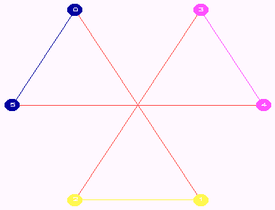
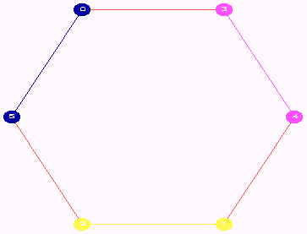
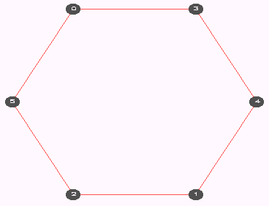
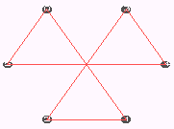

(A) (B)

(C) (D)

3.2 Benchmark Results

3.2.1 Table Of Iteration Methods

File/Method-> | 1opt | 2opt | 3opt
30city_0.TSP | 1.01275 | 1.03027 | 1.00050
30city_1.TSP | 1.12020 | 1.00000 | 1.00000
30city_2.TSP | 1.12272 | 1.00339 | 1.00000
30city_3.TSP | 1.31058 | 1.01112 | 1.00000
30city_4.TSP | 1.35593 | 1.01297 | 1.00000
30city_5.TSP | 1.17676 | 1.07681 | 1.02120
30city_6.TSP | 1.11552 | 1.01894 | 1.00000
30city_7.TSP | 1.02133 | 1.00069 | 1.00000
30city_8.TSP | 1.00000 | 1.00000 | 1.00369
30city_9.TSP | 1.12983 | 1.02536 | 1.00000
Average | 1.13656 | 1.01796 | 1.00254

3.3 Discussion of Iteration Techniques

3opt has a wider picture and hence often results in a better path. Examination of a problem may reveal that a change increases the path length and is hence not a viable option. Increase the K level of the problem however results in us also seeing that this change makes way for a new change which decreases the path length more than the first change decreases the path length. It is by this example that we see that an increase in K-level often results in changes being made which would not otherwise have been made. This is why generally increasing the K-level results in a more optimised path. Sometimes a change is made which results in another (later) change not being made. A lesser K-level optimiser would not have made the first change and it is for this reason that sometimes a lesser optimiser can produce a better solution.

Just as it is assumed in insertion that there exists a way or many ways that insertion can take place which will result in an optimal path length, it is also assumed that the same exists for iteration techniques. The method is probably not ‘search for all possible changes and make the best one of these’; this technique simply brings about an end more quickly. Hence the reason why 2opt sometimes beats 3opt – just because 3opt makes a lesser number of changes to bring about a solution does not mean that for a given problem it is the best. Its level of success depends entirely on the choice it makes, in this case the change which decreases the path length most. Hence, as with insertion, the choice made at each step has an overall impact on the result. A version of 3opt which uses another changing mechanism such as ‘find a decrease path length change and make it’ might actually bring about a better solution than ‘find all possible changes and make the one which decreases path length most’.

In general 3opt is a better algorithm than 2opt which is better than 1opt but all algorithms can produce a perfect solution depending on how they are applied at each step. Using ‘the best change of all changes’ as a changing mechanism often results in a good path, though as it is not perfect for all cases it is not the TSP solution.

4.0 Simulated Annealing (DS)

This method simulates metal annealing. Starting at a chosen temperature, with a cooling rate, a number of changes to be made at each temperature and an annealing method (1-Opt or 2-Opt) the algorithm works as follows. At a given temperature (T), a number of changes are made. Possible changes are determined by probability based on the size of the change to path length (ΔE) and the current temperature. It is given by
e
p
/
Δ
=
T

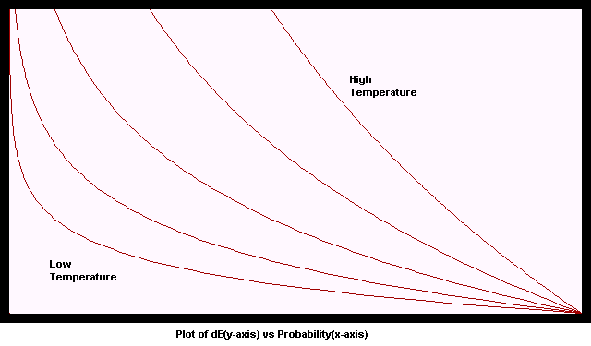
From the above plot of the probability formula it is possible to see that for a constant ΔE the probability decreases as the temperature decreases. At very low temperatures only high ΔE values have a good chance of being selected.

This formula means that as the temperature decreases the chance of making a good change increases and the chance of making a bad change decreases. The null change always has a probability of one (1). A change is chosen by adding all the probabilities (including the null change) and randomising a value in the range 0 to this sum total. The change to make is determined from this random number. After all changes are made at the given temperature the new temperature as set as the given temperature multiplied by the cooling rate. When no changes were made in the last set of changes or the temperature is equal to 0.0 the annealing stops.
E
−

4.1 Benchmark Results

All paths started off as they were in the problem (optimal paths). No randomisation or other technique was applied.

4.1.1 Table Of Annealing Methods

File/Method-> | 1opt | 2opt | 1opt / 2opt
30city_0.TSP | 1.1181620 | 1.0000000 | 1.1181620
30city_1.TSP | 1.0000000 | 1.0742022 | 0.9309234
30city_2.TSP | 1.0713162 | 1.0074675 | 1.0633754
30city_3.TSP | 1.1817702 | 1.0000000 | 1.1817702
30city_4.TSP | 1.0068429 | 1.0068429 | 1.0000000
30city_5.TSP | 1.0000000 | 1.0219562 | 0.9785155
30city_6.TSP | 1.1185141 | 1.0189381 | 1.0977253
30city_7.TSP | 1.0109267 | 1.0000000 | 1.0109267
30city_8.TSP | 1.0248152 | 1.0203795 | 1.0043471
30city_9.TSP | 1.1330078 | 1.0000000 | 1.1330078
Average | 1.0665355 | 1.0149786 | 1.0507960

5.0 Comparison of TSP techniques.

