PulseBox
Web Remote — Technical Documentation
Generated against modules/web_remote.py at the current APP_VERSION.
The web remote is a single PulseBox module (modules/web_remote.py) that runs a lightweight HTTP server in a background thread alongside the Tkinter UI. It serves one inlined single-page app and a small REST-like JSON API, letting any phone, tablet, or browser on the LAN browse the library, control playback, and manage the queue.
It has no third-party dependencies — only Python's built-in http.server, base64, socket, and threading.
Scope: everything in the Web Remote sections is taken directly from modules/web_remote.py. The locations of the player, library, and playlist classes are inferred from their imports/usage and marked (inferred) in the file tree.

1. Architecture
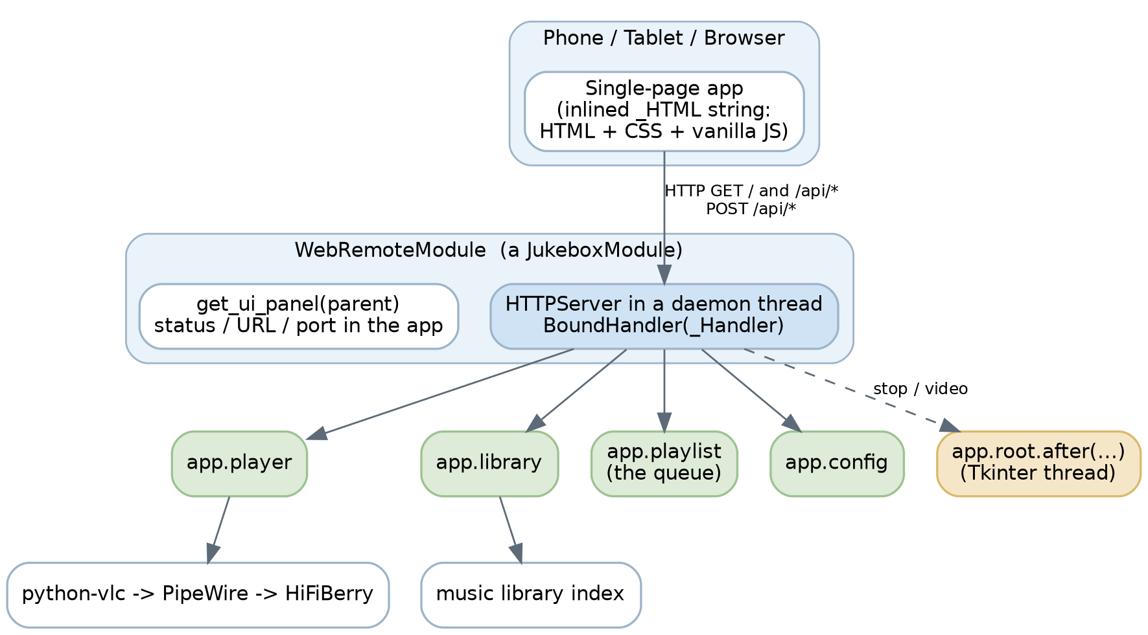
Key points:
- The server runs on its own daemon thread (PulseBox-WebRemote), so it never blocks the Tkinter mainloop.
- The browser exchanges only JSON over /api/*; the single HTML payload is served at /.
- GUI-affecting actions (stop navigates to the playlist page; video play opens the player) are marshalled back onto the Tkinter thread via app.root.after(0, …).
- APP_VERSION is injected into the page at serve time by replacing the __APP_VERSION__ placeholder in do_GET.

2. Entity / data model
Structures exchanged across the API. Album and Track are the library's native dictionaries; Status, Selection, Station, and Video are shaped by the API builders.
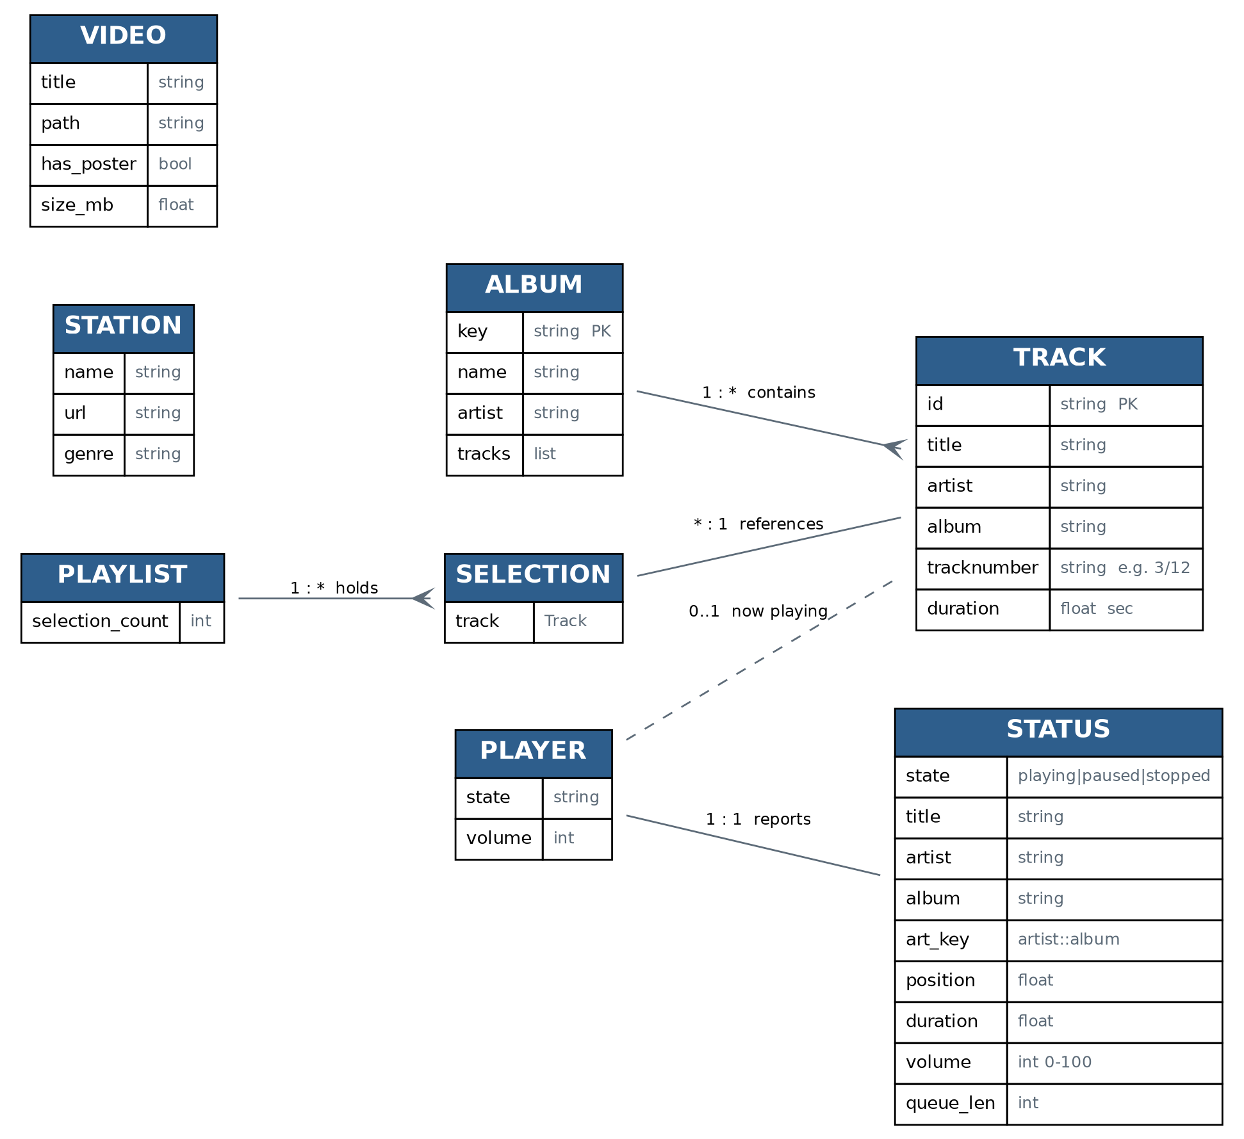
Notes on the model:
- art_key is the string "<artist>::<album>". The browser fetches /api/art/<art_key>; the server resolves it by matching artist+album across the library, so one key works for album rows and now-playing art. Missing art returns a transparent placeholder and the UI falls back to a gradient tile.
- Track numbers are stored raw as tracknumber (a string that may be "3/12"). /api/library exposes the parsed integer as track_num; /api/album/<key> exposes it as track_no. Both are sorted ascending.
- Selection is the queue entry; the API surfaces only title, artist, and album from each pending selection's .track.
- Station comes from the radio page's fallback list, not a database. Video is produced by scanning the configured video directory.

3. File structure
pulsebox/
├── main.py app entry point, module loader (inferred)
├── core/
│ ├── config.py JukeboxModule base, APP_VERSION, config [ok]
│ ├── player.py playback engine (app.player) (inferred)
│ ├── library.py music index (app.library) (inferred)
│ ├── playlist.py queue (app.playlist) (inferred)
│ └── audio_spdif.py HiFiBerry Tx Source=AIF helper (added)
├── ui/
│ ├── theme.py design tokens: ACCENT, BG_*, FONT_*, PAD [ok]
│ ├── radio_page.py FALLBACK_STREAMS, radio UI [ok]
│ ├── video_page.py scan_video_library(), video UI [ok]
│ └── ... other Tkinter pages (playlist, etc.)
├── modules/
│ └── web_remote.py THIS module: HTTP server + inlined SPA [ok]
└── scripts/
└── spdif_fix.sh installer fragment (added)
[ok] = confirmed from imports in web_remote.py. (inferred) = referenced via app.player / app.library / app.playlist but the file location isn't proven by web_remote.py alone.

Anatomy of web_remote.py
Region | What it is
Module docstring | Human summary plus a (partial) endpoint list
_get_local_ip, _fmt_time | Helpers
_HTML = r"""…""" | The entire SPA: HTML + CSS + JS, served at /
class _Handler(BaseHTTPRequestHandler) | Routing (do_GET / do_POST) plus JSON builders
class WebRemoteModule(JukeboxModule) | Lifecycle, server management, settings panel

4. Request lifecycle
- The app loads the module and calls on_load(app), which reads the configured port and starts the server thread.
- _start_server() defines a BoundHandler(_Handler) whose module class attribute back-references the live module. That's how each request reaches self.module.player, self.module.app, etc.
- A browser hits / → do_GET serves _HTML with the version substituted.
- The SPA polls GET /api/status every second and renders views on demand.
- User actions issue POST /api/*; handlers call into app.player / app.playlist and return small JSON acks.
- GUI-affecting actions are pushed onto the Tkinter thread with app.root.after(0, …).

5. HTTP API reference
Base URL: http://<pi-ip>:8080 (port configurable in the module's panel). Responses are JSON unless noted. Unknown paths return 404.

GET
Path | Returns
/ | The web remote UI (HTML); __APP_VERSION__ substituted with APP_VERSION
/api/status | Status object (below). Polled ~1×/sec
/api/now | Status plus art_b64 (base64 JPEG) for the now-playing view
/api/queue | { queue: [ {title, artist, album}, … ] } — pending selections
/api/library | { albums: [Album…], total: N }; each album includes its full tracks array
/api/art/<album_key> | Album art as image/jpeg; key may be a library key or artist::album
/api/album/<album_key> | { album: {name, artist, key, tracks:[{id,title,track_no,duration}]} }
/api/radio | { stations: [{name,url,genre}, …] } from ui.radio_page.FALLBACK_STREAMS
/api/videos | { videos: [{title,path,has_poster,size_mb}, …] }
/api/video-art/<video_path> | Poster as image/jpeg when has_poster

Status object
{
"state": "playing|paused|stopped",
"title": "…", "artist": "…", "album": "…",
"art_key": "artist::album",
"position": 42.0, "duration": 215.0,
"volume": 55,
"queue_len": 3
}

POST
Bodies are JSON; empty or omitted bodies are tolerated.
Path | Body | Effect / response
/api/play | — | player.play() → {ok:true}
/api/pause | — | player.pause() → {ok:true}
/api/stop | — | player.stop(), then navigates UI to playlist page
/api/next | — | player.next_track()
/api/prev | — | player.previous_track()
/api/volume | {volume:0-100} | player.set_volume(v) → {ok,volume}
/api/seek | {position} | player.seek(pos)
/api/queue/add | {track_id,album_key} | adds track to queue → {ok, message}
/api/queue/clear | — | playlist.clear_selections()
/api/radio/play | {url,name} | player.play_url(url,title=name)
/api/video/play | {path} | opens video on the app screen (UI thread)
/api/system/reboot | — | sudo reboot in a thread
/api/system/shutdown | — | sudo shutdown -h now in a thread
The module's top-of-file docstring lists only a subset (it predates the radio, video, and system routes). This table is authoritative — consider syncing the docstring.

6. The module system
Every PulseBox feature subclasses JukeboxModule (from core.config). The web remote is one such module.

Class metadata (class attributes)
class MyModule(JukeboxModule):
MODULE_ID = "my_module" # unique slug
MODULE_NAME = "My Module" # display name
MODULE_VERSION = APP_VERSION
MODULE_DESCRIPTION = "What it does."
MODULE_AUTHOR = "Andrew J. Morgan"

Lifecycle methods
Method | When | Notes
__init__(self) | construction | call super().__init__(), set up instance state
on_load(self, app) | module enabled | call super().on_load(app) first; afterwards self.app, self.config, self.player, self.library are available. Start threads/servers here.
on_unload(self) | disable / exit | tear down (stop servers/threads), then super().on_unload()
get_ui_panel(self, parent) | settings view | return a tk.Frame (use tokens from ui.theme)

What a module can reach (via app / base class)
Reference | Provides
self.app.player | get_current_track(), get_state(), get_position(), get_duration(), get_volume(), play(), pause(), stop(), next_track(), previous_track(), set_volume(int), seek(float), play_url(url, title=…)
self.app.library | get_all_albums() → list[Album], get_track(id) → Track | None
self.app.playlist | selection_count, pending_selections (each has .track), add_selection(track) → (ok, msg), clear_selections()
self.config | get(key, default), set(key, value)
self.app.root / show_page | Tkinter root + page navigation (call on the UI thread via root.after)

Skeleton: a new module
# modules/hello.py
import tkinter as tk
from core.config import JukeboxModule, APP_VERSION
from ui.theme import ACCENT, BG_CARD, FONT_SUBHEAD, PAD

class HelloModule(JukeboxModule):
MODULE_ID = "hello"
MODULE_NAME = "Hello"
MODULE_VERSION = APP_VERSION
MODULE_DESCRIPTION = "Minimal example module."
MODULE_AUTHOR = "Andrew J. Morgan"

def __init__(self):
super().__init__()
self._worker = None

def on_load(self, app):
super().on_load(app) # self.app / self.config now set
# start background work, register hooks, etc.

def on_unload(self):
# stop background work here
super().on_unload()

def get_ui_panel(self, parent) -> tk.Frame:
frame = tk.Frame(parent, bg=BG_CARD, padx=PAD, pady=PAD)
tk.Label(frame, text="Hello", font=FONT_SUBHEAD,
fg=ACCENT, bg=BG_CARD).pack(anchor="w")
return frame
Drop the file in modules/, give it a unique MODULE_ID, and the app's module loader picks it up the same way it loads web_remote. Bump APP_VERSION in core/config.py with each release.

7. Extending the web remote (new endpoint + tab)
Adding a feature to the remote is three small edits inside web_remote.py.
a) Add a route in _Handler.do_GET (or do_POST):
elif path == "/api/playlists":
self._json(self._playlists())
b) Add the builder as a method on _Handler, reading from self.module.* and returning a plain dict:
def _playlists(self) -> dict:
pls = self.module.app.library.get_playlists()
return {"playlists": [{"id": p.id, "name": p.name} for p in pls]}
c) Wire the UI inside the inlined _HTML JS, using the existing data helpers:
async function loadPlaylists(){
const data = await getJSON("/api/playlists");
// render data.playlists into a view…
}
To add a whole new tab, mirror an existing one: a <div class="view" data-tab="playlists"> block, a <button class="tab" data-tab="playlists" onclick="showTab('playlists')"> in #tabbar, an optional per-tab colour rule, and a loader call in the init block. showTab() handles activation generically.
Keep responses small and JSON-only; stream images through their own image/* endpoints (as /api/art and /api/video-art do) rather than embedding them in JSON, except the deliberate art_b64 in /api/now.

8. Threading & safety notes
- The HTTP server is a daemon thread; it dies with the app. on_unload calls server.shutdown() to stop it cleanly on disable.
- Handlers run on server threads. Reading player/library state is fine; anything touching Tkinter widgets must be deferred with app.root.after(0, …) (see /api/stop and /api/video/play).
- reboot / shutdown shell out to sudo in a throwaway thread so the HTTP response returns before the system goes down.
- Access is unauthenticated and LAN-trusted by design — keep the port on a trusted network.

