RSG 3‑D
STRUCTURAL CONCRETE INSULATED PANELS
Master Product Brief
Technical Performance | Application Methods | Competitive Positioning | Market Applications

105%  Degree of Composite Action |  | 0.012"  End Slip at Ultimate Load |  | 30+ Yrs  20 Countries, Zero Storm Damage |  | R‑20  Baseline Continuous Insulation

“The most sustainable & resilient building system in the world.”
— RSG 3‑D

Classification: Confidential — Internal Reference  Version: 3.0 | Validated by: TCA Grey Book | ICC-ES ESR‑2435  Testing: Utah State University, 2023–2024

CONTENTS

1 | Executive Summary | 2
2 | The RSG 3‑D System | 3
3 | Application Methods: Shotcrete & Tilt-Up | 5
4 | The EVG Truss Connector | 8
5 | Third-Party Validation: TCA Grey Book | 9
6 | ICC-ES Evaluation Report ESR‑2435 | 11
7 | Thermal Performance and Energy Code | 12
8 | Commercial and Industrial Applications | 14
9 | Competitive Positioning | 15
10 | Key Figures at a Glance | 17

1. EXECUTIVE SUMMARY

RSG 3‑D manufactures structural concrete insulated panels (SCIPs) that deliver the structural performance of solid concrete with the thermal efficiency of continuous insulation — in a single, factory-engineered wall system. The technology is built on the EVG 3D Construction System, an Austrian-engineered platform with decades of global deployment and a comprehensive structural engineering basis under ACI 318, DIN 1045, and ONORM standards.

The same panel core — EVG welded wire truss + EPS foam — is used across every RSG 3‑D project. What changes is the method by which the concrete wythes are applied: tilt-up cast-and-crane for large commercial and industrial buildings, and shotcrete applied in-place for residential and smaller commercial projects. This gives RSG 3‑D a unique ability to serve the full project spectrum within a single, code-evaluated system.

“Group A (RSG 3‑D) achieved 105% of fully composite nominal moment strength, failed in a ductile flexural mode, produced end slip of just 0.012 inches at ultimate load, and was the only system that could be designed using the standard unmodified Slender Wall Method.”
— TCA Grey Book — Utah State University, 2023–2024

In 2023 and 2024, the Tilt-up Concrete Association (TCA) completed the most rigorous full-scale independent testing program ever conducted on concrete insulated panels for tilt-up construction. Twenty panels were tested across five connector systems at Utah State University. The RSG 3‑D system — Group A — was the benchmark performer across every category measured.

RSG 3‑D panels also carry ICC-ES Evaluation Report ESR‑2435, confirming compliance with applicable US building codes. The system delivers a baseline R‑20 continuous insulation value (R-4 per inch with standard 5" EPS core), upgradeable with GPS or higher-density EPS. In over 30 years across 20 countries, no RSG 3‑D structure has ever suffered damage from hurricanes, earthquakes, wildfires, or floods.

“50% less concrete and 80% less rebar compared to traditional tilt-up construction — a transformation of both the structural and environmental profile of the wall system.”
— RSG 3‑D Embodied Carbon Analysis

2. THE RSG 3‑D SYSTEM

2.1 What It Is
RSG 3‑D structural concrete insulated panels are composite sandwich wall elements consisting of two reinforced concrete wythes connected by a continuous three-dimensional welded wire truss that passes through a rigid EPS foam core. The system is manufactured using EVG Wire Mesh Welders — fully automatic precision welding equipment that produces consistent, high-tolerance panels at production scale.

The panel is lifted or erected into position and functions structurally as a composite section, with both wythes acting in concert to resist axial loads, out-of-plane bending, and lateral forces. The insulation core remains continuous across the full panel area with no thermal bridging at connector locations.

2.2 Wall System Comparison
The following cross-sectional visuals illustrate the four principal tilt-up wall configurations compared in the TCA embodied carbon study. All dimension labels are in inches. The RSG 3‑D panel achieves superior thermal and structural performance at substantially reduced concrete volume and steel content.

Solid Tilt-Up Wall  8" Solid Concrete  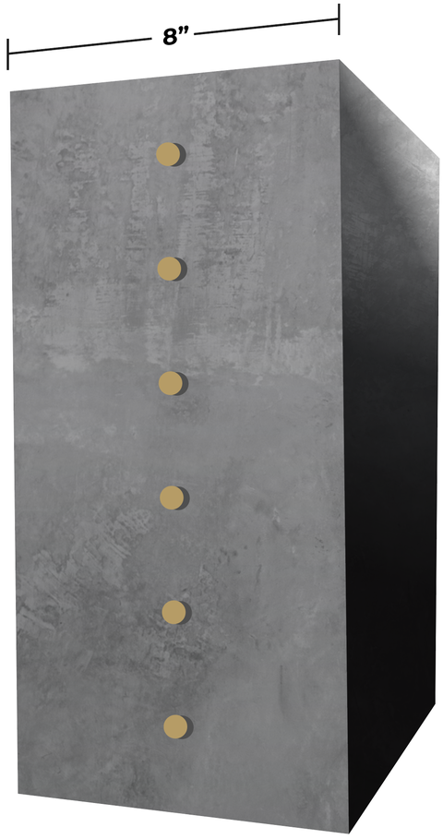 |  | Insulated Tilt-Up  3" / 2" EPS / 11"  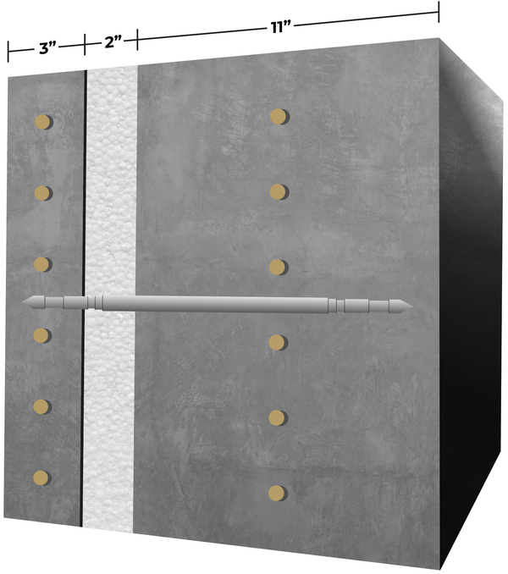 |  | Composite Tilt-Up  3" / 2" EPS / 7"  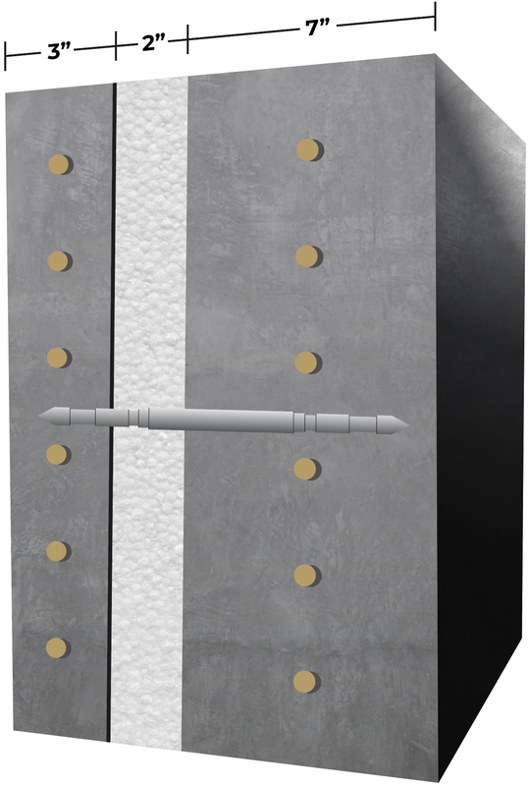 |  | RSG 3‑D Panel  2" / 5" EPS / 3" (Composite)  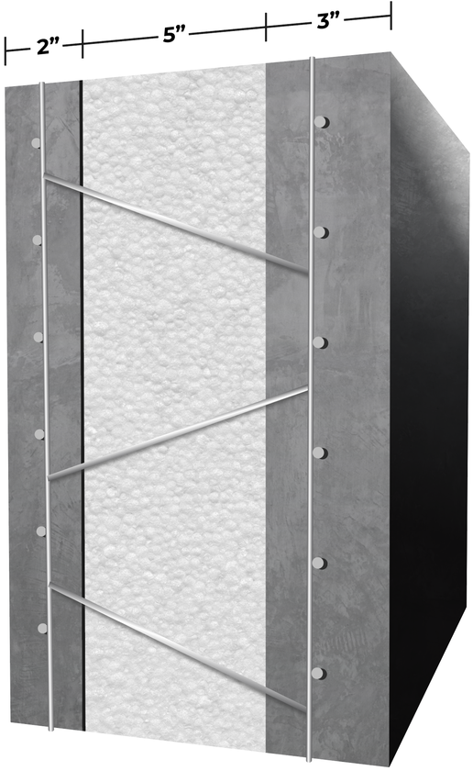

Highest Carbon  8" concrete, zero insulation |  | High Carbon  14" total concrete, non-composite |  | Medium Carbon  10" total concrete, FRP connectors |  | Lowest Carbon ✓  5" total concrete, EPS core, 80% less rebar

2.3 Panel Configuration
Standard RSG 3‑D panels are configured as follows (all dimensions in inches):

- EPS core thickness: 1⅝" to 5" (in ⅜" increments); baseline specification is 5" for R‑20 continuous
- Cover mesh wire diameter: 0.118" (approx. 3/16"), BST500 steel, 2" × 2" grid
- Diagonal truss wire diameter: 0.150" (approx. 5/32") galvanized steel, BST500
- Truss wire density: 9.3 or 18.6 diagonals per square foot
- Distance from mesh face to EPS surface: ½" (standard), ⅝", or ¾"
- Standard panel width: 4’-0" (48 inches)
- Panel length: variable; standard range 6’-7" to 20’-0"; longer panels producible

For tilt-up applications at commercial spans, panels are configured with solid concrete zones at lifting locations and panel perimeters — consistent with standard RSG fabrication practice and matching the configuration tested in the TCA research program.

2.4 How It Works Structurally
The EVG truss connector transfers shear forces between the two concrete wythes through tension and compression in the diagonal wires rather than through bearing or friction. This mechanism is fundamentally different from the point-load transfer of discrete FRP connectors. The result is a distributed, continuous shear connection that behaves analogously to the web of a composite steel-concrete beam.

“RSG 3‑D panels matched the load-deflection curve of solid concrete panels — a bilinear response rather than the trilinear response characteristic of partially composite systems. No other insulated panel system tested achieved this.”
— TCA Research Program, Utah State University

3. APPLICATION METHODS: SHOTCRETE & TILT-UP

The RSG 3‑D panel is a single product platform — the same EVG wire truss core and EPS foam — used across the full project spectrum from custom residential homes to large commercial and industrial buildings. The key distinction between project types is not the panel itself, but the method used to apply the concrete wythes. This flexibility allows RSG 3‑D to serve as the structural wall system wherever concrete construction is appropriate, without being constrained by the logistical requirements of tilt-up.

2  Application Methods—One Panel System |  | < 15k  Sq Ft Where Shotcrete Excels |  | No Crane  Shotcrete Requires No Heavy Lift Equip. |  | ICC  ESR‑2435 + IBC §1908 Coverage

3.1 The Tilt-Up Method
In tilt-up construction, RSG 3‑D panels are cast flat on the project slab — typically with the EPS core and EVG wire truss embedded as the panel is poured — then tilted into final vertical position by crane once the concrete has cured. Tilt-up is the preferred method for large-footprint commercial and industrial buildings where the economics of large, repetitive panels and available slab casting area make the workflow highly efficient.

- Large-bay warehouse, distribution, cold storage, and big-box retail
- Buildings typically exceeding 15,000 sq ft in footprint
- Sites with sufficient slab area for horizontal panel casting
- Projects where crane mobilization cost is amortized over a large panel count
- Full structural evaluation under ICC-ES ESR‑2435 and TCA Grey Book research program

3.2 The Shotcrete Method
For residential construction and smaller commercial buildings — typically those under approximately 10,000–15,000 sq ft — tilt-up is often the wrong tool. Slab casting area may be insufficient, crane economics don't pencil out, or the building geometry includes multiple stories, curved walls, or complex configurations that suit the in-place shotcrete workflow better than flat-cast tilt-up.

In the shotcrete method, RSG 3‑D panels are erected vertically into their final position — by hand or with light lifting equipment, no crane required — and then concrete is applied pneumatically to both sides of the EPS core in place. The result is structurally identical to a tilt-up panel: two reinforced concrete wythes, continuous EPS insulation, and the EVG wire truss connecting them as a composite section.

“In 30+ years and 20 countries, RSG 3‑D has built thousands of residential units alongside commercial centers and institutional facilities — using the same panel system with the shotcrete method wherever tilt-up is impractical or unavailable.”
— RSG 3‑D Company Overview

3.3 Shotcrete Application Process
01 | Erect RSG 3‑D panels vertically into final position. Panels are lightweight (EPS core displaces concrete mass) and can be handled by a small crew without a crane.
02 | Brace panels in position. Standard temporary bracing is used during concrete application and curing.
03 | Apply shotcrete pneumatically to both faces of the panel, covering the welded wire reinforcement. Concrete may be applied wet-mix (pre-batched) or dry-mix (batched at nozzle). Pressurized plastering equipment or hand troweling are also permitted per ESR‑2435.
04 | Achieve minimum wythe thickness of 1” clear cover for wall panels (1½" for floor/roof panels). Structural wythes are typically 1½" to 2" per project design requirements.
05 | Cure concrete in place. Strip bracing once design strength is achieved.
06 | Complete connections to foundation, floor diaphragm, roof, and adjacent panels per structural drawings.

3.4 Mix Specifications & ICC Coverage
Shotcrete for RSG 3‑D panels is governed by ICC-ES ESR‑2435 and IBC Section 1908 (2015, 2018, 2021, and 2024 editions). The key mix requirements are:

- Minimum specified compressive strength: 2,500 psi at 28 days
- Normal-weight concrete only (not lightweight aggregate)
- Maximum aggregate size: 3/8" (must conform to ACI 506R-90, Gradation No. 1)
- Wet-mix or dry-mix process both permitted (design professional to specify)
- Special inspection required: sampling, test specimen preparation, and acceptance per IBC Section 1705.3 (2024/2021) or Section 1908.10 (2018/2015)

“Shotcrete must comply with IBC Section 1908 and must have a minimum specified compressive strength of 2,500 psi at 28 days. Special inspection duties include verification of sampling and acceptance criteria.”
— ICC-ES ESR‑2435 / IBC §1908

3.5 When to Use Shotcrete vs. Tilt-Up
The decision between methods is primarily driven by building size, site constraints, and project economics. The panel product and structural outcome are identical — the key pivot is the construction sequence.

Factor | Shotcrete Application | Tilt-Up (Cast & Crane)
Best-fit project size | Residential; commercial buildings up to ~10,000–15,000 sq ft | Large-footprint commercial, industrial, warehouse
Crane required? | No — panels are erected by hand or with light equipment | Yes — crane required to tilt panels into position
Casting area needed? | None — concrete applied in-place | Large slab area required to cast panels flat
Wall geometry | Highly flexible — curves, angles, complex openings, multiple stories | Best for straight, repetitive large panels
Sequence | Frame panels → erect vertically → apply shotcrete in-place | Cast flat on slab → cure → tilt & brace
Project pivoting | Ideal where site constraints or project mix require a non-tilt-up approach within the same RSG system | Fixed to tilt-up sequence; no site flexibility
ICC Coverage | IBC Section 1908 (shotcrete); ICC-ES ESR‑2435 | ICC-ES ESR‑2435 (structural design)
Same panel core? | Yes — identical EVG wire truss + EPS core product | Yes — identical EVG wire truss + EPS core product

Within a single mixed-use development — such as a retail center anchored by a large-format tenant with smaller in-line tenants and pad sites — RSG 3‑D can be specified as the wall system throughout. Tilt-up can be used for the anchor building, while shotcrete serves the smaller buildings and residential components, all from the same panel system under the same structural evaluation report.

3.6 Residential Applications
The shotcrete method is the RSG 3‑D approach for residential construction. Single-family homes, multifamily buildings, and mixed residential-commercial projects all benefit from:

- No crane requirement — panels erected and concreted with standard construction crew and equipment
- Inherent multi-disaster resilience: in 30+ years of residential deployments, no RSG 3‑D home has been damaged by hurricane, earthquake, wildfire, or flood
- R‑20 continuous insulation baseline (upgradeable with GPS or high-density EPS) — far exceeding residential energy code requirements in most US and Australian climate zones
- Mold, insect, and vermin resistance inherent in concrete-and-EPS composite construction
- Low maintenance lifecycle: concrete exterior wythes require no repainting, caulking, or siding replacement
- Fire resistance inherent in concrete structure — no additional fireproofing required for standard residential ratings

“If you build two or three houses out of this stuff, you’re going to have a pretty resilient neighborhood. If you build a community, or even a decent portion of a community out of this, you’re going to have a future-proof community.”
— Ken Calligar, CEO, RSG 3‑D

4. THE EVG TRUSS CONNECTOR

4.1 Engineering Basis
The EVG 3D Construction System was developed in Austria and is supported by a comprehensive Structural Engineering Handbook (EVG, 2005, authored by Dr. Klaus Matz). The handbook provides design methods under ACI 318, DIN 1045, and ONORM, and has been validated through testing at recognized research centers across Austria and internationally.

The handbook confirms that all theoretical principles and calculation methods of reinforced concrete construction apply directly to 3D components, subject only to the reduction of effective concrete cross-section for the EPS core and the requirement that shear forces transfer exclusively through the truss diagonals. This is the design basis — not an approximation.

4.2 Connector Performance Data
In the TCA double shear component tests, the EVG truss connector (Group A) produced the following measured properties:

Parameter | Measured Value
Avg. ultimate shear capacity | 2.82 kip per sq ft
Shear stiffness K0.5Fu | 101.86 kip/in per sq ft
Post-peak load retention | ~75% of peak (ductile degradation)
Number of specimens tested | 6 (of 30 total across all groups)
Failure mode | Ductile — gradual degradation with large displacement

4.3 Why Connector Type Matters
The distinction between a steel wire truss connector and an FRP pin or basket connector is not a materials substitution — it is a fundamentally different structural mechanism with different consequences for panel behavior, failure mode, design method, and field reliability.

STEEL WIRE TRUSS (RSG 3‑D)  - Continuous distributed shear transfer across panel  - Yields before rupture — ductile energy dissipation  - Large deflections without composite loss  - Standard Slender Wall Method design  - No UV degradation, resin crazing, or glass fatigue |  | FRP PIN / BASKET CONNECTORS  - Discrete point connections at defined spacing  - Elastic until rupture — no yield plateau, no warning  - Sudden horizontal shear failure at peak load  - Requires modified analytical methods  - Susceptible to UV, resin crazing, glass fiber fatigue

5. THIRD-PARTY VALIDATION: TCA GREY BOOK

5.1 Study Overview
The Tilt-up Concrete Association (TCA), in partnership with five wythe connector suppliers, commissioned a comprehensive structural research program at Utah State University. The study, completed in 2023–2024, represents the most rigorous independent testing of concrete insulated panels for tilt-up construction conducted since the 1980s.

20  Full-Scale Panels Tested |  | 5  Connector Systems Compared |  | 41 ft  Panel Span Tested |  | 3  Solid Concrete Controls

5.2 Group A (RSG 3‑D) Full-Scale Results
All three Group A panels failed in a ductile flexural mode — welded wire rupture followed by concrete crushing in the compression wythe. No horizontal shear failures occurred in any Group A panel.

Parameter | Measured Value
Panel span (tested) | 41 ft (12.5 m)
Average cracking moment | 19.75 kip·ft
Average ultimate moment | 56.66 kip·ft
Degree of Composite Action (DCA) | 105% of fully composite nominal moment
End slip at ultimate — dead end | 0.012 inches
End slip at ultimate — support end | 0.007 inches
Failure mode | Ductile — welded wire rupture + concrete crushing
Load-deflection curve | Bilinear (matches solid panel)
Design method applicable | Standard Slender Wall Method (unmodified)
Panels exceeding design moment | 3 of 3 (100%)

5.3 Competitive Comparison
The table below presents head-to-head test results across all five connector groups. RSG 3‑D (Group A) is highlighted.

Metric | RSG 3‑D (Grp A) | HK Composites (B) | Thermomass (E) | Dayton / IconX (C/D)
Composite Action (DCA) | 105% — Fully Composite | 33% | 67% | 78–113%*
End Slip at Ultimate | 0.012 inches | 0.062 inches | 0.054 inches | 0.027–0.82 inches
Failure Mode | Ductile flexural | Brittle shear | Brittle shear | Ductile* / Shear
Design Method | Standard Slender Wall | Modified | Modified | Modified
All Panels Exceeded Design Moment? | Yes — all 3 panels | Yes | Yes | Yes (varies)

* Groups C and D achieved high DCA only at high connector densities (93 and 155 connectors respectively). When connector counts were reduced to economical configurations, both groups failed in horizontal shear.

5.4 Key TCA Conclusions
“Horizontal shear failure is a less ductile failure mode than flexural steel yielding and it is recommended that high levels of composite action be used in future designs.”
— TCA Grey Book, Utah State University (2023–2024)

“The Group A panels performed very close to fully composite making them well predicted by the Slender Wall Method.”
— TCA Grey Book, Utah State University (2023–2024)

6. ICC-ES EVALUATION REPORT ESR‑2435

The RSG 3‑D panel system is covered by ICC-ES Evaluation Report ESR‑2435, confirming compliance with applicable provisions of the International Building Code (IBC) and referenced ACI standards. ESR‑2435 is an active evaluation report covering both the tilt-up and shotcrete application methods for RSG 3‑D panels.

6.1 Coverage
- Structural design basis: ACI 318 LRFD for combined axial and out-of-plane loading
- Allowable compressive load capacity as a function of panel geometry and concrete strength
- Shear strength of the panel in the plane of the wall
- Connector properties: EVG truss wire shear transfer capacity, stiffness, and installation requirements
- Panel dimensions, concrete wythe thickness minimums, and EPS core specifications (all in inches)
- Shotcrete application: compliance with IBC §1908 including wet-mix, dry-mix, and pressurized plastering methods
- Fabrication quality control requirements and installation requirements for both application methods

6.2 Significance for Specification
ICC-ES evaluation reports are the primary mechanism by which building officials, architects, and structural engineers confirm that proprietary products meet code requirements without requiring custom testing on each project. ESR‑2435 is typically required — or strongly preferred — for product approval on commercial and institutional projects across US jurisdictions.

ESR‑2435 is available for download from the RSG 3‑D product page and should be the first document provided to any structural engineer evaluating the system. The report provides reference values — capacities, stiffnesses, and design procedures — for both the tilt-up and shotcrete application workflows.

7. THERMAL PERFORMANCE AND ENERGY CODE RELEVANCE

RSG 3‑D panels provide continuous insulation (ci) across the full wall assembly — a critical requirement of modern energy codes including ASHRAE 90.1 and the International Energy Conservation Code (IECC). The EPS core is uninterrupted across the panel face, and the EVG truss connector wire cross-sections are small enough that their thermal bridging contribution is negligible relative to the insulating value of the EPS layer.

“The RSG 3‑D baseline wall specification uses a 5" EPS core, delivering R‑20 continuous insulation at R-4 per inch. This is the starting point — not the ceiling. Higher-density EPS or GPS cores increase R-value without adding panel thickness.”
— RSG 3‑D System Performance Data

7.1 R-Value Basis and Upgrade Path
All RSG 3‑D exterior wall specifications start from a baseline EPS core of 5 inches, delivering R‑20 of continuous insulation. This is calculated at R-4 per inch of standard EPS, consistent with industry-accepted values for expanded polystyrene insulation.

- Baseline: 5" standard EPS core — R‑20 continuous
- Upgraded: higher-density EPS (Type II or higher) — higher R/inch in same thickness
- High-performance: GPS (graphite-impregnated polystyrene) core — R‑25 to R‑28 possible at 5" thickness
- Maximum: increasing core thickness beyond 5" provides further improvement at R-4/inch base rate

For energy-intensive building types — cold storage, data centers, climate-controlled retail — the ability to specify GPS or high-density EPS within the same panel geometry, without changes to structural design, framing, or installation, represents a significant design flexibility advantage.

7.2 Continuous Insulation Advantage
Conventional tilt-up construction uses solid concrete walls with no insulation (R-value approximately R-0.08 per inch for concrete), or cavity insulation systems applied after panel erection. Cavity insulation systems require additional framing, air barriers, and cladding layers that add cost, complexity, and thermal bridging. RSG 3‑D delivers the insulation within the structural wall itself.

Wall Type | Effective R-Value | Additional Trades Required
Solid concrete (8") | ~R-0.64 (no insulation) | Separate insulation, framing, cladding
Cavity insulation system | R-13 to R-19 nominal (with thermal bridging losses) | Stud framing, air barrier, exterior cladding
RSG 3‑D (5" EPS — baseline) | R‑20 continuous — no thermal bridging | None — wall is complete on erection
RSG 3‑D (5" GPS — upgraded) | R‑25+ continuous | None — same geometry, upgraded core material

7.3 Energy Code Compliance
Under ASHRAE 90.1-2019 and equivalent IECC provisions, the continuous insulation requirement for mass walls in most US climate zones ranges from R-5.7 to R-11.4 ci depending on climate zone and wall type classification. RSG 3‑D panels at the R‑20 baseline exceed these requirements across all US climate zones without supplemental insulation.

For high-performance building programs (LEED, BOMA BEST, BC Energy Step Code, and similar), the R‑20+ insulation performance of RSG 3‑D panels contributes directly to modeled energy savings and may reduce the required performance of mechanical systems — a whole-building cost benefit not always captured in initial wall cost comparisons.

7.4 Thermal Mass and Fire Performance
RSG 3‑D panels retain both concrete wythes, preserving thermal mass benefit while the EPS core ensures the mass is on the conditioned-space side of the insulation layer — the thermally optimal configuration for most climates. The concrete wythes provide inherent fire resistance, typically achieving 2-hour or 4-hour ratings depending on wythe thickness and concrete cover — without the need for applied fireproofing systems.

8. COMMERCIAL AND INDUSTRIAL APPLICATIONS

RSG 3‑D panels are engineered for load-bearing wall applications across the full commercial and residential spectrum. The system is compatible with standard construction workflows for both tilt-up (large commercial) and shotcrete (residential, smaller commercial) — requiring no specialized equipment beyond what contractors already operate in each respective workflow.

“If you build a community, or even a decent portion of a community out of this, you’re going to have a future-proof community.”
— Ken Calligar, CEO, RSG 3‑D

🏭 Industrial & Warehouse (Tilt-Up)  Large-bay warehouse, distribution center, and manufacturing facilities. RSG 3‑D is directly competitive with conventional solid tilt-up, with built-in R‑20 insulation for temperature-controlled and energy-code-compliant construction. |  | 🏬 Commercial Retail (Tilt-Up or Shotcrete)  Retail centers, mixed-use commercial, grocery anchors, and pad sites. Large anchor tenants suit tilt-up; smaller in-line tenants and pads under ~15,000 sq ft suit shotcrete. One panel system serves the entire project.
❄️ Cold Storage & Food Processing (Tilt-Up)  Applications requiring controlled temperatures benefit most from RSG 3‑D’s R‑20 baseline (upgradeable to R-25+ with GPS). Continuous insulation eliminates thermal bridging that drives condensation and energy loss in conventional cold storage envelopes. |  | 🏠 Residential (Shotcrete)  Single-family, multifamily, and mixed residential-commercial projects use the shotcrete method. No crane, R‑20+ baseline envelope, inherent disaster resilience, and low maintenance lifecycle make RSG 3‑D a compelling alternative to wood frame or masonry in any climate.

9. COMPETITIVE POSITIONING

9.1 RSG 3‑D vs. FRP Connector CIP Systems (Tilt-Up)
The TCA Grey Book provides the definitive head-to-head comparison. RSG 3‑D alongside the four leading FRP connector systems under identical conditions by an independent research team. The results are unambiguous.

“RSG 3‑D is the only insulated tilt-up system that behaves like a solid wall — same design method, same failure mode, same ductility. The TCA data is peer-reviewed, independently funded, and published — not proprietary marketing claims.”
— RSG 3‑D Technical Positioning Summary

- RSG 3‑D is the only insulated tilt-up system that behaves like a solid wall — same design method, same failure mode, same ductility
- Design simplicity has real value: engineers comfortable with solid tilt-up can specify RSG panels without learning a new analytical method
- Ductile failure is a code preference and a safety preference — it is the mode building codes are calibrated to assume

9.2 RSG 3‑D vs. Conventional Solid Tilt-Up
The competitive argument for RSG 3‑D against solid walls centers on total project value rather than unit wall cost:

Advantage | Detail
Energy Compliance | R‑20 continuous insulation built in — meets ASHRAE 90.1 / IECC across all US climate zones without supplemental insulation trade
Thermal Performance | R‑20 baseline vs ~R-0.64 for 8" solid concrete — not a marginal difference; a transformation of the thermal envelope
Upgrade Path | GPS or higher-density EPS core delivers R-25+ in the same panel geometry without structural redesign
Reduced Weight | EPS core displaces concrete, reducing panel dead load, foundation sizing, crane pick loads, and seismic mass
Embodied Carbon | 50% less concrete and 80% less rebar vs. conventional tilt-up, dramatically reducing A1–A3 embodied carbon
Speed of Enclosure | Insulated wall is complete when panel is erected — no follow-on insulation trades required
Disaster Resilience | 30+ year global track record: no RSG structure has ever been damaged by hurricane, earthquake, wildfire, or flood
Method Flexibility | Shotcrete method allows the same panel to be used on residential and small commercial buildings within the same project or portfolio

9.3 Positioning Statement
“RSG 3‑D is not the cheapest wall. It is the best-validated, best-performing, and most design-friendly insulated panel system available — with third-party test data, an active ICC-ES evaluation report, and two proven application methods that cover the full project spectrum from single-family residential to large-bay industrial.”
— RSG 3‑D Master Product Brief

10. KEY FIGURES AT A GLANCE

The following reference data is drawn from the TCA Grey Book and EVG Engineering Handbook. All TCA figures are from peer-reviewed, independently conducted testing at Utah State University. All dimensions are in inches.

TCA Full-Scale Panel Test Results — Group A (RSG 3‑D)
Parameter | Measured Value
Panel span (tested) | 41 ft (12.5 m)
Average cracking moment | 19.75 kip·ft
Average ultimate moment | 56.66 kip·ft
Degree of Composite Action (DCA) | 105% of fully composite nominal moment
End slip at ultimate — dead end | 0.012 inches
End slip at ultimate — support end | 0.007 inches
Failure mode | Ductile — welded wire rupture + concrete crushing
Load-deflection curve | Bilinear (matches solid panel)
Design method applicable | Standard Slender Wall Method (unmodified)
Panels exceeding design moment | 3 of 3 (100%)

Double Shear Connector Test Results — Group A
Parameter | Measured Value
Avg. ultimate shear capacity | 2.82 kip per sq ft
Shear stiffness K0.5Fu | 101.86 kip/in per sq ft
Post-peak load retention | ~75% of peak (ductile degradation)
Number of specimens tested | 6 (of 30 total across all groups)
Failure mode | Ductile — gradual degradation with large displacement

EVG Panel System Reference Data
Parameter | Specification
EPS core thickness (standard range) | 1⅝" to 5" (in ⅜" increments)
EPS core — baseline specification | 5" (R‑20 continuous at R‑4/inch)
High-performance option | GPS or higher-density EPS core for R-value > R‑20 at same thickness
Cover mesh wire diameter | 0.118" (3/16")
Cover mesh spacing | 2" × 2"
Diagonal truss wire diameter | 0.150" (5/32") galvanized
Truss wire density | 9.3 or 18.6 diagonals per sq ft
Min. concrete wythe — interior | 1⅝" minimum (2" structural)
Min. concrete wythe — exterior | 2" minimum
Standard panel width | 4’-0" (48")
Design standard | ACI 318, DIN 1045, ONORM
Third-party evaluation | ICC-ES ESR‑2435 (active)
Industry validation | TCA Research Program (2023–2024)

RSG 3‑D | Structural Concrete Insulated Panels | Master Product Brief
Technical data sourced from TCA Grey Book (Utah State University, 2023–2024), EVG Structural Engineering Handbook (Dr. Klaus Matz, 2005), and ICC-ES ESR‑2435. Shotcrete specifications per IBC Section 1908.

