SLIC/GOLD Interface

Design Document

for

Supply Chain Management

Reference: SLC Template

Prepared By: Douglas Elder

Superseded Issues: None

TABLE OF CONTENTS

1.0 Design Methods and Standards 1
2.0 User Interface Descriptions 1
3.0 Logical Design 2
4.0 Design Alternatives Not Selected 2
5.0 System Design Assumptions, Application Controls and Constraints 3
6.0 Architectural Recommendations and Constraints 4
7.0 Physical Design (how and when) 4
8.0 Integration Test Scenarios 5
9.0 Design Document Update History 5
10.0 User Approval Documentation 6
Appendix A – Data Element Description (HAX04) 7
Appendix B – Cross-Reference SLIC/GOLD Elements to be updated 8
Appendix C – Spirent Catalog API Definition 9

1.0 Design Methods and Standards

'C' Programs and Shell scripting will be used to develop this interface. Oracle Tables will be developed if necessary in order to handle any cross-referencing of data between GOLD and SLIC.

2.0 User Interface Descriptions

The interface will be a batch process that runs on a regular schedule. The only man-machine dialog needed will be the development of a SLIC Tailor Screen used by the Supply Chain Management (SCM) or Provisioning User to load Part Numbers into a table that will be covered by any SCM contract.

3.0 Logical Design

- Source and destination systems.
- Support Logistic Integrated System (SLIC).
SLIC is the Provisioning/LSA System used on the F/A-18E/F program. It contains the LSA Maintenance Plan and the Part technical information. It will provide the technical information of the Part to GOLD. This information consists of Item Name, Unit Issue, Shelf Life and other data. Appendix B identifies the elements in SLIC that will be moved to GOLD.
- Government Online Data Base (GOLD).

- Functional Flow Chart of the Interface.

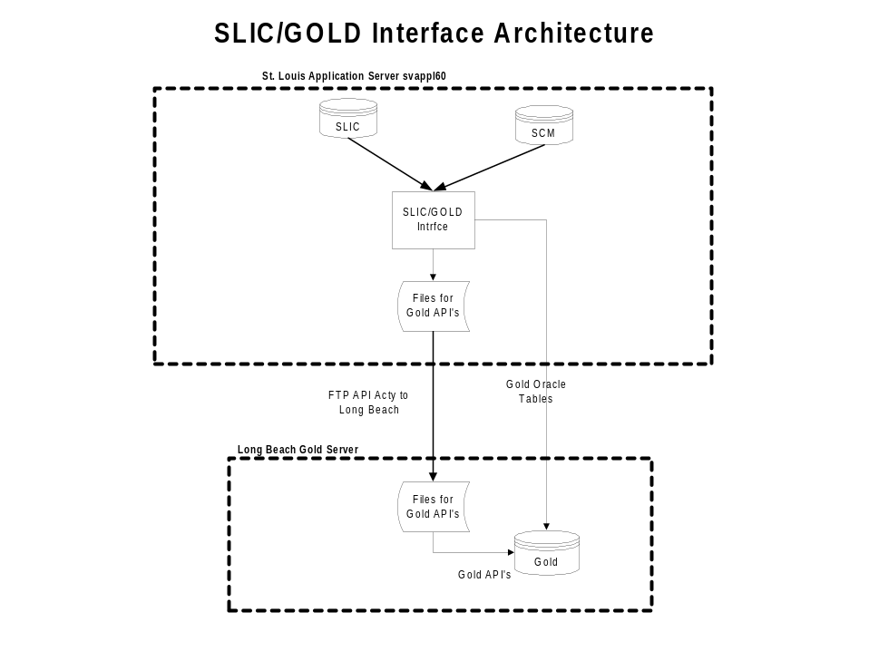

- Key Business rules:
- SLIC will be the data steward for the information passed to GOLD.
- All SCM Part Number must be loaded into the HAX04 Table. This table relates the Part Number/Cage to the SCM Contract.
- Whenever an 'HA' REFNUMHA/CAGECDXH is pulled to be sent to GOLD all of it's related 'HB' rows will be moved.

4.0 Design Alternatives Not Selected

None.

5.0 System Design Assumptions, Application Controls and Constraints

- System Assumptions.
- St. Louis will be able to create Oracle Database links between the Long Beach Data Base Server and the St. Louis Data Base Servers so the application running on the St. Louis server has access to the GOLD data to determine what has information in SLIC that has changed or if the Part Number needs to be sent to GOLD.
- St. Louis will get FTP access to the Long Beach Server.
- Spirent will be able to complete their API Development in time for implementation.
- Application Controls.
Application Controls are the safeguards over the integrity of information in an organization. They can be defined as methods of ensuring that only complete, accurate, and valid data is entered and updated in a computer system; that processing accomplishes the correct task; that processing results meet expectations; and that the integrity of the data is maintained. Application controls include:
- Authorization of Input.
Not applicable since this is a batch application.
- Accuracy of input or update.
Not applicable since this is a batch application.
- Constraints.
- Overall System Performance.
The access of the GOLD Tables from the St. Louis server will through data base links created on the St. Louis Server. There may be some performance problems on some calls to the GOLD Tables because the St. Louis Oracle Optimizer does not know certain optimizing information about the GOLD Oracle Tables. This is expected to be minor since all accesses to the tables will be based on a unique qualification.
- Security.
Access to the GOLD Tables must be made using an Oracle ID established by the Long Beach DBA.
- Reliability.
The reliability of the information between Long Beach and St. Louis is only accurate at the time the batch process runs. There may be times when the information in SLIC may be changed after the update record has been created and before the update is applied to GOLD.
- Synchronization.
The update of GOLD from SLIC will not be real-time. The processing of the batch and the time in which the GOLD API can run will need to have the two time difference figured in.
- Space.
It is expected the transaction volume between SLIC and GOLD will be small, however, it is expected that when SLIC does a DLSC screening of the complete file that the volume could get large.

Architectural Recommendations and Constraints

Follow 'C' Programming, ORACLE standards and/or ORACLE Data Base Administrator (DBA) recommendations.

Physical Design (how and when)

- Establish an Oracle Table to identify all Part Numbers that are covered under an SCM contract(HAX04).
- Establish Oracle Data Base triggers on the following tables in SLIC. These triggers will capture various inserts and updates on the tables that are performed by the Provisioning community during the day. The information is placed into Staging Table for later processing by batch.

Table | Type of Transactions captured
HA | Updates
HB | Inserts
HG | Inserts/Updates
HP | Insert
HAX04 | Inserts

- Develop applications to unload the Staging Tables.
- Develop applications that will create update/create transactions to the GOLD Catalog API. The applications should perform the following functions, compare the SLIC REFNUMHA to the GOLD Part.
- Based upon the compare it will create either an update or create record for the GOLD Catalog API. Updates will only pass to Gold those fields that have changed.
- The following GOLD Tables will need to be updated or created by this interface:

Table | Transactions | Comments
CAT1 | Update/Insert
VENC | Insert/Update of Lead Time
VENN | Insert
VNNA | Insert
HAX04 | Inserts

- Create an application that will take update/create transactions and build a XML formatted file.
- FTP the XML formatted file to the Long Beach GOLD Server for processing by the Catalog API.

8.0 Integration Test Scenarios

Test | Results
Insert/Updating information in the following SLIC Screen - HA, HB, HP, HG, HGX04 | Related Staging Tables will contain the keys to the SLIC Tables for processing into the Batch Process.
Test the pulling of the HB information whenever a new Part Number being put into GOLD. | All valid alternate HB rows will be processed into the Batch.
Processing a Part Number that is not in the Oracle Table that contains valid SCM Parts | No output activity will be created
Demonstrate the update of a GOLD CAT1 that has had data changed in SLIC. | Only the Updates will be passed to the Catalog API.
Demonstrate the creation of a new Vendor Code for processing into GOLD for both the Update/Insert of a CAT1 and the non-update of a CAT1. | Updates/Inserts of Vendor Data.
Demonstrate the update of the Leadtime on the VENC occurs when no update of the CAT1. | Update of Vendor Data.
Demonstrate the creation of a complete Catalog XML for the CAT1, VENDOR DATA and WHSE Data. | Valid XML
Demonstrate the creation of a valid Catalog XML when no update of a CAT1 occurs. | Valid XML format

9.0 Design Document Update History

10.0 User Approval Documentation

Appendix A – Data Element Description (HAX04)

The following layout defines the Table that controls whether or not a Part Number will be passed to GOLD for all SCM Programs. If a Part Number is not loaded into this table then the Part will not be processed to GOLD, even though it has been manually loaded into GOLD.

Name | Type | Lngth | Comments
CAGECDXH | CHAR | 5
REFNUMHA | CHAR | 32
SCM_PROGRAM | CHAR | 10

Appendix B – Cross-Reference SLIC/GOLD Elements to be updated

The following identifies those fields in SLIC that need to be passed to GOLD for either insert or update.

Field | Type | Ln |  | Format |  | SLIC Field | SLIC Tble | Gold Column | Comments
Part No | A/N | 32 |  |  |  | ADDREFHB | HB | PART | Alternate Part Numbers
Cage | A/N | 5 |  |  |  | ADCAGEHB | HB | MANUF_CAGE | Cage related to Part No
Prime Part No | A/N | 32 |  |  |  | REFNUMHA | HA | PRIME
Item Name | A/N | 19 |  |  |  | ITNAMEHA | HA | NOUN
Unit Issue | A | 2 |  |  |  | UNITISHA | HA | See Comments | Possible Multiple Columns in GOLD
Security Code | A | 1 |  |  |  | PHYSECHA | HA | SECURITY_CODE | SLIC only contains code
Precious Metal Indicator | A/N | 1 |  |  |  | PMICODHA | HA | PMI_CODE
Demil Code | A/N | 1 |  |  |  | DEMILHA | HA | DEMILITARIZATION_CODE | SLIC only contains code.
National Stock Number |  | 20 |  |  |  | See Comments | HA
Cog Code | A/N | 2 |  |  |  | COGNSNHA | HA/HBX | COGNIZANCE_CODE
Material Control Code | A/N | 1 |  |  |  | MATNSNHA | HA/HBX
FSC | N | 4 |  |  |  | FSCNSNHA | HA/HBX | NSN
NIIN | A/N | 9 |  |  |  | NIINSNHA | HA/HBX | NSN
SMIC/MMAC | A/N | 2 |  |  |  | SMMNSNHA | HA/HBX
Activity Code | A/N | 2 |  |  |  | ACTNSNHA | HA/HBX
SMR Code | A/N | 6 |  |  |  | SMRCODHG | HG | SMRC
Source of Supply | A/N | 3 |  |  |  | SOS | HAX | SOURCE_OF_SUPPLY
Shelf Life Code | A/N | 1 |  |  |  | SHLIFEHA | HA |  | SLIC only contains code
Lead Time | N | 3 |  | 999 |  | PRDLDTHA | HA | AVE_CAP_LEAD_TIME | SLIC will convert months to days
Critical Item Code | A/N | 1 |  |  |  | CRITIHA | HA | CRITICAL_ITEM_CODE | SLIC only contains code
Alternate Part | A/N |  | 32 |  | ADDREFHB |  | HB | PART
Alternate Cage | A/N |  | 5 |  | ADCAGEHB |  | HB
Supplier Cage Information | A/N |  | 5 |  | SUPLYRCD |  | HGX | VENDOR_CODE
Repair Cage Information | A/N |  | 6 |  | DRPONEHG |  | HG | VENDOR_CODE

Appendix C – Spirent Catalog API Definition

The following is documentation on the documentation on the Catalog API.

Table of Contents
Documentation on Catalog API Create Requirements.
Documentation on Catalog API Inquiry Requirements.

