**How-to create a Pro*C application using Visual Studio 2015**

To use C++ files edit the pcsfg.cfg:

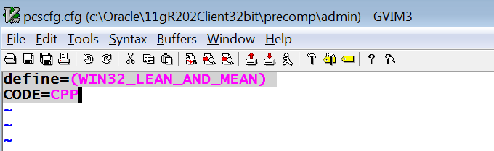

Do this for both **Debug** and **Release** Configurations

For the xxxxxxx.cpp C++ file’s Property Page

Configuration Properties

C/C++

Preprocessor:

Preprocessor Definitions: _MBCS;%(PreprocessorDefinitions);_CRT_SECURE_NO_WARNINGS

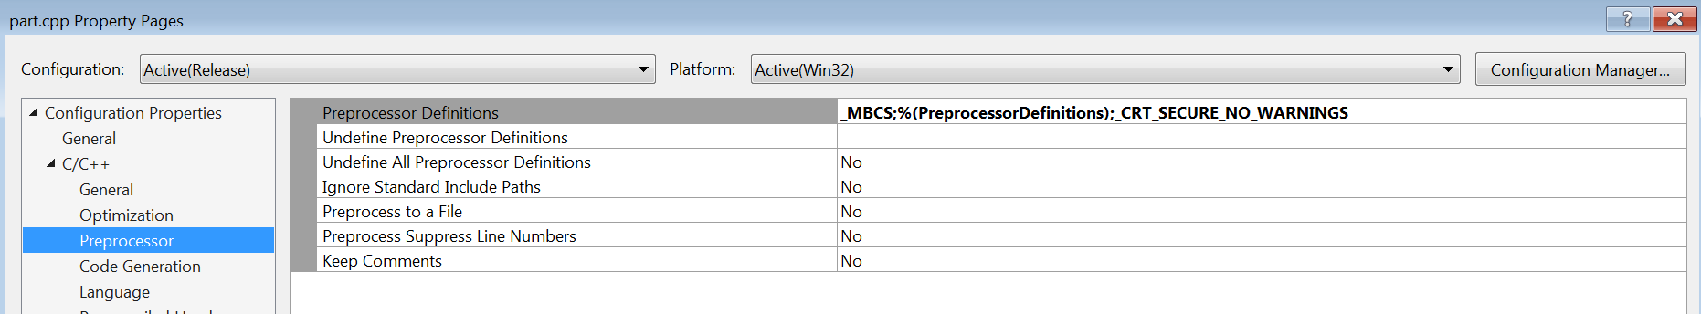

For the xxxxxx.pc Pro*C file’s Property Page

Configuration Properties:

General:

Exclude from Build: No

Content: No

Item Type: Custom Build

Click Apply to see the Custom Build Tool

Custom Build Tool:

General:

Command Line: proc.exe INAME=$(ProjectName).pc

Outputs: $(ProjectDir)$(ProjectName).cpp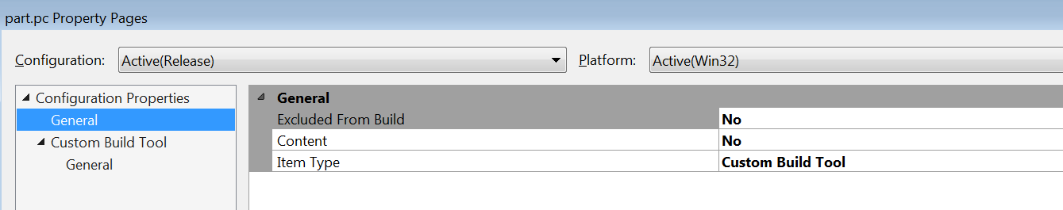

Project Property Pages

Configuration Properties:

Debugging:

Command Arguments: output_file oracle_user_id oracle password

Environment: ORACLE_HOME=C:\Oracle\11gR202Client32bit

TNS_ADMIN=C:\Oracle\11gR202Client32bit\network\admin

LOCAL=STL_DPRDSUP

PATH=C:\Oracle\11gR202Client32bit\bin;C:\Oracle\11gR202Client32bit\precomp\lib;%PATH%

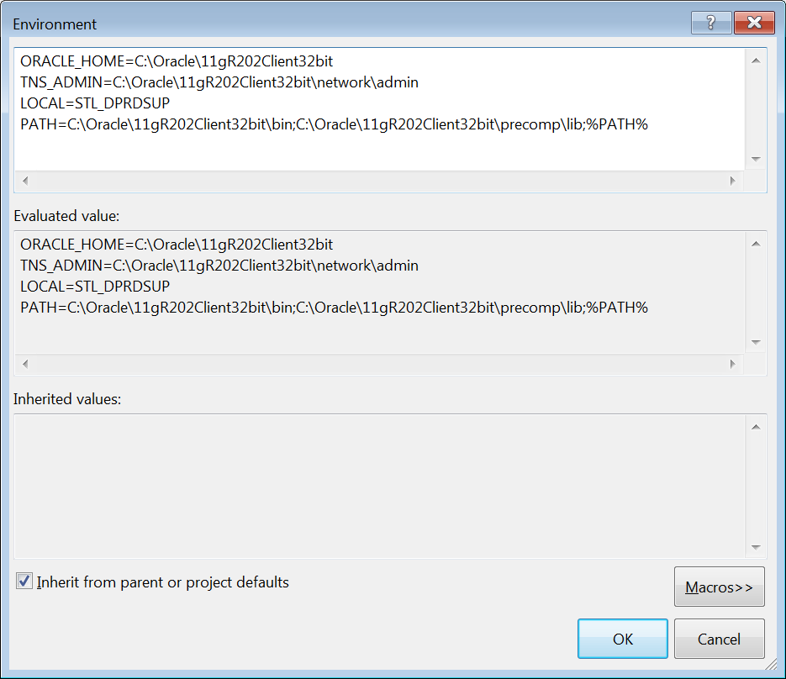

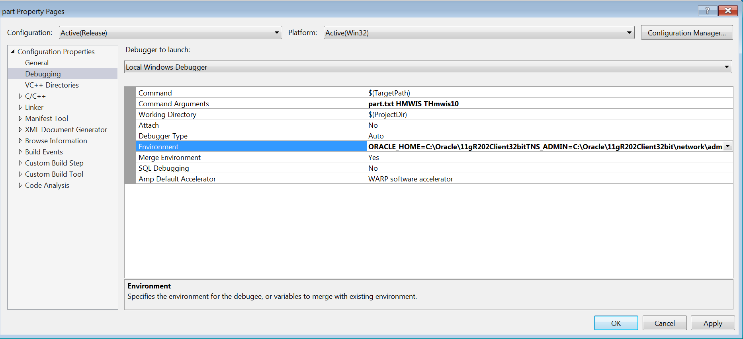

VC++ Directories:

Executable Directories: Prepend C:\Oracle\11gR202Client32bit\bin;

Include Directories: Prepend C:\Oracle\11gR202Client32bit\precomp\public;

Library Directories: Prepend C:\Oracle\11gR202Client32bit\precomp\lib;C:\Oracle\11gR202Client32bit\precomp\lib\msvc;

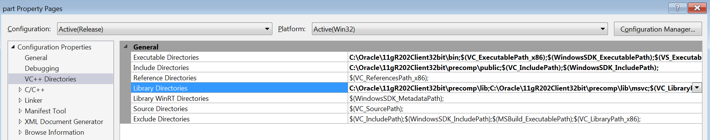

Linker:

Input:

Additonal Dependencies: Prepend orasql11.lib;

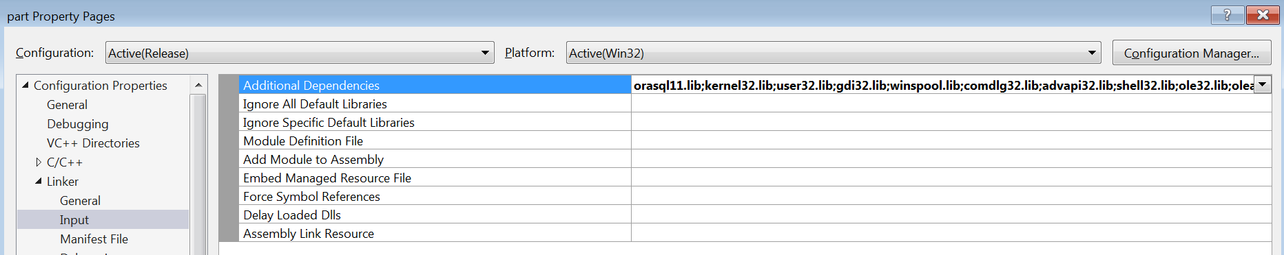

Before main add this:

static void pause()

{

printf("Hit any key to continue: ");

getchar();

}

}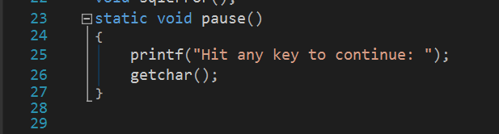

In main add this:

#ifdef __linux__

oracle_instance = getenv("TWO_TASK");

if (oracle_instance == NULL) {

printf("\nYou must set environment variable TWO_TASK to the Oracle tnsname");

pause();

exit(4);

}

#elif _WIN32

oracle_instance = getenv("LOCAL");

if (oracle_instance == NULL) {

printf("\nYou must set environment variable LOCAL to the Oracle tnsname");

pause();

exit(4);

}

#else

printf("\nThis application must run on Linux or Windows!");

exit(4);

#endif

printf("\nCompiled %s on %s at %s\n", __FILE__, __DATE__, __TIME__);

#ifdef DEBUG

printf("argc=%d\n", argc);

{ int i;

for (i = 0; i < argc; i++) {

printf("%d. %s\n", i, argv[i]);

}

}

#endif

if (argc > 1) {

strcpy(filename, argv[1]);

if (argc > 2) {

if (argc == 4) {

username = argv[2];

password = argv[3];

#ifdef DEBUG

printf("username changed to %s\n", username);

printf("password changed to %s\n", password);

#endif

}

else {

usage();

pause();

exit(4);

}

}

}

