**Project Status Report I**

|  |
| --- |
| Date of Report Issue/Prepared: Jan 17th, 2019 |

Report Prepared By: Tamara Saldina

Employer/Organization: In Tech House Design

|  |  |  |
| --- | --- | --- |
| Project Name:  Project Team:  Period Reporting:  Overall Project Health | ITHD | |
| T_06 | |
| Start Date: **Jan 07, 2019** | End Date: **Jan 18, 2019** |
| Green (Good) - Yellow (Warning) - Red (Bad) | |

Summary

|  |
| --- |
| **Project Status Summary** |
| This project status reports about our project’s sprint 5 mostly focused on front-end of the desktop app and website with some basic core database setup. |

|  |  |
| --- | --- |
| **Accomplishments As Planned** | **Planned but not Accomplished** |
| Working front-end for the web version | Authorization |
| Working front-end for the desktop application | Guards |
| Successful meeting with a stakeholder |  |
| Start implementing migrations |  |

Upcoming Objectives for Jan 19, 2019 to Feb 1, 2019

|  |  |  |  |  |
| --- | --- | --- | --- | --- |
|  | | **Planned Activities/Tasks for Next Period** | |  |
| Activity/Task | Assigned To | | Duration | Date |
| Authorization | Jerome | | 14 days | Feb 1, 2019 |
| Guards | Jerome | | 14 days | Feb 1, 2019 |
| Redirection | Tamara | | 14 days | Feb 1, 2019 |
| Finish database migrations | Tamara | | 14 days | Feb 1, 2019 |
| 10 User controls for the desktop app | Jordan, Ana | | 14 days | Feb 1, 2019 |
| Creating local copy of the DB, connecting it to the desktop app (development phase only) | Morgan | | 14 days | Feb 1, 2019 |

|  |  |  |  |
| --- | --- | --- | --- |
|  | **Milestones for Next Period** | | |
| Milestone (Objective) | | Assigned To | Delivery Date |
| Properly working Login/Logout | | Jerome | Feb 1, 2019 |
| Meeting with a stakeholder | | Team | January 30, 2019 |
| Completion of the front-end for the desktop | | Ana, Jordan | Feb 1, 2019 |
| Completion of the front-end for the website | | Tamara | Feb 1, 2019 |

Managing Issues and Risk

|  |  |  |
| --- | --- | --- |
| **Issues/Problems** | **Resolution Strategy** | **Due Date** |
| Unable to manually create database externally for Laravel | researching auto integration of database by Laravel | Feb 1, 2019 |

|  |  |  |  |
| --- | --- | --- | --- |
| **Upcoming Risks** | **Risk Ranking**  **(Hi, Med, Low)** | **Risk Impact**  **(Hi, Med, Low)** | **Mitigation Strategy** |
| stakeholder won't like the frontend | Low | Low | before demo of the sprint explain that UI design is not the part of the sprint, it will be enhanced and implemented later |

**NOTE: Attach additional sheets if insufficient space available**

**Additional documents:**

**Our stakeholder left some comments about the website logic in our Trello**

**account for our project**

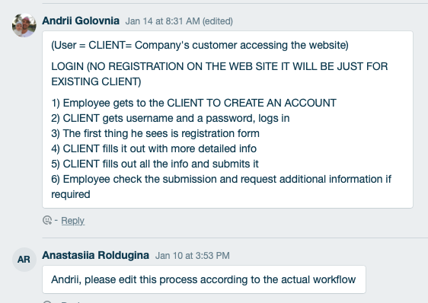

**Submission Guidelines:**

Please submit as “T<team number>_ProjectStatusReport1”.

For e.g. T29_ProjectStatusReport1

This is a group submission i.e. one per group.

**Due Dates:**

**Sunday, Jan 20, 2019 (11:59 p.m.)**