Business Requirements Document

Buddyfy

Business Requirements Document

Version Beta

19/12/2015

Revision History

|  |  |  |  |
| --- | --- | --- | --- |
| Date | Version | Description | Author |
| 19/12/2015 | Beta |  | Anant Sangar |
| 01/01/2015 | Beta | Updated Wireframe | Anant Sangar |
|  |  |  |  |
|  |  |  |  |
|  |  |  |  |
|  |  |  |  |
|  |  |  |  |

Contents

1.) Introduction 5

2.) Business Goals and Objectives 5

2.1 Business Functionality and Scope 5

3.) Business Process Flow Charting and Diagrams 7

4.) Types of activities that can be considered 11

5.) Usercase 1 with Wirefram 12

# Introduction

Socialising has always played an vey important role in our lives. With a healthy and growing social life can build strong and rewarding relationships with other people. We believe that there is a “gap” in the market for a “proper” socializing app yet. There are some apps like Tinder, Lovoo, Happn and ect, however these tend to bring people together in form of a dating process. However by covering only “dating” we seem to ignore or leave out all other parts of social meetings and gatherings. This is the gap we want to fill with Buddyfy. Our app would bring people with the same purpose together, be it for going for just a drink, party, eating or even shopping, sports or events. With our app you will always find a buddy nearby ready to join for the activity you are planning to do. The targeted market are professionals and people looking to expand their social life outside of their cirlces. The whole workflow of the app will be designed around a innovative sales solution concept.

# Business Goals and Objectives

The main aim of this project is to develop an website and application that would allow people to enhance their social life outside of their own circles. The main forecast of completetion of this project is set around mid. April. Alongside the app, another aim is to provide a new and innovative sales, marketing and promoting solution for companies which would generate the main revenue for us. It is intended that in the beginning the main features of the app will alsways remain free for the users of the app.

The following paragraph will define the objective to attaine the main aim:

* Create a Welcome/Landing page (with Bootstrap)
* Create the User Interaction page (with Material Design Lite)
* Create backend platform for data-entry

## 2.1 Business Functionality and Scope

The main reason as for initiating the project is giving people the ability to find “buddies” or “people” for a certain type of activity where depeding on the activity they choose to pick they will get a recommendation from us. The application will provide users the functionality to select from a range of activities and then find a buddy nearby who is doing the same activity as you are. The way this will work on the app is described in section XX. We have to make sure that value is created for both customers and users by providing extraordinary quality and up to date data. The market segmentation does not need to be created as the market already exists which is mainly the consumption business. The app will have to main functionalties, first being a “ordinary” app for users to meet new people and then secondly a “marketing” tool for companies where our revenue will be generated from. Companies will have the ability to recommend themselves on our app by signing a contract with us. For example, if we have an exclusive contract with the pub “Whetherspoons”, we will recommend this pub at first place if the users of our app decide to go for drinking. The detailed description of this is written in section XX. The overall scope seems to be very extensive as it can provide a very lange number of activities for the users to choose. Some of the activities include: Drinking, Eating, Sports, Shopping, Gym and many more.

Looking at the business side of this project it is intended to form a “Consulting” company that provides sales and marketing solution to consumers through innovative solutions such as “BuddyFy”. The apps we produce will have two kinds of consumers: namely the users of the app and then companies that are using our app as a sales and marketing solution. An example of how a company would use our product as a sales solution is described in the following paragraph:   
  
“Let’s say that a company has openend a new pub, has some promotions and is well established for a particular type of cousine. Then the app can use “BuddyFy” to promote and market their new pub in that region. The ordinary user of the app will see the promotion, when he is trying to find a buddy for going out on a dinner or lunch“.

The ultimate goal is to make our product two sided as in provide something new and innovative to ordinary users of apps and at the same time that app can be used by companies and orginasations as a tool to promote their products, market something, grow their sales with or just raise awareness.

# Business Process Flow Charting and Diagrams

The following chart will describe the platforms that will be needed in order realise this project.

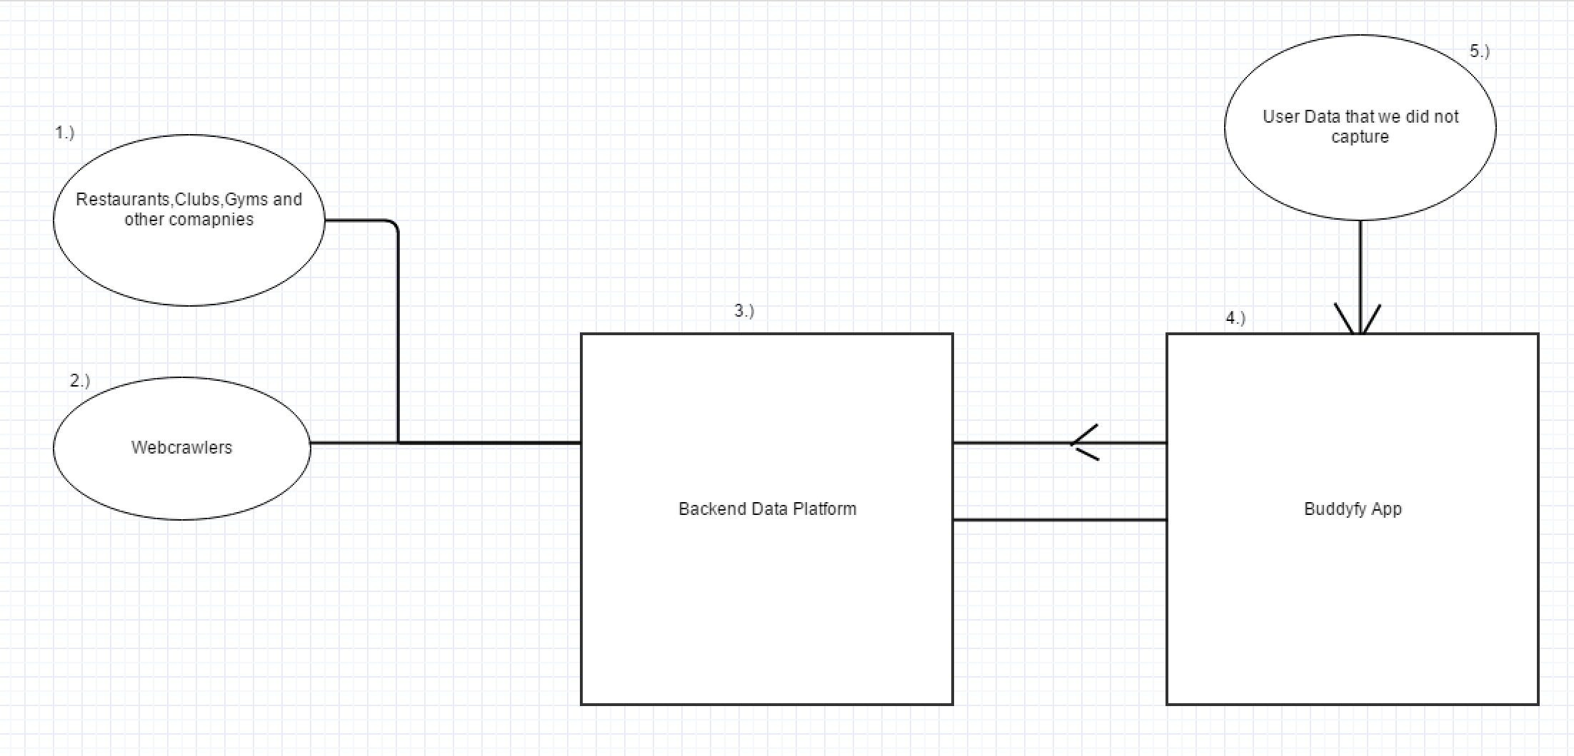

Alongside the webapp (4) itself, we will need a “Backend Data Platform” (5) where we can store data easily through a GUI. We will receive the data through Webcrawlers (2) through Sign Up Newsletters (2.1) and by companies sending us the data itself (1). All data received by (1), (2) and (2.1) will come into a “Queue” in a form of list on our Backend Data platform which will be processed and published by us once the data has been evaluated. There will be a data analyst who will constantly source and validate raw data from the queue which then will be published on our app. For this business to be successful it is very important that the data is maintained and impoved. Here the key element will be that we find sources that will provide us with upcoming events or promotions in the future again which can be found through webcrawlers, companies sending us the data itself and users entering their own events.

From the diagram one can clearly convey that the project will need two major platforms:

1. Backend Data Platform: manage our data that will be shown on our app
2. Buddyfy Webapp: the main app itself

Furthermore we will need webcrawler to be set on specific information webpage, which will then crawl the web on an hourly basis and send the information to our “queue”.

The queue will take a similar form as shown in the pictures below:

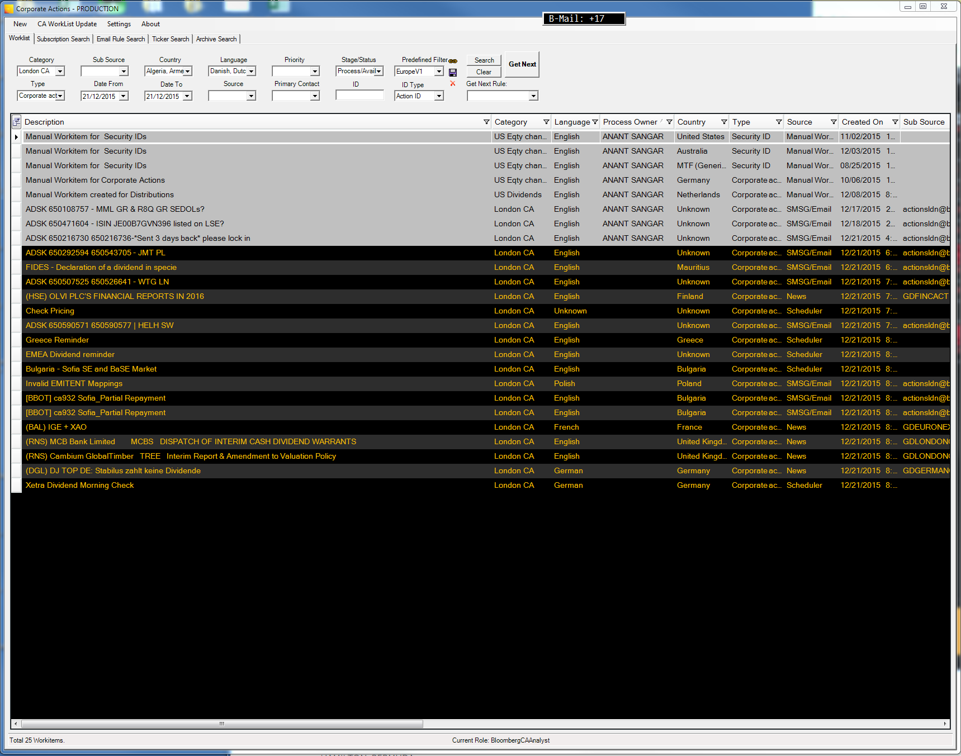

Here you can clearly see, how the data should ideally be processed in the backed. All items, from emails and webcrawlers, will come into a queue such as displayed above, where each item represent 1 email with content. The item then can be openend and the information will be displayed as follows:

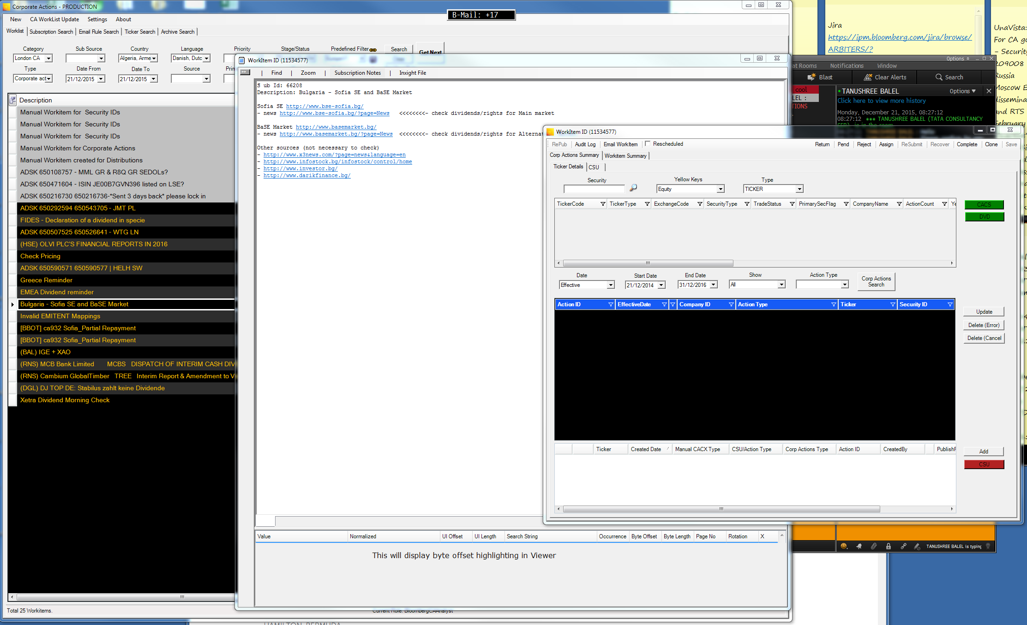

After validating the data, you can published the data and press on complete.

The main app itself, “BuddyFy”, should have the following features:

1. The main and landing page, which will give users general information about the app, what it is and our marketing campaign. Furthermore it will provide them the Sign in and Sign up area. If they choose to Sign up it will direct them to a new single page giving them the ability to enter their information required and a sign up button. Sign ups should also be possible through Google, Yahoo, Facebook and Phone numbers. Once the Sign up button has been pressed, the user will be redirected to “BuddyFy Home”.
2. “BuddyFy Home”, will give the user the following options as animated big buttons:

* Find your buddy
* Your upcoming events
* Events near you
* Promotions
* Find random Buddy

Alonside the above described points the user will also be give a navigation bar on the left side of the page.

The following chart describes how the user will typically navigate through in our application from signing up to finding a buddy.

# Types of activities that can be considered

* Activity group – Food, Drinking, Clubbing/Party, Sports, Events, Concerts, Shopping
* Activity subgroup:
  + Food: Italian, Indian,….
  + Drinking: Cocktails, Beer, Spirits, Dance Bars
  + Clubbing/Partying: Music types (list of example: Jazz, Rock…, other)
* Sports:
  + Gym, Tennis, Football, Ski, Golf, Climbing,
* Concert: (show only if available in your city)
  + Rock, Jazz, Metal…
* Events:
  + Flugshows, Charity events, German market, Maifest, Oktoberfest, New years eve… (should be created dynamically when we publish the data)
* Shopping:
  + Clothes, Home supplies, Groceries

# Usercase 1 with Wirefram

The following paragraphs will explain the workflow of the app through “Wireframes” and each wireframe will have the necessary fields explained.

1. Main page landing

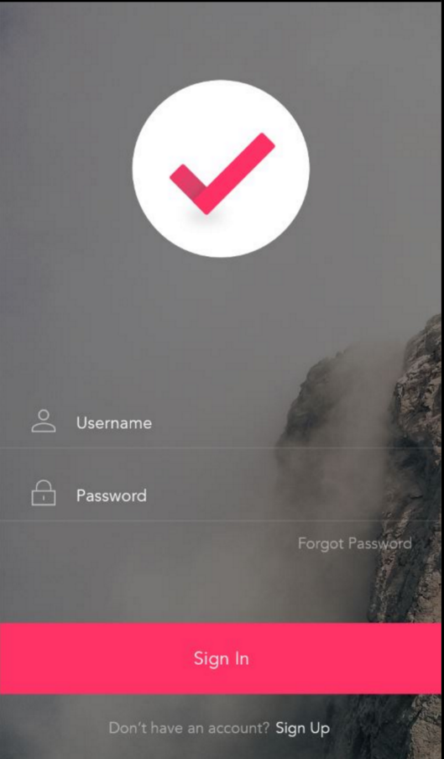This is the main landing page where the user can Sign In and Sign Up. He also has the option “Forgot Password” in case the user forgets his password. The following fields will be necessary for the database for Sign In :

* Username
* Password

Sign up is explained in the next section.

1. 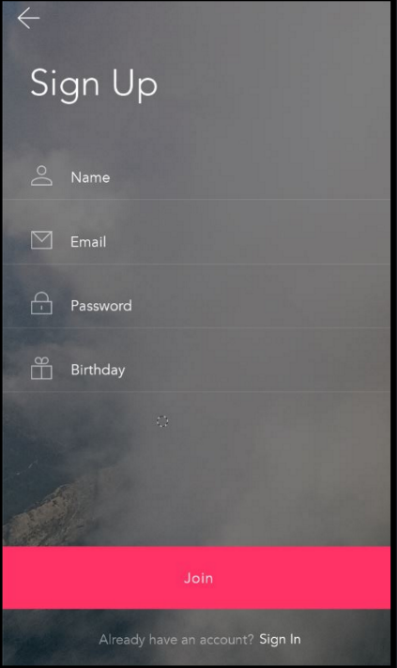BuddyFy Sign Up Form

When the user starts the app he will be presented the 1.2) SignUp screen. Here he will also have the ability to SignUp with Facebook, Google, Twitter and Yahoo. The following fields for the database are necessary:

* First name
* Last name
* Location (optional) – not in the picture
* Email address
* Passwort

1. BuddyFy Home.

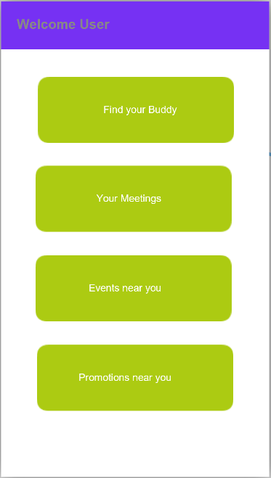Once the User has “Signed Up” or “Signed In”, he will be redirected to the main page 2.) BuddyFy Home. Here the user will be presented a short 20 seconds intuitive instruction video about how to navigate through the app. Fields needed for the database: none. In the following section assume that the user clicks on the button Find your buddy.

1. Find your Buddy Information Profile

* Here the user is directed to 2.1.1) Find your Buddy Information Profile. 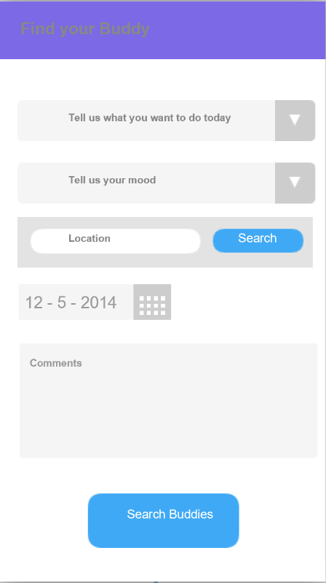In “Tell us what you want to do today” the user will select an activity group such as “Drinking, Clubbing, Food,..”. In “Tell us your moo” (this needs rephrasing) the user will select his activity type depending on what activity group he has chosen. For example if he has chosen “Club” in activity group, in activity type he will be presented the following option “Jazz, Hip-Hop, RnB…”. Once he has selected his activity type our business model will work as a pop up. The user will be shown a pop up which is explained in the next section. Fields needed for the database:
* Activity group (list)
* Activity type (list)
* Location (long, lat, Address)
* Date and Time field
* Comments (string)

1. Recommendation/ Promotion Pop Up

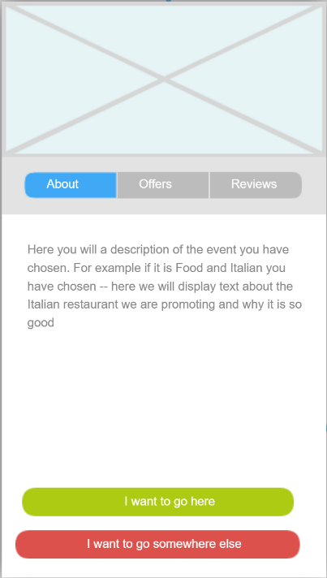For now: once the User has selected his activity and activity gtype he will be shown a pop up with advertisement of the relevant activity. At a later point in time: Once the user has selected “Club” and “Jazz, he will be shown this pop up where he will be presented advertisement of a club that currently offers Jazz music and has some other offers. The user has three tabs to choose from: About, Offers and Reviews.   
He then can choose either to go there or choose another club. Let’s assume that he chooses that he want’s to go there. The following fields will be needed for the database:

* Venue Description
* Image for Venue (maybe a list that can be swiped)  
  1. Recommendation/ Promotion Pop Up – Offers

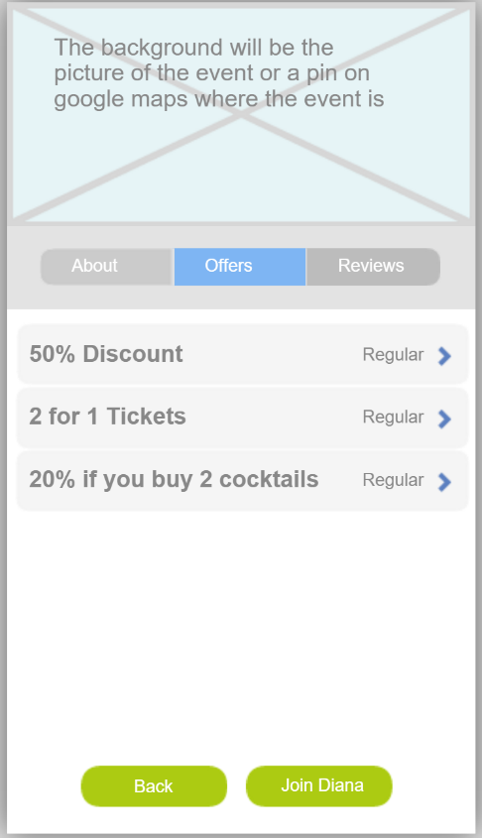This is also intended for later: If the user selects on the tab “Offers” he will get a list of offers and reviews which he then can select by touch and view in detail. Similarly if he clicks on the Tab review the user will be shown a similar screen where he will be shown reviews from users with stars. In the next section we assume that the user selects “Go to this venue”.

Fields needed for the database:

* Offerlist
* Offerdescription
* Image

1. Buddies list:

* 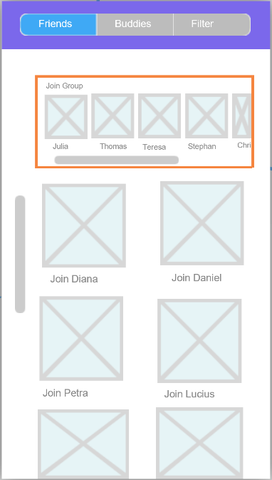Once the user has chosen to go the the recommended event he will be shown a list of all people who want to do the same activity. Note here that in the beginning we will only match people with the same activity group not same activity type. For example if someone chooses Clubbing we will show him all people with clubbing. Here the user can choose if he want to join a group or a person. He can scroll through the pictures of the group members. The next we assume that the user clicks on the group and the following screen will show:   
    
  Fields needed for the database:
* Groupmembers
* Groupname

6.1) BuddyList Group

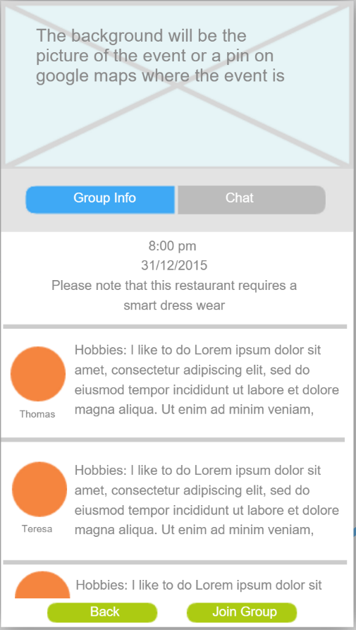When the user selects a group he will be shown the screen on the left side. There he can see a list of all group members including the date,time and comments of that group. Here he can either click on “Join Group” or “Back”, If he clicks on “Back” he will be redirected to Buddies list. If he clicks on “Join Group” he will be shown the screen showed in the following paragraph. If he clicks on chat before he joins the group or person he will be shown the following screen:   
  
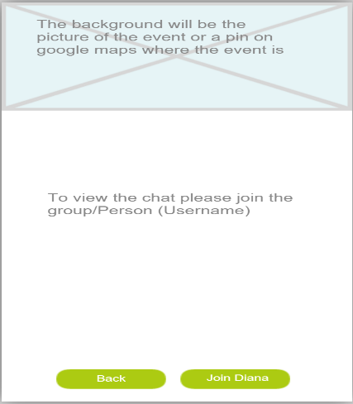

1. Meetup list profile:

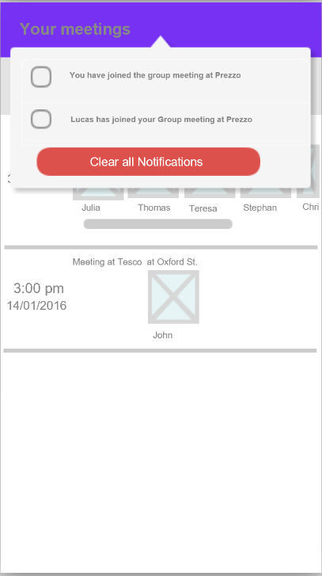Once the User has pressed on “Join Group” he will be shown a notification and then once he presses “Clear Notification” he will be shown a list of all his meetups. When he clicks on any of the meetup he will be again shown the following screen:

8.) BuddyList Group joined

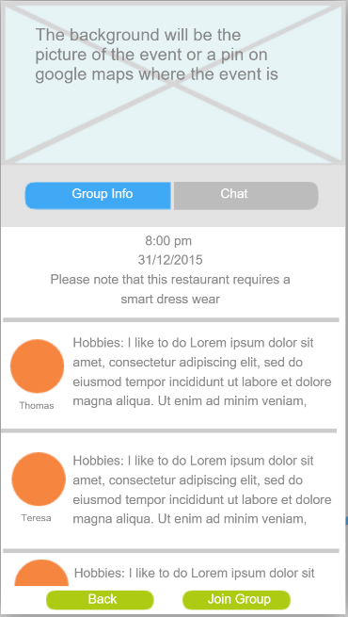Then he can click on chat and talk to all the persons who have access to the chat. (This is how you will find your buddy). Then the user can click on chat and the following screen will be shown

9.) Chat

