* It is important to have a clear understanding of the App/Developer economy in which the development will take part
* Games is the dominant category with 36% of all downloads, and generates over 71% of App Market by Numbers all revenue across the Apple App Store globally. Google Play shows even higher levels of revenue generated from the Games category with 89% of all revenue coming from games.
* Other entertainment apps come second in popularity with 8% of all downloads, but only generate 2% of total revenues.
* While the social networking category is 6th measured in download volumes, it’s a growing category and generates around 3% of total revenues.
* ‘**educational games**’ category— that analysts say may be the next Big Thing
* Fitness app are a growing market as well
* 3 tips other developers share:
  + Quality is table stakes. Your app should constantly delight users
  + Know your audience: Listen to them and use their feedback to improve user acquisition for your app
  + Limit the number of ad networks: Stick with 3-5 ad networks and constantly optimize your results by using their analytics to improve monetization and mediation
* Monetization:
  + 30% of Android developers are attracted to in-app advertising
  + 19% to in-app purchases and 20% to freemium models
  + iOS pay per download, the model preferred by 36%, ties with in-app purchases (35%)
  + Find one or two models that work for your app — such as advertising and in-app purchases — and stick to them
* How to make app successful?:
  + Keep it simple in the beginning (MVP)
  + Make simple app first and then add small enhancements here and there to improve the overall user experience
  + developers of non-game apps are better off making one, good, basic app and fiddling with it to improve the user experience
* Discovery Dilemma:
  + imagine your app user is a customer walking into a grocery store in search of a few items only to find all the aisles and category labels have been eliminated
  + users tend to focus on top results anyway when they search for apps on the app store
  + All the other apps that don’t surface in those first few pages are invisible to most users

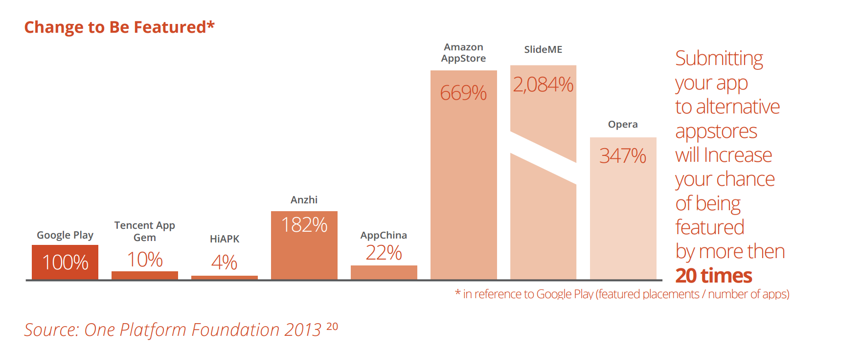

* Think about multiple app store strategy in order to reach a larger market

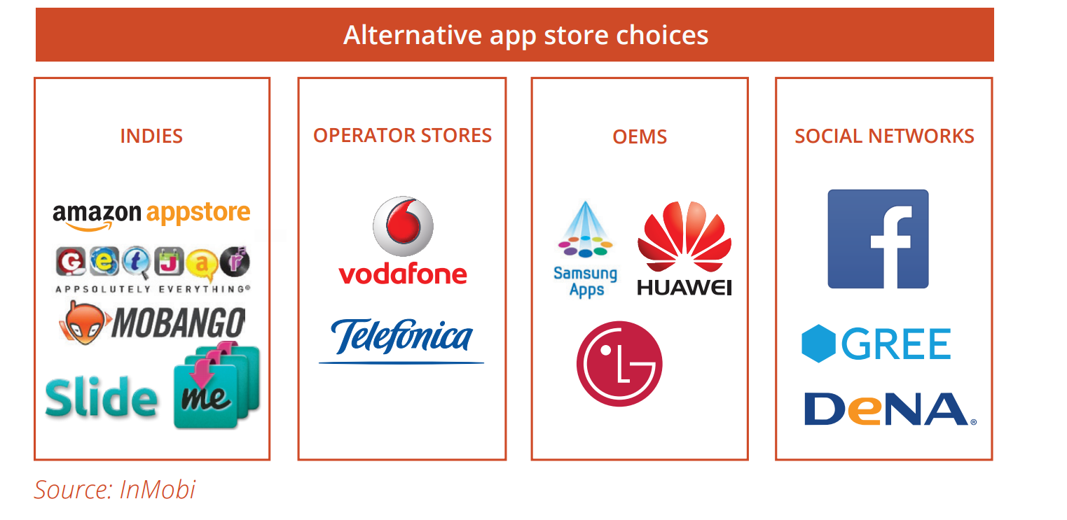

* App Store Optimization
  + You have to master ASO which stands for App Store Optimization
  + builds on the foundations of search engine optimization
  + focuses on the tools and techniques to ensure relevant keywords and content will be picked up by app store search algorithms
  + it will give your app the visibility (to users searching for a relevant app) and result in a significant boost in downloads
  + For ASO one can use the following service: <http://www.appcodes.com/>
  + Use Google Adwords keyword tool to get ideas on popular search phrases that are relevant to your app
  + Google Adwords can give you a good indication of the sort of keywords you should have top of mind as you identify the keywords best suited to your type of app
  + To narrow down the options just type some relevant search queries into the app store search bar and make a list of the keyword suggestions it serves up. If these are popular keywords driving volumes, then it’s an important clue and should provide you with a basic shortlist of relevant keywords you might want to target
  + A great resource is Priori Data, a company that provides tools to quantify the app Your Attention, Please economy (<https://prioridata.com/landingpage>)
  + The company’s products track global market movements, local country and category trends, and individual publisher and app performance in a single, intuitive interface
  + Your keyword should be a term that a user will associate with your app
  + The right keywords for you will be the words that best describe your app
* Making a powerful first impression
  + Make sure your app icon, name, and description make a compelling first impression
  + The goal of your landing page is to convert potential views into downloads
  + Once a user lands on your app store page, you have less than 3 seconds to captivate them, before they leave
  + important to have a detailed, well-written app store description
  + It should articulate the value proposition in the first sentence, so people can decide right away if they want to download it
  + A good description is essential. Briefly explain what your app does and why it’s useful, then add whatever else you think is important for your audience
  + InMobi’s Ryan Merket suggests app developers harness SMS or QR codes to close the loop. In the case of text messaging, users can send the link to your app to their phone (from the desktop) so they can download when they are on their own time, not at work or on the go. Companies like Your Attention, Please Twilio make this a breeze
* Guerrilla marketing
  + Define your target segment of app users and make sure your campaign will resonate with them
  + the message must match your audience and deliver a clear call-to-action
  + Research relevant events, conferences or public gatherings where your audience is most likely to be present (Fish where the fish are)
  + Think out of the box ( ☺ )
* Engagement marketing
  + Social media is the best way to create and cement deep ties with your app users
  + word of mouth advertising (WOM) travels swiftest and leaves the greatest impression
  + make the proper match between your app business plan (what you want to achieve) and the steps you will employ to get you there
  + Reach a new audience (your user’s circle of friends) by making it easy for people to tell their friends about your awesome content and invite them to check it out
  + Provide an attractive incentive for people to join your app community. For example, you might allow members access via the app to special content, cool offers, or just the chance to connect with other members.
  + AppBooster, a newcomer startup headquartered in Sweden, offers a solution that enables a new kind of viral sharing — and one that doesn’t even require users to have the app installed
  + social media monitoring benefits from a “divide-and-conquer” approach
    - Google Alerts for your app , your company’s name and any members of the team that are active in social media and represent your app business when they post, tweet and express themselves
    - Facebook and Twitter alerts for your app, your company and your social- savvy team members. (This is even more important if you do not maintain an active presence on either social network).
    - Site-specific alerts for every social network on which you or your app have an active presence
* Pre-launch
  + An important part of the app marketing is creating a community and getting in-touch with your potential app users
  + You can do this by targeting related forums, relevant Facebook groups, spreading the word on Twitter and so on
  + Keep in mind that your users are a bit like your biz dev department. If they like your app, they will tell you. Encourage them to share their views and listen in to their comments and conversations and you may detect important feedback about what they like about your app