Contents

1.) Objective 1

2.) Target Users 1

3.) Non - functional requirements 1

3.1) Security 1

3.2) Performance 1

3.3) Scalability 1

3.4) Internationalisation 1

4.) Functional Requirements 1

4.1) Use cases 1

5.) Project Estimates 1

# 1.) Objective

This document provides the understand of the technical requirements for the creation of a new smart and innovative way for meeting people near you based on events. Buddify will give the user a solution/platform to find a “Buddy” near you based on interests selected by the user itself. These interests can vary from different type of activities such as: nightlife, events and sports.

# 2.) Target Users

This project is intended mainly for Facebook users who want to socialise or want to try something innovative and new in socialising. The main target audience are people who are keen on using app such as Tinder, Lovoo and other dating apps. We are also targeting people who are highly active on social media.

# 3.) Non - functional requirements

## 3.1) Security

## 3.2) Performance

The application will be developed for iOS and Android in native due to performance issues. It is essential that the user of the app will get an excellent and smooth UI/UX experience.

## 3.3) Scalability

We give utmost priority to build mobile application that are scalable. Saleability is ensured by using platforms such as Amazon WebServices, NodeJS based Rest API. Furthermore we are using intelligent UI patterns and design, app integration with other data sources such as Google Places API and Yelp API, social media integration for facebook (maybe Twitter) and the distribution of the app across app stores (in the beginning it will be Google Play Store and App Store). The usage of the above mentioned services will ensure the capability to handle greater load.

## 3.4) Internationalisation

## 3.5) Legal and Data Protection

It is intended to launch the application in London, Nottingham, Salzburg, Vienna and India.

# 4.) Functional Requirements

## 4.1) Use cases

* Sign In
* Sign Up
* (optional forgot password in case of using email)
* Set Interests
* Tab1: Feed:
  + Find nearby Events based on Interests (all interests which can be changed, scrollable)
  + Join nearby Events based in Interests (By clicking on “I am interested” the user will get available for this event to be matched)
  + Find nearby Buddies who share the same interest as you
  + Match nearby Buddies who share the same interests as you
* Tab2: Buddify:
  + Select activity category
    - Nightlife
    - Events and Entertainment
    - Sport
  + Select type of activity category
    - Nightlife
      * Clubs
      * Bars
      * Pubs
    - Events and Entertainment
      * Concerts
      * Art exhibition
      * Museum
      * Sport matches
      * Cinema
    - Sport
      * Football
      * Tennis
      * Gym
      * Jogging

## 4.2) Use cases (First time login)

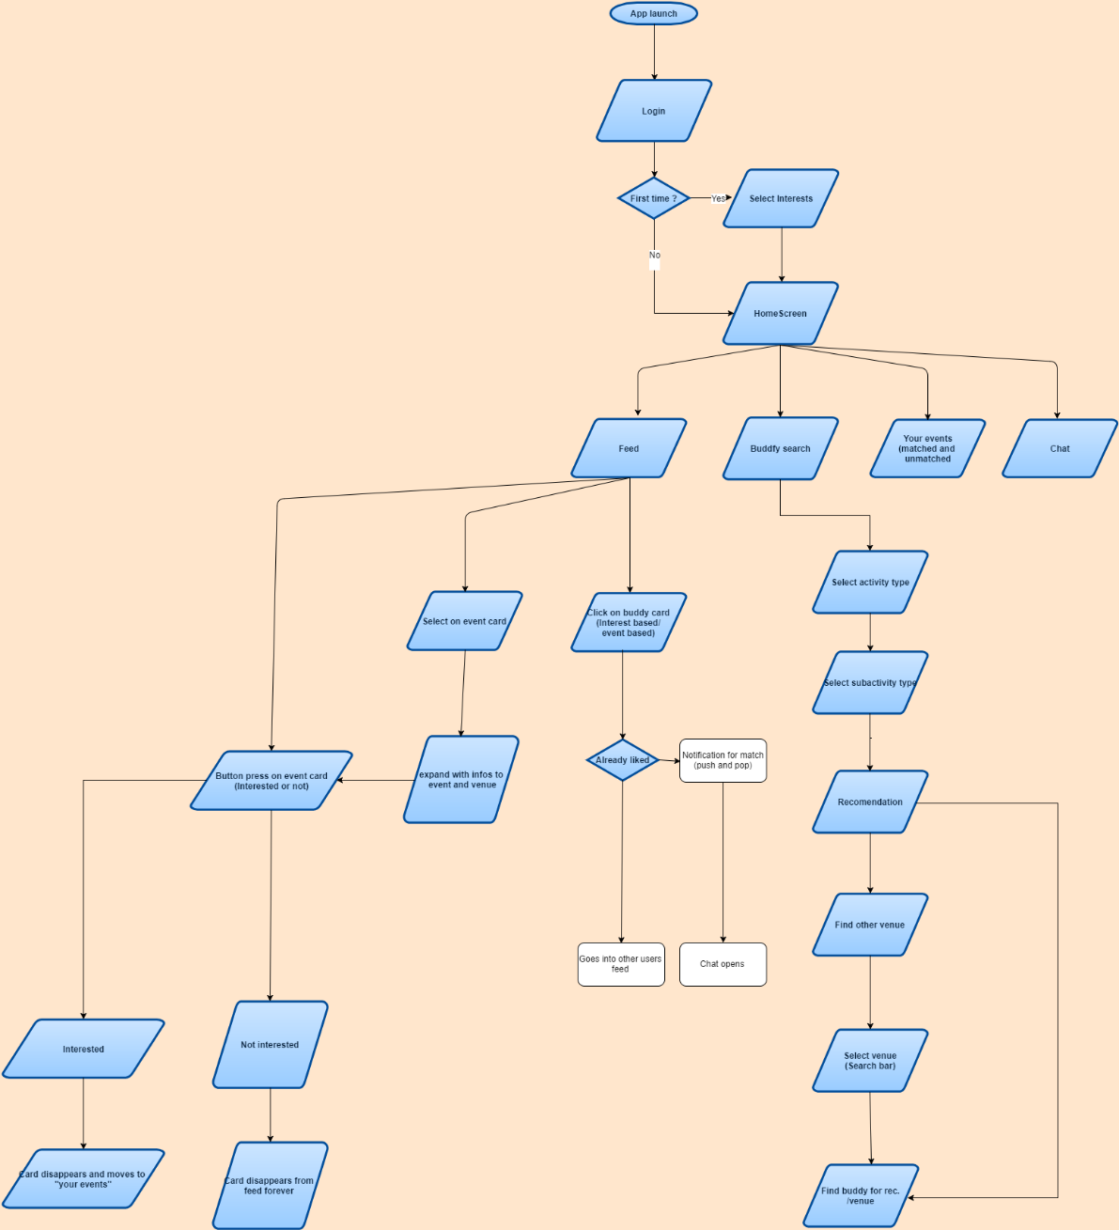

# 5.) Project Estimates