SUpplement to - Example Manuscript Template for a Data Analysis Project

Andreas Handel

2021-11-03

*This just shows some materials that could go into a supplementary file. Often you want/need references here too. You can use the same reference bib file for this and the main text (as done here) or have separate bib files.*

# 1 Overview

A quick overview of what readers can find in the supplement.

# 2 Code and file information

Explain here what each code/file is and does, and in which order (if any) users need to run thing to reproduce everything. Essentially, give a full set of instructions to re-generate everything.

# 3 Additional Method Details

Often, the main manuscript only allows for an overview description of the methods. Use the supplement to describe all your methods, models and approaches in a lot of detail. Reference specific parts of your code as needed.

# 4 Additional results

Show additional results here. Those can be some useful exploratory/descriptive figures or tables, or results from additional analyses that didn’t make it into the main text.

## 4.1 Example additional result

Table 4.1 shows an additional table summarizing a model fit.

Table : Table 4.1: Data summary table.

| term | estimate | std.error | statistic | p.value |
| --- | --- | --- | --- | --- |
| (Intercept) | 138.4726341 | 16.6800813 | 8.301676 | 0.0000719 |
| Weight | 0.3440417 | 0.2290177 | 1.502249 | 0.1767313 |

Figure 4.1 shows a scatterplot figure produced by one of the R scripts.

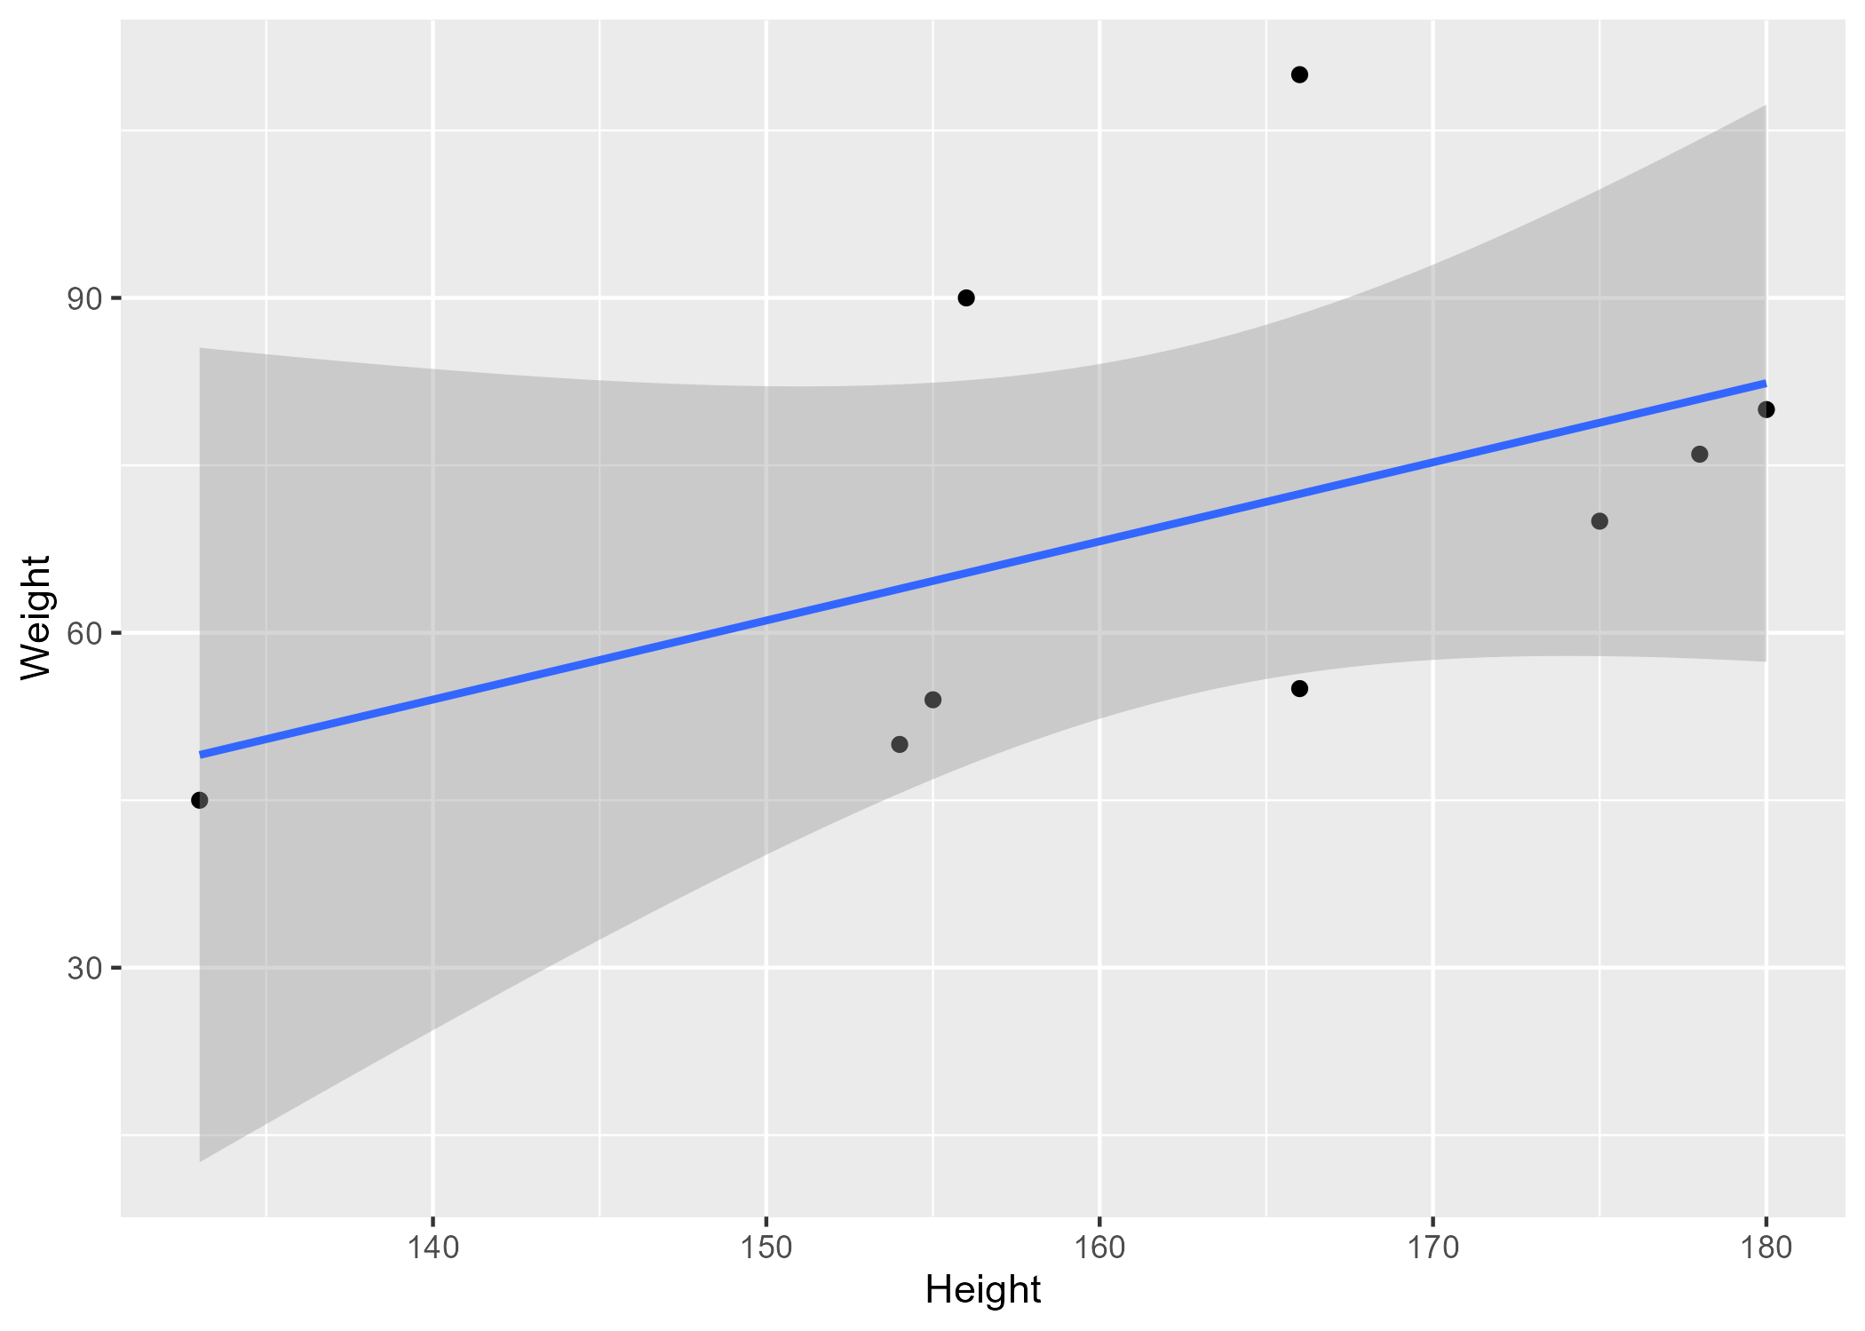

Figure : Figure 4.1: Analysis figure.

# 5 Discussion

Any additional discussion regarding the supplementary material/findings.

These papers (McKay et al., 2020; McKay, Ebell, Dale, Shen, & Handel, 2020) are good examples of papers published using a fully reproducible setup similar to the one shown in this template.

# References

McKay, B., Ebell, M., Billings, W. Z., Dale, A. P., Shen, Y., & Handel, A. (2020). Associations Between Relative Viral Load at Diagnosis and Influenza A Symptoms and Recovery. *Open Forum Infectious Diseases*, *7*(11), ofaa494. <https://doi.org/10.1093/ofid/ofaa494>

McKay, B., Ebell, M., Dale, A. P., Shen, Y., & Handel, A. (2020). Virulence-mediated infectiousness and activity trade-offs and their impact on transmission potential of influenza patients. *Proceedings. Biological Sciences*, *287*(1927), 20200496. <https://doi.org/10.1098/rspb.2020.0496>