**CAP4630 Introduction to Artificial Intelligence**

**Homework 6 (10 pts, Due Nov 28 2022)**

[Homework solutions must be submitted through Canvas. No email submission is accepted. Only pdf, word, and txt files are allowed. If you have multiple pictures, please include all pictures in one Word/pdf file. You can always update your submissions before due date, but only the latest version will be graded.]

**Question 1 [1 pt]**: For each of the following expression, explain whether the expression is a sentence or not. If the expression is a sentence, please show at least three models of the sentence.

1. 3x+2 ≥ 0
   1. Yes, it is a sentence.
   2. Is True if x = 0
   3. Is True if x > 0
   4. Is True if |x < 0|
   5. {x = 0}, {x > 0}, {|x < 0|}
2. x-y=1
   1. Yes, it is a sentence.
   2. Is True if x=7, y = 6
   3. Is True if x = 10, y = 9
   4. Is True if x = 2, y = 1
   5. {x = 7, y = 6}, {x = 10, y = 9}, {x = 2, y = 1}
3. 2x+y > 0
   1. Yes, it is a sentence.
   2. Is True if x >= 0, y > 0
   3. Is True if x < 0 and y > |x|
   4. Is True if x > 0, y = 0
   5. {x >= 0, y > 0}, {x < 0, y > |x|}, {x > 0, y = 0}
4. x4y+=
   1. No, is not a sentence.

**Question 2 [1 pt]:** Complete the truth table in Figure 1.

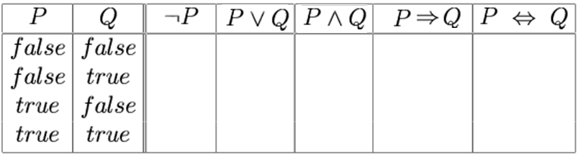

Figure 1

|  |  |  |  |  |  |  |
| --- | --- | --- | --- | --- | --- | --- |
| P | Q | ¬P | P ∨ Q | P ∧ Q | P => Q | P ⬄Q |
| False | False | True | False | False | True | True |
| False | True | True | False | True | True | False |
| True | False | False | False | True | False | False |
| True | True | False | True | True | True | True |

**Question 3 [2 pts]:** Convert following sentences into Conjunctive Normal Form (CNF)

1. A ⇒ (B∨C)
   1. ¬ A ∨ B ∨ C
2. (A∨B) ⇔ C
   1. ((A∨B) => C) ∧ (C => (A∨B))
   2. (¬ (A∨B) ∨ C) ∧ (¬ C ∨ (A∨B))
   3. ((¬ A ∧ ¬ B) ∨ C) ∧ ((¬ C ∨ A) ∨ (¬ C ∨ B))
   4. (¬ A ∨ C) ∧ (¬ B ∨ C) ∧ ((¬ C ∨ A) ∨ (¬ C ∨ B))
3. (A∧B) ⇔ C
   1. ((A ∧ B) => C) ∧ (C => (A∧ B))
   2. (¬ (A ∧ B) ∨ C) ∧ (¬ C ∨ (A ∧ B))
   3. ((¬ A ∨ ¬ B) ∨ C) ∧ ((¬ C ∨ A) ∧ (¬ C ∨ B))
   4. ((¬ A ∨ C) ∨ (¬ B ∨ C)) ∧ (¬ C ∨ A) ∧ (¬ C ∨ B)
4. A⇔ (B∨C)
   1. A => (B∨C) ∧ (B∨C) => A
   2. (¬ A ∨ B ∨ C) ∧ (¬ (B∨C) ∨ A)
   3. (¬ A ∨ (B∨C)) ∧ ((¬ B ∧ ¬ C) ∨ A)
   4. (¬ A ∨ B ∨ C) ∧ ((¬ B ∨ A) ∧ (¬ C ∨ A))

**Question 4 [1 pt]:** Figure 2 shows the Wumpus world game, where the agent starts from location [1,1], and does not sense breeze or stench.

* Please use propositional logics to write sentences to describe the observations and rules & backgrounds (after agent enters location [1,1], and only consider Pit). [0.5 pt]
  + Let Pi,j be true if there is a pit in [i,j].
  + Let Bi,j be true if there is a breeze in [i,j].
  + R1: ¬ P1,1
  + R2: ¬ B1,1
  + R3: ¬ B1,1 ⬄ (¬ P1,2 ∧ ¬ P2,1)
  + R4: Pi,j ⬄ Fall
  + R5: ¬ Pi,j ⬄ Safe
* After the agent enters location [2, 1] and senses Breeze, please use propositional logics to write sentences to describe the observations and rules & backgrounds (after agent enters location [2,1], and only consider Pit). [0.5 pt]
  + Let Pi,j be true if there is a pit in [i,j].
  + Let Bi,j be true if there is a breeze in [i,j].
  + R1: ¬ P2,1
  + R2: B2,1
  + R3: B2,1 ⬄ (P3,1 ∨ P2,2)
  + R4: Pi,j ⬄ Fall
  + R5: ¬ Pi,j ⬄ Safe

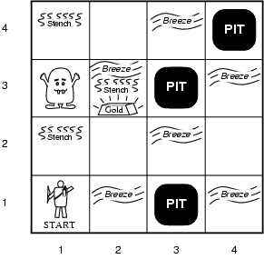

Figure 2

**Question 5 [1 pt]:** What is the semantic (meaning) of the following sentence?[0.5 pt] **S**how detailed steps to decompose sentence into CNF format [0.5 pt]

1. The semantic meaning of the sentence is that if there is a Breeze (B) in cell (1,3), then there is a Pit in either cell (1,2) OR cell (1,4) OR cell (2,3)

B1,3 ⇔ (P1,2 ∨ P1,4∨ P2,3)

(B1,3 => (P1,2 ∨ P1,4∨ P2,3)) ∧ ((P1,2 ∨ P1,4∨ P2,3) => B1,3)

(¬ B1,3 ∨ P1,2 ∨ P1,4 ∨ P2,3) ∧ (¬ (P1,2 ∨ P1,4 ∨ P2,3) ∨ B1,3)

(¬ B1,3 ∨ P1,2 ∨ P1,4 ∨ P2,3) ∧ (¬ P1,2 ∧ ¬ P1,4 ∧ ¬ P2,3) ∨ B1,3)

(¬ B1,3 ∨ P1,2 ∨ P1,4 ∨ P2,3) ∧ (¬ P1,2 ∨ B1,3 ) ∧ (¬ P1,4 ∨ B1,3 ) ∧ (¬ P2,3 ∨ B1,3)

**Question 6 [1 pt]:** Figure 3 shows the Wumpus world game, where the agent starts from location [4,1], and does not sense breeze or stench.

* Please use propositional logics to write sentences to describe the observations and rules & backgrounds (after agent enters location [4,1], and only consider Pit). (0.5 pt)
  + Let Pi,j be true if there is a pit in [i,j].
  + Let Bi,j be true if there is a breeze in [i,j].
  + R1: ¬ P1,1
  + R2: ¬ B1,1
  + R3: ¬ B1,1 ⬄ (¬ P1,2 ∧ ¬ P2,1)
  + R4: Pi,j ⬄ Fall
  + R5: ¬ Pi,j ⬄ Safe
* Given above settings, please use model checking to validate that location [4,2] is safe (or KB **╞** ¬P4,2). Please list all models as a table (only consider Pit), and mark model(s) of KB and model(s) of α. Explain why KB **╞** ¬P4,2 (0.5 pt)

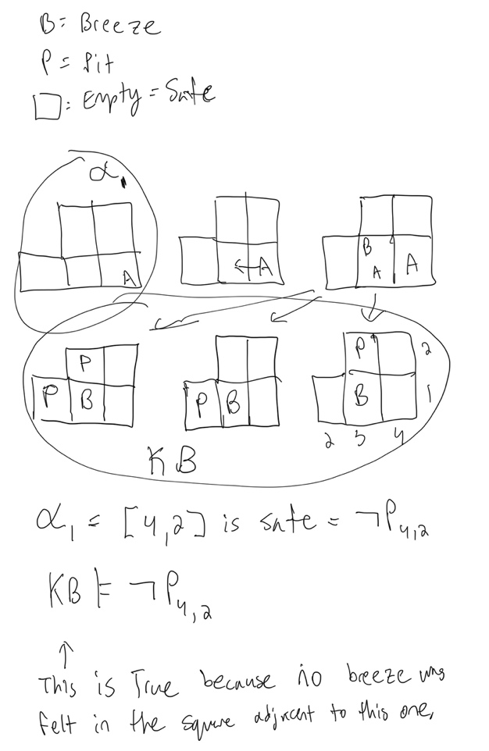

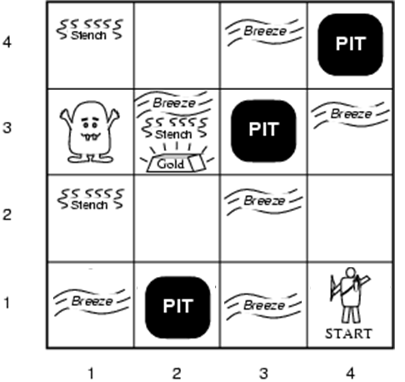

Figure 3

**Question 7 [3 pts]** Figure 4 shows the Wumpus world game, where the agent starts from location [1,1], and does not sense breeze or stench. After that, the agent moves to location [1,2] and sense a Breeze (B). Then the agent moved back to [1,1], and further moved to location [2,1] and senses a Stench (S). Based on the above observations and the Wumpus world game rules, please use resolution algorithm to prove following entailment.

* + Let Pi,j be true if there is a pit in [i,j].
  + Let Bi,j be true if there is a breeze in [i,j].
  + Let Si,j be true if there is a stench in [i,j].
  + Bi,j ⬄ There is a pit in an adjacent cell.
  + Si,j ⬄ There is a wumpus in an adjacent cell.
* KB╞ ¬W1,3 (There is no Wumpus at location [1,3]) [0.5 pt]

R1: ¬ S1,2

R2: ¬ S1,2 ⬄ (¬ W1,3 ∧ ¬ W2,2)

KB = {R1, R2}

¬ S1,2 => (¬ W1,3 ∧ ¬ W2,2) ∧ (¬ W1,3 ∧ ¬ W2,2) => ¬ S1,2

¬ ¬ S1,2 ∨ (¬ W1,3 ∧ ¬ W2,2) ∧ ¬ (¬ W1,3 ∧ ¬ W2,2) ∨ ¬ S1,2

(S1,2 ∨ (¬ W1,3 ∧ ¬ W2,2)) ∧ ((W1,3 ∨ W2,2) ∨ ¬ S1,2)

(T OR (F AND F)) AND ((T OR T) OR F)

(T OR F) AND (T OR F)

T AND T = TRUE

You can plug these clauses into the algorithm, and this proves the entailment is True.

* KB╞ W3,1∨ W2,2 (There is a Wumpus at location [3,1] or location [2,2]) [0.5 pt]

R1: S2,1

R2: S2,1 ⬄ (W2,2 ∨ W3,1)

(S2,1 => (W2,2 ∨ W3,1)) ^ ((W2,2 ∨ W3,1) => S2,1)

(¬ S2,1 v (W2,2 ∨ W3,1)) ^ (¬ (W2,2 ∨ W3,1) v S2,1)

(¬ S2,1 v (W2,2 ∨ W3,1)) ^ ((¬ W2,2 ^ ¬ W3,1) v S2,1)

(F or (T or T)) and ((F and F) or T)

(F or T) and (F or T)

T and T = True

You can plug these clauses into the algorithm, and this proves the entailment is True.

* *KB* ╞ W3,1 (There is a Wumpus at location [3,1]) [0.5 pt]

R1: S2,1

R2: B1,2

R3: S2,1 ⬄ (W2,2 ∨ W3,1)

R4: ¬ S1,2 ⬄ (¬ W1,3 ∧ ¬ W2,2)

(S2,1 ⬄ (W2,2 ∨ W3,1)) ^ (¬ S1,2 ⬄ (¬ W1,3 ∧ ¬ W2,2))

((S2,1 => (W2,2 ∨ W3,1)) ^ ((W2,2 ∨ W3,1)=> S2,1))^((¬ S1,2 =>(¬ W1,3 ∧ ¬ W2,2)) ^ ((¬ W1,3 ∧ ¬ W2,2)=> ¬ S1,2)

(¬ S2,1 v (W2,2 ∨ W3,1)) ^ (¬ (W2,2 ∨ W3,1) v S2,1)^ (¬ ¬ S1,2 ∨ (¬ W1,3 ∧ ¬ W2,2) ∧ ¬ (¬ W1,3 ∧ ¬ W2,2) ∨ ¬ S1,2 )

FROM ABOVE EXAMPLES WE CAN DERIVE: TRUE AND TRUE = TRUE

You can plug these clauses into the algorithm, and this proves the entailment is True.

* *KB* ╞ P1,3 (There is a Pit at location [1,3]) [0.5 pt]

R1: B1,2

R2: ¬ B2,1

R3: B1,2 ⬄ (P1,3 v P2,2)

R4: ¬ B2,1 ⬄ (¬ P2,2 v ¬ P3,1)

(B1,2 ⬄ (P1,3 v P2,2)) ^ (¬ B2,1 ⬄ (¬ P2,2 v ¬ P3,1))

((B1,2 => (P1,3 v P2,2))^((P1,3 v P2,2)=> B1,2))^ ((¬ B2,1 => (¬ P2,2 v ¬ P3,1))^((¬ P2,2 v ¬ P3,1)=>¬ B2,1))

((¬B1,2 v (P1,3 v P2,2))^( ¬ (P1,3 v P2,2) v B1,2)) ^ ((¬¬ B2,1 v (¬ P2,2 v ¬ P3,1))^( ¬ (¬ P2,2 v ¬ P3,1) v ¬ B2,1))

((¬B1,2 v (P1,3 v P2,2))^(( ¬P1,3 ^ ¬P2,2) v B1,2)) ^ ((B2,1 v (¬ P2,2 v ¬ P3,1))^((P2,2 ^ P3,1) v ¬ B2,1))

(F v T)^(F v T)^(T v F)^(T v F)

T ^ T ^ T ^ T = True

You can plug these clauses into the algorithm, and this proves the entailment is True.

* *KB* ╞ ¬ P2,2 (There is no Pit at location [2,2]) [0.5 pt]

R1: B1,2

R2: ¬ B2,1

R3: B1,2 ⬄ (P1,3 v P2,2)

R4: ¬ B2,1 ⬄ (¬ P2,2 v ¬ P3,1)

(B1,2 ⬄ (P1,3 v P2,2)) ^ (¬ B2,1 ⬄ (¬ P2,2 v ¬ P3,1))

((B1,2 => (P1,3 v P2,2))^((P1,3 v P2,2)=> B1,2))^ ((¬ B2,1 => (¬ P2,2 v ¬ P3,1))^((¬ P2,2 v ¬ P3,1)=>¬ B2,1))

((¬B1,2 v (P1,3 v P2,2))^( ¬ (P1,3 v P2,2) v B1,2)) ^ ((¬¬ B2,1 v (¬ P2,2 v ¬ P3,1))^( ¬ (¬ P2,2 v ¬ P3,1) v ¬ B2,1))

((¬B1,2 v (P1,3 v P2,2))^(( ¬P1,3 ^ ¬P2,2) v B1,2)) ^ ((B2,1 v (¬ P2,2 v ¬ P3,1))^((P2,2 ^ P3,1) v ¬ B2,1))

(F v T)^(F v T)^(T v F)^(T v F)

T ^ T ^ T ^ T = True

You can plug these clauses into the algorithm, and this proves the entailment is True.

* *KB* ╞ ¬ W2,2 (There is no Wumpus at location [2,2]) [0.5 pt]

R1: ¬ S1,2

R2: ¬ S1,2 ⬄ (¬ W1,3 ∧ ¬ W2,2)

KB = {R1, R2}

¬ S1,2 => (¬ W1,3 ∧ ¬ W2,2) ∧ (¬ W1,3 ∧ ¬ W2,2) => ¬ S1,2

¬ ¬ S1,2 ∨ (¬ W1,3 ∧ ¬ W2,2) ∧ ¬ (¬ W1,3 ∧ ¬ W2,2) ∨ ¬ S1,2

(S1,2 ∨ (¬ W1,3 ∧ ¬ W2,2)) ∧ ((W1,3 ∨ W2,2) ∨ ¬ S1,2)

(T OR (F AND F)) AND ((T OR T) OR F)

(T OR F) AND (T OR F)

T AND T = TRUE

You can plug these clauses into the algorithm, and this proves the entailment is True.

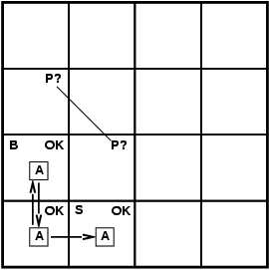

**Figure 4**