UberEats 2.0



**Presented By:**

Morgan Blein

Stefanie Koch

Jamie Laforge

Jessica Martin

Tamer Rasamny

Marketing Research - MKTG6401

Professor Yi He

12/10/2015

**Table of Contents**

**Statement of Objectives**

**The Intended Client…………………………………………………………………………...2**

**Facts about Uber……………………………………………………………………….......... 2   
Facts About UberEats……………………………………………………………………….. 2  
Industry Background: The Food Delivery Ecosystem………………………………….2**  
**Statement of Research Goals……………………………………………………………….3**

**Problem Definition**  
**Strengths………………………………………………………………………………………..3**  
**Weaknesses…………………………………………………………………………………….4**  
**Opportunities…………………………………………………………………………………...4**

**Threats…………………………………………………………………………..……………….4**  
**SWOT Analysis……...…...…………………………………………………………………….5**  
**Analysis of Competitors ……………………………………………………………………..5**

**Methodology & Operationalization of Variables**

**Research Method(s) Used…………………………………………………………………....7**

**Variables…………………………………………………………………………...…………....7**

**Research Procedure……………………………………………………..…………………....8**

**Data Analysis, Discussion, and Marketing Strategies**  
**Major Findings………………………………………………………………………………….8**

**Further Research Proposal…………………………………………………………………10**

**Marketing Recommendations.……………………………………………………………..11**

**Appendix**

**References**

Statement of Objectives

**The Intended Client**

For the purpose of our marketing research study, we have chosen Uber as our intended client, with our focus being on UberEats, one of their more recent food delivery services. We decided to work for this client because this service is new and there is a wealth of clients and competitors in this specific market.  **Facts about Uber**The concept for Uber came to light in 2008 when Garrett Camp, the founder of Stumble-Upon, saw a need to address the taxi problem in San Francisco. The company then launched in 2009 with Garrett Camp and Travis Kalanick as its co-founders.

Uber is a mobile App that allows riders to submit a trip destination request which is then routed to local drivers nearby, who in turn would pick them up at a prearranged location in minutes. Since it’s launch, Uber has become a great success and currently operates in 60 countries and 330 cities. The Uber cab service however is not the only industry that Uber is looking to revolutionize. Since it’s launch, Uber has expanded its Uber-like transportation services to a myriad of other realms such as: UberCargo (transportation of cargo), UberCarpool (Uber carpool transportation), UberFresh (Transportation of fresh produce), and most recently UberEats (Food delivery service).  
  
**Facts About UberEats**With regards to UberEats, it is a sub-service of Uber which uses the same drivers that carry passengers to also deliver food for a $3 delivery flat fee. As of now, the UberEats service is rapidly expanding is now available in: San Francisco, Los angeles, New York, Chicago, Toronto, Barcelona, Atlanta, Washington D.C, Austin and most recently Seattle and are looking to expand to other markets. The seamless UX/UI of the app alongside an affordable alternative to food delivery make it ideal for customers to use.  
  
**Industry Background: The Food Delivery Ecosystem**The UberEats service is competing in a very saturated and wide market. Many startup companies with heavy funding are making a name for themselves in several niches of this market (Postmates,Sprig, SpoonRocket, Caviar, and Munchery for example).

Moreover UberEats will be competing with well established giants of the industry such as Grubhub and Eat24 (recently acquired by Yelp). In order to differentiate themselves and gain market share, UberEats will need to rely on Uber’s established assets and smart positioning.

With the U.S. spending $70 billion a year on takeout/delivery, the food delivery industry has a huge growth potential. Additionally, 95% of these takeout orders are being placed by phone with a paper menu. UberEats is working to tap into this large pool of potential customers utilizing their mobile app.

**Statement of Research Goals**

Our specific statement of research goals: **“How can UberEats leverage its assets and key partnerships in order to steadily rise its market share within the food delivery industry?”**

The Focus of our research is to better understand the needs and wants of consumers in the food delivery service industry. More specifically, to better understand the future opportunities for UberEats to offer various food delivery options at an affordable price. In order to expand UberEats’ location offerings, as well as market share, research is geared to generally gauge the food industry market to uncover untapped markets and consumer segments.

Our areas of focus will include:

* Help Uber understand and fulfill the needs of as many customers as possible .
* How UberEats can provide more meal options to customers by expanding restaurant partnerships/network
* Keeping delivery costs to a minimum without increasing delivery time.
* Expanding the service to other metropolitan/urban cities.
* Competitive market place analysis in order to understand how to gain market shares.
* Uncover new segments to market to.
* Explore UberPerks or other incentives for participating restaurants/customers.

Problem Definition  
  
**Strengths**

Uber is, especially in the USA, a well well-recognized brand, so for the new “sub-service” UberEats, it should be easier to hit the market and get brand awareness. Furthermore Uber has a high standard of service and verified drivers and a huge amount of cars available. Due to the fact that Uber has no full-time drivers, there are no responsibilities toward employees. Moreover the operational costs are lower, compared to other taxi or delivery service companies. One of the most attractive advantage is the cashless payment system as well as the tracking of the car Uber operates with. In addition to that, Uber allows its customer to choose highly rated drivers and also provides a record of the spendings. To avoid sceptical behaviour or uncertainty, Uber offers their users a dual rating system, to boost trust and safety.

Due to the high number of cars available, the food delivery is promised to be within 10 minutes. As the brand name “Uber” is already well established, UberEats should be easy to introduce to existing Uber Users as well as potential new customers.

**Weaknesses**

The idea can be easily imitated. Nothing will prevent competition from presenting the same concept. The loyalty between Uber and its drivers is quite low, but this is not really important concerning the delivery service. Furthermore there could appear some privacy concerns, because Uber records where customer gets the taxi from. It also notes where s/he goes with it. The biggest downside what we think is, that UberEats has only a very small delivery area and time bracket for ordering. The service is not available everywhere. In San Francisco for example, it is only available in the financial district, soMa, Nob Hill, Mission Bay MO-FR from 11am-2pm.

Additionally to the small designated delivery area, UberEats only offers 3-4 meals per day. On one hand, this is of course a less variety, but on the other hand it stands for exclusiveness and quality. UberEats changes its menu every day, so the customer gets surprised and don’t know what to expect next week.

**Opportunities**

Looking at the Opportunities for Uber and Ubereats, the company could easily provide additional services, because the brand is already well established. (school-shuttle for children). Furthermore they could enter another market like (India), where traditional taxis are expensive and inconvenient. So there could be a Huge potential demand/market in developing countries. Another opportunity would be opening an own Uber restaurant and deliver from there. Moreover we see a huge opportunity for Ubereats to partner up with other companies and due to that receiving also a lot of discounts and mutual benefits.

**Threats**

Uber’s biggest threat is the opposition from taxi drivers and government as well as that other food delivery services enter the market with the same service concept and compete. It is easy for customers to switch to another substitute. Moreover, it is uncertain how future regulations develop in this business.

**SWOT Analysis**

The SWOT presents a high-level overview of what Uber sees as its main issues. It helps provide the foundation for further communication plans.To conclude we can definitely see, that the strengths and Opportunities of Uber and UberEats outweigh the weaknesses and threats. We concentrated more on the external issues than the internal, because we did not have many internal insights. To fulfill our SWOT Analysis, we focused on our top 3 top competitors, in order to make sure which benefits and USPs UberEats has against other food delivery services.

**Analysis of Competitors**

Due to our research we found out that EAT24, Dominos and GrubHub are our top 3 competitors. Based on additional research activities (analysing homepage, and Apps usability, offerings, customer reviews, valuations etc) we created a Bench-mark graphic which illustrates our main competitors in comparison with uber.

**We consider 4 factors which are most important to compare:**

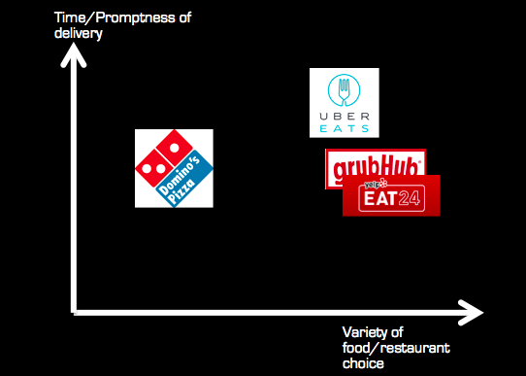

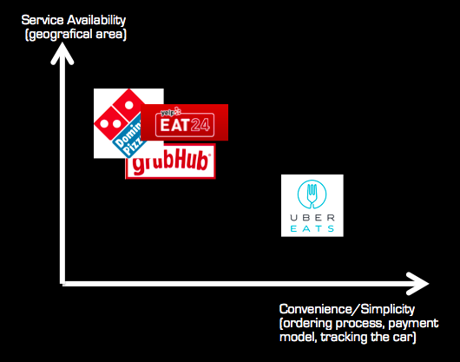

**USP Uber against competitors:**

* **Tracking possibility**
  + consumer can follow the delivery process via smartphone and can check when and in which car their food is arriving exactly
* **Delivery within 10 min**
  + More drivers are available, Uber App algorithm figures out immediately who picks up and brings the food
* **Easy cashless payment method**
  + already sign up with your credit card, so consumers do not have to take cards or either cash with them to buy the driver and the food.
* **Diversity and variety of special food**
  + not only burgers, pizza -->organic, high quality food and desserts
* **Brand performance** (Exclusiveness, High Quality)
  + Exclusiveness and elegant logo, compared to every other food delivery service, Uber Eats presents its delivery service very classy. Choosing the colours black and blue gives the customers another perception of this service, compared to all the other red,“cheap-discount“ logo looks.

Methodology & Operationalization of Variables

**Research Method(s) Used**

Quantitative research was done, primarily with the exploratory method by distributing a 23 question survey. These methods were used to gather as much industry consumer information in order to ‘predict’ consumer behavior and generalize to the larger population.  
  
**Variables**

Seven hypotheses were researched:

1. **Independent Sample T-Test:**

IV- Gender

DV- Willingness to try new food delivery methods

1. **Paired Sample T-Test:**

IV- Age

DV- Willingness to try new food delivery methods

1. **Simple Regression:**

IV- Total annual income

DV- Importance of price

1. **Multiple Regression:**

IV- Age, gender, income

DV- Familiarity with Uber

1. **Multiple Regression:**

IV- Age, gender, income

DV- Willingness to try new food delivery methods

1. **Multiple Regression:**

IV- Preference of payment

DV- Willingness to try new food delivery methods

1. **Multiple Regression:**

IV- Familiarity with Uber, Importance of food ordering process

DV- Willingness to try new food delivery methods

**Research Procedure**  
The units of analysis were the survey respondents, with a sample size of 94. The sample consisted of 44 men and 50 women, with a majority in the age bracket 22 to 30 (38.71% 22-26yrs and 27.96% 27-30yrs). The other age brackets were: under 21 7.53%, 31 to 39 8.6%, 40 to 54 11.83%, and 55+ 5.83%. The income brackets that contained the greatest number of units of analysis were under $25K (23.66%), between $100K and $149K (21.51%), and between $50K and $74K (18.28%). The other income brackets, $150K+ contained 13.98%, between $25K and $49K contained 12.90%, and between $75K and $99K contained 9.68%. A non-probability sampling was used, specifically a convenience sampling. The survey was distributed through the researcher’s social media sites, with no incentives given.   
  
Data Analysis, Discussion, and Marketing Strategies  
  
**Major Findings**

**Hypotheses 1, 2, 4, and 5** p-value was => .05 so it was found that these results were insignificant and no conclusion could be drawn as to the potential adoption of the new service related to demographics.

**Hypothesis 3** held the conclusion that as total annual income increases so does the importance of the price of the food delivery service. Conversely, as the total annual income decreases so does the importance of the price of the food delivery service.

1. **Research Question:**

Being that we want to see if there is a correlation between annual household income and price sensitivity, we will state the research question as follows:

**Does one’s annual household income have an affect on their sensitivity towards food delivery prices?**

**b. Statistical Hypothesis:**

**Null Hypothesis (Ho):**  There is no relationship between one’s Annual Household Income and their perceived attitude towards delivery prices.

**Alternative Hypothesis (HA):** There is a relationship between one’sAnnual Household Income and their perceived attitude towards delivery prices.

**Outcome:**  After conducting our analysis, we were able to disprove the Null Hypothesis that there is no relationship between one’s income and their sensitivity towards price. We found there to be a positive correlation between one’s Annual Household Income and how important they perceived the price of a delivery to be.

**Hypothesis 6** resulted with the payment methods of cash or check being negatively correlated with willingness to try new food delivery methods. While the payment method of credit card, whether with the phone or upon delivery was positively correlated with willingness to try new food delivery methods. Therefore, if the food delivery method is operated with credit card, consumers will be more willing to try the new method.

**a.** **Research Question:**

Being that we want to see if there is a correlation between payment methods and willingness to try new food delivery methods we will state the research question as follows:

**Does one’s method of payment have an affect on their willingness to try new food delivery methods?**

**b. Statistical Hypothesis:**

**Null Hypothesis (Ho):**  There is no relationship between one’s method of payment and their willingness to try new food delivery methods.

**Alternative Hypothesis (HA):** There is a relationship between one’s method of payment and their willingness to try new food delivery methods.

**Hypothesis 7** produced the outcome that the more familiar one is with Uber and the higher the units of analysis rated the importance of the food ordering process, the more willing they are to try new food delivery methods.

**a.** **Research Question:**

Being that we want to see if there is a correlation between familiarity with Uber and the importance of the food ordering process with willingness to try new food delivery methods we will state the research question as follows:

**Does one’s familiarity with Uber and rated importance of the food ordering process have an affect on their willingness to try new food delivery methods?**

**b. Statistical Hypothesis:**

**Null Hypothesis (Ho):**  There is no relationship between one’s familiarity with Uber and the importance of the food ordering process with willingness to try new food delivery methods

**Alternative Hypothesis (HA):** There is a relationship between one’s familiarity with Uber and the importance of the food ordering process with willingness to try new food delivery methods.

**Open Ended Question (Have you used Uber’s services before? Which ones?)** resulted with only 2 people having used UberEats, while 55 out of the 94 surveyed have used Uber’s ride-share service.

**Further Research Proposal**

**Hypothesis 3**

* More research is needed to determine how likely one is to use a food delivery service dependent on their income in order to target that income bracket accordingly. For example, if it is later determined that consumers with higher incomes are more likely to use a food delivery service, then marketing can be geared to cater to their price sensitivity, such as promotions, discounts, or rewards to give them a perceived value.

**Hypothesis 6**

* Research to determine what factors could make credit card use even easier or simpler could have a great impact on consumers willingness to try UberEats as their new food delivery service. General information on credit card use could lead to some insight on how to accomplish a superior payment interface.

**Hypothesis 7**

* Research regarding which aspects of the food ordering process are rated most important, for example: which medium used to order (i.e. phone, website, app), time it takes to place order and to be delivered, ease of ordering, communication throughout ordering process, and payment and tip options. Additionally, more research regarding the demographics of which consumer segment is most likely to use a food delivery service is needed to narrow down who to market to in order to make more aware of the Uber brand.

**Open Ended Question: Have you used Uber’s services before? Which ones?**

* Additional research can include determining how consumers of the Uber ride-share service had come to learn of them. Whatever medium the Uber ride-share consumers used to become aware of the ride-share service could be used to reach potential UberEats consumers.

**Marketing Recommendations**

**Hypothesis 3**

* If it’s found that people with higher incomes are more likely to use a food delivery service then, knowing they are price sensitive, we could then market to them by offering promotions such as, discount, sales, and rewards to give them a perceived value. Additionally, if it’s found that people with lower incomes are more likely to use a food delivery service, knowing that target segment is less price sensitive, we can focus on other incentives, such as a varied menu options or complimentary disposable dinnerware.

**Hypothesis 6**

* From the research, one can conclude that preference of credit card usage is due to its simplicity, therefore, to make Uber’s payment interface even more user friendly, rather than input credit card information manually, technology can be obtained to input credit card information by simply taking a photograph of the credit card (similar technology is used to deposit checks through atm’s).

**Hypothesis 7**

* Once demographic research is collected determining which consumer segment is most likely to utilize a food delivery service, that segment can be targeted to be made aware of the Uber brand. For example, if it’s determined that a younger consumer segment is most likely to use a food delivery service then Uber can utilize SEM to target that segment on social media, as well as, on common sites visited by this target market. Additionally, since the importance of the food ordering process is positively correlated with willingness to try new food delivery methods, the marketing recommendation would be to improve the food ordering process. The food ordering process could be improved with a small amount of input from the users regarding their preferences (survey, left/right swipe from Tinder, or thumbs up/down from Pandora), possibly with a rating system similar to stars, but instead with forks. With this input UberEats could send push notifications letting users know their ‘favorites’ are being served (similar to Amazon and their ‘recommendations’).

**Open Ended Question: Have you used Uber’s services before? Which ones?**

* This is an untapped market. Uber should market to its ride-share consumers, as we know from hypothesis 7, the more familiar with the Uber brand the more willing to try new food delivery methods. With each Uber ride, the consumer could be provided with a discount or points earned towards UberEats (similar cross promotional partnership is practiced by Safeway and Chevron; the more you spend at Safeway the more points you earn towards discounts on gas at Chevron).

Appendix  
**Title of Asset**

Appendix A: Survey instrument:

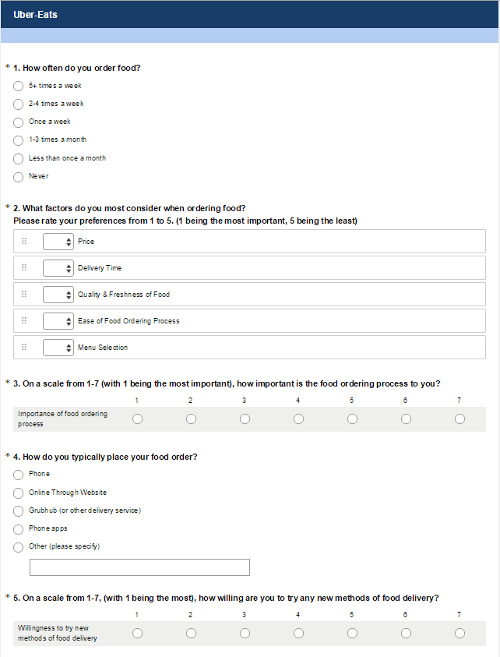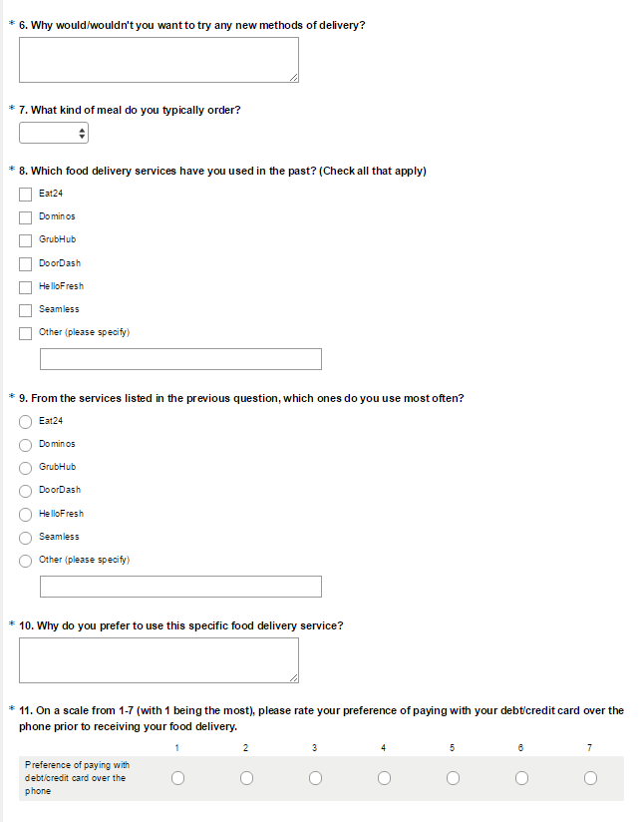

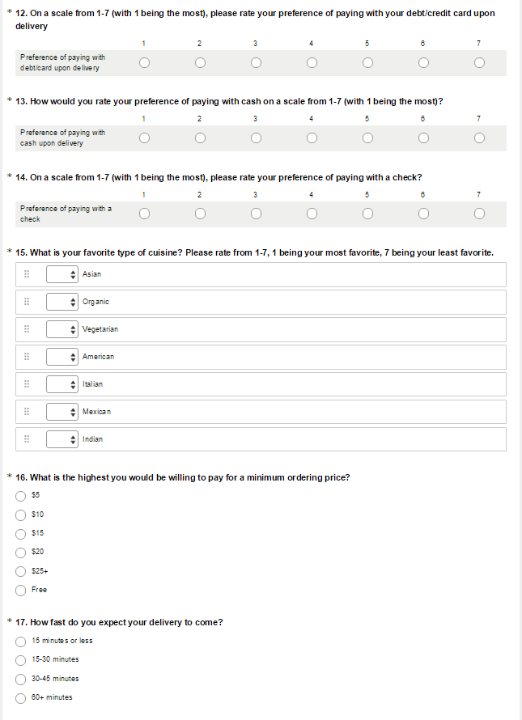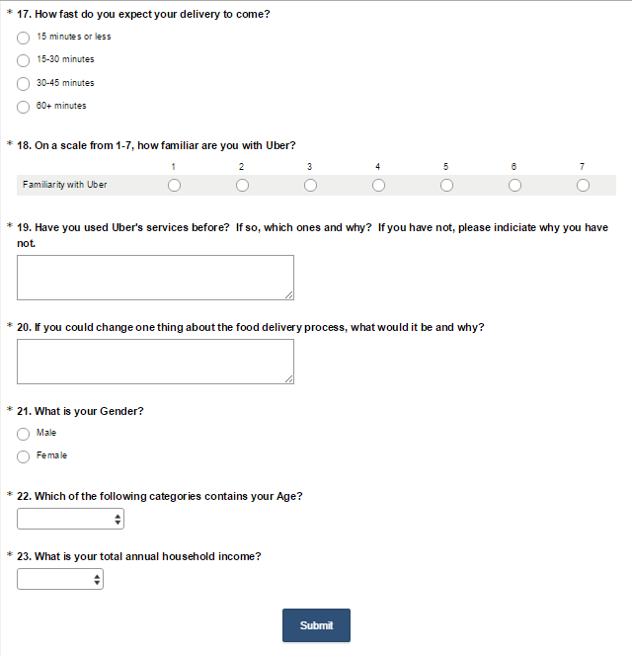

23 questions.

**Appendix B: SPSS tables:**

1. **Independent Sample T-Test:**

IV- Gender

DV- Willingness to try new food delivery methods

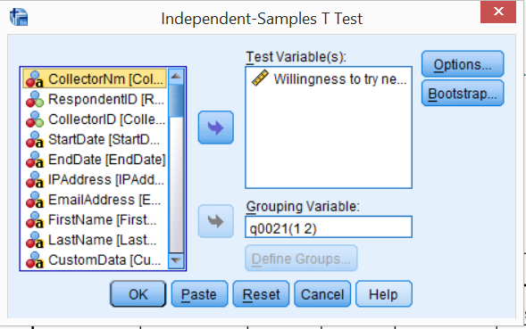

|  |  |  |  |  |  |
| --- | --- | --- | --- | --- | --- |
| **Group Statistics** | | | | | |
|  | What is your Gender? | N | Mean | Std. Deviation | Std. Error Mean |
| Willingness to try new methods of food delivery | Male | 44 | 3.0455 | 1.71117 | .25797 |
| Female | 50 | 2.9000 | 1.78714 | .25274 |

|  |  |  |  |  |  |  |  |  |  |  |
| --- | --- | --- | --- | --- | --- | --- | --- | --- | --- | --- |
| **Independent Samples Test** | | | | | | | | | | |
|  | | Levene's Test for Equality of Variances | | t-test for Equality of Means | | | | | | |
| F | Sig. | t | df | Sig. (2-tailed) | Mean Difference | Std. Error Difference | 95% Confidence Interval of the Difference | |
| Lower | Upper |
| Willingness to try new methods of food delivery | Equal variances assumed | .679 | .412 | .402 | 92 | .689 | .14545 | .36216 | -.57382 | .86473 |
| Equal variances not assumed |  |  | .403 | 91.326 | .688 | .14545 | .36114 | -.57188 | .86279 |

1. **Paired Sample T-Test:**

IV- Age

DV- Willingness to try new food delivery methods

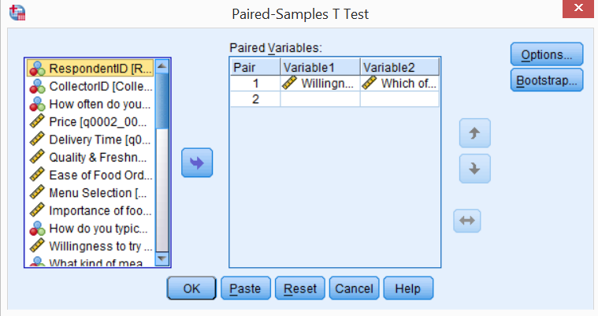

|  |  |  |  |  |  |
| --- | --- | --- | --- | --- | --- |
| **Paired Samples Statistics** | | | | | |
|  | | Mean | N | Std. Deviation | Std. Error Mean |
| Pair 1 | Willingness to try new methods of food delivery | 2.9247 | 93 | 1.70190 | .17648 |
| Which of the following categories contains your Age? | 2.9462 | 93 | 1.32177 | .13706 |

|  |  |  |  |  |
| --- | --- | --- | --- | --- |
| **Paired Samples Correlations** | | | | |
|  | | N | Correlation | Sig. |
| Pair 1 | Willingness to try new methods of food delivery & Which of the following categories contains your Age? | 93 | -.050 | .633 |
|  |  |  |  |  |

|  |  |  |  |  |  |  |  |  |  |
| --- | --- | --- | --- | --- | --- | --- | --- | --- | --- |
| **Paired Samples Test** | | | | | | | | | |
|  | | Paired Differences | | | | | t | df | Sig. (2-tailed) |
| Mean | Std. Deviation | Std. Error Mean | 95% Confidence Interval of the Difference | |
| Lower | Upper |
| Pair 1 | Willingness to try new methods of food delivery - Which of the following categories contains your Age? | -.02151 | 2.20660 | .22881 | -.47595 | .43294 | -.094 | 92 | .925 |
|  |  |  |  |  |  |  |  |  |  |

1. **Simple Regression:**

IV- Total annual income

DV- Importance of price

|  |  |  |
| --- | --- | --- |
| **Notes** | | |
| Output Created | | 01-DEC-2015 16:20:09 |
| Comments | |  |
| Input | Data | C:\Users\morgan\Documents\CSU\fall2015\MKTG6401 market research\project\final\Data_All_151201\result.sav |
| Active Dataset | DataSet3 |
| Filter | <none> |
| Weight | <none> |
| Split File | <none> |
| N of Rows in Working Data File | 94 |
| Missing Value Handling | Definition of Missing | User-defined missing values are treated as missing. |
| Cases Used | Statistics are based on cases with no missing values for any variable used. |
| Syntax | | REGRESSION  /DESCRIPTIVES MEAN STDDEV CORR SIG N  /MISSING LISTWISE  /STATISTICS COEFF OUTS R ANOVA  /CRITERIA=PIN(.05) POUT(.10)  /NOORIGIN  /DEPENDENT q0002_0001  /METHOD=ENTER q0023. |
| Resources | Processor Time | 00:00:00.02 |
| Elapsed Time | 00:00:00.02 |
| Memory Required | 216900 bytes |
| Additional Memory Required for Residual Plots | 0 bytes |

[DataSet3] C:\Users\morgan\Documents\CSU\fall2015\MKTG6401 market research\project\final\Data_All_151201\result.sav

|  |  |  |  |
| --- | --- | --- | --- |
| **Descriptive Statistics** | | | |
|  | Mean | Std. Deviation | N |
| Price | 2.8222 | 1.41880 | 90 |
| What is your total annual household income? | 3.3000 | 1.77023 | 90 |

|  |  |  |  |
| --- | --- | --- | --- |
| **Correlations** | | | |
|  | | Price | What is your total annual household income? |
| Pearson Correlation | Price | 1.000 | .268 |
| What is your total annual household income? | .268 | 1.000 |
| Sig. (1-tailed) | Price | . | .005 |
| What is your total annual household income? | .005 | . |
| N | Price | 90 | 90 |
| What is your total annual household income? | 90 | 90 |

|  |  |  |  |
| --- | --- | --- | --- |
| **Variables Entered/Removeda** | | | |
| Model | Variables Entered | Variables Removed | Method |
| 1 | What is your total annual household income?b | . | Enter |
| a. Dependent Variable: Price | | | |
| b. All requested variables entered. | | | |

|  |  |  |  |  |
| --- | --- | --- | --- | --- |
| **Model Summary** | | | | |
| Model | R | R Square | Adjusted R Square | Std. Error of the Estimate |
| 1 | .268a | .072 | .061 | 1.37483 |
| a. Predictors: (Constant), What is your total annual household income? | | | | |

|  |  |  |  |  |  |  |
| --- | --- | --- | --- | --- | --- | --- |
| **ANOVAa** | | | | | | |
| Model | | Sum of Squares | df | Mean Square | F | Sig. |
| 1 | Regression | 12.822 | 1 | 12.822 | 6.784 | .011b |
| Residual | 166.334 | 88 | 1.890 |  |  |
| Total | 179.156 | 89 |  |  |  |
| a. Dependent Variable: Price | | | | | | |
| b. Predictors: (Constant), What is your total annual household income? | | | | | | |

|  |  |  |  |  |  |  |
| --- | --- | --- | --- | --- | --- | --- |
| **Coefficientsa** | | | | | | |
| Model | | Unstandardized Coefficients | | Standardized Coefficients | t | Sig. |
| B | Std. Error | Beta |
| 1 | (Constant) | 2.115 | .308 |  | 6.868 | .000 |
| What is your total annual household income? | .214 | .082 | .268 | 2.605 | .011 |
| a. Dependent Variable: Price | | | | | | |

1. **Multiple Regression:**

IV- Age, gender, income

DV- Familiarity with Uber

|  |  |  |  |  |
| --- | --- | --- | --- | --- |
| **Model Summary** | | | | |
| Model | R | R Square | Adjusted R Square | Std. Error of the Estimate |
| 1 | .079a | .006 | -.027 | 2.14469 |
| a. Predictors: (Constant), What is your total annual household income?, What is your Gender?, Which of the following categories contains your Age? | | | | |

|  |  |  |  |  |  |  |
| --- | --- | --- | --- | --- | --- | --- |
| **ANOVAa** | | | | | | |
| Model | | Sum of Squares | df | Mean Square | F | Sig. |
| 1 | Regression | 2.585 | 3 | .862 | .187 | .905b |
| Residual | 409.372 | 89 | 4.600 |  |  |
| Total | 411.957 | 92 |  |  |  |
| a. Dependent Variable: Familiarity with Uber | | | | | | |
| b. Predictors: (Constant), What is your total annual household income?, What is your Gender?, Which of the following categories contains your Age? | | | | | | |

NO CONVERGENCE

1. **Multiple Regression:**

IV- Age, gender, income

DV- Willingness to try new food delivery methods

|  |  |  |  |  |
| --- | --- | --- | --- | --- |
| **Model Summary** | | | | |
| Model | R | R Square | Adjusted R Square | Std. Error of the Estimate |
| 1 | .063a | .004 | -.030 | 1.72694 |
| a. Predictors: (Constant), What is your total annual household income?, What is your Gender?, Which of the following categories contains your Age? | | | | |

|  |  |  |  |  |  |  |
| --- | --- | --- | --- | --- | --- | --- |
| **ANOVAa** | | | | | | |
| Model | | Sum of Squares | df | Mean Square | F | Sig. |
| 1 | Regression | 1.046 | 3 | .349 | .117 | .950b |
| Residual | 265.427 | 89 | 2.982 |  |  |
| Total | 266.473 | 92 |  |  |  |
| a. Dependent Variable: Willingness to try new methods of food delivery | | | | | | |
| b. Predictors: (Constant), What is your total annual household income?, What is your Gender?, Which of the following categories contains your Age? | | | | | | |

NO CONVERGENCE

1. **Multiple Regression:**

IV- Preference of payment

DV- Willingness to try new food delivery methods

|  |  |  |
| --- | --- | --- |
| **Notes** | | |
| Output Created | | 01-DEC-2015 15:59:01 |
| Comments | |  |
| Input | Data | C:\Users\morgan\Documents\CSU\fall2015\MKTG6401 market research\project\final\Data_All_151201\result.sav |
| Active Dataset | DataSet3 |
| Filter | <none> |
| Weight | <none> |
| Split File | <none> |
| N of Rows in Working Data File | 94 |
| Missing Value Handling | Definition of Missing | User-defined missing values are treated as missing. |
| Cases Used | Statistics are based on cases with no missing values for any variable used. |
| Syntax | | REGRESSION  /DESCRIPTIVES MEAN STDDEV CORR SIG N  /MISSING LISTWISE  /STATISTICS COEFF OUTS R ANOVA  /CRITERIA=PIN(.05) POUT(.10)  /NOORIGIN  /DEPENDENT q0005_0001  /METHOD=ENTER q0011_0001 q0012_0001 q0013_0001 q0014_0001. |
| Resources | Processor Time | 00:00:00.02 |
| Elapsed Time | 00:00:00.03 |
| Memory Required | 217772 bytes |
| Additional Memory Required for Residual Plots | 0 bytes |

[DataSet3] C:\Users\morgan\Documents\CSU\fall2015\MKTG6401 market research\project\final\Data_All_151201\result.sav

|  |  |  |  |
| --- | --- | --- | --- |
| **Descriptive Statistics** | | | |
|  | Mean | Std. Deviation | N |
| Willingness to try new methods of food delivery | 2.9681 | 1.74413 | 94 |
| Preference of paying with debt/credit card over the phone | 3.6915 | 2.22414 | 94 |
| Preference of paying with debt/card upon delivery | 3.7234 | 2.08117 | 94 |
| Preference of paying with cash upon delivery | 3.4043 | 2.08073 | 94 |
| Preference of paying with a check | 4.7021 | 2.10391 | 94 |

|  |  |  |  |  |  |  |
| --- | --- | --- | --- | --- | --- | --- |
| **Correlations** | | | | | | |
|  | | Willingness to try new methods of food delivery | Preference of paying with debt/credit card over the phone | Preference of paying with debt/card upon delivery | Preference of paying with cash upon delivery | Preference of paying with a check |
| Pearson Correlation | Willingness to try new methods of food delivery | 1.000 | .161 | .101 | -.162 | -.471 |
| Preference of paying with debt/credit card over the phone | .161 | 1.000 | -.184 | -.370 | -.222 |
| Preference of paying with debt/card upon delivery | .101 | -.184 | 1.000 | .220 | .050 |
| Preference of paying with cash upon delivery | -.162 | -.370 | .220 | 1.000 | .084 |
| Preference of paying with a check | -.471 | -.222 | .050 | .084 | 1.000 |
| Sig. (1-tailed) | Willingness to try new methods of food delivery | . | .061 | .166 | .059 | .000 |
| Preference of paying with debt/credit card over the phone | .061 | . | .038 | .000 | .016 |
| Preference of paying with debt/card upon delivery | .166 | .038 | . | .017 | .317 |
| Preference of paying with cash upon delivery | .059 | .000 | .017 | . | .210 |
| Preference of paying with a check | .000 | .016 | .317 | .210 | . |
| N | Willingness to try new methods of food delivery | 94 | 94 | 94 | 94 | 94 |
| Preference of paying with debt/credit card over the phone | 94 | 94 | 94 | 94 | 94 |
| Preference of paying with debt/card upon delivery | 94 | 94 | 94 | 94 | 94 |
| Preference of paying with cash upon delivery | 94 | 94 | 94 | 94 | 94 |
| Preference of paying with a check | 94 | 94 | 94 | 94 | 94 |

|  |  |  |  |
| --- | --- | --- | --- |
| **Variables Entered/Removeda** | | | |
| Model | Variables Entered | Variables Removed | Method |
| 1 | Preference of paying with a check, Preference of paying with debt/card upon delivery, Preference of paying with cash upon delivery, Preference of paying with debt/credit card over the phoneb | . | Enter |
| a. Dependent Variable: Willingness to try new methods of food delivery | | | |
| b. All requested variables entered. | | | |

|  |  |  |  |  |
| --- | --- | --- | --- | --- |
| **Model Summary** | | | | |
| Model | R | R Square | Adjusted R Square | Std. Error of the Estimate |
| 1 | .512a | .262 | .229 | 1.53114 |
| a. Predictors: (Constant), Preference of paying with a check, Preference of paying with debt/card upon delivery, Preference of paying with cash upon delivery, Preference of paying with debt/credit card over the phone | | | | |

|  |  |  |  |  |  |  |
| --- | --- | --- | --- | --- | --- | --- |
| **ANOVAa** | | | | | | |
| Model | | Sum of Squares | df | Mean Square | F | Sig. |
| 1 | Regression | 74.253 | 4 | 18.563 | 7.918 | .000b |
| Residual | 208.652 | 89 | 2.344 |  |  |
| Total | 282.904 | 93 |  |  |  |
| a. Dependent Variable: Willingness to try new methods of food delivery | | | | | | |
| b. Predictors: (Constant), Preference of paying with a check, Preference of paying with debt/card upon delivery, Preference of paying with cash upon delivery, Preference of paying with debt/credit card over the phone | | | | | | |

|  |  |  |  |  |  |  |
| --- | --- | --- | --- | --- | --- | --- |
| **Coefficientsa** | | | | | | |
| Model | | Unstandardized Coefficients | | Standardized Coefficients | t | Sig. |
| B | Std. Error | Beta |
| 1 | (Constant) | 4.570 | .705 |  | 6.486 | .000 |
| Preference of paying with debt/credit card over the phone | .027 | .079 | .035 | .343 | .732 |
| Preference of paying with debt/card upon delivery | .136 | .079 | .163 | 1.732 | .087 |
| Preference of paying with cash upon delivery | -.123 | .083 | -.147 | -1.475 | .144 |
| Preference of paying with a check | -.381 | .077 | -.460 | -4.922 | .000 |
| a. Dependent Variable: Willingness to try new methods of food delivery | | | | | | |

1. **Multiple Regression:**

IV- Familiarity with Uber, Importance of food ordering process

|  |  |  |  |
| --- | --- | --- | --- |
| **Descriptive Statistics** | | | |
|  | Mean | Std. Deviation | N |
| Willingness to try new methods of food delivery | 2.9681 | 1.74413 | 94 |
| Familiarity with Uber | 3.3404 | 2.12286 | 94 |
| Importance of food ordering process | 3.2979 | 1.38990 | 94 |

|  |  |  |  |  |
| --- | --- | --- | --- | --- |
| **Correlations** | | | | |
|  | | Willingness to try new methods of food delivery | Familiarity with Uber | Importance of food ordering process |
| Pearson Correlation | Willingness to try new methods of food delivery | 1.000 | .444 | .314 |
| Familiarity with Uber | .444 | 1.000 | .235 |
| Importance of food ordering process | .314 | .235 | 1.000 |
| Sig. (1-tailed) | Willingness to try new methods of food delivery | . | .000 | .001 |
| Familiarity with Uber | .000 | . | .011 |
| Importance of food ordering process | .001 | .011 | . |
| N | Willingness to try new methods of food delivery | 94 | 94 | 94 |
| Familiarity with Uber | 94 | 94 | 94 |
| Importance of food ordering process | 94 | 94 | 94 |

|  |  |  |  |
| --- | --- | --- | --- |
| **Variables Entered/Removeda** | | | |
| Model | Variables Entered | Variables Removed | Method |
| 1 | Importance of food ordering process, Familiarity with Uberb | . | Enter |
| a. Dependent Variable: Willingness to try new methods of food delivery | | | |
| b. All requested variables entered. | | | |

|  |  |  |  |  |
| --- | --- | --- | --- | --- |
| **Model Summary** | | | | |
| Model | R | R Square | Adjusted R Square | Std. Error of the Estimate |
| 1 | .494a | .244 | .228 | 1.53287 |
| a. Predictors: (Constant), Importance of food ordering process, Familiarity with Uber | | | | |

|  |  |  |  |  |  |  |
| --- | --- | --- | --- | --- | --- | --- |
| **ANOVAa** | | | | | | |
| Model | | Sum of Squares | df | Mean Square | F | Sig. |
| 1 | Regression | 69.081 | 2 | 34.541 | 14.700 | .000b |
| Residual | 213.823 | 91 | 2.350 |  |  |
| Total | 282.904 | 93 |  |  |  |
| a. Dependent Variable: Willingness to try new methods of food delivery | | | | | | |
| b. Predictors: (Constant), Importance of food ordering process, Familiarity with Uber | | | | | | |

|  |  |  |  |  |  |  |
| --- | --- | --- | --- | --- | --- | --- |
| **Coefficientsa** | | | | | | |
| Model | | Unstandardized Coefficients | | Standardized Coefficients | t | Sig. |
| B | Std. Error | Beta |
| 1 | (Constant) | .972 | .441 |  | 2.201 | .030 |
| Familiarity with Uber | .322 | .077 | .392 | 4.183 | .000 |
| Importance of food ordering process | .279 | .118 | .222 | 2.371 | .020 |
| a. Dependent Variable: Willingness to try new methods of food delivery | | | | | | |

Research questionnaire, Charts, Graphs, Tables, Perceptual Maps, Advertisements that illustrate concepts, etc.

References

<http://pestleanalysis.com/swot-analysis-for-uber/>

<http://www.mbaskool.com/brandguide/it-technology/12847-uber.html>

<http://www.businessinsider.com/ubereats-is-convenient-but-overpriced-2015-6>

<http://techcrunch.com/gallery/a-brief-history-of-uber/slide/12/>

<http://www.eater.com/2015/3/18/8227077/food-delivery-apps-san-francisco-tech>