**About-Prototype Reflection:**

While I was working on my prototype, I couldn’t get my content to look like my wireframes. Instead of my photo being on the right, it was on the left. All of my content simply goes down the page in one column. I also could not get my photo to successfully appear on my page.

This is the link to my About page:

<https://morganbranson.github.io/webdevelopment/about.html>

This is my wireframe for my About page:

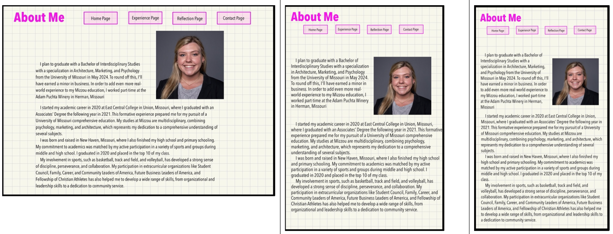

I still need to work on many things for my website. I am starting to understand the styling part of it better. However, organizing where my content goes is what I am struggling with as of now. For my navigation section, I’m not sure what I have wrong.