Evaluating bee habitat provisioning within agricultural landscapes

Morgan Mackert

December 9, 2016

The overarching goal of my research is to determine what influence contour buffer and filter strips in agricultural fields have on the abundance and diversity of the native bee community in the surrounding area.

View the bee data.

## Date Site TotalBees   
## 5/12/2016: 2 Bowman : 5 Min. : 0.00   
## 5/15/2016: 2 Cretsinger: 5 1st Qu.: 21.50   
## 5/18/2016: 2 Kaldenberg: 5 Median : 41.50   
## 5/19/2016: 2 McClellan : 5 Mean : 65.67   
## 5/22/2016: 2 Peckumn : 5 3rd Qu.: 68.25   
## 5/29/2016: 2 Plunkett : 5 Max. :434.00   
## (Other) :28 (Other) :10

Plot the bee data to look for outliers. 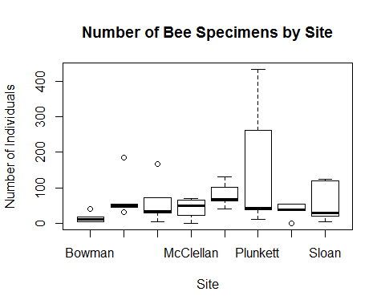

View the plant data.

## Date Site TotalPlants   
## 5/12/2016: 2 Bowman : 5 Min. : 0.0   
## 5/15/2016: 2 Cretsinger: 5 1st Qu.: 1.0   
## 5/18/2016: 2 Kaldenberg: 5 Median : 2.0   
## 5/19/2016: 2 McClellan : 5 Mean : 3.5   
## 5/22/2016: 2 Peckumn : 5 3rd Qu.: 6.0   
## 5/29/2016: 2 Plunkett : 5 Max. :13.0   
## (Other) :28 (Other) :10

Plot the plant data to look for outliers. 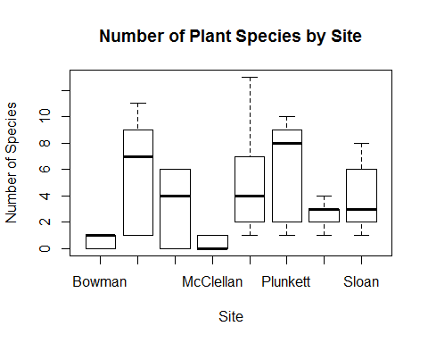

The best general linear model as of now is as follows. It includes Site as well as an interaction between Date and plant species richness.

setwd("C:/Users/Morgan/Documents/ISU/Semester 3/R/mmackert/Data")  
beesvsplantsbysitedate <- glm(formula = simplebees$TotalBees ~ simplebees$Date * simpleplants$TotalPlants + simplebees$Site, family = poisson)  
summary(beesvsplantsbysitedate)