Evaluating bee habitat provisioning within agricultural landscapes

Morgan Mackert

December 13, 2016

##   
## Attaching package: 'lubridate'

## The following object is masked from 'package:base':  
##   
## date

Load bee and plant data.

## Date Site TotalBees  
## 1 2016-05-03 Plunkett 11  
## 2 2016-05-03 Bowman 4  
## 3 2016-05-04 Kaldenberg 5  
## 4 2016-05-04 McClellan 0  
## 5 2016-05-12 Sheller 0  
## 6 2016-05-12 Sloan 4

## Date Site TotalPlants  
## 1 2016-05-03 Plunkett 1  
## 2 2016-05-03 Bowman 0  
## 3 2016-05-04 Kaldenberg 0  
## 4 2016-05-04 McClellan 0  
## 5 2016-05-12 Sheller 2  
## 6 2016-05-12 Sloan 1

Plot the number of bee specimens and the number of plant species by date, and include best fit line.

setwd("C:/Users/Morgan/Documents/ISU/Semester 3/R/mmackert/Data")  
with(simplebees, plot(TotalBees ~ Date, ylab = "Bee Abundance"));  
with(simplebees, abline(lm(TotalBees ~ Date)))

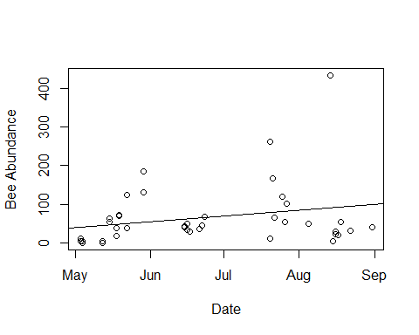

with(simpleplants, plot(TotalPlants ~ Date, ylab = "Flowering Plant Richness"));  
with(simpleplants, abline(lm(TotalPlants ~ Date)))

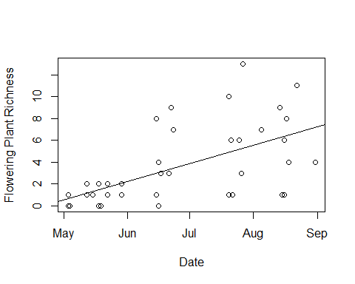

Plot the number of bee specimens and the number of plant species by site.

with(simplebees, plot(TotalBees ~ Site, ylab = "Bee Abundance"))

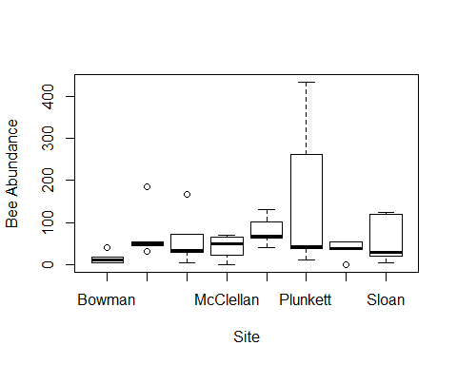

with(simpleplants, plot (TotalPlants ~ Site, ylab = "Number of Bee Species"))

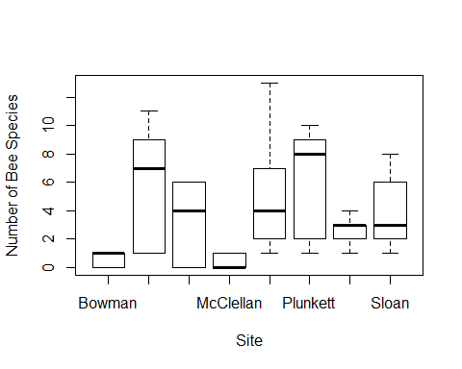

Now do it with ggplot.

beesbysiteplot <- ggplot(simplebees, aes(x = Date, y = TotalBees)) +   
 geom_point(shape = 19, size = 2) +   
 geom_smooth(method = lm) +  
 ggtitle("Bee Abundance") +  
 theme(plot.title = element_text(size = 20, face = "bold", margin = margin(10, 0, 10, 0))) +  
 labs(x = "Date", y = "Number of Individuals")  
beesbysiteplot

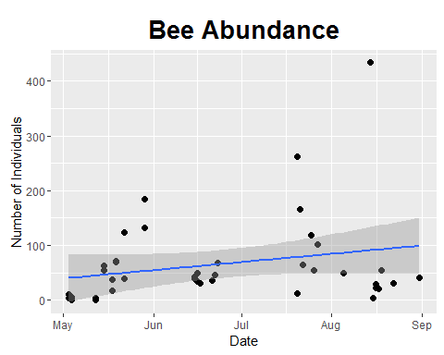

plantsbysiteplot <- ggplot(simpleplants, aes(x = Date, y = TotalPlants)) +  
 geom_point(shape = 19, size = 2) +  
 geom_smooth(method = lm)+  
 ggtitle("Plant Richness") +  
 theme(plot.title = element_text(size = 20, face = "bold", margin = margin(10, 0, 10, 0))) +  
 labs(x = "Date", y = "Number of Species")  
plantsbysiteplot

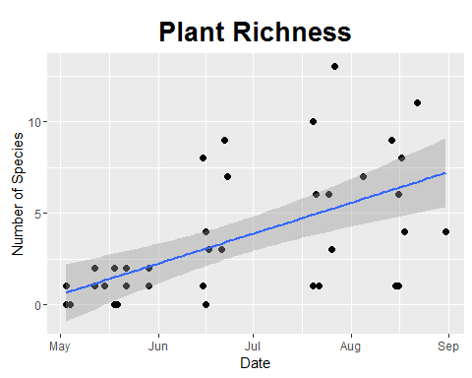

Color code the lines by site.

beesbysiteplotcolorline <- ggplot(simplebees, aes(x = Date, y = TotalBees, color = Site)) +   
 geom_point(shape = 19, size = 2) +  
 geom_line() +  
 ggtitle("Bee Abundance") +  
 theme(plot.title = element_text(size = 20, face = "bold", margin = margin(10, 0, 10, 0))) +  
 labs(x = "Date", y = "Number of Individuals")  
beesbysiteplotcolorline

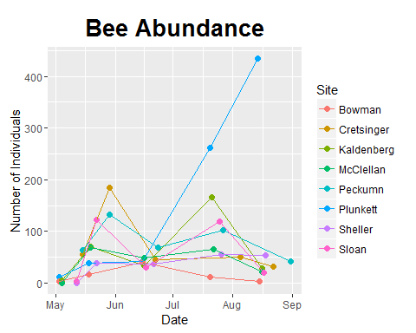

plantsbysiteplotcolorline <- ggplot(simpleplants, aes(x = Date, y = TotalPlants, color = Site)) +  
 geom_point(shape = 19, size = 2) +  
 geom_line() +  
 ggtitle("Plant Richness") +  
 theme(plot.title = element_text(size = 20, face = "bold", margin = margin(10, 0, 10, 0))) +  
 labs(x = "Date", y = "Number of Species")  
plantsbysiteplotcolorline

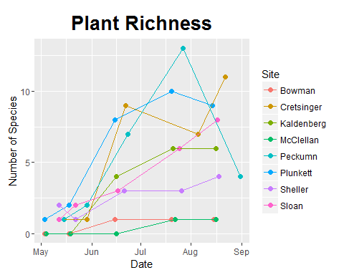

Plot bee abundance versus blooming forb richness by sample period.

TotalsByPeriodplot <- ggplot(TotalsByPeriod, aes(x = SPPlants, y = SPBees, color = (SamplePeriod))) +  
 geom_point(shape = 19, size = 3) +  
 geom_line() +  
 geom_abline() +  
 ggtitle("Bee Abundance vs. Flowering Plant Richness\nby Sample Period") +  
 labs(x = "Flowering Plant Species Richness", y = "Bee Abundance") +  
 theme(legend.title = element_text(color = "black", size = 12, face = NULL)) +   
 scale_color_discrete(name = "Sample Period", breaks = c("EarlyMay", "LateMay", "June", "July", "August")) +  
 theme_bw()  
TotalsByPeriodplot

