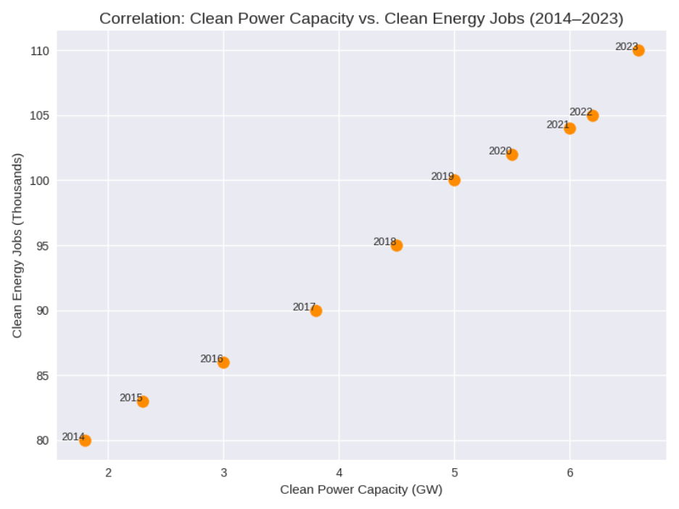This scatterplot shows the relationship between clean power capacity, in GW, and clean energy jobs, in thousands, in North Carolina from 2014 to 2023. Each point represents a single year, and from the upward pattern, it is very clear that with the rise in clean power capacity, jobs in clean energy rise almost proportionally. The points of earlier years-2014 through 2016-cluster near the lower-left with lower capacity and fewer jobs, while those from later years, 2020 through 2023, appear in the upper-right, reflecting both higher capacity and higher employment. Overall, this visual provides a strong positive correlation-that the more North Carolina invested in clean power, the more its clean energy jobs grew consistently.

