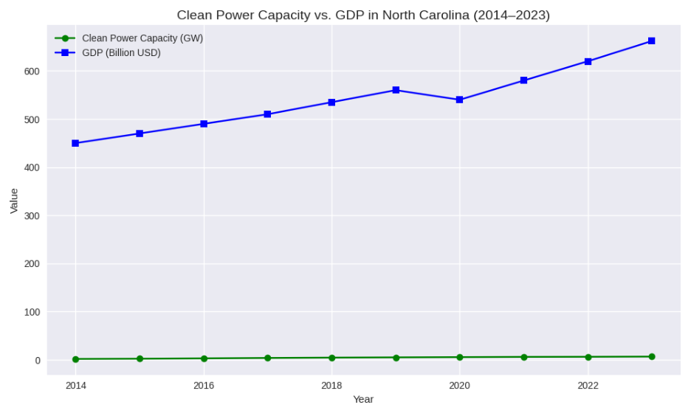
This line graph illustrates the growth in clean power capacity (measured in GW) alongside state GDP (in billions of USD) for North Carolina between 2014 and 2023. The green line, which starts just above 2 GW in 2014 and rises steadily to exceed 6 GW by 2023, depicts clean energy capacity at the lower portion of the chart. Simultaneously, the blue line shows GDP climbing from around $450 billion to more than $650 billion. Despite differences in scale, both lines consistently trend upward. This visualization demonstrates that as North Carolina increased its clean energy capacity, the state's economy also expanded, highlighting that clean power progress and economic growth occurred together during this timeframe.

