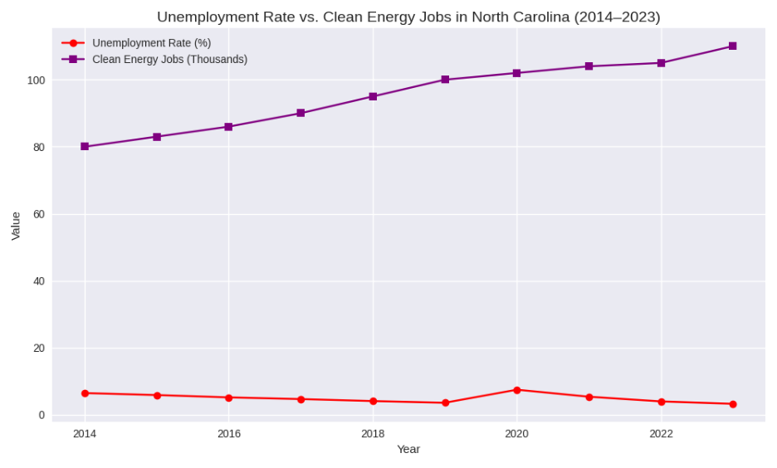
This chart compares North Carolinas unemployment rate (%) with clean energy Job levels from 2014 to 2023. The purple line shows the clean energy jobs rising steadily from around 80,000 to more than 110,000 across the last decade. On the other hand, the red line shows the unemployment rate declining over time apart from a temporary spike in 2020 due to COVID 19. The opposite movement of the two different lines, clean energy jobs increasing while unemployment decreases illustrate a clear negative relationship. This visual suggests that as clean energy employment has grown in North Carolina, overall unemployment tended to fall while supporting the idea that clean energy growth aligns with stronger labor market conditions.

