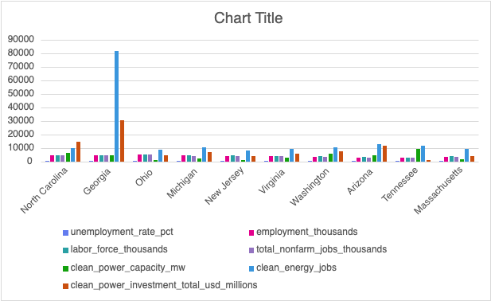

This graph compares ten states across key labor and clean energy metrics, including unemployment, total employment, labor force size, clean power capacity, clean energy jobs, and investment. It should be noted that the states with larger overall economies like North Carolina, Georgia, and Washington tend to have higher clean power capacity and more clean-energy jobs. Unemployment rates, on the other hand, remain quite similar across all states, starting from approximately 4.4% and peaking at 5.1%. In summary, this chart shows that it is the states with more labor and with more economic activity that invest most in clean energy; in itself, it does not create large differences in unemployment.

