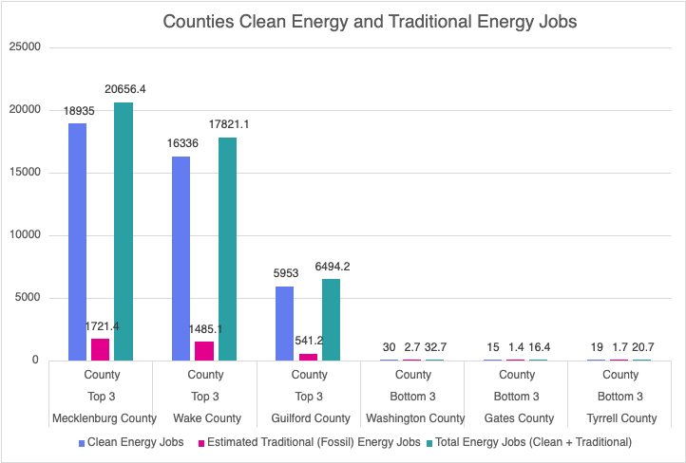
This chart compares clean energy and traditional fossil energy jobs across North Carolina's top three and bottom three counties. In every country, large or small, clean energy jobs overwhelmingly dominate, making up about 92% of all energy employment. For instance, Mecklenburg, Wake, and Guilford all show very high clean-energy jobs with only a small fraction coming from fossil jobs. Even in the lowest-employed counties (Washington, Gates, and Tyrrell), the same pattern holds. Overall, the visual indicates that clean energy is the primary source of employment statewide, regardless of the size of the county or total job levels.

