FETMS Beam Efficiency Calculator
User’s Manual

FEND-40.09.00.00-014-B-MAN
Version: B
Status: Draft
2016-01-27

Prepared By: | Organization | Date
Josh Crabtree  Morgan McLeod | NRAO  NRAO | 2010-02-17  2016-01-27
IPT Leader Approvals: | Organization | Date
System Engineering Approvals: | Organization | Date
Configuration Control Board Approval: | Organization | Date
JAO Director Release Authorization: | Organization | Date

Change Record

Version | Date | Affected Section(s) | Change Request # | Reason/Initiation/Remarks
A | 2010-01-12 | All | N/A | Initial
A | 2010-02-12 | 2.1, 7.1, Appendix A | N/A | Added reference documents. Updated output file format description. Added software version history table.
A | 2010-02-17 | 6.2, 8.6, Appendix A | N/A | Added information about handling two z distance scans.
B1 | 2015-12-15 | All  Renamed to ‘FEND-40.09.00.00-014-B-MAN’ | N/A | MMcLeod: updated for Beameff version 1.3.5 including new options for ACA 7 meter optics and band 1 test dewar.
B2 | 2016-01-27 | All | N/A | MMcLeod: updated for BeamEff 2.0

Table of Contents

1 Purpose 6
2 Related Documents and Explanatory Information 6
2.1 References 6
2.2 Abbreviations and Acronyms 6
3 Overview of the software 7
4 Requirements 7
5 Calling the Program 7
6 Input File 7
6.1 “Settings” section 8
6.2 Scan sections 8
7 Output File 11
7.1 [settings] section 11
7.2 [results_ssidX] section 11
7.3 Copol Scans 11
7.4 Cross Pol Scans 13
8 Plotting 14
8.1 Nearfield amplitude 14
8.2 Nearfield phase 14
8.3 Farfield amplitude 15
8.4 Farfield phase 15
8.5 Pointing Angles 16
8.6 Notes about Z2 listings 17
8.7 Troubleshooting and Advice 17
Appendix A Efficiency Calculations Memo from R. Hills 18
Appendix B Comparing results of automated vs. manual (Spreadsheet) methods 19

List of Figures

Figure 1 - Settings section of an input file 8
Figure 2 - Scan sections of an input file 10
Figure 3- Nearfield amplitude plots for a copol/crosspol pair 14
Figure 4- Nearfield phase plot 14
Figure 5- Farfield amplitude plots for a copol/crosspol pair 15
Figure 6- Farfield phase plot 16
Figure 7- Plot of pointing angles for a specific band 16
Figure 8- Comparison of results for manual (spreadsheet) vs. automated (Beam Efficiency Calculator program) 20

Purpose

This document provides a basic user manual for the Beam Efficiency Calculator application. Topics discussed include format of input and output files, and plots generated by the program.

Related Documents and Explanatory Information

References

The following documents contain additional information and may be referenced in this document.

Reference | Document Title | ALMA Doc. Number
[RD1] | ALMA Front End Optics Design Report Appendix 12 Design Changes since CDR | FEND-40.02.00.00-035-B-REP
[RD2] | ALMA MEMO #456- Characteristics of a Reflector Antenna :  Parameters, graphs and formulae for Cassegrain systems with Mathematica expressions for numerical computation | N/A
[RD3] | Calculation of Efficiencies, etc, from Beam-Scanning Data  Richard Hills 16th June 2008 revised 22nd June | N/A

Abbreviations and Acronyms

For a complete set of acronyms and abbreviations, please go to the ALMA Acronym Finder web page.

Overview of the software
This is a program written in the C language (versions 1.3.6 and before) and ported to C++ (versions 2.0 and after), which analyzes a series of beam scans and produces efficiency data and plots (via gnuplot) for the scans. The purpose is to reduce the amount of time it takes to get efficiency data and allow for automation of the processing of large numbers of beam scans. The only argument it requires is the file path of an input text file. The input file contains information about the scans to be analyzed, grouped into “scansets”. Each scanset consists of up to fiver scans (copol and crosspol for pol 0 and pol 1, plus an optional “copol180” scan to be used for source probe asymmetry correction) for a specific frequency, band number and tilt elevation angle. For each scan, a nearfield and farfield listing must be included. These files may be NSI formatted text files, comma, or tab delimited text files.

Efficiency data is calculated and plot images are created for each scan. The algorithms used to obtain efficiency values are discussed in [RD3]. While running, the console window will display progress messages. An output text file is created containing efficiency numbers and file paths for each plot image. This output file can then be used for automated report generation.

Requirements
To use this program, the following are required:
- Gnuplot (version 4.2.6 or higher in the 4.x series. Untested with 5.x.)
- Windows machine or Linux machine.
- Source code or executable copy of the software. The software is open-source and is available at https://github.com/morganmcleod/ALMA-FETMS-beameff

Calling the Program
The program may be called via command line. The only argument taken by the program is the file path of the input text file. The format of the input file is described below.

Input File
The input file is structured as a configuration ini file with sections and keys.

“Settings” section
This section must be called “[settings]”. The keys are as follows:
- gnuplot – This is the file path where the console mode gnuplot is located. The gnuplot executable is “pgnuplot.exe” on Windows. On Linux it is typically “/usr/bin/gnuplot”. The file path must be enclosed in double quotes. Backslashes or forward slashes may be used.
- outputdirectory – This is the location where all files created by the program will be stored. The file path must be enclosed in double quotes. Backslashes or forward slashes may be used.
- delimiter – This key defaults to the value “tab” meaning the tab character. Any other literal character may be specified. Typically it will either be “,” or “tab”.

- centers – The following four choices are supported in version 1.3.5, 1.3.6, and 2.x of the software. In earlier versions, only “nominal” and “actual are supported:
  - actual - If “actual” is specified, then the efficiency values will be calculated with respect to the calculated pointing angle (center of mass) of the beam.
  - nominal - If “nominal” is specified, then efficiencies will be calculated with respect to the nominal subreflector direction, which is based on the band number of the scan.
  - aca7meter - specifies that the nominal pointing angles and other constants for the ACA 7 meter antenna will be used.
  - band1test - specifies that the pointing angles for the band 1 test dewar shall be used. Only supported in version 1.3.5 or newer and only for band 1.

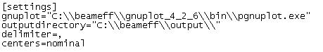
Figure 1 - Settings section of an input file

Scan sections
A section must be included for each scan to be analyzed. There is no naming convention for these sections, the only requirement is that each section name be unique. Typically they are named like “[scan_1]”, “[scan_2]”, etc. The keys are as follows:
- f – Frequency (GHz)
- band – Band number
- tilt – Tilt angle of the cartridge/cryostat in degrees.
- pol - Pol (may be 0 or 1)
- sb - 1=USB, 2=LSB. This is required for properly flipping the phase (rotating) USB scans.
- type – One of:
  - copol indicating a co-polar scan for the indicate pol.
  - xpol indicating a cross-polar scan.
  - copol180 indicating a co-polar scan taken with the probe rotated 180 degrees from one of the copol scans in the same scanset. To be used for source probe asymmetry correction.
  - dual indicating a scan taken 45 degrees between pol0 and pol1. Experimental.
- scanset – A scanset consists of up to five scans at a specific band, frequency and tilt angle. Each scan in a scanset must have the same scanset id number.
- nf – File path of the nearfield listing of the scan. Enclose in double quotes.
- ff – File path of the farfield listing of the scan. Enclose in double quotes.
- nf2 – (optional) File path of the Z2 nearfield listing of the scan. Enclose in double quotes (see section 8.6 for more information regarding two z distance scans).
- ff2 – (optional) File path of the Z2 farfield listing of the scan. Enclose in double quotes (see section 8.6 for more information regarding two z distance scans).
- datetime – Timestamp for the scan. The suggested format is “YYYY-MM-DD HH:MM:SS:ssss”. If NSI format text files are used, this value will be automatically extracted from the files.
- notes – Any notes for the scan. This key is optional.
- nf_startrow - This number represents the first row of data in the nearfield listing file. If the file being read is an NSI formatted nearfield listing, then the program will automatically determine the start row.
- ff_startrow - This number represents the first row of data in the farfield listing file. If the file being read is an NSI formatted farfield listing, then the program will automatically determine the start row.
- nf2_startrow - (optional) First row of data for a Z2 nearfield listing (see section 8.6 for more information regarding two z distance scans).
- ff2_startrow - (optional) First row of data for a Z2 farfield listing (see section 8.6 for more information regarding two z distance scans).
- ifatten – Amount of attenuation (dB). If there is no attenuation difference between a copol and xpol pair, then this value is not required. This number is a positive value.
- zdistance - The nominal probe distance in mm from the feed center at the time the scan was captured. This is used to initialize the phase fit search. If this value is not provided or if it is exactly zero then the previous default value of 260 will be assumed.
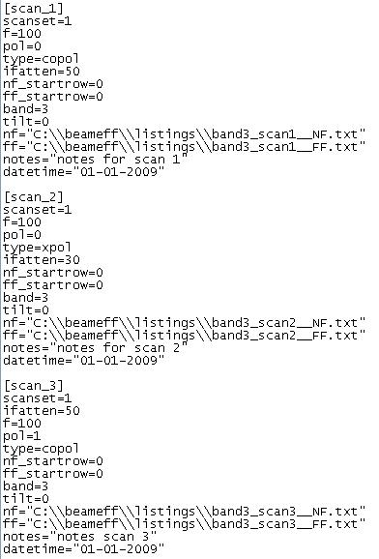
Figure 2 - Scan sections of an input file

Output File
The main output from the program is a text file (“output.txt”) stored in the output directory specified in the input file. The format is essentially a copy of the input file, with additional keys added to each section to represent efficiency values and image file locations. The names of the scan sections are the same as in the input file.

[settings] section
The following items are added to the [settings] section:
- software_version - the version of the BeamEff software which produced the output file.
- pointingangles - the filename of the pointing angles plot of the last-processed scanset. This is mainly for backwards compatibility. The plot filename is also included in the [results_ssidX] section described below.

[results_ssidX] section
This is new with version 2.0. It collects the results which are not specific to a single polarization. There will be one section for each scanset processed.
- pointingangles - the filename of the pointing angles plot.
- nominal_z_offset– Average delta_z value (mm) for the pol 0 and pol 1 scans in the scanset.
- squint_percent - Beam squint (% FPBW).
- squint_arcseconds - Beam squint (arcseconds).
- corrected_pol - which polarization was corrected (0 or 1). Value is -1 if no copol180 scan was provided for probe asymmetry correction. This will be the opposite polarization from the copol180 scan.
- x_corr - the amount of phase center correction in horizontal mm. 0 if no copol180 scan was provided.
- y_corr - the amount of phase center correction in vertical mm. 0 if no copol180 scan was provided.
- dist_between_centers_mm - the distance between the phase centers after correction (if any).

Copol Scans
A section for a copol scan contains all keys and values from the corresponding section of the input file, along with the following additional keys:
- ifatten_diff - the difference in IF attenuation between this copol scan and the corresponding xpol scan.
- eta_spillover – Spillover efficiency using the “alternative” definition from R. Hills paper, given in [RD3], that is the ratio of the co-polar power on the subreflector to the total co-polar power.
- eta_taper – Amplitude Taper Efficiency
- eta_illumination – Illumination Efficiency (eta_spillover • eta_taper)
- ff_xcenter – Calculated azimuth pointing angle of the farfield beam (center of mass).
- ff_ycenter – Calculated elevation pointing angle of the farfield beam (center of mass).
- nf_xcenter - Calculated horizontal center of mass for the nearfield beam.
- nf_ycenter - Calculated vertical center of mass for the nearfield beam.
- az_nominal – Nominal azimuth pointing angle for the farfield beam. This value is based on the band number of the scan and the centers option described in section 6.1.
- el_nominal – Nominal elevation pointing angle for the farfield beam. This value is based on the band number of the scan and the centers option described in section 6.1.
- max_nf_amp_db – Maximum amplitude (dB) or nearfield listing.
- max_ff_amp_db – Maximum amplitude (dB) or farfield listing.
- delta_x – Phase center offset value (mm) in the X direction.
- delta_y – Phase center offset value (mm) in the Y direction.
- delta_z – Phase center offset value (mm) in the Z direction.
- corrected_x - delta_x plus phase center correction for probe asymmetry, if any.
- corrected_y - delta_y plus phase center correction for probe asymmetry, if any.
- eta_phase – Phase efficiency value found using a minimization routine to find delta_x, delta_y and delta_z, starting with the delta_z initialized to zdistance described above in section 6.2
- ampfit_amp - figure which is maximized during the amplitude fit in [0...1].
- ampfit_width_deg – Width (degrees) of the Farfield beam at the -3 dB level.
- ampfit_u_off_deg– Amplitude offset (deg) in the horizontal direction.
- ampfit_v_off_deg– Amplitude offset (deg) in the vertical direction.
- ampfit_d_0_90– Ratio of beam diameters at 0 degrees and 90 degrees.
- ampfit_d_45_135– Ratio of beam diameters at 45 degrees and 135 degrees.
- plot_copol_nfamp– File path of nearfield amplitude plot image.
- plot_copol_nfphase– File path of nearfield phase plot image.
- plot_copol_ffamp– File path of farfield amplitude plot image.
- plot_copol_ffphase– File path of farfield phase plot image.

- eta_tot_np– Aperture efficiency if not accounting for effect of cross pol scan.
- eta_pol– Polarization efficiency using the “alternative” definition from R. Hills paper, given in [RD3], that is the ratio of total copol power to total copol+xpol power, NOT masked for the secondary.
- eta_tot_nd- Aperture efficiency if not accounting for defocus loss.
- defocus_efficiency– Defocus efficiency.
- total_aperture_eff– total aperture efficiency (=eta_phase x eta_spillover x eta_pol x eta_defocus)
- shift_from_focus_mm– Shift from focus (mm).
- subreflector_shift_mm– Subreflector shift (mm) required to achieve shift_from_focus_mm.
- defocus_efficiency - Defocus efficiency.
- edge_db- Edge taper (dB).

- defocus_efficiency_due_to_moving_the_subreflector- Defocus efficiency due to moving the subreflector to the best compromise position for pol 0 and pol 1.

Cross Pol Scans
A section for a crosspol scan contains all keys and values from the corresponding section of the input file, along with the following additional keys:
- max_ff_amp_db – Maximum amplitude (dB) or farfield listing.
- plot_xpol_nfamp– File path of nearfield amplitude plot image.
- plot_xpol_nfphase– File path of nearfield phase plot image.
- plot_xpol_ffamp– File path of farfield amplitude plot image.
- plot_xpol_ffphase– File path of farfield phase plot image.
- max_dbdifference- Amplitude difference (dB) between the corresponding copol scan and this crosspol scan, corrected for ifatten_diff.
- eta_spill_co_cross- Spillover efficiency of copol and crosspol scan (sum of copol and crosspol power on subreflector, divided by square sums of amplitude on subreflector). This is the TICRA formulation of eta_spill-over, also described in [RD3]
- eta_pol_on_secondary- Polarization efficiency on secondary (Ratio of copol power on secondary, to copol and crosspol power on secondary). This is the TICRA formulation of eta_polarization, also described in [RD3] and what should be compared to the ALMA polarization efficiency specification.
- eta_pol_spill- Product of eta_spill_co_cross and eta_pol_on_secondary.

Plotting
A set of plot images (png format) is created for each scan, and a plot of pointing angles is created for each band. The plots are described below.

Nearfield amplitude
Naming convention is band*_pol*_*pol_*ghz_nfamp_tilt*_scanset_*.png, where the asterisks represent band number, pol, type(“co” or “x”-pol), frequency, tilt angle and scanset, respectively. For a crosspol scan, the plot is normalized with respect to the amplitude difference (dB) between the copol and crosspol scans.

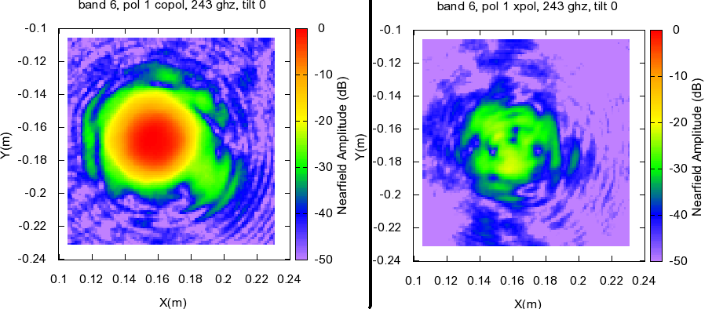
Figure 3- Nearfield amplitude plots for a copol/crosspol pair

Nearfield phase
Naming convention is band*_pol*_*pol_*ghz_nfphase_tilt*_scanset_*.png, where the asterisks represent band number, pol, type(“co” or “x”-pol), frequency, tilt angle and scanset, respectively.
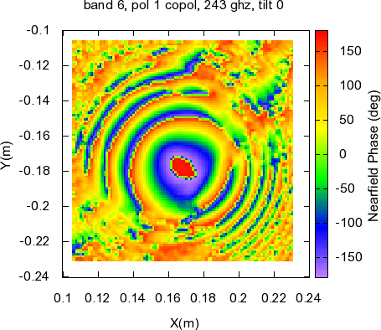
Figure 4- Nearfield phase plot

Farfield amplitude
Naming convention is band*_pol*_*pol_*ghz_ffamp_tilt*_scanset_*.png, where the asterisks represent band number, pol, type(“co” or “x”-pol), frequency, tilt angle and scanset, respectively. For a crosspol scan, the plot is normalized with respect to the amplitude difference (dB) between the copol and crosspol scans. A circle representing the subreflector is overlaid on the plot.

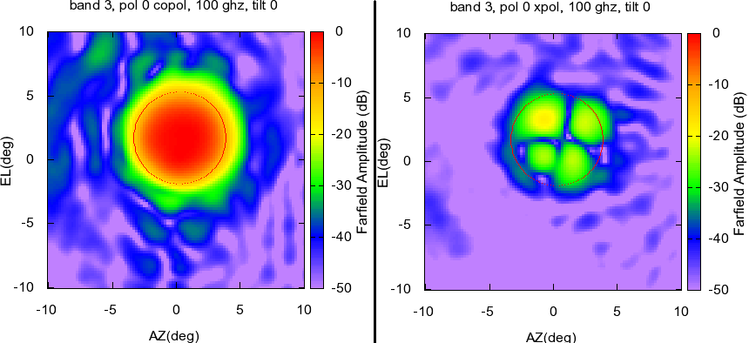
Figure 5- Farfield amplitude plots for a copol/crosspol pair

Farfield phase
Naming convention is band*_pol*_*pol_*ghz_ffphase_tilt*_scanset_*.png, where the asterisks represent band number, pol, type(“co” or “x”-pol), frequency, tilt angle and scanset, respectively. A circle representing the subreflector is overlaid on the plot.
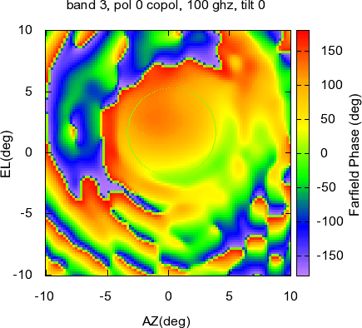
Figure 6- Farfield phase plot

Pointing Angles
Naming convention is band*_scanset*_pointingangles.png, where the asterisk represents band number.
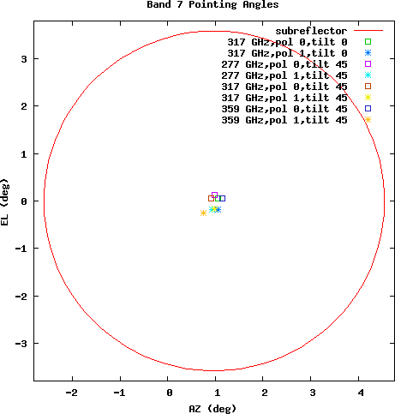
Figure 7- Plot of pointing angles for a specific band

Notes about Z2 listings
In some cases two scans will be performed which are identical, except that one of the scans is ¼ wavelength closer to the receiver than the other scan. The program will combine the two listings such that standing wave reflections are removed, using either z1+iz2 or z1-iz2 combination. The program will determine which combination is appropriate. It doesn’t matter whether the Z1 scan is ¼ wavelength closer to or farther away from the receiver than the Z2 scan. This feature is performed for each individual scan, so it is not necessary that all four scans in a scan set have two Z listings. All parameters other than Z distance must be identical for a Z1 scan and a corresponding Z2 scan.

Troubleshooting and Advice
- The software does not perform farfield transformations of nearfield listings. Therefore, the farfield listings must be created before using the program, and the user must determine FFT size, angular span and dimensions. Recommended values are FFT size 512, angular span of +/- 15 degrees, and dimension of at least 101x101 points.
- The nearfield and farfield listings must not be normalized.
- Make sure that the specified output directory exists. The program will crash otherwise (a future version of the software will create the directory if it doesn’t exist).
- It might be helpful to allow full control permissions to all users in the directory where the program is stored, though this shouldn’t be necessary.
- The nearfield and farfield listings may be in vertical or horizontal strips.
- A crosspol scan listing must contain the same number of data points as its corresponding copol listing. A future version of the software may not impose this requirement, if it is deemed necessary. What this means is that if a copol farfield listing contains 101x101 points, then its corresponding crosspol listing must also be 101x101 points.
- (removed for 2.0) Any output to the console window will be simultaneously written to a text file called “stdoutput.txt” in the same directory location as the program itself. This may be useful if the program is being used by a third party graphical interface application.

Efficiency Calculations Memo from R. Hills
The memo referenced as [RD3] was distributed by Richard Hills on 2008-06-16 and revised on 2008-06-22. The algorithms were implemented in a spreadsheet (also created by R. Hills). The phase-fitting and amplitude-fitting algorithms implemented in the Beam Efficiency calculator are based on “Conjugate Gradient Methods in Multidimensions” described in the book “Numerical Recipes in C” (Press et al., 2007).

[Text of memo removed. Please see Calculation_of_Efficiencies.pdf for the details.]

Comparing results of automated vs. manual (Spreadsheet) methods
Below is a table showing a side by side comparison of efficiency data obtained via the program described in this document, vs. using the R. Hills spreadsheet. For bands 3, 6 and 9, sets of scans were analyzed first using the spreadsheet. The same scans were then analyzed using the Beam Efficiency Calculator program, and the data is compared in the table below.

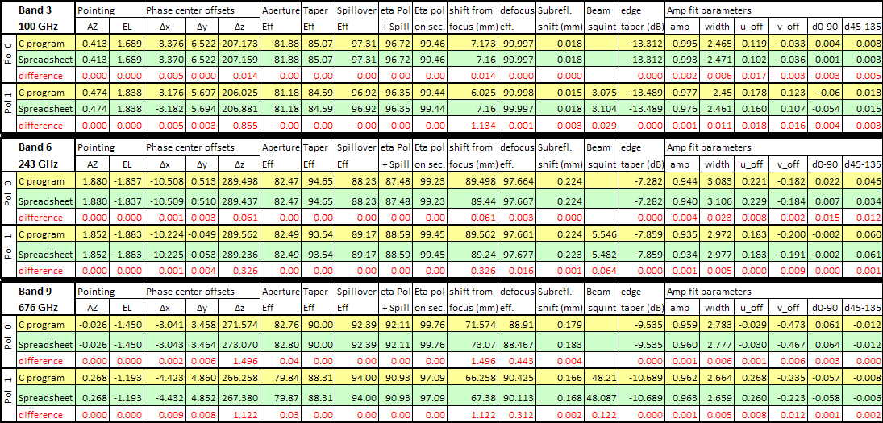
Figure 8- Comparison of results for manual (spreadsheet) vs. automated (Beam Efficiency Calculator program)

