Beam Efficiency Calculator LabView GUI
User Manual

FEND-40.09.00.00-015-B-MAN
Version: B
Status: Draft
2015-12-01

Prepared By: | Organization | Date
Josh Crabtree  Morgan McLeod | NRAO  NRAO | 2010-02-19  2015-12-01
IPT Leader Approvals: | Organization | Date
System Engineering Approvals: | Organization | Date
Configuration Control Board Approval: | Organization | Date
JAO Director Release Authorization: | Organization | Date

Change Record

Version | Date | Affected Section(s) | Change Request # | Reason/Initiation/Remarks
A | 2010-01-12 | All | N/A | Initial
A | 2010-02-17 | 5.1, 6.2, 8.2, 8.3, 8.4, 8.5 | N/A | Added information about two z distances, and included software version history table.
A | 2010-02-19 | 8.5 | N/A | Updated software version history table.
B01 | 2015-12-01 | 4, 5.1, removed 8.1  Renamed ‘FEND-40.09.00.00-015-B-MAN’ | N/A | Updated for version 1.1.0, LabVIEW 2013, Beameff version 1.3.5.

Table of Contents

1 Purpose 5
2 Related Documents and Explanatory Information 5
2.1 References 5
2.2 Abbreviations and Acronyms 5
3 Overview of the software 6
4 Requirements 6
5 Input File 6
5.1 Creating the Input File 7
5.2 Loading an input file 9
6 Getting Efficiencies and Plots 9
6.1 Setup 9
6.2 Calling the Beam Efficiency Calculator 10
7 Output 10
7.1 Efficiency Output File 10
7.2 Viewing Plots and Efficiency Data 11
7.3 Loading an Efficiency output file 11
8 Generating Reports 11
8.1 HTML Report 11
8.2 Word Format Report 11
8.3 Notes about Z2 listings 11
8.4 Troubleshooting and Advice 11
8.5 Software Version History 12

List of Figures

Figure 2- Loading an input file in the Main panel 8
Figure 3- File paths for input file and C executable 8
Figure 4- Get Efficiencies 9
Figure 5- Command String window 9
Figure 6- Selecting and Loading an Efficiency Output File 9

Purpose

This document provides a basic user manual for the LabView Graphical user Interface application for interacting with the Beam Efficiency Calculator application.

Related Documents and Explanatory Information

References

The following documents contain additional information and may be referenced in this document.

Reference | Document Title | ALMA Doc. Number
[RD1] | Beam Efficiency Calculator User Manual | ALMA-40-09-00-00-014-A-MAN

Abbreviations and Acronyms

ALMA Atacama Large Millimeter Array
CSV Comma Separated Values
NSI Nearfield Systems, Inc.

Overview of the software
This is a LabView application which acts as an interface to the Beam Efficiency Calculator program described in [RD1]. The interface allows for easy creation of (or loading of previously created) input files. After beam efficiencies have been calculated and plots produced, the data and images may be viewed and exported into reports.

Requirements
To use this program, the following are required:
- Gnuplot (version 4.2.6 or higher in the 4.x series. Untested with the 5.x series.)
- Windows 7 machine
- .
- Software is available in compiled binaries as well as LabVIEW 2013 source code at https://github.com/morganmcleod/ALMA-FETMS-beameff This is open source software. Version information is tracked on the GitHub site.

Input File
The Beam Efficiency Calculator program requires an input file structured as a configuration ini file with sections and keys. The format of this file is discussed in [RD1]. The LabView GUI allows for assistance in creating that file. Previously created files may be loaded and used as well.

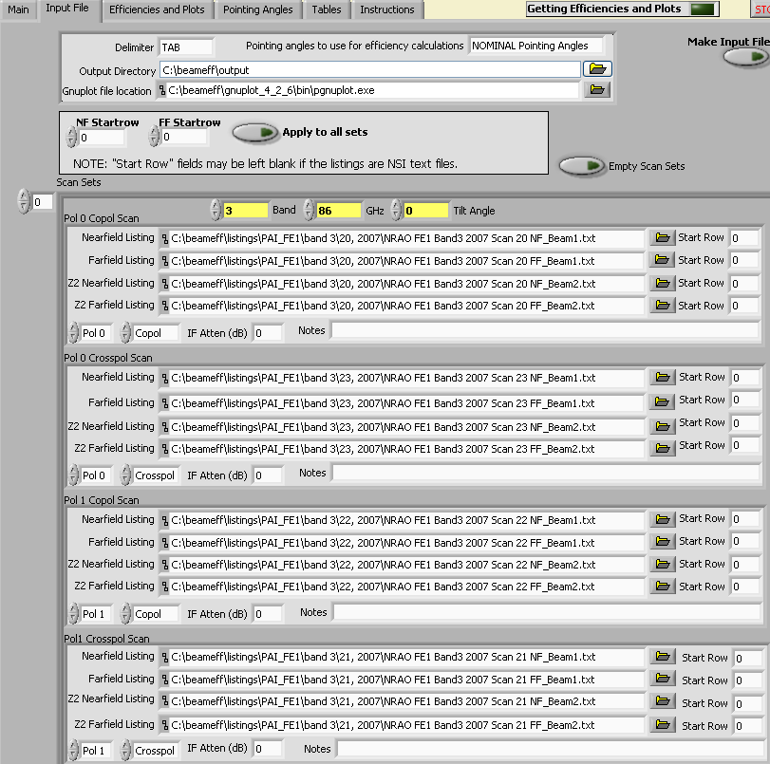
Figure 1- Input file creation panel

Creating the Input File
The “Input File” tab contains controls for modifying the various settings and contents of an input file. The controls are described below.

- Delimiter (TAB or COMMA)- Delimiter to be used for all nearfield and farfield listings.
- Pointing Angles to use for efficiency calculations (NOMINAL, ACTUAL, ACA 7 Meter, and Band1 Test) - See [RD1] for descriptions of these options.
- Output Directory- Directory to be used for all output from the program (output efficiency file and plot images).

- Gnuplot file location- file path of gnuplot executable (pgnuplot.exe).
- Startrow- Number representing first row of data in the corresponding nearfield or farfield listing. The first row is 1.
- NF Startrow- First row of data for all nearfield listings.
- FF Startrow- First row of data for all farfield listings.
- Apply to all sets- This applies the chosen NF Startrow and FF Startrow values to all scans being analyzed.
- Scan Sets- This is an array of scan sets. For each scan set, band, frequency and tilt angle must be specified. For each individual scan, pol, type (copol or crosspol), IF attenuation (dB), start rows and file paths of listings must be specified.
- Empty Scan Sets- Empties the array of scan sets.
- Band- Band number for the four scans comprising a scan set.
- GHz- Frequency for the four scans comprising a scan set.
- Tilt Angle- Tilt Angle for the four scans comprising a scan set.
- GHz- Frequency for the four scans comprising a scan set.
- Nearfield Listing- File path for the nearfield listing of a scan.
- Farfield Listing- File path for the farfield listing of a scan.
- Z2 Nearfield Listing- (Optional) File path for the Z2 distance nearfield listing of a scan. The program will combine the two listings to remove standing wave reflections. See section 8.3 for more information about this feature.
- Z2 Farfield Listing- (Optional) File path for the Z2 distance farfield listing of a scan.
- Pol 0/ Pol 1- Selector to indicate pol value of a scan.
- Copol/Crosspol- Selector to indicate scan type.
- IF Atten (dB)- Amount of IF attenuation used for scan.
- Notes- Notes for scan.
- Make Input File- Creates an input text file containing the values and settings selected in the Input File panel. The name of the input file is automatically created, and the naming convention is MM_DD_YYYY__HH_MM AM_INPUT.txt. (Note- “AM” or “PM” are used before “INPUT”). The path of the newly created file will be the value of the “Input File” field in the Main panel.

Loading an input file
A previously created input file may be loaded from the Main panel. Upon selecting an input file using the browser tab, the contents will be read and used to populate the controls in the Input File panel. Every time the program is opened, the input file value will be what it was when the program was previously used. However, when the program is initially started, the input file contents won’t be displayed automatically in the Input File panel. This is not required for the efficiency program to operate, but it might be useful to the user to inspect the input file contents. Pressing the “Load Input File” button will populate the controls on the Input File panel.

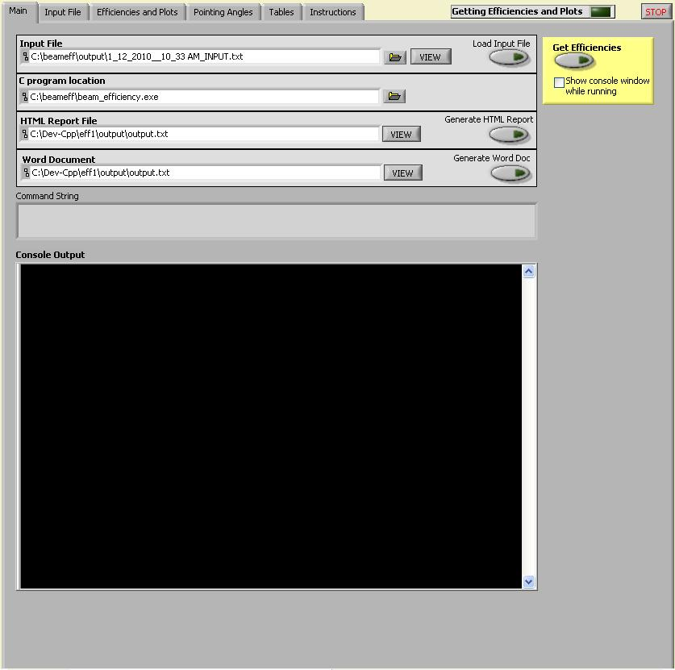
Figure 2- Loading an input file in the Main panel

Getting Efficiencies and Plots

Setup
Before calling the beam efficiency calculator, two things must be done:
- Specify an Input File
- Specify file path of Beam Efficiency Calculator (“beam_efficiency.exe”)
Figure 3- File paths for input file and C executable

Calling the Beam Efficiency Calculator
Figure 4- Get Efficiencies
- Check “Show console window while running” if desired. If checked, a console window will pop up and display progress messages. These messages should also be displayed in the “Console Output” box in the Main panel. This option may be useful for troubleshooting.
- Get Efficiencies- Once this button is pressed, the Beam Efficiency Calculator program will read in the input file, calculate efficiency data, and produce plots. The time for processing a set of scans is about eight seconds (or two seconds per scan).
- Command String- By pressing the “Get Efficiencies” button, the user is actually performing a command line operation. The command is displayed in this window.
Figure 5- Command String window

Output

Efficiency Output File
The main output of the Beam Efficiency Calculator is a text file called “output.txt”, stored in the output directory specified in the input file. The format of this file is discussed in [RD1]. It is essentially a copy of the input file, with additional key values for efficiency data and plot image file paths. The path for this file is shown in the “Efficiencies and Plots” panel.

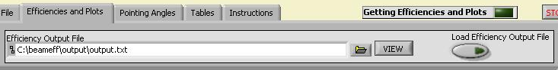
Figure 6- Selecting and Loading an Efficiency Output File

Viewing Plots and Efficiency Data
After the efficiencies have been calculated, the plots and data are viewable “Efficiencies and Plots”, “Pointing Angles”, and “Tables” panels. This may be useful to examine before generating a report, to make sure there aren’t any problems.

Loading an Efficiency output file
Previously created efficiency output files may be loaded using the “Load Efficiency Output File” button. Once loaded, the plots and data may be viewed as well.

Generating Reports

HTML Report
After efficiencies have been calculated (or after a previously created efficiency output file has been loaded), an HTML report may be created by pressing the “Generate HTML Report” button on the Main panel. The report will display tables of efficiency data as well as plots for the scans. The source code for this application is open source, so the user is free to modify the format of this report as desired.

Word Format Report
After pressing the “Generate Word Doc” button, a Word document will be created. The document contains tables and plots, similar to the HTML report format. The source code for this application is open source, so the user is free to modify the format of this report as desired.

Notes about Z2 listings
In some cases two scans will be performed which are identical, except that one of the scans is ¼ wavelength closer to the receiver than the other scan. The program will combine the two listings such that standing wave reflections are removed, using either z1+iz2 or z1-iz2 combination. The program will determine which combination is appropriate. It doesn’t matter whether the Z1 scan is ¼ wavelength closer to or farther away from the receiver than the Z2 scan. This feature is performed for each individual scan, so it is not necessary that all four scans in a scan set have two Z listings. All parameters other than Z distance must be identical for a Z1 scan and a corresponding Z2 scan.

Troubleshooting and Advice

- The nearfield and farfield listings must not be normalized.
- Make sure that the specified output directory exists. The program will crash otherwise (a future version of the software will create the directory if it doesn’t exist).
- It might be helpful to allow full control permissions to all users in the directory where the program is stored, though this shouldn’t be necessary.
- The nearfield and farfield listings may be in vertical or horizontal strips.
- It is not necessary to modify listings for scans, based on which sideband is being looked at. The program will automatically determine if the listing should be modified based on where the beam is pointing relative to the nominal angle for the band. If necessary, the listing values will be modified inside the program, though the actual listing files will not be altered.
- A crosspol scan listing must contain the same number of data points as its corresponding copol listing. A future version of the software may not impose this requirement, if it is deemed necessary.

