Transunion Credit Report Cheat Sheet
Updated 2025

Top Report Details
- Report ID / Search ID / Ordered By: Internal tracking for your files.
- Order & Completion Dates: When the report was run and finalized.
- Name Screened / SSN Match: Confirms the identity is an exact SSN match — this is good and required for accuracy.
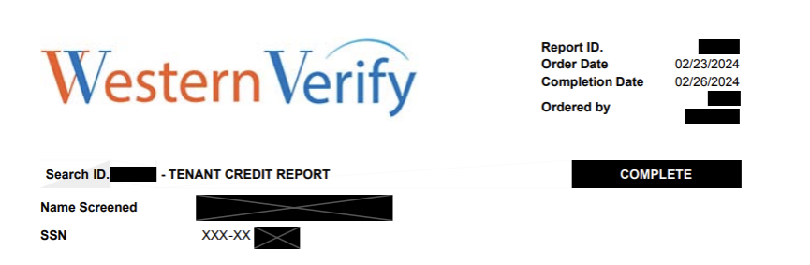

Personal Information
Includes:
- Full Legal Name
- Aliases (AKA)
- SSN (last 4 digits)
- Date of Birth
- Address History
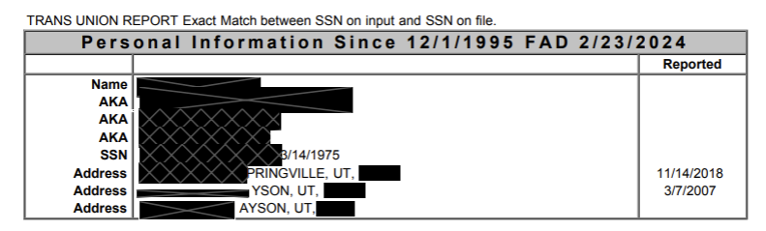
🔸 Good Signs:
- Consistent addresses and names.
- No discrepancies in SSN or DOB.
🔸 Red Flags:
- Lots of different names or addresses in short timeframes — may indicate instability or identity misuse.
- Old addresses linked to collections or fraud cases.

Score Summary
- Score Model: VANTAGESCORE 4.0
- Score: (typically ranges 300–850)
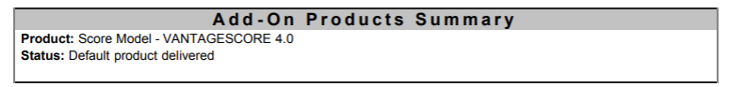
VantageScore 4.0 Credit Score Ranges:
Excellent: 781 to 850
Good: 661 to 780
Fair: 601 to 660
Poor: 500 to 600
Very Poor: 300 to 499

Score Factors (reasons this score is low):
- E.g., "No open accounts," "Unpaid collections" — each one hurts the score. These help you understand why the score is what it is.
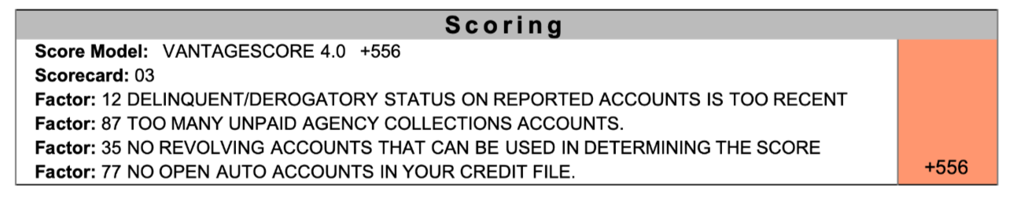
🔹 Collection Accounts
These are unpaid debts that went to collections. Each line shows:
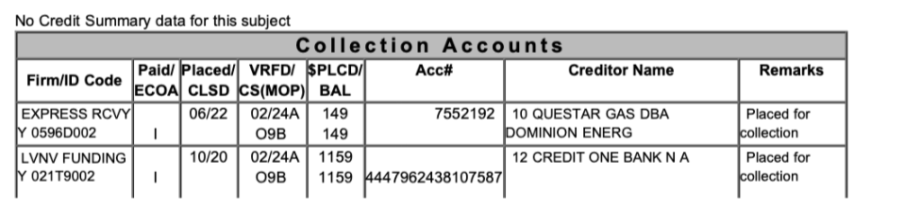
Credit Account Headings Explained:
DLA
→ Date of Last Activity
The last date there was any activity on the account, such as a payment or charge.
ECOA
→ Equal Credit Opportunity Act Code
Indicates the type of relationship the consumer has with the account:
I = Individual
J = Joint
A = Authorized user
M = Maker (cosigner)
T = Terminated
U = Undesignated
S = Shared
Opened
→ Date Account Opened
When the account was originally opened.
Clsd/PD
→ Closed / Paid Date
- The date the account was closed or paid off.
High
→ High Credit
- The highest balance ever owed on the account.
Limit
→ Credit Limit
The maximum amount of credit extended to the borrower.
Pmt
→ Payment Amount
- Typically the scheduled monthly payment.
Term
→ Term of Loan
- Loan term, often in months (e.g., 60 months = 5 years).
$Bal
→ Balance
- The current outstanding balance on the account.
$Past Due
→ Past Due Amount
- The portion of the balance that is overdue.
Date
→ Date Reported
- The date the account information was last reported to the bureau.
Mths
→ Months Reviewed
- Number of months of payment history included in the report.
30 / 60 / 90
→ Late Payments
- Number of times the account was 30, 60, or 90+ days late.
Rating
→ Account Status / Payment Rating
Status of the account, such as:
1 = Pays as agreed
2 = 30 days late
3 = 60 days late
4 = 90 days late
5 = 120+ days late
7 = Wage earner plan
8 = Repossession
9 = Charge-off

Field Description
Creditor Name Who is owed (e.g., T-Mobile, Esurance)
Balance Amount still owed
Date Placed When the account went into collections
Remarks Disputes, payment plans, charge-offs

🔸 Good Signs:
- No collection accounts.
- Paid or settled collections with $0 balance.
🔸 Red Flags:
- Multiple unpaid collections.
- Recent collection activity (in last 1-2 years).
- Disputes listed (means applicant is contesting debt).

🔹 Revolving/Installment Accounts (Credit Cards)
Shows credit card activity and payment history.
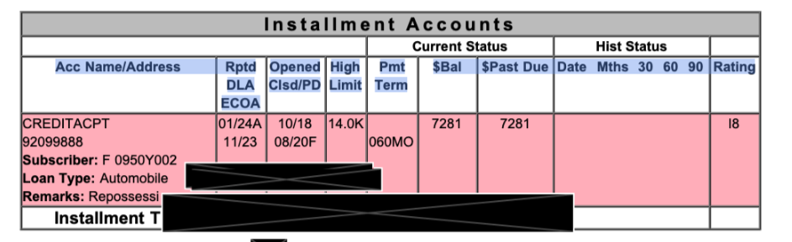
Key Fields:
- Acc Name/Loan Type: Creditor and card type
- Status: I (Individual), R9 (charged off), etc.
- High Limit / Balance: Shows usage
- Past Due: Indicates missed payments
- Rating (R9, R1, etc.): R1 = good, R9 = bad

🔸 Good Signs:
- Low balances, R1 or R2 ratings
- Open accounts in good standing

🔸 Red Flags:
- R9 = seriously delinquent or charged off
- High utilization (balance close to or over limit)
- “Closed by credit grantor” = may indicate risk

🔹 Inquiries
- Who has accessed the report recently.
Date / Name: Who pulled it (e.g., Utah Community)
Type:
- I: Individual or soft pull
- H: Hard inquiry (impacts credit)

🔸 Good Signs:
- Few inquiries
Mostly soft pulls (e.g., for tenant screening)

🔸 Red Flags:

- Multiple hard inquiries in short time = credit seeking behavior
Explanation of Each Column:
1. Date
This is the date the inquiry was made: March 12, 2025.
2. Name/Address
UTAH COMMUNI Q
The name of the creditor or business that pulled the credit report. This could be short for Utah Community Credit Union or a similar lender.
3. Code
UT02400030
4. MKT (Market Type)
MWB
This code refers to the industry type or market classification of the inquirer.
MWB often means Mortgage, Bank, or Financial Institution. It helps indicate what type of company made the request
5. Type
This represents the type of inquiry:
I = Individual (hard inquiry – initiated by you, usually affects your credit score)

Other possible values:
A = Account Review
P = Prescreen
X = Employment
C = Collection
6. Inq/Loan Amount
(Blank in this example)

Sometimes this shows an estimated amount of the loan or credit product being applied for (like a $25,000 auto loan).
If blank, the lender may not have provided that info or it's not required for the type of inquiry.
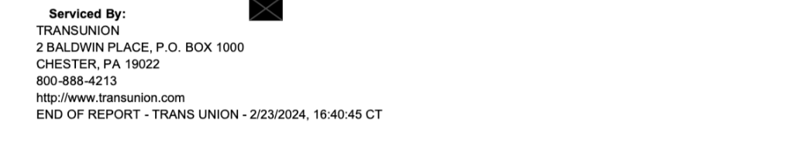
Servicer Info
Just shows TransUnion’s contact details — not relevant to applicant screening.

