Important result summary

2020-10-11 Game board representation: int vs array
Using reconciliation of Kaggle training data, run src/data/tests/compare_representations.py. Observed integer representation uses twice time of array representation:
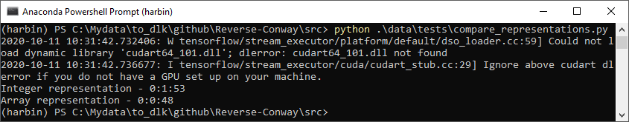
The computer used is

For reference, the result of Conway game solver using integer representation is given in directory Reverse-Conway\ref\outputs\20201011_ga_int_rep.

See Reverse-Conway\ref\outputs\20201012_int_vs_arr for an output of comparison.

2020-10-12 Game board representation: array of int vs array of bool
Use the following code to see which is more efficient: array of integer or array of Boolean.
import numpy as np
import time

import numpy as np
import time

def timing(msg):
global prev_t
t = time.time()
det = t - prev_t
prev_t = t
print('{} - {}'.format(msg, det))

def do_int_rep():
for j in range(tot_len):
(x, y, z, u) = tuple(space_int[4*j: 4*j+4])
1 - (x * (y * ((z + u) %2)))
timing('Int array rep ')

def do_boo_rep():
for j in range(tot_len):
(x, y, z, u) = tuple(space_boo[4*j: 4*j+4])
np.logical_not(np.logical_and(x, np.logical_and(y, np.logical_xor(z, u))))
timing('Bool array rep ')

def do_boo_rep_2():
for j in range(tot_len):
(x, y, z, u) = tuple(space_boo_2[4*j: 4*j+4])
np.logical_not(np.logical_and(x, np.logical_and(y, np.logical_xor(z, u))))
timing('Bool slim array rep')

prev_t = time.time()
tot_len = 200000
space_int = np.random.randint(0,2,size=(tot_len*4, 25, 25, 1))
space_boo = space_int.astype(bool)
space_boo_2 = space_boo.reshape((tot_len*4, 25, 25))
timing('Prepared')

do_int_rep()
do_boo_rep()
do_boo_rep_2()

It shows array of Boolean is more efficient. And removing the superfluous last 1D does not help much.
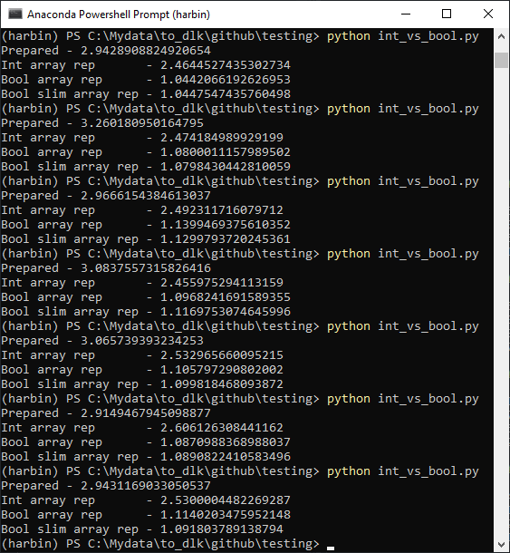
2020-10-17 Supervised CNN and mixed deltas
Experience shows the test case of the first 1000 board games in Kaggle test file is a fairly stable approximation of the total 50K games. Today various tests were performed using supervised CNN and different deltas. The code used is branch mixed_cnn at https://github.com/morgannewellsun/Reverse-Conway/tree/mixed_cnn. The results show no improvement against the simple initial baseline CNN. So it is not checked into the master branch. The key source code files are
- single.py: The main driver code
- components/cnnman.py: Difference CNN approaches (supervised / unsupervised / one short for delta=5 / 5 steps of delta 1 each / etc.) are managed here.
- components/reversega.py: GA implementation with CNN handling stripped out. Variable “stepwise” controls if multi-step of delta=1 should also be used.
- data/revconwayreport.py: report format changes.
The summary results are in folders Reverse-Conway\ref\outputs\20201017*. The main drawback of these approaches is the time spent on extra CNN predictions, which take quite some time.
- 20201017_all_mixed: GA initial population is divided equally into 4 pieces as the combination of supervised / unsupervised and direct delta (so delta>1 is done in one CNN revert) and stepwise delta (so delta>1 is done by multi-step of 1-delta CNN). This is so time consuming to run.
- 20201017_sup_unsup: GA initial population is divided equally into 2 pieces of supervised and unsupervised CNN models.
- 20201017_unsup_direct: Unsupervised direct delta. For benchmark.

Also, a complete run using supervised CNN is give in 20201016_complete_supervised_cnn. Comparing with 20201013_complete_ga, we see the total time is similar, about 1 hour and 20+ minutes. But supervised version performance is much worse.

2020-10-18 Explore along unsupervised CNN
With the above understanding, we continue along unsupervised CNN (using Reverse-Conway/pretrained_models/initial_baseline_delta_*).

First we observe the current implementation of GA does not remove duplicated entries in the population. A game board is represented by a numpy array, which is unhashable. In 20201017_hash, we hash a board using a 0/1 string. It has the code there. But the run time is significantly longer. And the dupes removed are not so many (see “trims” column in output/details.txt). So we should continue allowing duplication in a population.

Second, we try different stopping time. Earlier variable ga_max_iters controls how many iterations. Now we added ga_max_stales=2. Each iteration, we compute the best and the worst errors in the population. If after 2 iterations, there are no improvements in both errors, the GA iteration will stop. With this, we can use more population. The complete run is 20201018_pop100. We see improvements.

2020-11-26 Use Morgan’s crossfade model
The improvement is significant for delta=1.
Now we move development code repo to Kaggle’s notebook repository.

