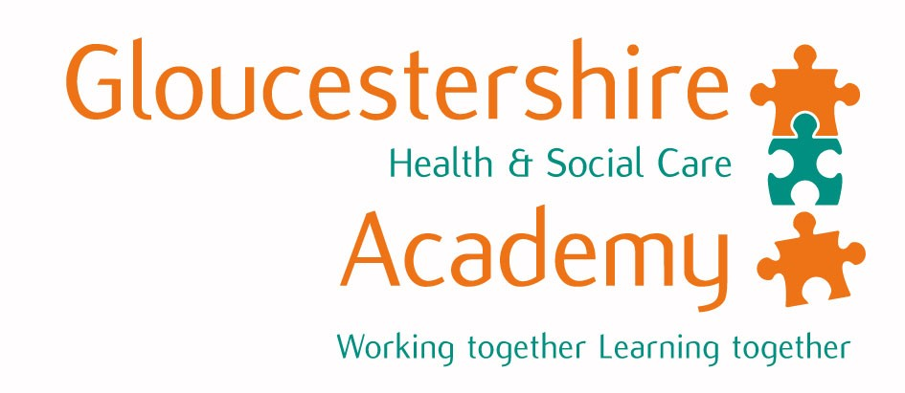

… at the …

Number 99
Monthly news
1st February 2012

Dr Simon Ackroyd, Consultant Paediatrician writes:-

I have been asked to reflect on my experience of the changes I have witnessed in education. Since starting out 46 years ago the curriculum has undoubtedly changed dramatically. Other aspects of the style of education have changed, sometimes less obviously.

First experience

In ‘pre-clinical’ there was no contact or discussion about patients and the closest that any of us got to a patient was the Post-Morten room, which we could freely attend and hear entertaining, if somewhat garrulous, discussions of what patients had wrong with them. Keith Simpson, a renowned Forensic Pathologist, was immensely popular for both his lectures, which were highly entertaining, as well as his post-mortem performances, which were really an act of theatre. However we did see a lot and there was no doubt that exposure to post-mortem evidence, along with pathology teaching, was immensely valuable and perhaps is rather neglected now.

Ward Rounds

I overlapped the era of very autocratic Consultants talking down to everyone and the newer, more communicative Consultants. However there were the older Consultants who did not change! This was sometimes quite entertaining and I remember one particular occurrence when the Queen’s Physician decided to do a sigmoidoscopy in front of the students and, in the process, entangled his rather expensive tie with the sigmoidoscope. A demand for “Scissors Sister” led to the loss of said tie and general entertainment and hilarity, although of course you could not show that!

Bedside Teaching

This was considered the priority. Hence a lot of time was spent standing in groups around unfortunate patients whilst their diagnosis and clinical signs were discussed and dissected quite openly. Little thought was given to the misinformation they may have been picking up in the process.

Communication Skills

The only communications teaching I had was from a Microbiologist about whether to tell patients what was wrong with them. He described the case of a young man with leukaemia. On being told the diagnosis he drove out in his sports car up the motorway and killed himself. On the strength of that the best advice is to never tell patients what is wrong with them! No further discussion and no further training. Certainly no role play – thank goodness.

Since then things on the ward front have, I feel, been fairly static. The curriculum has changed hugely, with obvious emphasis on communication skills and breaking bad news. All of that has been a good move forwards, although at times it is rather over-emphasised to the detriment of learning anything about medicine.

The emphasis on round-the-bed teaching continues, though in a more considerate fashion with patients not being upset. Essential information is discussed around the bed but subsequent discussions are carried out elsewhere.

Computers – of course the most dramatic change in the last 40 years has been computers. This has affected teaching, moving from blackboards to overhead acetate sheets to computers and DVDs. The ability to put together a lot of information and make it available to a lot of people at the same time has, I think, transformed teaching. It makes it much easier to communicate.

Students in Cheltenham used to attend from Bristol and other Universities, particularly London, for two or three weeks at a time. In Paediatrics we would have them here for a few weeks and then they would go back to the more formal training within their training base. This was very enjoyable from the point of view of teaching and most students enjoyed it a lot. However the more recent change to the Academy setting has, I think, been a great advantage on all sides.

Having regular groups of students for whom we are responsible to train gives departments a sense

of ownership of the training programme and also an opportunity to really ensure a really good attachment for students.

In Paediatrics we have been doing this now for about seven or eight years. Four blocks of seven weeks gives good access without taking over the whole year’s timetable and so there is plenty of room for catch up of other commitments.

Work load is shared across the department so that all Consultants will potentially be involved at times with teaching, with formal tutorials and workshops, around the bed and in outpatient clinics.

The involvement of Registrars and SHOs is difficult in the formal setting because of the shift system of working but with acute work it is a good opportunity for them to take part in teaching and experience that.

The increasing emphasis on self-directed learning has its advantages but it also has its disadvantages. It is much easier as a student to get to grips with a subject initially from a good discussion or tutorial and then to read about it than it is to sometimes read a clinical work, which they are not familiar with at all and which does not always make sense. Linking clinical teaching to patients, and individual patients, helps and I think the emphasis on that is considerably stronger now than it has been in the past.

The Future

I envisage that the Academy will continue as it is but develop, possibly getting larger. The idea of sharing out students around different hospitals is an excellent one and I think that for DGHs it provides a very good involvement with teaching and a stimulus to the Department. Hopefully that will continue.

Gloucestershire Academy website:
http://www.gloucestershireacademy.nhs.uk/bristol_st/index.htm

