
1st June 2012
Number 103
Monthly News
University of Bristol at Gloucestershire Academy

Developments in the pastoral care and nurture of medical students, University of Bristol.
Greetings from Senate House, University of Bristol. Thank you for giving me this opportunity to contribute to the newsletter of the Gloucestershire Academy.
I was appointed Director of Student Affairs (Clinical Dean) this time last year and began in August. My aim is to enable students to develop to their full potential, within the “landing lights” of GMC expectations (Medical students: professional values and fitness to practice. GMC March 2009) and the Faculty of Medicine’s regulations. I manage the provision of academic and pastoral advice to students. I have a clinical background in surgery, neurosurgery and Emergency Medicine (until December 2010 Consultant at the BRI), and now Palliative Care. I am “re-training”, working as a staff grade in Dorothy House Hospice. I have a long and deep interest in the welfare, progress and professional development of “tomorrow’s doctors”.
There are unique and changing challenges that we all face, both in our delivery and our students’ reception of medical training, particularly in today’s target driven NHS. The stress in the clinical arena is increasing. The NHS changes are causing uncertainty. There is risk of fragmentation. Our professional identity as doctors seems constantly threatened. It is hard sometimes to find and show others the “joy of medicine”. This must all seem confusing to students trying to navigate their way in these “choppy waters”. The medical curriculum is one of the busiest and most demanding in the University. The combination of academic learning and clinical exposure presents an unusual experience. Students can feel vulnerable, and they are expected to make major career decisions much earlier, with less exposure and time for reflection.
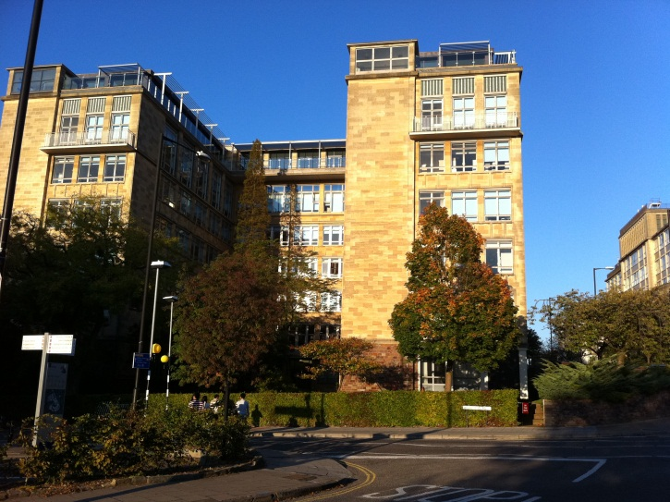
In response to this I set out on a new era, working with Peter Fletcher, Academy Dean and Chair of MEC, and others. This coincided with the move to Senate House. (see left)
This brought together all administrative staff of the Medical Faculty. We are working to strengthen the unity of the medical school and its 7 Clinical Academies. We have set up new lines of communication with our students with quicker response times. My office seeks to co-ordinate the various levels of support including:

- General pastoral care (including difficulties meeting the course requirements, as well as financial, housing, family and social issues): Ros and Emma, the Faculty Student Advisors, and the Year coordinators
- Development in the preclinical years (Year 1 & 2, 2 in 1 graduates): Dr Eugene Lloyd.
- Graduate Student Tutor: Dr Nicki Cohen
- Development during clinical placements (Years 3-5): On behalf of the Faculty, the Academy Deans and their staff care for clinical students whilst they are under their supervision.
- Professional and academic development: Academic Mentors.
I have 3 areas of interest. I am keen to encourage the professionalism and career thinking of our students. I also want to help their progress at the transition points, notably from Year 2 to 3, and then from Final Year to Foundation Doctor. I also want to ensure that students receive skills training in the modern clinical setting, where the drive to meet targets and lack of staff can limit effective teaching. These interests led to 3 initiatives: the Academic Mentor Scheme, the Undergraduate Medical e-Portfolio and the CAPS skills log book.
The Academic Mentor is a new level of support, focusing on our students’ professional development (and academic milestones) and career thinking. The aim is that every student will have a Mentor who will stay with them throughout the 5-6 years of their undergraduate training. They will meet a minimum of twice a year. Although not primarily pastoral (because there is already in place a pastoral team, and such care can be time consuming) the Mentors will identify and refer students as needed. So far all students in Years 1 and 2 have Mentors and have met. We plan to mentor the present Year 3 from September, as they start year 4, and then the new intake in February 2013. By February 2014 every student will be supported in this way.
Every student has been enrolled on an Undergraduate Medical e-Portfolio (UMeP). This is a prototype, produced by NHSe Scotland, who design and manage the Foundation and other professional e-portfolios. The prime drive for this was to train our undergraduates to use the e-portfolio before they start as F1s. They will thus be familiar with the way of thinking needed, the importance of structured reflection and the recording of skills and other assignments. This will help that transition. The UMeP is also the foundation of their relationship with the Mentor. At undergraduate level the student is expected to write and maintain their UMeP, record their exam achievements, and write a structured career reflection before each mentor meeting. This meeting is also recorded.
In Tomorrow’s Doctors 2009 the GMC list the 32 cores skills expected of a foundation doctor. These form the basis for the CAPS log book, the prime log book for the Consultation and Practical Skills (CAPS) vertical theme. Students will have this with them on all clinical placements to record their skills training incrementally. Written and cross-referenced, it sets out a minimum experience expected for each skill. Once achieved the student signs to say they are competent. The UMeP will have a facility to record these. The student is expected to keep their UMeP up to date, and so learn the need for regular maintenance – also part of foundation training. The UMeP will have the record that the Medical School can use for references and reports.
The Mentor scheme, UMeP and CAPS log book are all inter-related. They are approved by MEC to be a mandatory part of the curriculum, for progress through the course. They will be in standing orders for the 2012/13 academic year. We believe that this new era will help the professional development of our students, and restore their enjoyment. There will always be sick people, who are vulnerable, and who need excellent medical attention and care. Maintaining enthusiasm as medical students and doctors is vital.
If you have any comments you are welcome to write to me at med-dsa@bristol.ac.uk
Revd Mr Nigel Rawlinson

Director of Student Affairs, Faculty of Medicine, UoB
Specialty Doctor, Palliative Medicine, Dorothy House Hospice
Honorary Consultant in Emergency Medicine, University Hospitals Bristol
Associate Minister, All Saints Church, Weston, Bath

