
1st July 2015
Number 140
Monthly News
University of Bristol at Gloucestershire Academy

Dr Srirathan Sanjeev, Clinical Teaching Fellow writes:-
DATES FOR YOUR DIARY:-

Tuesday 15th December from 12.30pm @ Redwood Education Centre – Annual Educational Leads Study Afternoon for Unit Coordinators, Unit Tutors & Element Leads

Year 3 Long Case Exams w/c 14/12/15

We are seeking examiners for the above Yr3 Long Case exams. If you are available and interested in examining please email angie.coulson@glos.nhs.uk

USEFUL LINKS:-
Gloucestershire Academy Website – Click Here

Gloucestershire Academy Contacts – Click Here

As we approach the end of the academic year, we have said goodbye to our final cohort, the 2nd Year LiTHE (Learning in the Hospital Environment) students that we have been lucky enough to teach over the last two months. We wish them all the best on their return to Gloucestershire Academy in September.

"I desire no other epitaph...than the statement that I taught medical students in the wards, as I regard this as by far the most useful and important work I have been called upon to do"
Sir William Osler, from The Fixed Period in Aequanimitas.

With the last lot of students gone to enjoy their summer holidays, it never ceases to surprise me how quickly time goes. It's been almost a full year since starting as a Clinical Teaching Fellow (CTF), and looking back over this period, I wonder if I myself have learnt anything this year, and how this job might affect my practice as a doctor in the future. When friends and family ask me what I'm doing currently in my career, "I teach medical students" seems to be the first words from my mouth. While that statement in itself is certainly not a lie, it's a very superficial answer.

A Brief History of the Clinical Teaching Fellow
The CTF jobs in the Severn region started out in North Bristol NHS Foundation Trust (Southmead Hospital) around 2002. The hospital had a requirement to employ more junior doctors to fill their out-of-hours rota, but didn’t have the money to pay for the doctors to fill clinical jobs. Following discussions with the Undergraduate department, they came up with the idea for the Academy to employ a doctor during the day to teach medical students, and for the Trust to employ the same doctor to fill the gap in the on-call rota. Slowly the on-call duties were phased out, but the teaching role remained. Starting out with only one fellow in 2009, the CTF job in Gloucestershire has flourished over the years to the point where the academy will welcome a new team consisting of five members as of August 2015.

What does a Clinical Teaching Fellow do?
As the name suggests a Teaching Fellow is expected to teach medical students. In this academy we dedicate our time to the Year 3 Medicine and Surgery students. We also teach final year students during their Preparing for Professional Practice (PPP) placement in the run up for them beginning Foundation Training. We finish the year with 2nd year students during LiTHE. On a weekly basis, we run sessions where we discuss cases from the ward, bedside teaching sessions to supplement the teaching they receive from doctors in the hospital, and clinical skills sessions. Medical students tend to ask a lot of questions (quite rightly so), but in doing so I’ve found that I’ve really had to brush-up on my knowledge of clinical conditions over the course of the year. This in turn helped me in January when sitting the General Practice entrance exam, and will no doubt help me when I return to the wards in August. I’ve also realized that if I don’t know the answer to a question, it’s better to be honest and admit that I don’t know. Students can see through you very quickly, which in turn can affect whether they trust you and the information you are delivering.

When I started the job, I didn’t appreciate how much of my time would be taken up with organisational work. We’ve been devolved of responsibility for patient care this year, which makes finding a suitable patient for bedside teaching or examinations that extra bit challenging. We rely a lot on the good will of the ward staff to point us in the right direction when it comes to finding patients. I’ve also come to realise that being prepared for teaching sessions can also take a considerable amount of time. Having previously only taught medical students ad hoc on the wards, it’s very different when you have dedicated time to teach medical students, and not have to worry about rushing away because one of your patients is becoming more unwell on the ward. Working with three other fellows means that you have to be able to work well within a team (our office can feel quite crowded), in order to deliver the teaching that the students deserve.

Teaching Year 3 Students to Suture
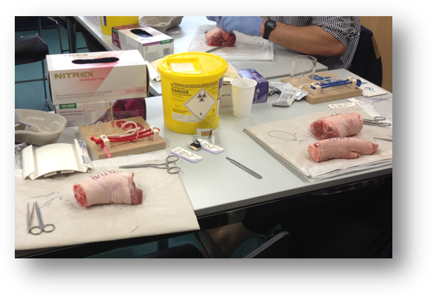
A big part of our job is pastoral care for the students, and it can take many forms, ranging from providing extra teaching for a student who has not passed an exam, to supporting one coping with bereavement, and everything in between. Acting as an advocate, we can provide assistance for students if they need it, even if it’s just someone for them to talk to. While the final year students were here, we were given the opportunity to tutor a group of students, which involved having one-to-one meetings to discuss clinical and non-clinical issues. In the current climate of low moral within the NHS, I feel it’s important to be able to show students the positives.

There is a strong emphasis on medical education research at Gloucestershire Academy and all four CTFs in Gloucestershire have been given the chance to run a number of projects over the course of the year. Picking up various research skills along the way, we will be taking our projects to the national medical education conference ASME (Association for the Study of Medical Education) this month to present our findings.

Have I learnt anything?

I’ve mentioned that this year I’ve had to keep my knowledge and skills up to date, promote the health and wellbeing of the students, and work in partnership with both the students and within a team to help deliver the best level of teaching in an open and honest manner. When I look back on this list, if I was to substitute the word ‘student’ for ‘patient’, this essentially becomes the GMC’s Duties of a Doctor. So despite working with students as opposed to patients this year, I’ve been able to professionally develop, as well as gain a few additions to my CV (including a PG Cert in Medical Education).
On the whole I’ve both enjoyed and consider it a privilege to have taught medical students this year, and take away many skills that are transferable to working in clinical medicine. Who knows, maybe I’ll end up in higher education further down the line.

Dr Peter Fletcher, Academy Dean, writes:

In this my final newsletter as Gloucestershire Academy Dean I want to thank the team for putting up with me for the last 11 years. I also want to thank the many doctors, nurses and allied health professionals who have given their time so generously to the teaching of our students. Our staff are fabulous clinicians and are first class role models for our students of how to put patients at the centre of all we do.

I am delighted to report that Phil Davies, Consultant in the Emergency Department has been appointed as Academy Dean from 1st September 2015. Phil has been Deputy Dean for 2 years and has been a fantastic teacher of our students and an invaluable source of support to our students, our teachers and indeed me for which many thanks. Now you are formally appointed Phil I can confirm that there is no executive loo, no luncheon vouchers and no roped off parking space (or indeed Academy limo). Good luck!.

