
1st March 2015
Number 136
Monthly News
University of Bristol at Gloucestershire Academy

Dr Tom Woodward, Clinical Teaching Fellow writes:-
DATES FOR YOUR DIARY:-

EXAMINERS REQUIRED: -

Final Year Long Case Exams 2015
9.00-13.00

12th March @ CGH

1st Objective Long Case Exams for Year 3

W/c 11th May 2015
@ CGH & GRH

If you are interested in examining for any of the above dates please email Helena.bowen@glos.nhs.uk

USEFUL LINKS:-
Gloucestershire Academy Website – Click Here

Gloucestershire Academy Contacts – Click Here

An eventful start to 2015 in Gloucestershire Academy
One of the joys of being a Clinical Teaching Fellow is that every day, week or month brings new challenges and excitements. The first quarter of 2015 has been no exception, and with spring around the corner I wanted to take this opportunity to look back at the start of the year and see what we’ve achieved so far.
The year began with busy preparations for the arrival of new students from Years 3-5. With the departure of the long serving Emily Matthews the month before the undergraduate office was busier than ever, and special thanks goes to Angie, Coralie and our newest member Helena for their hard work getting to grips with Emily’s previous workload at the start of a new term.
At the start of the year we said goodbye to our previous cohort of Year 3 Medical Students who we shall miss, but we have subsequently welcomed in an excited new group who are now settled in well.
For the Teaching Fellows this meant inductions needed to be planned and then run for our new students. These needed to cover the usual trust induction material but also challenge our new students to think about the concept of Professionalism. Teaching Fellow Lucy Whitton’s thrilling idea of a courtroom style induction saw battles not unlike those seen in a Hollywood justice-drama played out across the floors of Redwood Education Centre. Multiple cases where a student or doctor’s conduct was questionable were brought before a Jury of students, with student Prosecutions and Defence teams arguing the case for and against each one..
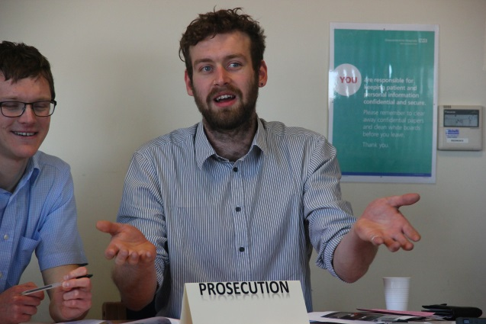

Students arguing a case in the Courtroom

Professionalism can be a difficult subject to teach because there is a perception amongst students that it is somewhat dull and dry, however that may be because delivering a didactic lecture on it (as is often the norm) is the wrong way to go about it. This novel way of teaching about professionalism issues was well received by the students and feedback was very positive, students were engaged and entertained and a tricky subject became fun.
The start of 2015 also heralded the beginning of the end of their medical degree for our Year 5 students. The degree’s final module before electives and then graduation is called Preparing for Professional Practice, or PPP. It is a unit where students spend the majority of their time shadowing junior doctors and “practising for practice” as a doctor. One of the novel strategies that I have piloted alongside the other Clinical Teaching Fellows and Academy staff in Gloucestershire is the addition of medical student bleeps for the PPP placement. Students are given bleeps in small groups to carry during their morning ward shadowing. One of the Clinical Teaching Fellows then bleeps them repeatedly throughout the morning, asking them for advice about mock patients. The students don’t know what they are going to be called about but all of the scenarios are based on real situations encountered regularly by junior doctors – and some of the scenarios are designed to be quite challenging.
This is the first year that bleeps have been used to teach telephone communication skills and so far the feedback has been unambiguously positive. Students have said that they have not had the chance to think about what will happen in August when they are going to start taking calls as the junior doctor on call. The project forces students to think about what they will do when they cannot attend straight away in person, how they will triage patients and keep them safe until they or a colleague can review them – all frequent scenarios that will occur when ‘on call’ next year.
Another change in the New Year has been the increase in Medical Student use of the Sim Suite, G1. Students primarily from Year 5 have been attending regular Sim teaching. There are more Year 5 students than ever in Gloucestershire this year, so Srirathan Sanjeev, one of the Clinical Teaching Fellows, has been dividing up groups during Sim and giving students the chance to be involved with running sessions from “behind the looking glass,” in the control room. Feedback from the experience so far has been positive and this novel way to deal with large simulation groups will be continued in the future when necessary.
There are a plethora of other Sim-based projects running also. One of the projects Lucy Whitton is running at current involves the use of aviation phase-brief techniques, and another more entertaining project simulates a Zombie Apocalypse as a way to teach trauma and resuscitation techniques around a major incident. This humorous slant on Sim has been thoroughly enjoyed by students but retains its educational and serious values well.
It has not just been the Teaching Fellows who have been trying to teach in different and more effective ways. Our Year 5 medical students are engaging with the ‘PALS’ (Peer Assisted Learning Scheme), run by Dr Abigail Samuels in Gloucestershire. Year 5 students come to Year 3 teaching sessions and with the aid of a CTF deliver teaching to our Year 3s. This has been going well and hopes are bright for the future of these budding educators.
A group of students in Year 5 have taken PALS one step further and are developing some new teaching methods. Students Dan Yeomans and Freya Yoward in conjunction with fellows at North Bristol Academy and with Gloucestershire Fellows’ help have been piloting a reflection proforma for Year 3 Clerking portfolios. With luck the hope is that this will aid students in developing their reflective thinking skills and help them to keep clear and effective portfolios. Furthermore Dan and Freya have been working with student Lowri Bowen, Dr Samuels and the CTFs to introduce a very visual jigsaw based teaching method for Orthopaedic Fracture Classification systems in the Year 3 Musculoskeletal module. The hope is that this will aid and improve understanding of these important topics.
The developments described in this month’s newsletter are just a handful of the new and exciting events going on in Gloucestershire Academy. There is so much else going on and thanks has to go to all of the CTFs, clinical tutors, hospital doctors, nurses, administrative team and AHPs that train our medical students and help to make all this possible. There is a vast amount of work going on behind the scenes as well as out in the hospital and classrooms to make sure that Gloucestershire remains in the vanguard of Medical Education.

