***… at the …***

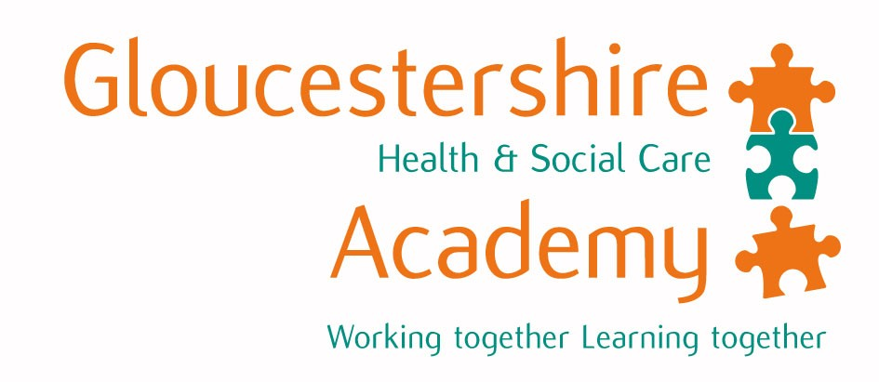

**Number 98**

**Monthly news**

**1st January 2012**

**Diana Thomas, Senior Professional Education Practitioner / Modern Matron writes:-**

**Pre-registration Nurse Education**

There have been recent changes made to the curriculum of all fields of Nursing and Midwifery. This has been as a result of Nursing & Midwifery Council guidelines published last year (Standards for Pre-Registration Nurse Education).

One of the challenges of developing a new curriculum is to ensure that all modules are flexible to reflect the changes to health care, policy, provision and delivery of services. The new curriculum has a clear sequence of topics and sharp and demonstrable increases in the levels of intellectual input throughout the programme.

The curriculum has developed uni-professional and shared modules, which allow students to revisit, extend and further their knowledge, understanding and skills with other practitioners of health care including medical students. These modules are structured to facilitate an equal balance of theory and practice; ensuring evidence based knowledge and understanding, critical reflection, the development of critical analysis and critical thinking skills and have a strong emphasis on the supervision of learning and assessment.

There is also a strong focus on Inter-professional modules. The revised syllabus for these modules is reflected in a new title “The Purpose, Scope and Context of Inter-professional Collaboration”. Students are expected to both contextualise and analyse the various drivers for and against effective inter-professional working. The central Inter-professional Conference is paramount to this module, but there is also on-going development of the “2nd Life” platform. This addition is an adjunct to established teaching and learning approaches and allows students to optimise on learning opportunities in order to model a wide range of inter-professional scenarios in “real time” environments.

The inter-professional module is shared across all health and social care programmes as well as with medical students from the University of Bristol. It aims to investigate service user or carer involvement,

power, social policy, professions and professional roles and team/group working.

The quality and purpose of pre-registration nurse placements has long been debated by the public, the nursing profession itself and our professional bodies (Royal College of Nursing [*equivalent to the BMA*] and the Nursing and Midwifery Council [*equivalent to the GMC*]) with regards to the clinical element of nurse training. The changes in the curriculum have reflected the opinions of stakeholders, service users, carers, service providers and academic institutions, and the placement pathways under the new curriculum have been designed to map the patient journey in terms of available and emerging learning opportunities which placements can provide.

In nursing, as in all other health care pre-registration training, we strive to bridge the “theory to practice gap”. The rapidly changing health care agenda and the often uncertain health and social care landscape has meant that learning in practice expands beyond the historical hospital based approach to one where community practice is no longer viewed as “specialist”. Greater emphasis on these types of placements also strengthens the nursing philosophy in areas such as patient dignity, vulnerable individuals and marginalised groups. Current health policy focuses on improving health, advocating more choice and a much greater emphasis and understanding on care closer to home. The new curriculum reflects this with regards to the placement pathways that have been developed.

There is more of an emphasis on a “patient facing” approach to practice which as we know, occurs everywhere and not just in a hospital setting and it has been recognised that in order to understand the patient journey and overall experience, a more rounded approach to placements needs to be offered. The model that is used in this region supports the development of transferrable skills for an increasingly diverse patient population that will prepare individuals to be competent, caring, creative and critical practitioners who are able to face the challenges of health care in a diverse range of settings in the future.

**Medical Dean Dr Peter Fletcher pays tribute to Dr John Prior who died on 20th November 2011.**

Do “those who can, do, while those that can’t teach?” In fact doctors who are best at ‘doing’, understand what they are doing and can explain it to everyone else make not just the best doctors but also the best teachers. All knew of John’s talents in Medicine generally and Thoracic Medicine specifically – see:

<http://www.thisisannouncements.co.uk/12710941?s_source=clsw_tiwg>, but not all may be aware of his exceptional talents as a teacher.

In Latin ‘doctor’ means teacher (and teaching is one of the 7 qualities of *Good Medical Practice)* and John had always taught students, doctors and other health care professionals. In 2004 when Gloucestershire’s NHS created a University of Bristol Clinical Academy, John became one of our first Unit Coordinators and Tutors. He looked after 12 year 3 students for 9 weeks at a time as they navigated their way through a unit comprising thoracic medicine, cardiology, vascular surgery and other ‘tubes’ related specialty elements.

John excelled at delivering their learning, persuading others to help him deliver the curriculum and for those students being very much THEIR tutor. In the weekly tutorials John and his tutor group ranged over many aspects of medicine and health care within and without the curriculum! He was their first port of call with problems while remaining responsible for getting them through the unit and throughout acted as a role model of the doctor they wanted to become.

On graduation day the student body (*Galenicals*) award prizes to their teachers including one per Academy. In 2008 they awarded the Gloucestershire Teacher of the Year prize to John; it was well deserved and he was so proud to receive it. We and his last ever group of students will miss him greatly.

**We would like to thank everyone for their support in 2011 and wish you all a Happy and Prosperous New Year**