How does Economic Policy Uncertainty (EPU) affect the excess returns of the U.S stock market, and what role do other financial and economic variables play in explaining this relationship?

Introduction

This study investigates how Economic Policy Uncertainty (EPU) influences the excess returns of the US stock market, considering the role of other financial and economic variables (Baker et.al., 2016). It explores the impact of EPU fluctuations on stock returns while accounting for factors such as interest rates, bond spreads, stock market indices, and historical structural breaks.

Excess returns are defined as the difference between the returns on the S&P 500 index (CRSP_SPvw) and the risk-free rate (Rfree). By incorporating financial variables, including the default return spread (DFR), term spread (TMS), long-term government bond returns (ltr), and the S&P 500 index scaled by 1000 (Index), this research aims to provide insights into the relationship between policy uncertainty, economic conditions, and stock market performance.

Economic Theories

Economic theory suggests that increased policy uncertainty reduces investor confidence, leading to lower investment and higher market volatility (Knight, 1957). The EPU index is hypothesized to negatively correlate with stock returns, reflecting risk aversion and weaker market performance.

Financial indicators are key to explaining excess returns. The TMS predicts economic conditions, with higher spreads signalling growth expectations (Froot, 1989). The DFR gauges credit risk, with wider spreads indicating risk aversion (Investopedia, 2024). ltr reflect inflation and stability influencing stock performance (Investopedia, 2024). The Efficient Market Hypothesis (EMH) justifies including the S&P 500 Index as a proxy for market-wide influences (CPI, 2024).

Structural breaks, like Black Monday (1987), the Asian Financial Crisis (1998), and the Great Recession (2008), significantly affect market dynamics. Dummy variables for these events account for their impacts, which continuous variables alone cannot capture.

Econometric Model

Guided by these theories and after rigorous testing and refinement, the final econometric model is specified as follows, with EPU_change scaled by 100:

$$Excess_Return = 0.0753+0.6055DFR_w1-0.2843TMS-0.4254ltr_w1-0.0200Index-0.0234EPU_change-0.1979dummy_Black_Monday_1987-0.1414dummy_Asia_1998-0.1475dummy_Recession_2008-0.0148recession_dummy$$

The coefficient on the EPU_change variable indicates that a 1-point increase in the EPU index leads to a decrease in excess returns by 0.000234 percentage points. This negative relationship suggests that higher policy uncertainty is associated with lower market performance, consistent with theory that uncertainty dampens investor confidence.

Data Formation, Description and Omitted Data

The dataset consists of 370 monthly observations from March 1985 to December 2015, covering a range of economic conditions. It is structured as pooled cross-sectional data, combining monthly observations for the U.S. over a 30-year period, capturing both stable and crisis periods. The model includes variables inspired by the work of Goyal and Welsch (2008), such as Dividend Price Ratio ($DP=log⁡({D12}/{Index})$), Dividend Yield ($DY=log⁡({D12}/{Index_{-1}})$), Earnings Price Ratio ( $EP=log⁡({E12}/{Index})$), Dividend Payout Ratio ($DE=log⁡({D12}/{E12})$), Default Yield Spread ($DFY=BAA-AAA$), Default Return Spread ($DFR=corpr-AAA$) and Term Spread ($TMS=lty-tbl$), along with the change in the EPU index ($∆EPU)$, integrated to reflect monthly fluctuations.

To avoid multicollinearity, variables used to create new ones were excluded from the regression model. This approach ensured the newly formed variables, grounded in economic theory, add value without redundancy. Only variables lacking log transformation were removed during this process, ensuring no omitted data. Extreme values were identified using the 3.5 standard deviation rule. Excess_Return, as the dependent variable, and EPU_change, as the study's focus, were not winsorized, but all other variables were, at the 1% level. Persistent outliers in EP, DE, and DFY were deemed acceptable (figure 1).

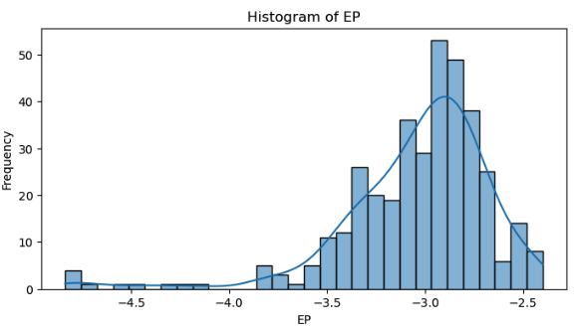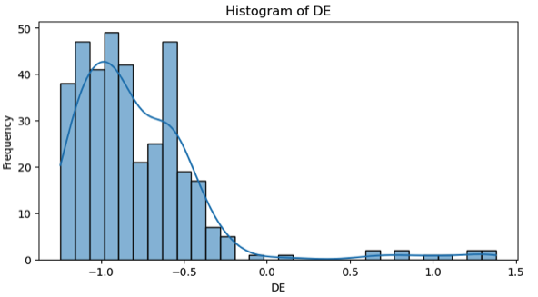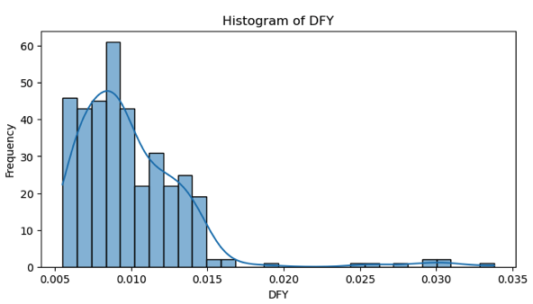
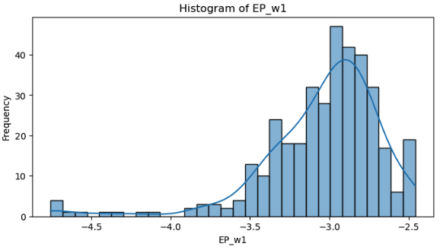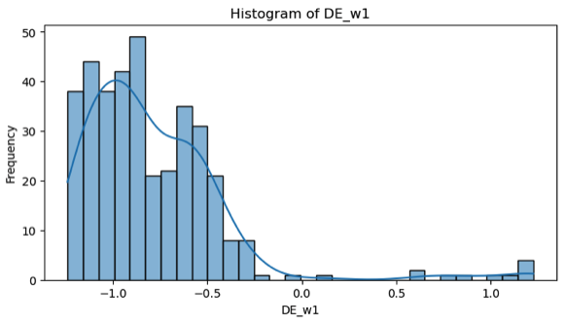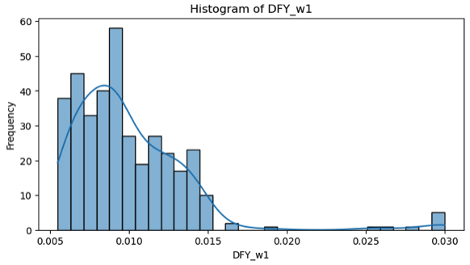
Figure 1: Histograms showcasing potential outliers before and after winsorisation at 1%.

While the dataset had no missing data or major errors, limitations exist. Financial data is subject to revisions, impacting long-term accuracy. Economic data may not fully capture disruptions from unforeseen events like geopolitical crises or natural disasters. Moreover, financial models often overlook investor sentiment and behavioural biases, which significantly influence markets but are hard to quantify.

Collinearity Diagnostics and Variable Selection

To address any remaining multicollinearity, a correlation matrix and Variance Inflation Factor (VIF) tests were conducted. Variables were iteratively removed based on their collinearity and perceived relevance to the model. Initially, the DP and EP were excluded, as the DE was considered more critical (with DE = DP - EP). Subsequently, variables such as DY, E12, D12, DFY, and bm were removed due to either high multicollinearity or limited relevance to the model. VIF values above 10 typically indicate problematic multicollinearity, but in this case, all remaining variables had VIF values below 7.5, indicating minimal multicollinearity and ensuring the robustness of the regression analysis.

Initial Regression Analysis: The "Kitchen Sink" Model

A preliminary regression model including all remaining variables was estimated, producing an R² of 0.133 and an adjusted R² of 0.114, with an F-statistic of 6.930, which was significant at the 5% level. The diagnostic tests conducted for the model revealed the following:

- Autocorrelation [appendix 2 for definition]: The Durbin-Watson statistic [4] was 2.170, indicating no evidence of autocorrelation in the residuals. This result was visually confirmed by a residuals versus lagged residuals plot, which did not show any clear pattern, suggesting the residuals are independent over time (figure 2).

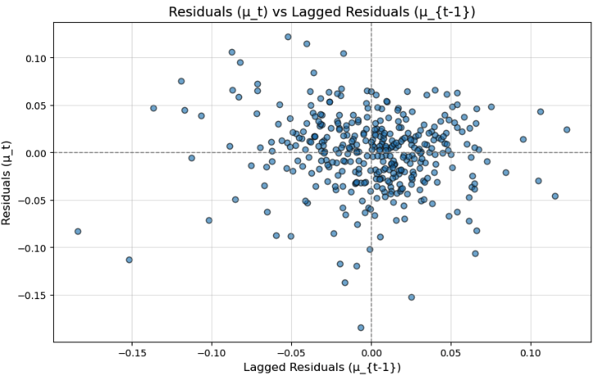
Figure 2: Plotting residuals against lagged residuals.

- Heteroscedasticity [3] The Breusch-Pagan [5], White [6], and Goldfeld-Quandt [7] tests all indicated the presence of significant heteroscedasticity, suggesting that the variance of errors were not constant across observations. This violates one of the assumptions of the Classical Linear Regression Model (CLRM), which assumes homoscedasticity.
- Normality [1] : The Jarque-Bera [8] test revealed that the residuals were not normally distributed, indicated by a significant test statistic, suggesting that the assumption of normally distributed errors was violated. Despite this, a residual vs. fitted values plot and a histogram of the residuals were generated, and visually, they appeared to follow a normal distribution (figure 3).

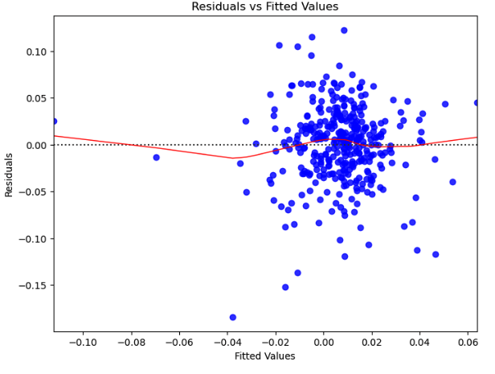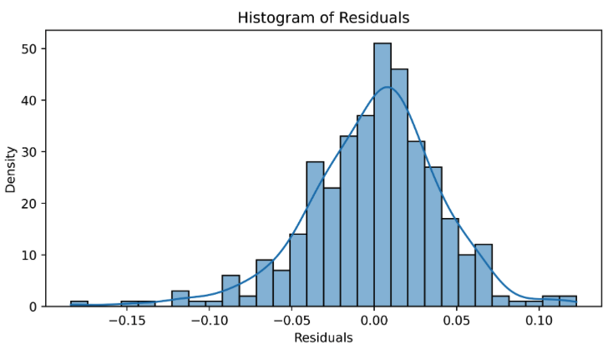
Figure 3: Plotting residuals against fitted values and residual distribution.

- Functional Form: Ramsey’s RESET test was conducted for higher-degree terms (2 and 3) and passed for these degrees, indicating that the model’s functional form was adequately specified for these terms. However, the model failed at degree 4, suggesting the presence of potential misspecification at higher orders of the functional form. Residual plots of fitted values and the independent variables did not reveal any clear patterns, but the overall results of this test indicated that model specification issues might exist at higher polynomial degrees.

To mitigate the impact of heteroscedasticity, robust standard errors (HC3) were employed, which correct for heteroscedasticity by adjusting the standard errors of the coefficients, allowing for more reliable statistical inferences.

Addressing Structural Breaks and Recessions

Given the potential influence of economic events on excess returns, structural breaks in the data were examined (figure 4). Significant deviations were found in October 1987 (Black Monday), August 1998 (Asian Financial Crisis), and October 2008 (Great Recession), which were confirmed as structural breaks through Chow tests. Dummy variables were created for these events to account for the possible data shifts during these crises. Additionally, a recession dummy variable was introduced to capture periods of economic downturn, covering U.S. recessions from July 1990-March 1991, March 2001-November 2001, and December 2007-June 2009, based on the NBER Business Cycle Dating Committee’s data.

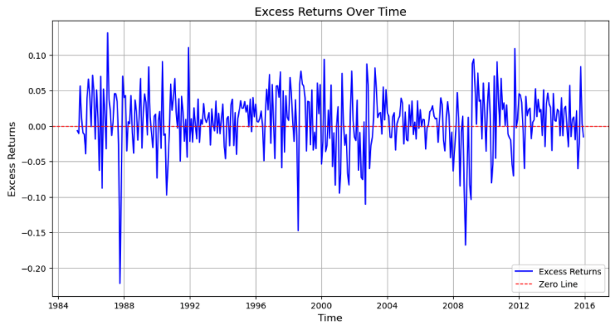
Figure 4: Plotting excess returns over time, indicating structural breaks.

The inclusion of these structural break and recession dummy variables significantly improved the model's explanatory power. The updated model achieved an R² of 0.258, an adjusted R² of 0.233, and an F-statistic of 4.278, significant at the 5% level. Despite this improvement, the model still faced issues with heteroscedasticity, as indicated by the White and Goldfeld-Quandt tests. However, the Breusch-Pagan test passed, suggesting that some of the heteroscedasticity concerns were alleviated with the introduction of dummies.

Model Refinement and Interpretation

The model was further refined using a stepwise approach to remove insignificant variables. Variables were excluded based on their high p-values when conducting z-tests, with an emphasis on retaining those that were theoretically important and demonstrated statistical significance. As a result, the variables DE, net interest spreads (nits), and inflation (infl) were removed, as they did not contribute significantly to the explanatory power of the model.

The final model achieved the following results:
- R²: 0.255
- Adjusted R²: 0.237
- F-statistic: 4.605, significant at the 5% level
- Durbin-Watson statistic: 2.289, confirming no autocorrelation in the residuals
- Jarque-Bera statistic: 7.641, with a p-value of 0.0219, indicating that while residuals were still not perfectly normal, the p-value improved compared to earlier model iterations. This suggested improvement in the normality of residuals after model refinement.

Residual plots and histograms (figure 5) indicated that while normality had not fully been achieved, the data showed improved symmetry in the distribution of errors. The inclusion of structural break dummies helped mitigate some of the non-normality, as evidenced by the reduced severity of the Jarque-Bera test.

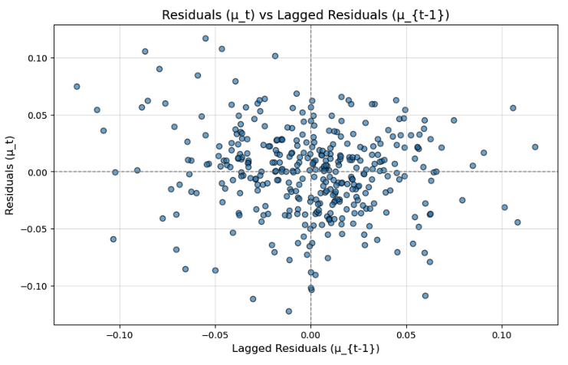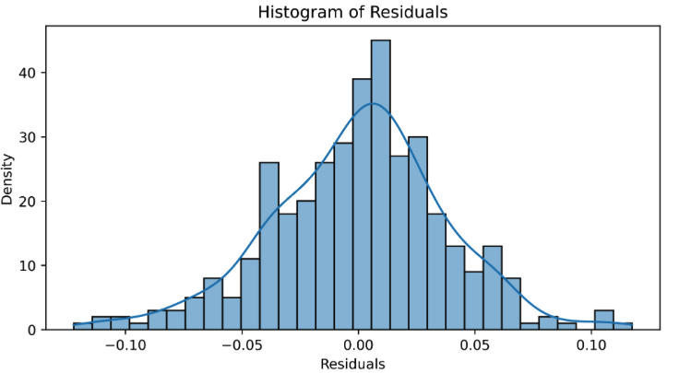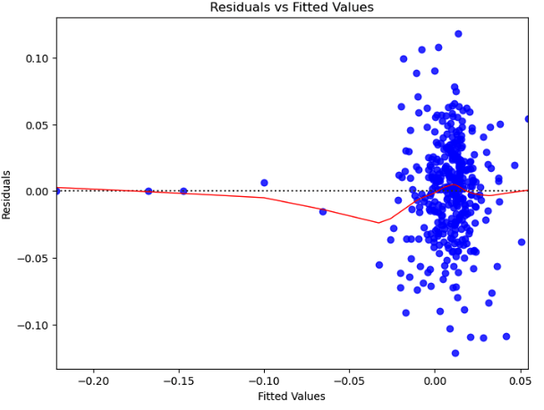
Figure 5: Updated residual plots and histograms following model refinement.

While the model provides valuable insights into the relationship between Economic Policy Uncertainty and U.S. stock market returns, it is important to recognize the limitations and assumptions inherent in the analysis. Non-normality of residuals and potential heteroscedasticity affect the accuracy of statistical inference.

References

Baker, S.R.,Bloom, N. & Davies, S.J., 2016. Measuring economic policy uncertainty. Quarterly journal of Economics, 131, pp.1593-1636.

Knight F.H. (1957). Risk, Uncertainty and Profit 1st ed. Boston: Houghton Mifflin Company. Available at https://fraser.stlouisfed.org/files/docs/publications/books/risk/riskuncertaintyprofit.pdf [Accessed 12 December 2024].

Froot.A.K. (1989). New Hope for the Expectations Hypothesis of the Term Structure of Interest Rates. The Journal of Finance, 44(2). [Accessed 12 December 2024].

Investopedia, 2024, Credit Spread. Available at: https://www.investopedia.com/terms/c/creditspread.asp#:~:text=A%20wider%20credit%20spread%20means,to%20accept%20a%20lower%20yield. [Accessed 12 December 2024].

Investopedia, 2024. Inflation and Interest Rate Relationship. Available at: https://www.investopedia.com/ask/answers/12/inflation-interest-rate-relationship.asp [Accessed 12 December 2024].

Corporate Finance Institute, 2024. Efficient Markets Hypothesis. Available at: https://corporatefinanceinstitute.com/resources/career-map/sell-side/capital-markets/efficient-markets-hypothesis/ [Accessed 12 December 2024].

Goyal, A. & Welsch, I., 2008. A comprehensive look at the empirical performance of equity premium prediction. Review of Financial Studies, 21, pp1455-1508 [Accessed 12 December 2024].

Appendix

[1] Normality of Residuals: Assumes that the residuals (errors) from the regression model are normally distributed. This is important for valid statistical inferences and hypothesis testing.

[2] Autocorrelation: Refers to the correlation of residuals across time or space. When present, it violates the assumption of independent errors, affecting the validity of the model’s results.

[3] Heteroscedasticity: Occurs when the variability of residuals changes across observations, violating the assumption of constant variance. It can distort standard error estimates and significance tests.

[4] Durbin-Watson Test: Measures autocorrelation in the residuals of a regression model. A value close to 2 indicates no autocorrelation, while values approaching 0 or 4 suggest positive or negative autocorrelation, respectively.

[5] Breusch-Pagan Test: Assesses heteroscedasticity by testing whether the variance of the residuals is constant. A significant result suggests heteroscedasticity.

[6] White Test: A general test for heteroscedasticity that also detects model misspecification by analysing residuals.

[7] Goldfeld-Quandt Test: Another test for heteroscedasticity, specifically examining whether variance differs between two groups of observations.

[8] Jarque-Bera Test: Tests the normality of residuals by checking for skewness and kurtosis. A significant result suggests non-normal residuals.

[9] Ramsey RESET Test: Evaluates whether a linear model is correctly specified by testing for omitted non-linear relationships. A significant result implies potential misspecification.

