Morgan Bronson

January 22, 2022

Technical Report for Hometown Map

Introduction:

For my hometown map, I chose to focus on the locations of thrift stores in the city of Idaho Falls. I consider thrift shopping to be one of my favorite hobbies, but because of work and homework, I don’t go very often. The focus of this map is depicting the distance of each store from Rexburg, Idaho, where I live. All the data I collected was obtained from Google Maps, so if there are discrepancies in the data, it’s due to that.

Data Used: Searched ‘Idaho Falls Thrift Stores’ on Google Maps.

Methods: Attribute Table. I decided, from the information the maps gave me, six characteristics that were important in making my map. I do with the application had more information, but it also had more than I expected. I chose to have the name of the store, the street address (not zip code, city, or state since all of those would’ve been basically the same), the Yelp rating, the hours each store is open, how expensive the items are at each store, the distance in miles from Rexburg, and the phone number for each location.

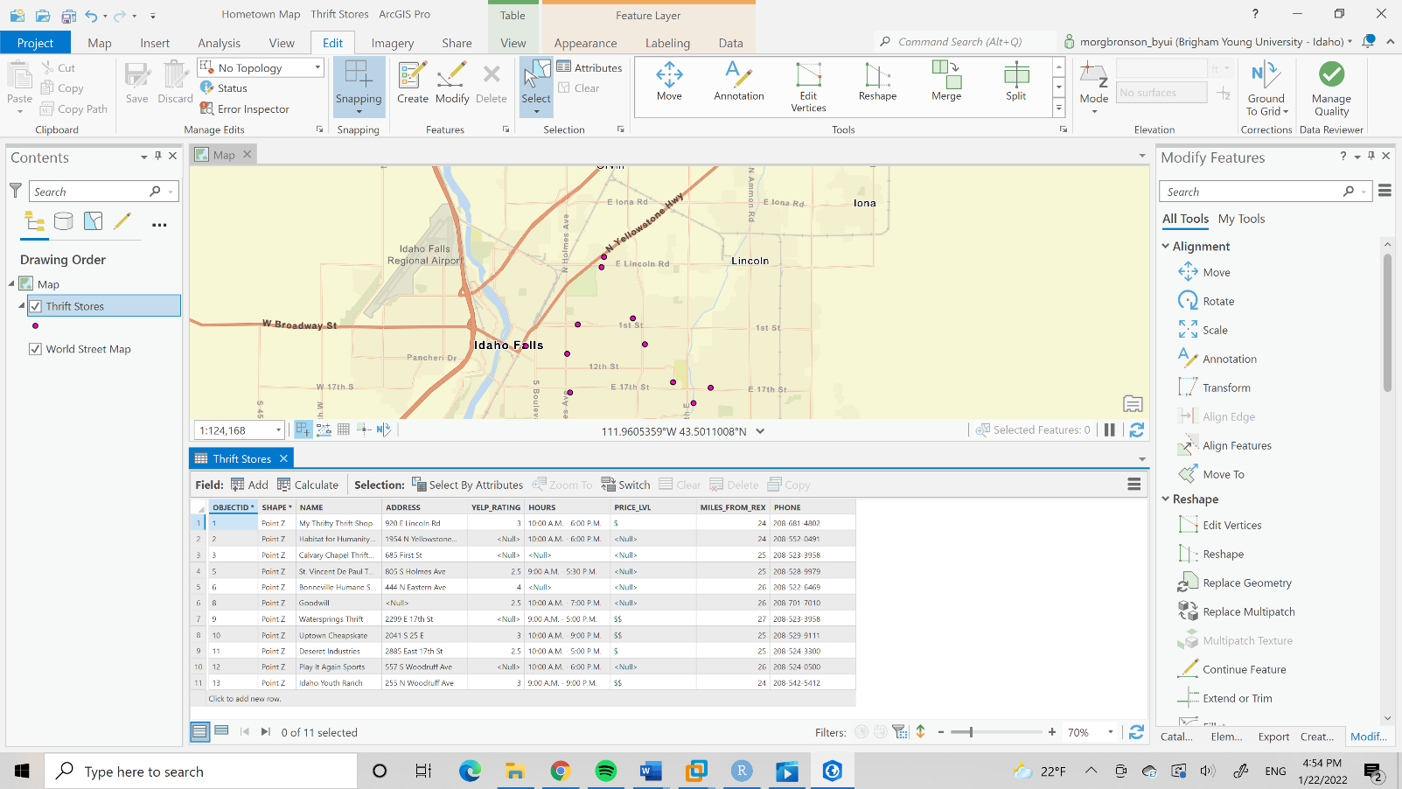

Conclusion: I feel like, for a basic map, my map was sufficient. I included all the required elements and the map seems very balanced. Cartographically speaking, the map isn’t very aesthetically pleasing, and I was having some issues with modifying the legend. I wanted to color the legends in regards of distance from Rexburg, but I was unable to change the legend so the numbers 24, 25, 26, and 27 were depicted separately. I’m not exactly sure where to find a resource for that, because I looked and found nothing. All of the websites I found were solely for ArcMap and don’t transfer over to ArcGIS. I feel like, aside from that, my map communicates its point effectively and is easy to read. My map is balanced and clean, and I think I did a decent job. I do wish there had been more information involving price or Yelp reviews on Google Maps because a map based off of those things would’ve been more interesting than on solely based off of distance from Rexburg, and probably more useful as well.

Map:

