Morgan Bronson

January 29, 2022

Technical Report for Earthquake Map

Introduction: Earthquakes have been a natural occurrence across the world since the formation of the Earth. Since 1900, and the advancement of technology, we have been able to record and collect more data regarding earthquakes and the attributes of natural events. This map illustrates the distribution, depth, and magnitude of earthquakes that have occurred in the Eastern Hemisphere since the year 1900 with a magnitude greater than a 7.

Data Used: Data was collected from the USGS ANSS Earthquake Catalog

https://earthquake.usgs.gov/earthquakes/search/

Methods:

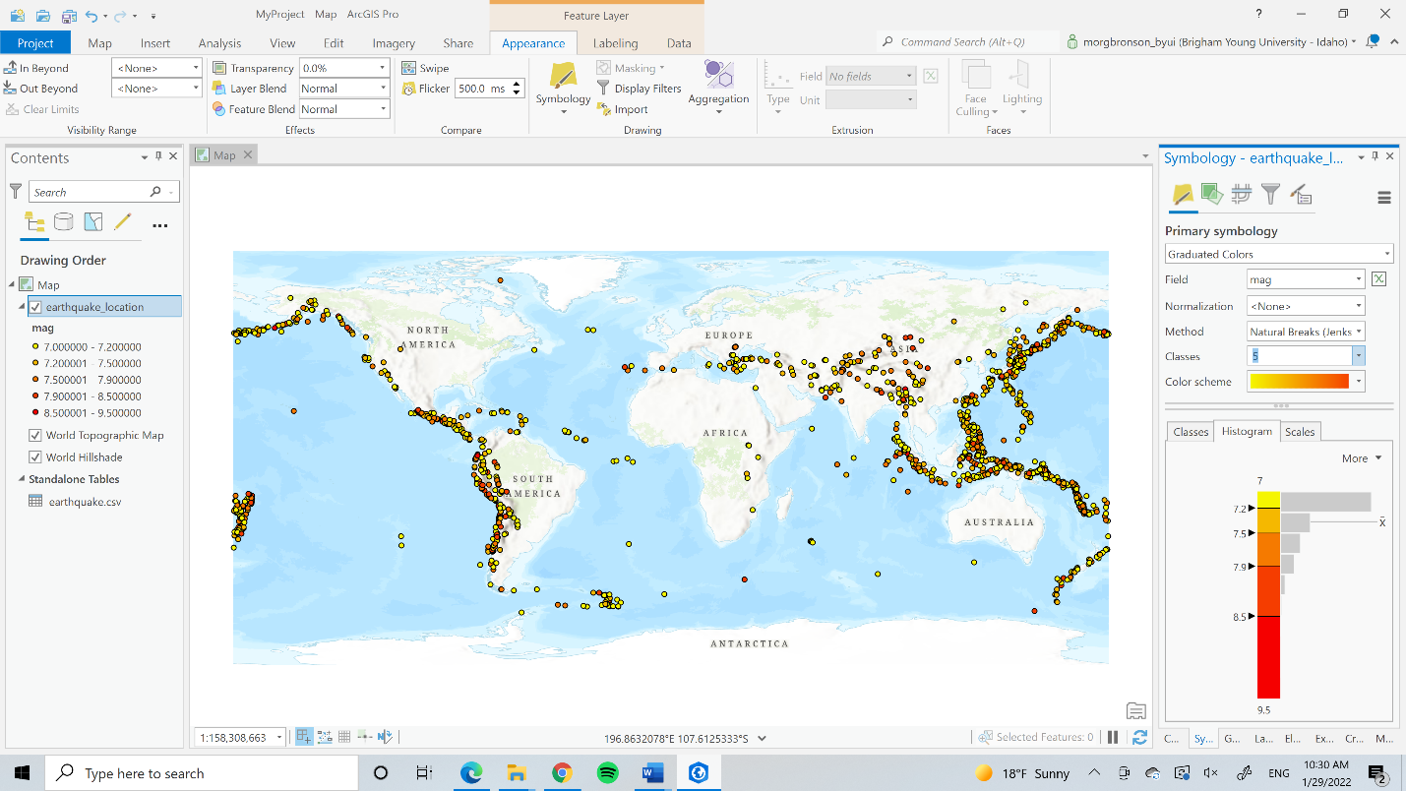

I chose the default ArcGIS provided: the natural breaks method with five classes. After switching the methods and classes, I decided the default ones better represented the data. I also decided that the magnitude would be better represented as size, but when I did that, I had some issues I was unable to resolve. I was unable to change the symbol or the label of the ‘size’ legend labels. I tried to do make the map more professional by limiting the significant numbers and changing the outline of the size borders, but for some reason, I’m having trouble figuring out my legends.

Conclusion: I feel like my map is a simple and effective way to communicate the distribution of earthquakes of the Eastern Hemisphere. There was a part where I did not follow the instructions because I could not figure out how to apply color to both the magnitude and depth data, and because I thought that magnitude would be better illustrated by size. Because of my decision, I was unable to format my legend in the way that I wanted and change the legend attributes. I’ve also been unable to export my legend. Every time I’ve tried today, the application has crashed, so I’m not sure what’s going on with that. I’m not sure why I’ve been having such an issue with my legends. I believe, aside from those little hiccups, my map is clear and easily interpretable by its viewers.

Map:

