Morgan Bronson

January 29, 2022

Technical Report for Covid-19 Map

Introduction: Since the winter of 2020, Covid-19 has been a rampant problem across the world. In Europe, a highly developed continent with varying degrees of access to healthcare, the distribution of Covid-19 cases differ from nation to nation. From this activity, I learned that following instructions is super important as well as organizing data efficiently. The attribute joins were really neat and I feel like that’s a skill that will carry into my future career.

Data Used: Covid.gdb with two feature classes:   
- WorldCountryPop: A point feature class of countries and their populations each   
decade from 1950 to 2010 and 2015. This was downloaded from the ArcGIS portal and   
modified for use in class.  
- World_Countries_(Generalized): A polygon feature class of countries. It was   
downloaded from ArcGIS Portal.  
CovidGlobal.csv: A table of Covid-19 cases downloaded from Github April 2020

Methods: I decided for both the population density and Covid-19 data to use the quantile data sectioning method since that’s the only way the data would visibly distribute on the map. I also chose to do six classes so the data would be more visible. This definitely isn’t the best histogram, but the data distribution is extremely skewed, so there was no other option to make the data visible on the map.

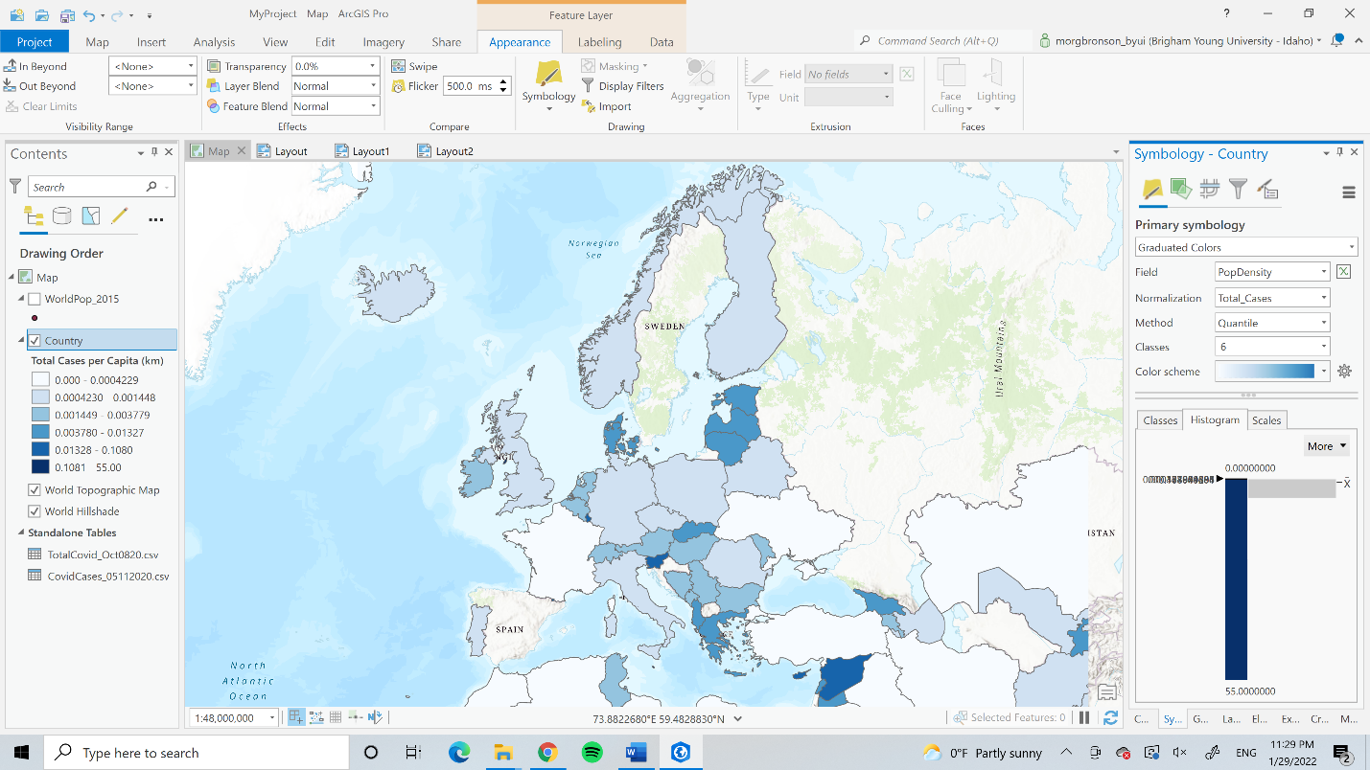

Conclusion: I ran into a lot of issues creating these maps. I’m not sure if I calculate the area in kilometers correctly and I have no idea if the population density or the Covid-19 calculations are correct. I have a sneaking suspicion that they are not, especially because the maps are exactly the same, and I highly doubt that Covid-19 would follow the same distribution as population density. Population density probably plays a role in Covid-19 spread, but I doubt it would be that exact. Next time, I want to take much more time to figure out whether my maps are correct and my calculations are exact, because if the data is skewed, the map is also going to be skewed. Aesthetics-wise, I feel like my map is easy to read and communicates the message well, although the data may not be accurate. The map looks professional, clean, and simple.

Map: