Apps are popular entertainment, educational and even life-saving source that is used by every living person that has phone or computer.

Aleksander Daniel Veske, Jelizaveta Kuznetsova, Maxim Makarskiy

**KAGGLE-MobileApps**

**Motivation and Objectives:**

In the project we wanted to compare two extremely popular platforms for buying apps: Apple Store and Google Play, in aim to help developers, who made an app that was originally made for one of the platforms (IOS or Android) and want to estimate how popular will be their product on the other platform.

It is needed for better understanding what will give more profit promotion and inculcation on one of platforms or partial transition to another platform.

**Data science methods:**

The popularity of the app depends on the app size, price and category.

Developers who have their app uploaded on one of the platforms can use the rating they already see at the moment to predict how successful will be the app on the second platform.

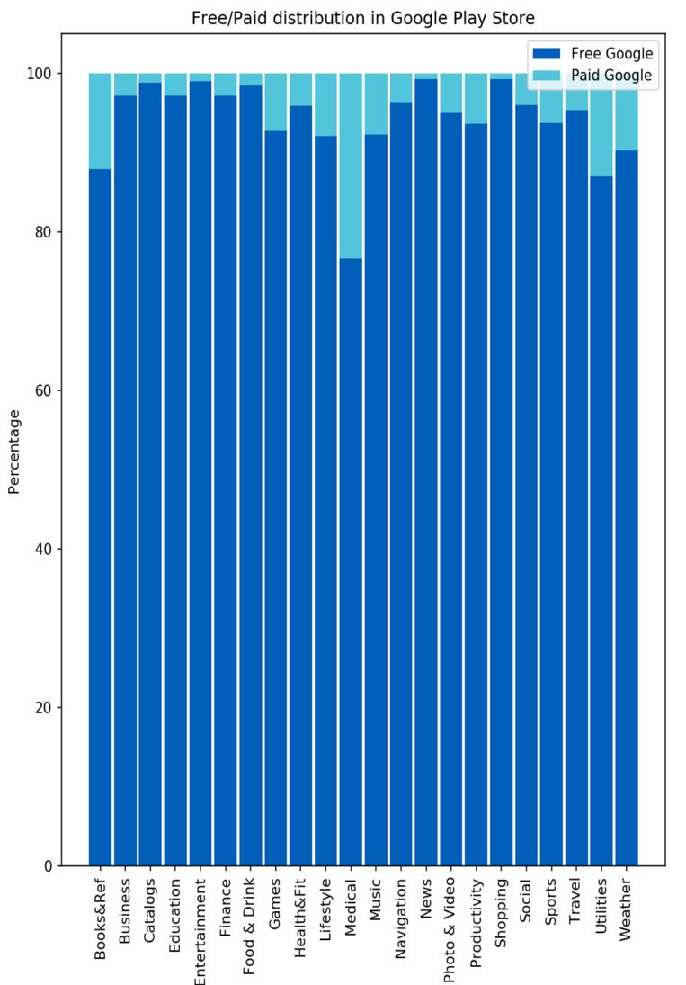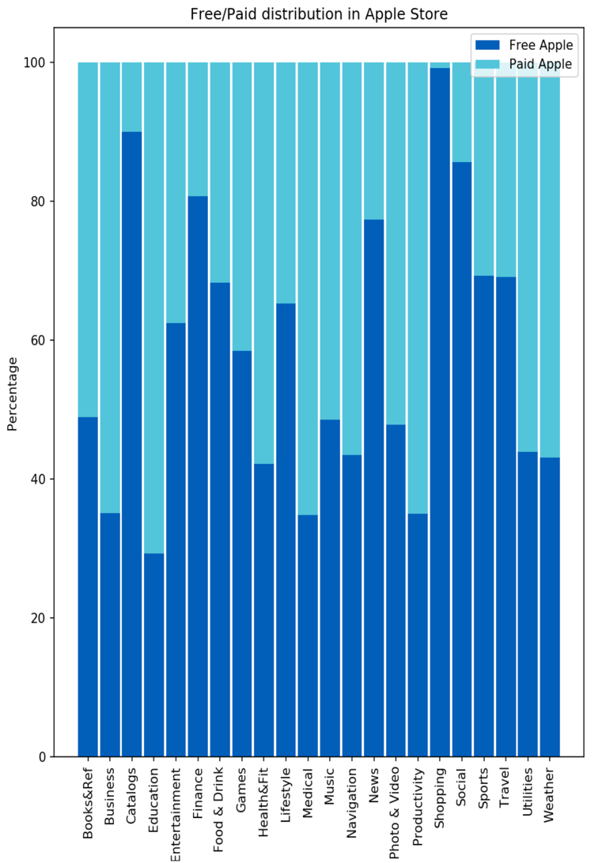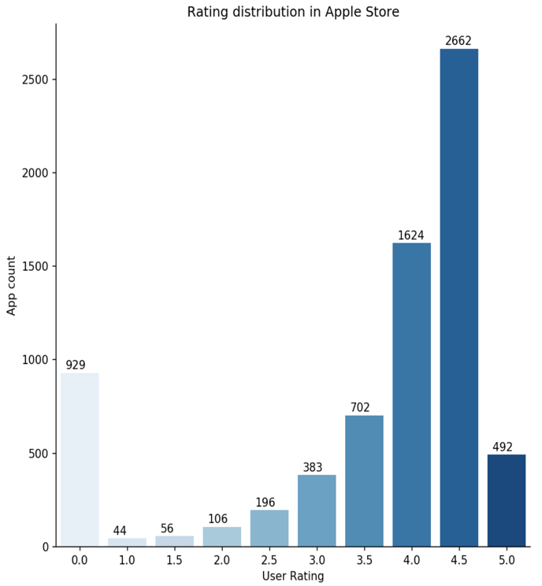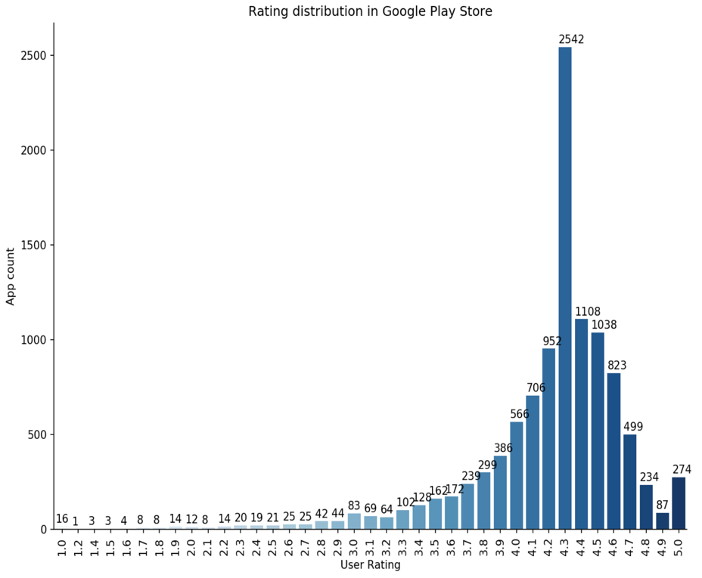

**Results:**

In our project we identified how certain attributes like price, size and category

affect the popularity of the app, also we successfully found multiple patterns in data.

One of our goals was to train the model, so it can predict how popular the app

will be on both platforms and on which platform the app will be more popular.

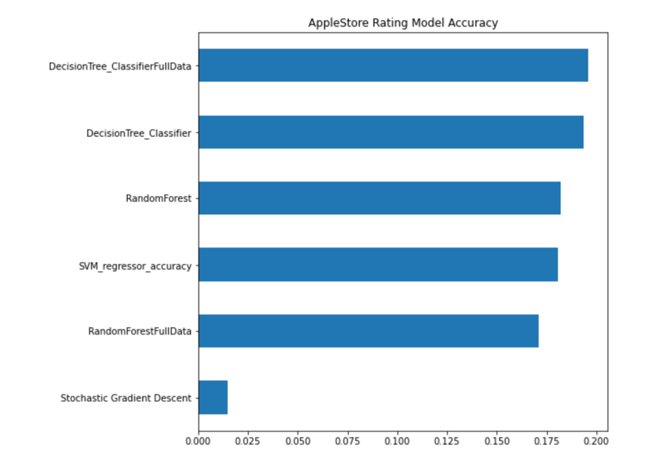 As a result, the model was not accurate enough to make predictions as we

planned, but one of the models predicts the popularity with an estimated

error +-1, so it can be used for predicting an extreme situations, such as a

total fail or a total success of an app.