PROJECT COMPLETION REPORT: Business process logging and analysis system (CLI)

Individual Project Technical Report
Document ID: PRJ-0201-001
Date: 03/03/2026
Last Update: 03/03/2026
Members:
- Mykhailo Tymoshenko
- Mykhailo Haliapa
Tech stack:
Estimate time spend: 2h

Project Lead: Mykhailo Haliapa
Report reviewer: Mykhailo Tymoshenko
Date of review: 02/23/2026

Kyiv-2026
Table of Content
I. EXECUTIVE SUMMARY 2
II. TECHNICAL SPECIFICATIONS 2
III. Code and text examples: 2
IV. QUALITY ASSURANCE (CODE REVIEW) 3
CONCLUSION & KEY LEARNINGS 3

I. EXECUTIVE SUMMARY
Objective: The objective of this project is to develop a Command Line Interface (CLI) application that simulates a basic business time-tracking system. The program allows users to log tasks along with the time spent on them and stores the data in a structured JSON format. The core logic focuses on recording, persisting, and analyzing task data to generate meaningful daily statistics.
Scope:
The system implements the following features:
- Adding a new task with its duration
- Automatic assignment of the current date
- Storing data in a JSON file
- Generating a daily report that includes:
  - Total time spent per day
  - The longest task of the day
  - Average task duration
- Basic file handling and data persistence
- Error-safe data loading when the file does not exist

II. TECHNICAL SPECIFICATIONS

Language & Environment: Python 3.11.9
Libraries/Dependencies: json
III. Code and text examples:
PROG CODE for .PY
import json
import os
from datetime import datetime

DATA_FILE = "data.json"

def load_data():
if not os.path.exists(DATA_FILE):
return []
with open(DATA_FILE, "r") as f:
return json.load(f)

def save_data(data):
with open(DATA_FILE, "w") as f:
json.dump(data, f, indent=4)

def add_task():
task_name = input("Enter task name: ")
duration = int(input("Enter duration in minutes: "))
date = datetime.now().strftime("%Y-%m-%d")

data = load_data()

data.append({
"task_name": task_name,
"duration": duration,
"date": date
})

save_data(data)
print("Task saved.")

def generate_report():
data = load_data()
today = datetime.now().strftime("%Y-%m-%d")

today_tasks = [task for task in data if task["date"] == today]

if not today_tasks:
print("No tasks for today.")
return

total_time = sum(task["duration"] for task in today_tasks)
longest_task = max(today_tasks, key=lambda x: x["duration"])
average_time = total_time / len(today_tasks)

print("\n--- Daily Report ---")
print(f"Date: {today}")
print(f"Total time: {total_time} minutes")
print(f"Longest task: {longest_task['task_name']} ({longest_task['duration']} min)")
print(f"Average task duration: {average_time:.2f} minutes")

def main():
print("1. Add task")
print("2. Generate report")
choice = input("Choose option: ")

if choice == "1":
add_task()
elif choice == "2":
generate_report()
else:
print("Invalid choice.")

if __name__ == "__main__":
main()
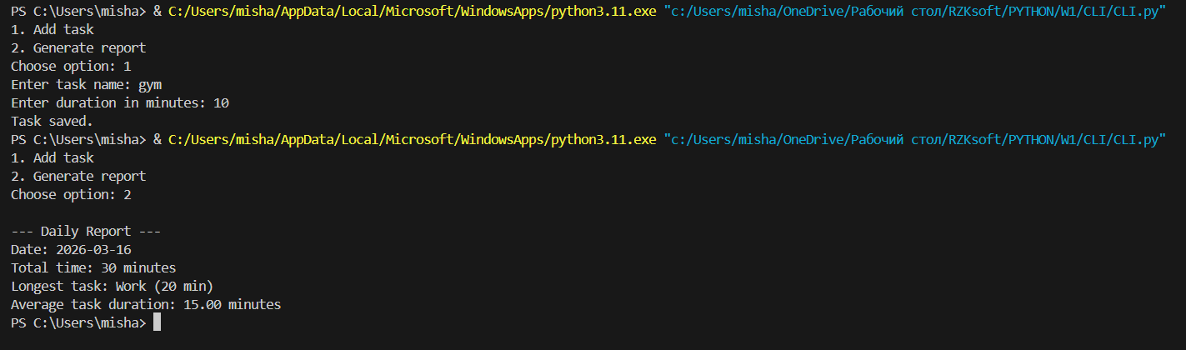

IV. QUALITY ASSURANCE (CODE REVIEW)
Reviewer: Mykhailo Tymoshenko
- Strengths: (e.g., Efficient use of List Comprehensions, well-structured SQL queries).
- Areas for Improvement: (e.g., Need for better docstrings, optimization of nested loops).
- Refactoring Actions: List changes made after the review.

CONCLUSION & KEY LEARNINGS

Most Significant Technical Takeaway
The most important technical takeaway from this project was learning how to implement data persistence using JSON together with file handling in Python. The program demonstrates how task data can be stored permanently in a file and later retrieved for analysis.
Another key learning point was working with date and time management using the datetime module to automatically assign the current date to each task. This allowed the system to filter tasks by day and generate meaningful statistics.
Additionally, the project helped reinforce concepts such as list comprehensions, aggregation of data (sum, max, average), and building a simple command-line interface (CLI) for interacting with the program.Overall, the project showed how relatively simple Python tools can be combined to create a functional time-tracking system that records tasks and generates useful daily insights.

Estimated Time vs. Actual Time Spent
- Estimated time: 2 hours
- Actual time spent: 3 hours

