# Module 2 - Correlation and Multiple Linear Regression

## Sox, Morgan

#install.packages("tidyverse")  
#install.packages("GGally")  
#install.packages("leaps")  
#install.packages("MASS")  
library(tidyverse)

## ── Attaching packages ───────────────────────────────────── tidyverse 1.2.1 ──

## ✔ ggplot2 3.1.0 ✔ purrr 0.2.5  
## ✔ tibble 1.4.2 ✔ dplyr 0.7.7  
## ✔ tidyr 0.8.2 ✔ stringr 1.3.1  
## ✔ readr 1.1.1 ✔ forcats 0.3.0

## ── Conflicts ──────────────────────────────────────── tidyverse_conflicts() ──  
## ✖ dplyr::filter() masks stats::filter()  
## ✖ dplyr::lag() masks stats::lag()

library(GGally)

##   
## Attaching package: 'GGally'

## The following object is masked from 'package:dplyr':  
##   
## nasa

library(leaps)  
library(MASS)

##   
## Attaching package: 'MASS'

## The following object is masked from 'package:dplyr':  
##   
## select

bike <- read_csv("hour.csv")

## Parsed with column specification:  
## cols(  
## instant = col_integer(),  
## dteday = col_date(format = ""),  
## season = col_integer(),  
## yr = col_integer(),  
## mnth = col_integer(),  
## hr = col_integer(),  
## holiday = col_integer(),  
## weekday = col_integer(),  
## workingday = col_integer(),  
## weathersit = col_integer(),  
## temp = col_double(),  
## atemp = col_double(),  
## hum = col_double(),  
## windspeed = col_double(),  
## casual = col_integer(),  
## registered = col_integer(),  
## count = col_integer()  
## )

bike = bike %>% mutate(season = as_factor(as.character(season))) %>%  
mutate(season = fct_recode(season,  
"Spring" = "1",  
"Summer" = "2",  
"Fall" = "3",  
"Winter" = "4"))

bike = bike %>% mutate(yr = as_factor(as.character(yr)))  
bike = bike %>% mutate(mnth = as_factor(as.character(mnth)))  
bike = bike %>% mutate(hr = as_factor(as.character(hr)))

bike = bike %>% mutate(holiday = as_factor(as.character(holiday))) %>%  
mutate(holiday = fct_recode(holiday,  
"NotHoliday" = "0",  
"Holiday" = "1"))

bike = bike %>% mutate(workingday = as_factor(as.character(workingday))) %>%  
mutate(workingday = fct_recode(workingday,  
"NotWorkingday" = "0",  
"WorkingDay" = "1"))

bike = bike %>% mutate(weathersit = as_factor(as.character(weathersit))) %>%  
mutate(weathersit = fct_recode(weathersit,  
"NoPrecip" = "1",  
"Misty" = "2",  
"LightPrecip" = "3",  
"HeavyPrecip" = "4"))

bike = bike %>% mutate(weekday = as_factor(as.character(weekday))) %>%  
mutate(weekday = fct_recode(weekday,  
"Sunday" = "0",  
"Monday" = "1",  
"Tuesday" = "2",  
"Wednesday" = "3",  
"Thursday" = "4",  
"Friday" = "5",  
"Saturday" = "6"))

Why do we convert “yr”, “mnth”, and “hr” into factors? Why not just leave them as numbers? We convert since they are catagorical values stored as numbers.

ggcorr(bike, label = TRUE)

## Warning in ggcorr(bike, label = TRUE): data in column(s) 'dteday',  
## 'season', 'yr', 'mnth', 'hr', 'holiday', 'weekday', 'workingday',  
## 'weathersit' are not numeric and were ignored

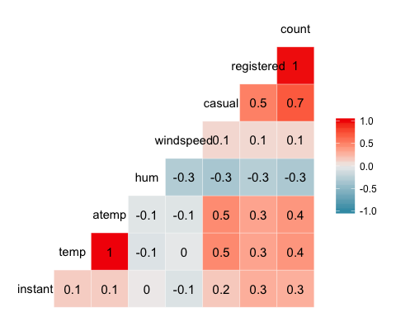

It appears that Temperature is the most highly correlated quantiative factor to count.

ggplot(bike,aes(x=hr,y=count)) + geom_boxplot()

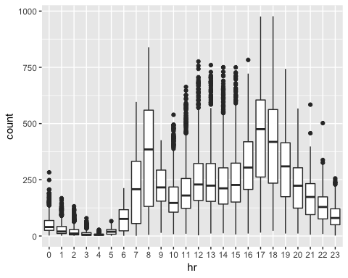 It is obvious that the hour of the day affects count as people likely rent bikes more when it is light outside and probably during normal commute times for work, school, or to and from lunch.

ggplot(bike,aes(x=season,y=count)) + geom_boxplot()

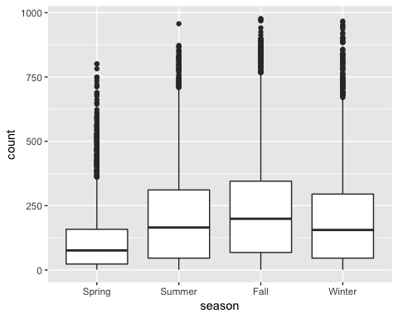

Season should also be included in the regression because you are mosre likely to ride a bike when the weather is fairly good.

ggplot(bike,aes(x=yr,y=count)) + geom_boxplot()

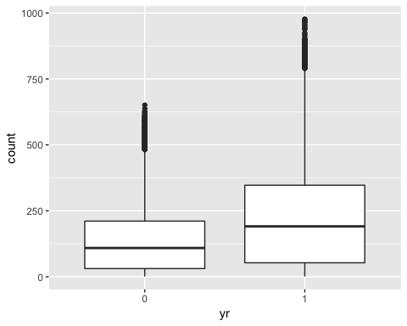

Year is likely not a signifigant value to add to the regression, even though we do see an higher number of bikes being used in the later year, it is likely due to more awareness of bikes being offered, not actually because of the year itself.

ggplot(bike,aes(x=mnth,y=count)) + geom_boxplot()

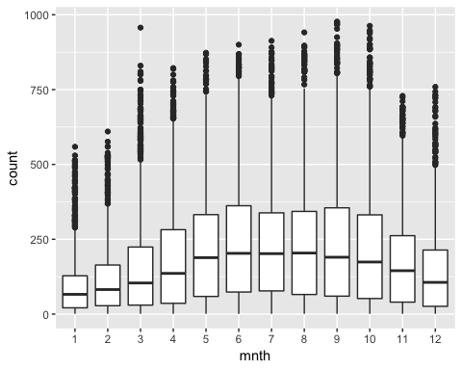

Month is likely affecting the use of bikes as the weather is different from month to month. This shoudl be included though multicollinearity is mostlikely present between month and season.

ggplot(bike,aes(x=holiday,y=count)) + geom_boxplot()

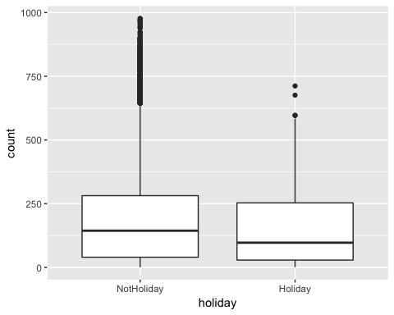

Holiday should be included in the regression since is does affect whether people will rent bikes or not in the DC area. this is probably due to the fact that people use the bikes for communiting rather than leisure.

ggplot(bike,aes(x=weekday,y=count)) + geom_boxplot()

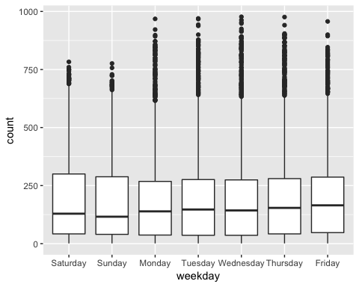

Day of the week appears to only midly affect the amount of bike sharing and there for is not a signifigant add to our model as it appears riders are riding for transportation around the area and have to travel on every day of the week.

ggplot(bike,aes(x=workingday,y=count)) + geom_boxplot()

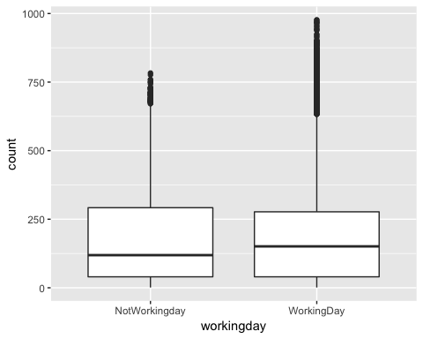

We once again do not see a signifigant change in overall bike use on working days vs. non-working days. This is expected as people still travel to do errands and around the DC area on both types of days.

ggplot(bike,aes(x=weathersit,y=count)) + geom_boxplot()

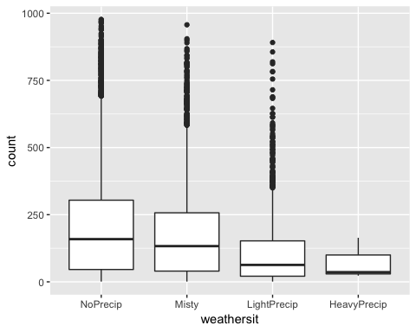

Weather should be included in our regression as it has a high affect on whether or not bikes are being used as transportation. This seems reasonable as there are alternatives to traveling by bike if it is raining outside.

bike2 = bike %>% dplyr::select(-c(instant, dteday, registered, casual))

All model & empty model

allmod = lm(count ~., bike2)  
summary(allmod)

##   
## Call:  
## lm(formula = count ~ ., data = bike2)  
##   
## Residuals:  
## Min 1Q Median 3Q Max   
## -393.87 -60.66 -7.96 51.31 439.18   
##   
## Coefficients: (1 not defined because of singularities)  
## Estimate Std. Error t value Pr(>|t|)   
## (Intercept) -67.542 6.612 -10.216 < 2e-16 ***  
## seasonSummer 38.178 4.856 7.862 4.00e-15 ***  
## seasonFall 32.055 5.749 5.575 2.51e-08 ***  
## seasonWinter 67.994 4.882 13.928 < 2e-16 ***  
## yr1 85.431 1.563 54.658 < 2e-16 ***  
## mnth2 3.426 3.920 0.874 0.38219   
## mnth3 14.299 4.407 3.244 0.00118 **   
## mnth4 6.230 6.548 0.951 0.34144   
## mnth5 20.657 7.007 2.948 0.00320 **   
## mnth6 6.238 7.205 0.866 0.38662   
## mnth7 -13.269 8.082 -1.642 0.10065   
## mnth8 7.897 7.879 1.002 0.31622   
## mnth9 32.269 7.001 4.609 4.07e-06 ***  
## mnth10 15.843 6.483 2.444 0.01455 *   
## mnth11 -9.840 6.238 -1.577 0.11474   
## mnth12 -6.256 4.954 -1.263 0.20672   
## hr1 -17.294 5.345 -3.236 0.00122 **   
## hr2 -26.369 5.364 -4.916 8.91e-07 ***  
## hr3 -37.112 5.403 -6.869 6.67e-12 ***  
## hr4 -40.263 5.408 -7.445 1.01e-13 ***  
## hr5 -23.501 5.373 -4.374 1.23e-05 ***  
## hr6 35.393 5.359 6.605 4.10e-11 ***  
## hr7 170.418 5.348 31.864 < 2e-16 ***  
## hr8 310.801 5.342 58.183 < 2e-16 ***  
## hr9 163.101 5.347 30.501 < 2e-16 ***  
## hr10 108.444 5.370 20.196 < 2e-16 ***  
## hr11 133.843 5.409 24.742 < 2e-16 ***  
## hr12 173.142 5.456 31.735 < 2e-16 ***  
## hr13 168.102 5.494 30.600 < 2e-16 ***  
## hr14 152.249 5.525 27.558 < 2e-16 ***  
## hr15 161.707 5.535 29.213 < 2e-16 ***  
## hr16 223.834 5.524 40.522 < 2e-16 ***  
## hr17 377.535 5.491 68.750 < 2e-16 ***  
## hr18 345.587 5.455 63.350 < 2e-16 ***  
## hr19 236.919 5.404 43.841 < 2e-16 ***  
## hr20 157.293 5.375 29.266 < 2e-16 ***  
## hr21 107.840 5.353 20.147 < 2e-16 ***  
## hr22 70.907 5.343 13.272 < 2e-16 ***  
## hr23 32.112 5.338 6.015 1.83e-09 ***  
## holidayHoliday -26.228 4.881 -5.374 7.81e-08 ***  
## weekdaySunday -16.089 2.878 -5.591 2.30e-08 ***  
## weekdayMonday -6.814 2.970 -2.294 0.02180 *   
## weekdayTuesday -5.240 2.899 -1.807 0.07071 .   
## weekdayWednesday -2.464 2.894 -0.851 0.39469   
## weekdayThursday -2.940 2.892 -1.016 0.30947   
## weekdayFriday 1.356 2.885 0.470 0.63823   
## workingdayWorkingDay NA NA NA NA   
## weathersitMisty -10.409 1.920 -5.421 6.00e-08 ***  
## weathersitLightPrecip -65.189 3.236 -20.145 < 2e-16 ***  
## weathersitHeavyPrecip -62.580 58.893 -1.063 0.28797   
## temp 116.384 29.513 3.943 8.06e-05 ***  
## atemp 127.975 30.624 4.179 2.94e-05 ***  
## hum -82.802 5.554 -14.909 < 2e-16 ***  
## windspeed -29.167 7.052 -4.136 3.55e-05 ***  
## ---  
## Signif. codes: 0 '***' 0.001 '**' 0.01 '*' 0.05 '.' 0.1 ' ' 1  
##   
## Residual standard error: 101.7 on 17326 degrees of freedom  
## Multiple R-squared: 0.6864, Adjusted R-squared: 0.6854   
## F-statistic: 729.1 on 52 and 17326 DF, p-value: < 2.2e-16

emptymod = lm(count ~1, bike2)   
summary(emptymod)

##   
## Call:  
## lm(formula = count ~ 1, data = bike2)  
##   
## Residuals:  
## Min 1Q Median 3Q Max   
## -188.46 -149.46 -47.46 91.54 787.54   
##   
## Coefficients:  
## Estimate Std. Error t value Pr(>|t|)   
## (Intercept) 189.463 1.376 137.7 <2e-16 ***  
## ---  
## Signif. codes: 0 '***' 0.001 '**' 0.01 '*' 0.05 '.' 0.1 ' ' 1  
##   
## Residual standard error: 181.4 on 17378 degrees of freedom

Forward model

forwardmod = stepAIC(emptymod, direction = "forward", scope=list(upper=allmod,lower=emptymod), trace = TRUE)

## Start: AIC=180764.7  
## count ~ 1  
##   
## Df Sum of Sq RSS AIC  
## + hr 23 286734681 285026910 168713  
## + temp 1 93677759 478083832 177657  
## + atemp 1 91907421 479854170 177721  
## + hum 1 59618351 512143240 178853  
## + mnth 11 42909976 528851615 179431  
## + season 3 37729358 534032233 179584  
## + yr 1 35876722 535884870 179641  
## + weathersit 3 12285030 559476561 180393  
## + windspeed 1 4970060 566791531 180615  
## + holiday 1 546889 571214702 180750  
## + workingday 1 524387 571237204 180751  
## + weekday 6 687929 571073662 180756  
## <none> 571761591 180765  
##   
## Step: AIC=168712.5  
## count ~ hr  
##   
## Df Sum of Sq RSS AIC  
## + atemp 1 50518941 234507969 165324  
## + temp 1 50101685 234925225 165355  
## + mnth 11 44822160 240204750 165761  
## + season 3 39619754 245407156 166117  
## + yr 1 36875130 248151780 166307  
## + weathersit 3 13766672 271260238 167858  
## + hum 1 4924310 280102600 168412  
## + windspeed 1 1476211 283550699 168624  
## + holiday 1 561784 284465126 168680  
## + weekday 6 719530 284307380 168681  
## + workingday 1 485366 284541544 168685  
## <none> 285026910 168713  
##   
## Step: AIC=165324  
## count ~ hr + atemp  
##   
## Df Sum of Sq RSS AIC  
## + yr 1 33463769 201044200 162650  
## + weathersit 3 9227265 225280704 164632  
## + hum 1 7008684 227499285 164799  
## + season 3 6580442 227927527 164835  
## + mnth 11 5854560 228653409 164907  
## + weekday 6 607638 233900331 165291  
## + holiday 1 274006 234233963 165306  
## + temp 1 152153 234355816 165315  
## + windspeed 1 120557 234387412 165317  
## + workingday 1 90170 234417799 165319  
## <none> 234507969 165324  
##   
## Step: AIC=162650.2  
## count ~ hr + atemp + yr  
##   
## Df Sum of Sq RSS AIC  
## + weathersit 3 8408358 192635842 161914  
## + season 3 7190305 193853896 162023  
## + mnth 11 6486062 194558138 162102  
## + hum 1 4341837 196702363 162273  
## + weekday 6 641648 200402552 162607  
## + holiday 1 324763 200719438 162624  
## + windspeed 1 109311 200934889 162643  
## + workingday 1 106404 200937797 162643  
## + temp 1 91735 200952465 162644  
## <none> 201044200 162650  
##   
## Step: AIC=161913.7  
## count ~ hr + atemp + yr + weathersit  
##   
## Df Sum of Sq RSS AIC  
## + season 3 7771024 184864818 161204  
## + mnth 11 7464989 185170852 161249  
## + hum 1 805099 191830743 161843  
## + weekday 6 686172 191949670 161864  
## + holiday 1 413536 192222305 161878  
## + workingday 1 212428 192423414 161897  
## + temp 1 134482 192501360 161904  
## + windspeed 1 44407 192591435 161912  
## <none> 192635842 161914  
##   
## Step: AIC=161204.1  
## count ~ hr + atemp + yr + weathersit + season  
##   
## Df Sum of Sq RSS AIC  
## + mnth 11 2051323 182813495 161032  
## + hum 1 1810161 183054657 161035  
## + weekday 6 704303 184160515 161150  
## + holiday 1 392702 184472116 161169  
## + temp 1 352584 184512234 161173  
## + workingday 1 214973 184649845 161186  
## <none> 184864818 161204  
## + windspeed 1 158 184864660 161206  
##   
## Step: AIC=161032.2  
## count ~ hr + atemp + yr + weathersit + season + mnth  
##   
## Df Sum of Sq RSS AIC  
## + hum 1 2356411 180457084 160809  
## + weekday 6 692672 182120823 160978  
## + holiday 1 312321 182501174 161004  
## + temp 1 233052 182580443 161012  
## + workingday 1 203953 182609542 161015  
## <none> 182813495 161032  
## + windspeed 1 68 182813428 161034  
##   
## Step: AIC=160808.7  
## count ~ hr + atemp + yr + weathersit + season + mnth + hum  
##   
## Df Sum of Sq RSS AIC  
## + weekday 6 581105 179875980 160765  
## + holiday 1 322997 180134087 160780  
## + workingday 1 194139 180262945 160792  
## + windspeed 1 114287 180342797 160800  
## + temp 1 100025 180357059 160801  
## <none> 180457084 160809  
##   
## Step: AIC=160764.7  
## count ~ hr + atemp + yr + weathersit + season + mnth + hum +   
## weekday  
##   
## Df Sum of Sq RSS AIC  
## + holiday 1 274717 179601263 160740  
## + workingday 1 274717 179601263 160740  
## + windspeed 1 112085 179763895 160756  
## + temp 1 77171 179798809 160759  
## <none> 179875980 160765  
##   
## Step: AIC=160740.1  
## count ~ hr + atemp + yr + weathersit + season + mnth + hum +   
## weekday + holiday  
##   
## Df Sum of Sq RSS AIC  
## + windspeed 1 111562 179489701 160731  
## + temp 1 95460 179505803 160733  
## <none> 179601263 160740  
##   
## Step: AIC=160731.3  
## count ~ hr + atemp + yr + weathersit + season + mnth + hum +   
## weekday + holiday + windspeed  
##   
## Df Sum of Sq RSS AIC  
## + temp 1 160954 179328746 160718  
## <none> 179489701 160731  
##   
## Step: AIC=160717.7  
## count ~ hr + atemp + yr + weathersit + season + mnth + hum +   
## weekday + holiday + windspeed + temp  
##   
## Df Sum of Sq RSS AIC  
## <none> 179328746 160718

summary(forwardmod)

##   
## Call:  
## lm(formula = count ~ hr + atemp + yr + weathersit + season +   
## mnth + hum + weekday + holiday + windspeed + temp, data = bike2)  
##   
## Residuals:  
## Min 1Q Median 3Q Max   
## -393.87 -60.66 -7.96 51.31 439.18   
##   
## Coefficients:  
## Estimate Std. Error t value Pr(>|t|)   
## (Intercept) -67.542 6.612 -10.216 < 2e-16 ***  
## hr1 -17.294 5.345 -3.236 0.00122 **   
## hr2 -26.369 5.364 -4.916 8.91e-07 ***  
## hr3 -37.112 5.403 -6.869 6.67e-12 ***  
## hr4 -40.263 5.408 -7.445 1.01e-13 ***  
## hr5 -23.501 5.373 -4.374 1.23e-05 ***  
## hr6 35.393 5.359 6.605 4.10e-11 ***  
## hr7 170.418 5.348 31.864 < 2e-16 ***  
## hr8 310.801 5.342 58.183 < 2e-16 ***  
## hr9 163.101 5.347 30.501 < 2e-16 ***  
## hr10 108.444 5.370 20.196 < 2e-16 ***  
## hr11 133.843 5.409 24.742 < 2e-16 ***  
## hr12 173.142 5.456 31.735 < 2e-16 ***  
## hr13 168.102 5.494 30.600 < 2e-16 ***  
## hr14 152.249 5.525 27.558 < 2e-16 ***  
## hr15 161.707 5.535 29.213 < 2e-16 ***  
## hr16 223.834 5.524 40.522 < 2e-16 ***  
## hr17 377.535 5.491 68.750 < 2e-16 ***  
## hr18 345.587 5.455 63.350 < 2e-16 ***  
## hr19 236.919 5.404 43.841 < 2e-16 ***  
## hr20 157.293 5.375 29.266 < 2e-16 ***  
## hr21 107.840 5.353 20.147 < 2e-16 ***  
## hr22 70.907 5.343 13.272 < 2e-16 ***  
## hr23 32.112 5.338 6.015 1.83e-09 ***  
## atemp 127.975 30.624 4.179 2.94e-05 ***  
## yr1 85.431 1.563 54.658 < 2e-16 ***  
## weathersitMisty -10.409 1.920 -5.421 6.00e-08 ***  
## weathersitLightPrecip -65.189 3.236 -20.145 < 2e-16 ***  
## weathersitHeavyPrecip -62.580 58.893 -1.063 0.28797   
## seasonSummer 38.178 4.856 7.862 4.00e-15 ***  
## seasonFall 32.055 5.749 5.575 2.51e-08 ***  
## seasonWinter 67.994 4.882 13.928 < 2e-16 ***  
## mnth2 3.426 3.920 0.874 0.38219   
## mnth3 14.299 4.407 3.244 0.00118 **   
## mnth4 6.230 6.548 0.951 0.34144   
## mnth5 20.657 7.007 2.948 0.00320 **   
## mnth6 6.238 7.205 0.866 0.38662   
## mnth7 -13.269 8.082 -1.642 0.10065   
## mnth8 7.897 7.879 1.002 0.31622   
## mnth9 32.269 7.001 4.609 4.07e-06 ***  
## mnth10 15.843 6.483 2.444 0.01455 *   
## mnth11 -9.840 6.238 -1.577 0.11474   
## mnth12 -6.256 4.954 -1.263 0.20672   
## hum -82.802 5.554 -14.909 < 2e-16 ***  
## weekdaySunday -16.089 2.878 -5.591 2.30e-08 ***  
## weekdayMonday -6.814 2.970 -2.294 0.02180 *   
## weekdayTuesday -5.240 2.899 -1.807 0.07071 .   
## weekdayWednesday -2.464 2.894 -0.851 0.39469   
## weekdayThursday -2.940 2.892 -1.016 0.30947   
## weekdayFriday 1.356 2.885 0.470 0.63823   
## holidayHoliday -26.228 4.881 -5.374 7.81e-08 ***  
## windspeed -29.167 7.052 -4.136 3.55e-05 ***  
## temp 116.384 29.513 3.943 8.06e-05 ***  
## ---  
## Signif. codes: 0 '***' 0.001 '**' 0.01 '*' 0.05 '.' 0.1 ' ' 1  
##   
## Residual standard error: 101.7 on 17326 degrees of freedom  
## Multiple R-squared: 0.6864, Adjusted R-squared: 0.6854   
## F-statistic: 729.1 on 52 and 17326 DF, p-value: < 2.2e-16

In our forward model we see hr, atemp, yr, weathersit, season, mnth, hum, weekday, holiday, windspeed, and temp. This model does not match all of our common sense observations, but it does have a strong r- squared at .6864 and a signifigant p-value. Overall the model includes certain factors that are strongly related like average temp and temperature which is probably not the best in a model due to multicolinerarity.

backmod = stepAIC(allmod, direction = "backward", trace = TRUE)

## Start: AIC=160717.7  
## count ~ season + yr + mnth + hr + holiday + weekday + workingday +   
## weathersit + temp + atemp + hum + windspeed  
##   
##   
## Step: AIC=160717.7  
## count ~ season + yr + mnth + hr + holiday + weekday + weathersit +   
## temp + atemp + hum + windspeed  
##   
## Df Sum of Sq RSS AIC  
## <none> 179328746 160718  
## - temp 1 160954 179489701 160731  
## - windspeed 1 177057 179505803 160733  
## - atemp 1 180751 179509498 160733  
## - holiday 1 298893 179627639 160745  
## - weekday 6 498795 179827541 160754  
## - mnth 11 2426171 181754917 160929  
## - hum 1 2300667 181629413 160937  
## - season 3 2398467 181727213 160943  
## - weathersit 3 4208731 183537478 161115  
## - yr 1 30920851 210249597 163480  
## - hr 23 196741474 376070220 173542

summary(backmod)

##   
## Call:  
## lm(formula = count ~ season + yr + mnth + hr + holiday + weekday +   
## weathersit + temp + atemp + hum + windspeed, data = bike2)  
##   
## Residuals:  
## Min 1Q Median 3Q Max   
## -393.87 -60.66 -7.96 51.31 439.18   
##   
## Coefficients:  
## Estimate Std. Error t value Pr(>|t|)   
## (Intercept) -67.542 6.612 -10.216 < 2e-16 ***  
## seasonSummer 38.178 4.856 7.862 4.00e-15 ***  
## seasonFall 32.055 5.749 5.575 2.51e-08 ***  
## seasonWinter 67.994 4.882 13.928 < 2e-16 ***  
## yr1 85.431 1.563 54.658 < 2e-16 ***  
## mnth2 3.426 3.920 0.874 0.38219   
## mnth3 14.299 4.407 3.244 0.00118 **   
## mnth4 6.230 6.548 0.951 0.34144   
## mnth5 20.657 7.007 2.948 0.00320 **   
## mnth6 6.238 7.205 0.866 0.38662   
## mnth7 -13.269 8.082 -1.642 0.10065   
## mnth8 7.897 7.879 1.002 0.31622   
## mnth9 32.269 7.001 4.609 4.07e-06 ***  
## mnth10 15.843 6.483 2.444 0.01455 *   
## mnth11 -9.840 6.238 -1.577 0.11474   
## mnth12 -6.256 4.954 -1.263 0.20672   
## hr1 -17.294 5.345 -3.236 0.00122 **   
## hr2 -26.369 5.364 -4.916 8.91e-07 ***  
## hr3 -37.112 5.403 -6.869 6.67e-12 ***  
## hr4 -40.263 5.408 -7.445 1.01e-13 ***  
## hr5 -23.501 5.373 -4.374 1.23e-05 ***  
## hr6 35.393 5.359 6.605 4.10e-11 ***  
## hr7 170.418 5.348 31.864 < 2e-16 ***  
## hr8 310.801 5.342 58.183 < 2e-16 ***  
## hr9 163.101 5.347 30.501 < 2e-16 ***  
## hr10 108.444 5.370 20.196 < 2e-16 ***  
## hr11 133.843 5.409 24.742 < 2e-16 ***  
## hr12 173.142 5.456 31.735 < 2e-16 ***  
## hr13 168.102 5.494 30.600 < 2e-16 ***  
## hr14 152.249 5.525 27.558 < 2e-16 ***  
## hr15 161.707 5.535 29.213 < 2e-16 ***  
## hr16 223.834 5.524 40.522 < 2e-16 ***  
## hr17 377.535 5.491 68.750 < 2e-16 ***  
## hr18 345.587 5.455 63.350 < 2e-16 ***  
## hr19 236.919 5.404 43.841 < 2e-16 ***  
## hr20 157.293 5.375 29.266 < 2e-16 ***  
## hr21 107.840 5.353 20.147 < 2e-16 ***  
## hr22 70.907 5.343 13.272 < 2e-16 ***  
## hr23 32.112 5.338 6.015 1.83e-09 ***  
## holidayHoliday -26.228 4.881 -5.374 7.81e-08 ***  
## weekdaySunday -16.089 2.878 -5.591 2.30e-08 ***  
## weekdayMonday -6.814 2.970 -2.294 0.02180 *   
## weekdayTuesday -5.240 2.899 -1.807 0.07071 .   
## weekdayWednesday -2.464 2.894 -0.851 0.39469   
## weekdayThursday -2.940 2.892 -1.016 0.30947   
## weekdayFriday 1.356 2.885 0.470 0.63823   
## weathersitMisty -10.409 1.920 -5.421 6.00e-08 ***  
## weathersitLightPrecip -65.189 3.236 -20.145 < 2e-16 ***  
## weathersitHeavyPrecip -62.580 58.893 -1.063 0.28797   
## temp 116.384 29.513 3.943 8.06e-05 ***  
## atemp 127.975 30.624 4.179 2.94e-05 ***  
## hum -82.802 5.554 -14.909 < 2e-16 ***  
## windspeed -29.167 7.052 -4.136 3.55e-05 ***  
## ---  
## Signif. codes: 0 '***' 0.001 '**' 0.01 '*' 0.05 '.' 0.1 ' ' 1  
##   
## Residual standard error: 101.7 on 17326 degrees of freedom  
## Multiple R-squared: 0.6864, Adjusted R-squared: 0.6854   
## F-statistic: 729.1 on 52 and 17326 DF, p-value: < 2.2e-16

The backward model is the same as the forward model. When we look at the workingday variable it is perfectly correlated with the holiday and days of the week and therefore accounted or in other way within the data.

bike = bike %>% mutate(yr = as.integer(yr)-1)  
bike3 = bike %>% dplyr::select(-c(instant, dteday, registered, casual))  
  
allmod1 = lm(count ~., bike3)  
summary(allmod1)

##   
## Call:  
## lm(formula = count ~ ., data = bike3)  
##   
## Residuals:  
## Min 1Q Median 3Q Max   
## -393.87 -60.66 -7.96 51.31 439.18   
##   
## Coefficients: (1 not defined because of singularities)  
## Estimate Std. Error t value Pr(>|t|)   
## (Intercept) -67.542 6.612 -10.216 < 2e-16 ***  
## seasonSummer 38.178 4.856 7.862 4.00e-15 ***  
## seasonFall 32.055 5.749 5.575 2.51e-08 ***  
## seasonWinter 67.994 4.882 13.928 < 2e-16 ***  
## yr 85.431 1.563 54.658 < 2e-16 ***  
## mnth2 3.426 3.920 0.874 0.38219   
## mnth3 14.299 4.407 3.244 0.00118 **   
## mnth4 6.230 6.548 0.951 0.34144   
## mnth5 20.657 7.007 2.948 0.00320 **   
## mnth6 6.238 7.205 0.866 0.38662   
## mnth7 -13.269 8.082 -1.642 0.10065   
## mnth8 7.897 7.879 1.002 0.31622   
## mnth9 32.269 7.001 4.609 4.07e-06 ***  
## mnth10 15.843 6.483 2.444 0.01455 *   
## mnth11 -9.840 6.238 -1.577 0.11474   
## mnth12 -6.256 4.954 -1.263 0.20672   
## hr1 -17.294 5.345 -3.236 0.00122 **   
## hr2 -26.369 5.364 -4.916 8.91e-07 ***  
## hr3 -37.112 5.403 -6.869 6.67e-12 ***  
## hr4 -40.263 5.408 -7.445 1.01e-13 ***  
## hr5 -23.501 5.373 -4.374 1.23e-05 ***  
## hr6 35.393 5.359 6.605 4.10e-11 ***  
## hr7 170.418 5.348 31.864 < 2e-16 ***  
## hr8 310.801 5.342 58.183 < 2e-16 ***  
## hr9 163.101 5.347 30.501 < 2e-16 ***  
## hr10 108.444 5.370 20.196 < 2e-16 ***  
## hr11 133.843 5.409 24.742 < 2e-16 ***  
## hr12 173.142 5.456 31.735 < 2e-16 ***  
## hr13 168.102 5.494 30.600 < 2e-16 ***  
## hr14 152.249 5.525 27.558 < 2e-16 ***  
## hr15 161.707 5.535 29.213 < 2e-16 ***  
## hr16 223.834 5.524 40.522 < 2e-16 ***  
## hr17 377.535 5.491 68.750 < 2e-16 ***  
## hr18 345.587 5.455 63.350 < 2e-16 ***  
## hr19 236.919 5.404 43.841 < 2e-16 ***  
## hr20 157.293 5.375 29.266 < 2e-16 ***  
## hr21 107.840 5.353 20.147 < 2e-16 ***  
## hr22 70.907 5.343 13.272 < 2e-16 ***  
## hr23 32.112 5.338 6.015 1.83e-09 ***  
## holidayHoliday -26.228 4.881 -5.374 7.81e-08 ***  
## weekdaySunday -16.089 2.878 -5.591 2.30e-08 ***  
## weekdayMonday -6.814 2.970 -2.294 0.02180 *   
## weekdayTuesday -5.240 2.899 -1.807 0.07071 .   
## weekdayWednesday -2.464 2.894 -0.851 0.39469   
## weekdayThursday -2.940 2.892 -1.016 0.30947   
## weekdayFriday 1.356 2.885 0.470 0.63823   
## workingdayWorkingDay NA NA NA NA   
## weathersitMisty -10.409 1.920 -5.421 6.00e-08 ***  
## weathersitLightPrecip -65.189 3.236 -20.145 < 2e-16 ***  
## weathersitHeavyPrecip -62.580 58.893 -1.063 0.28797   
## temp 116.384 29.513 3.943 8.06e-05 ***  
## atemp 127.975 30.624 4.179 2.94e-05 ***  
## hum -82.802 5.554 -14.909 < 2e-16 ***  
## windspeed -29.167 7.052 -4.136 3.55e-05 ***  
## ---  
## Signif. codes: 0 '***' 0.001 '**' 0.01 '*' 0.05 '.' 0.1 ' ' 1  
##   
## Residual standard error: 101.7 on 17326 degrees of freedom  
## Multiple R-squared: 0.6864, Adjusted R-squared: 0.6854   
## F-statistic: 729.1 on 52 and 17326 DF, p-value: < 2.2e-16

emptymod1 = lm(count ~1, bike3)   
summary(emptymod1)

##   
## Call:  
## lm(formula = count ~ 1, data = bike3)  
##   
## Residuals:  
## Min 1Q Median 3Q Max   
## -188.46 -149.46 -47.46 91.54 787.54   
##   
## Coefficients:  
## Estimate Std. Error t value Pr(>|t|)   
## (Intercept) 189.463 1.376 137.7 <2e-16 ***  
## ---  
## Signif. codes: 0 '***' 0.001 '**' 0.01 '*' 0.05 '.' 0.1 ' ' 1  
##   
## Residual standard error: 181.4 on 17378 degrees of freedom

forwardmod1 = stepAIC(emptymod1, direction = "forward", scope=list(upper=allmod1,lower=emptymod1), trace = TRUE)

## Start: AIC=180764.7  
## count ~ 1  
##   
## Df Sum of Sq RSS AIC  
## + hr 23 286734681 285026910 168713  
## + temp 1 93677759 478083832 177657  
## + atemp 1 91907421 479854170 177721  
## + hum 1 59618351 512143240 178853  
## + mnth 11 42909976 528851615 179431  
## + season 3 37729358 534032233 179584  
## + yr 1 35876722 535884870 179641  
## + weathersit 3 12285030 559476561 180393  
## + windspeed 1 4970060 566791531 180615  
## + holiday 1 546889 571214702 180750  
## + workingday 1 524387 571237204 180751  
## + weekday 6 687929 571073662 180756  
## <none> 571761591 180765  
##   
## Step: AIC=168712.5  
## count ~ hr  
##   
## Df Sum of Sq RSS AIC  
## + atemp 1 50518941 234507969 165324  
## + temp 1 50101685 234925225 165355  
## + mnth 11 44822160 240204750 165761  
## + season 3 39619754 245407156 166117  
## + yr 1 36875130 248151780 166307  
## + weathersit 3 13766672 271260238 167858  
## + hum 1 4924310 280102600 168412  
## + windspeed 1 1476211 283550699 168624  
## + holiday 1 561784 284465126 168680  
## + weekday 6 719530 284307380 168681  
## + workingday 1 485366 284541544 168685  
## <none> 285026910 168713  
##   
## Step: AIC=165324  
## count ~ hr + atemp  
##   
## Df Sum of Sq RSS AIC  
## + yr 1 33463769 201044200 162650  
## + weathersit 3 9227265 225280704 164632  
## + hum 1 7008684 227499285 164799  
## + season 3 6580442 227927527 164835  
## + mnth 11 5854560 228653409 164907  
## + weekday 6 607638 233900331 165291  
## + holiday 1 274006 234233963 165306  
## + temp 1 152153 234355816 165315  
## + windspeed 1 120557 234387412 165317  
## + workingday 1 90170 234417799 165319  
## <none> 234507969 165324  
##   
## Step: AIC=162650.2  
## count ~ hr + atemp + yr  
##   
## Df Sum of Sq RSS AIC  
## + weathersit 3 8408358 192635842 161914  
## + season 3 7190305 193853896 162023  
## + mnth 11 6486062 194558138 162102  
## + hum 1 4341837 196702363 162273  
## + weekday 6 641648 200402552 162607  
## + holiday 1 324763 200719438 162624  
## + windspeed 1 109311 200934889 162643  
## + workingday 1 106404 200937797 162643  
## + temp 1 91735 200952465 162644  
## <none> 201044200 162650  
##   
## Step: AIC=161913.7  
## count ~ hr + atemp + yr + weathersit  
##   
## Df Sum of Sq RSS AIC  
## + season 3 7771024 184864818 161204  
## + mnth 11 7464989 185170852 161249  
## + hum 1 805099 191830743 161843  
## + weekday 6 686172 191949670 161864  
## + holiday 1 413536 192222305 161878  
## + workingday 1 212428 192423414 161897  
## + temp 1 134482 192501360 161904  
## + windspeed 1 44407 192591435 161912  
## <none> 192635842 161914  
##   
## Step: AIC=161204.1  
## count ~ hr + atemp + yr + weathersit + season  
##   
## Df Sum of Sq RSS AIC  
## + mnth 11 2051323 182813495 161032  
## + hum 1 1810161 183054657 161035  
## + weekday 6 704303 184160515 161150  
## + holiday 1 392702 184472116 161169  
## + temp 1 352584 184512234 161173  
## + workingday 1 214973 184649845 161186  
## <none> 184864818 161204  
## + windspeed 1 158 184864660 161206  
##   
## Step: AIC=161032.2  
## count ~ hr + atemp + yr + weathersit + season + mnth  
##   
## Df Sum of Sq RSS AIC  
## + hum 1 2356411 180457084 160809  
## + weekday 6 692672 182120823 160978  
## + holiday 1 312321 182501174 161004  
## + temp 1 233052 182580443 161012  
## + workingday 1 203953 182609542 161015  
## <none> 182813495 161032  
## + windspeed 1 68 182813428 161034  
##   
## Step: AIC=160808.7  
## count ~ hr + atemp + yr + weathersit + season + mnth + hum  
##   
## Df Sum of Sq RSS AIC  
## + weekday 6 581105 179875980 160765  
## + holiday 1 322997 180134087 160780  
## + workingday 1 194139 180262945 160792  
## + windspeed 1 114287 180342797 160800  
## + temp 1 100025 180357059 160801  
## <none> 180457084 160809  
##   
## Step: AIC=160764.7  
## count ~ hr + atemp + yr + weathersit + season + mnth + hum +   
## weekday  
##   
## Df Sum of Sq RSS AIC  
## + holiday 1 274717 179601263 160740  
## + workingday 1 274717 179601263 160740  
## + windspeed 1 112085 179763895 160756  
## + temp 1 77171 179798809 160759  
## <none> 179875980 160765  
##   
## Step: AIC=160740.1  
## count ~ hr + atemp + yr + weathersit + season + mnth + hum +   
## weekday + holiday  
##   
## Df Sum of Sq RSS AIC  
## + windspeed 1 111562 179489701 160731  
## + temp 1 95460 179505803 160733  
## <none> 179601263 160740  
##   
## Step: AIC=160731.3  
## count ~ hr + atemp + yr + weathersit + season + mnth + hum +   
## weekday + holiday + windspeed  
##   
## Df Sum of Sq RSS AIC  
## + temp 1 160954 179328746 160718  
## <none> 179489701 160731  
##   
## Step: AIC=160717.7  
## count ~ hr + atemp + yr + weathersit + season + mnth + hum +   
## weekday + holiday + windspeed + temp  
##   
## Df Sum of Sq RSS AIC  
## <none> 179328746 160718

summary(forwardmod1)

##   
## Call:  
## lm(formula = count ~ hr + atemp + yr + weathersit + season +   
## mnth + hum + weekday + holiday + windspeed + temp, data = bike3)  
##   
## Residuals:  
## Min 1Q Median 3Q Max   
## -393.87 -60.66 -7.96 51.31 439.18   
##   
## Coefficients:  
## Estimate Std. Error t value Pr(>|t|)   
## (Intercept) -67.542 6.612 -10.216 < 2e-16 ***  
## hr1 -17.294 5.345 -3.236 0.00122 **   
## hr2 -26.369 5.364 -4.916 8.91e-07 ***  
## hr3 -37.112 5.403 -6.869 6.67e-12 ***  
## hr4 -40.263 5.408 -7.445 1.01e-13 ***  
## hr5 -23.501 5.373 -4.374 1.23e-05 ***  
## hr6 35.393 5.359 6.605 4.10e-11 ***  
## hr7 170.418 5.348 31.864 < 2e-16 ***  
## hr8 310.801 5.342 58.183 < 2e-16 ***  
## hr9 163.101 5.347 30.501 < 2e-16 ***  
## hr10 108.444 5.370 20.196 < 2e-16 ***  
## hr11 133.843 5.409 24.742 < 2e-16 ***  
## hr12 173.142 5.456 31.735 < 2e-16 ***  
## hr13 168.102 5.494 30.600 < 2e-16 ***  
## hr14 152.249 5.525 27.558 < 2e-16 ***  
## hr15 161.707 5.535 29.213 < 2e-16 ***  
## hr16 223.834 5.524 40.522 < 2e-16 ***  
## hr17 377.535 5.491 68.750 < 2e-16 ***  
## hr18 345.587 5.455 63.350 < 2e-16 ***  
## hr19 236.919 5.404 43.841 < 2e-16 ***  
## hr20 157.293 5.375 29.266 < 2e-16 ***  
## hr21 107.840 5.353 20.147 < 2e-16 ***  
## hr22 70.907 5.343 13.272 < 2e-16 ***  
## hr23 32.112 5.338 6.015 1.83e-09 ***  
## atemp 127.975 30.624 4.179 2.94e-05 ***  
## yr 85.431 1.563 54.658 < 2e-16 ***  
## weathersitMisty -10.409 1.920 -5.421 6.00e-08 ***  
## weathersitLightPrecip -65.189 3.236 -20.145 < 2e-16 ***  
## weathersitHeavyPrecip -62.580 58.893 -1.063 0.28797   
## seasonSummer 38.178 4.856 7.862 4.00e-15 ***  
## seasonFall 32.055 5.749 5.575 2.51e-08 ***  
## seasonWinter 67.994 4.882 13.928 < 2e-16 ***  
## mnth2 3.426 3.920 0.874 0.38219   
## mnth3 14.299 4.407 3.244 0.00118 **   
## mnth4 6.230 6.548 0.951 0.34144   
## mnth5 20.657 7.007 2.948 0.00320 **   
## mnth6 6.238 7.205 0.866 0.38662   
## mnth7 -13.269 8.082 -1.642 0.10065   
## mnth8 7.897 7.879 1.002 0.31622   
## mnth9 32.269 7.001 4.609 4.07e-06 ***  
## mnth10 15.843 6.483 2.444 0.01455 *   
## mnth11 -9.840 6.238 -1.577 0.11474   
## mnth12 -6.256 4.954 -1.263 0.20672   
## hum -82.802 5.554 -14.909 < 2e-16 ***  
## weekdaySunday -16.089 2.878 -5.591 2.30e-08 ***  
## weekdayMonday -6.814 2.970 -2.294 0.02180 *   
## weekdayTuesday -5.240 2.899 -1.807 0.07071 .   
## weekdayWednesday -2.464 2.894 -0.851 0.39469   
## weekdayThursday -2.940 2.892 -1.016 0.30947   
## weekdayFriday 1.356 2.885 0.470 0.63823   
## holidayHoliday -26.228 4.881 -5.374 7.81e-08 ***  
## windspeed -29.167 7.052 -4.136 3.55e-05 ***  
## temp 116.384 29.513 3.943 8.06e-05 ***  
## ---  
## Signif. codes: 0 '***' 0.001 '**' 0.01 '*' 0.05 '.' 0.1 ' ' 1  
##   
## Residual standard error: 101.7 on 17326 degrees of freedom  
## Multiple R-squared: 0.6864, Adjusted R-squared: 0.6854   
## F-statistic: 729.1 on 52 and 17326 DF, p-value: < 2.2e-16

The model components didn’t change, we do notice that the variable in the summary says yr now instead of yr1 like it did in the first forward model.