# CS 340 README Template

## About the Project/Project Title

Grazioso Salvare’s project consists of the database and client-facing web application that will use existing data from animal shelters. The software application will serve to identify and categorize available dogs for search and rescue training.

## Motivation

Databases and the APIs developed to manage them enhance the ability to find the “needle in the haystack” based off very little information. In the case of Grazioso Salvare, a database to query and organize the animals of interest by breed, age, and even sex will allow the staff to locate process more animal profiles than manual sorting through.

## Getting Started

*Although this explanation is meant for Linux based use, it can be adapted for whatever operating system is running on the server.*

To get a local copy up and running, follow these steps:

* Install the MongoDB and Python drivers
* Download the following files into your Mongo Directory:
  + aac_shelter_outcomes.csv
  + CRUD.py
  + CRUD_test.py – For Testing Purposes and Examples
* Follow installation steps before utilizing the database

## Installation

***Python ­***­­– In order to use admin functions by running the CRUD.py from the command line, Python must be installed to the device intended for use. To check if Python is already installed and which version you are currently running, run the command “$python3 --version” in the command line. If Python is not already installed, follow this tutorial to continue: <https://docs.python-guide.org/starting/install3/linux/>

***MongoDB*** – After installing the MongoDB drivers import the database from the CSV by opening the terminal and navigating to your Mongo directory. Before opening the shell, run the commands “/usr/local/bin/mongod_ctl start-noauth” and “mongoimport –db AAC –collection animals –type csv –headerline –file aac_shelter_outcomes.csv”, the output message should read how many documents were successfully imported.

## Usage

*NOTE: I still cannot get the files to run because of the Socket Exception I keep experiencing when trying to connect to Mongo. The screenshots provided do show examples of how to use CRUD.py from the command line.*

### Code Example

*Every time CRUD.py is accessed, the user will be prompted to enter their username and password.*

***CREATE*** –

*Be sure to change to the directory the CRUD.py file exists. Before running the function, make sure to set “data” to the dictionary with information to add to the database document.*

***READ*** –

*Set “data” to a dictionary of the key/value pair to search the database for.*



***UPDATE*** –

*In this case, be sure to set both “data” and “newData” with the key/value pairs to search and replace with the Update function.*

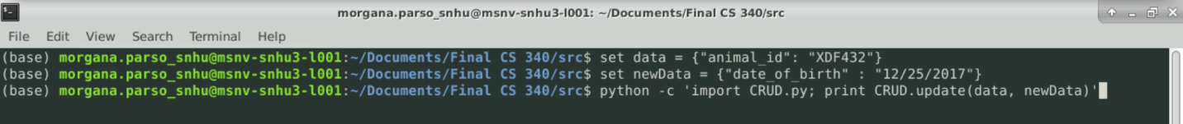

***DELETE*** –

***It is highly recommended to delete using the “animal_id” key***. This way we ensure only the specified document is deleted. Again, set “data” with a dictionary declaring which animal_id to delete.

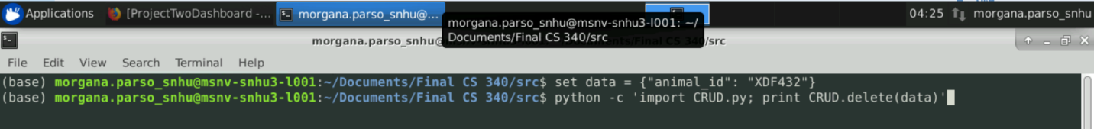

### Tests

Change into the directory in which the files have been installed. CRUDtest.py can be run from the command line with “python CRUDtest.py”. The module should automatically import CRUD.py to run the unit tests, assuming they exist in the same directory. I had trouble producing the results of these tests because Jupyter Notebook would not consistently import to CRUD module, even to my dashboard project, even though I’m sure I set it up correctly. The same error is produced in both files but the following is the error I get when I run the dashboard:

## Roadmap/Features

In the future, Grazioso Salvare might benefit in having multiple graph styles on their website, with the ability to choose which one is viewed at a time to optimize speed performance. GS should consider expanding their graph functions as they expand their filtering options past the set queries. It would be interesting to see more functions to support more specific filtering options like a range slider to filter for a specific age range or date of birth or date added.

## Contact

Morgana Parsons

morgana.parsons@snhu.edu