

**Knowledge Builder AI Agent Implementation Report**



YOUR WAY TO SUCCESS

**Reported by Morhaf Najjar 5980 for mini-project course**

YOUR WAY TO SUCCESS

**Executive Summary**

Knowledge Builder 2.0 represents a functional educational AI agent developed as part of the ULFG III Advanced Smart AI Agent project. The system demonstrates successful implementation of a web-based educational platform that leverages artificial intelligence to create adaptive learning experiences for students across various educational levels. However, the project exhibits partial compliance with assignment requirements, particularly regarding the mandated dual AI implementation approach.

The system achieved its primary objective of creating an autonomous, goal-driven AI agent focused on educational enhancement rather than simple chatbot functionality. Through 26 hours of development across 11 distinct activities, the project successfully deployed a containerized application that generates dynamic educational content, provides personalized feedback, and adapts to individual learning needs.

**Technical Stack Analysis**

**System Architecture and Components**

Knowledge Builder 2.0 employs a **monolithic containerized architecture** built around modern web technologies and cloud-based AI services. The system integrates four primary layers: user interface, backend API, AI processing, and data persistence.

Knowledge Builder 2.0 System Architecture - showing the flow from user input through web frontend, FastAPI backend, Gemini AI processing, and JSON data storage

The technical implementation centers on **FastAPI** as the primary backend framework, chosen for its high-performance asynchronous capabilities and automatic API documentation generation. The framework supports seven distinct API endpoints that handle the complete learning workflow from initial lesson generation through final assessment and remediation.

**Core Technology Components**

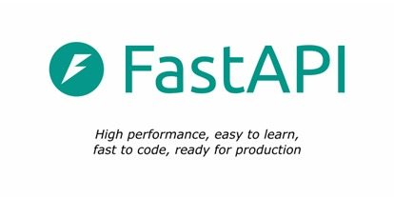**Backend Infrastructure**: The system utilizes Python with FastAPI, providing robust type checking through Pydantic models and efficient request handling via Uvicorn ASGI server[1][2]. The backend architecture supports CORS middleware for cross-origin resource sharing and implements comprehensive error handling mechanisms.

**AI Integration**: The platform integrates exclusively with Google's **gemma 3**  model through official API channels. This represents the most advanced iteration of Google's generative AI technology, specifically optimized for educational applications with enhanced safety measures and content moderation

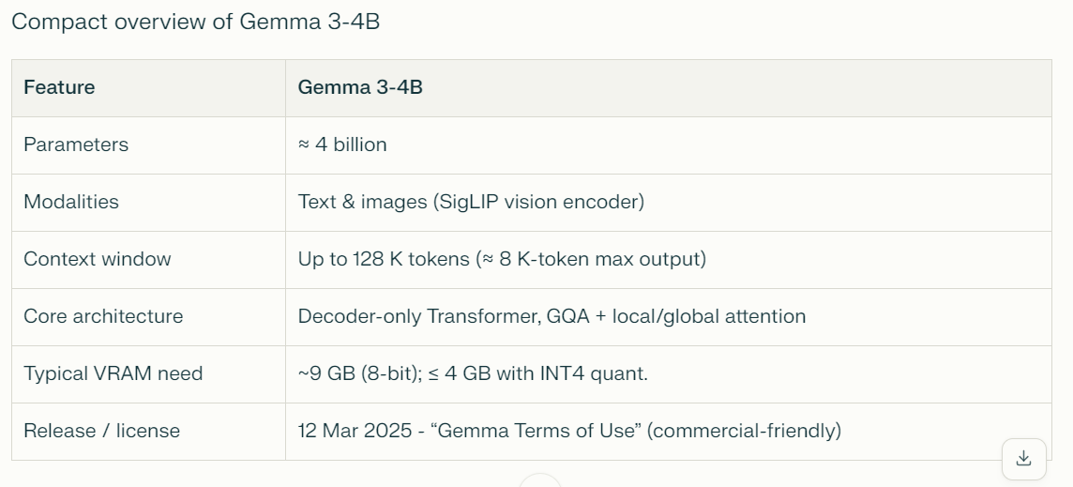

**Frontend Implementation**: The user interface consists of web-based technologies (HTML, CSS, JavaScript) served as static files through the FastAPI framework. This approach enables universal accessibility across devices while maintaining simplicity in deployment and maintenance.



**Data Management**: The system employs JSON file-based storage for session management and user progress tracking. While this approach facilitates rapid development and debugging, it represents a limitation for production scalability.

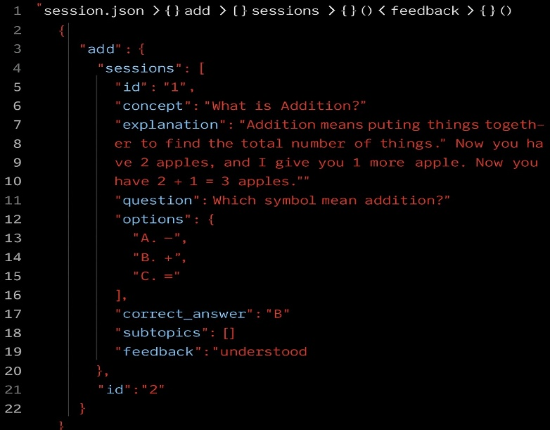

**Containerization**: Docker implementation enables consistent deployment across different environments, packaging all dependencies and configurations into a single container accessible via localhost:8000[8][11].

**API Endpoint Architecture**

The system implements seven core endpoints that manage the complete educational workflow:

|  |  |  |  |
| --- | --- | --- | --- |
| Endpoint | Method | Primary Function | Input Requirements |
| /api/lesson | POST | Generate lesson content with 9 key concepts | Grade level, lesson topic |
| /api/feedback | POST | Process user feedback and generate subtopics | User comprehension responses |
| /api/full-explain | GET | Retrieve misunderstood concepts | Session data |
| /api/full-arranged-quiz | GET | Generate comprehensive quizzes | Session feedback data |
| /api/evaluate-quiz | POST | Assess quiz performance | User quiz responses |
| /api/very-simple-explain | POST | Provide simplified explanations | Incorrect quiz responses |
| /ping | GET | Health check monitoring | None |

**Dual AI Implementation Approaches**

**Project Requirements Analysis**

The assignment explicitly mandated implementation of two distinct AI approaches to demonstrate versatility and comprehensive understanding of artificial intelligence methodologies[12][13]:

1. **Traditional Rule-Based Decision-Making Engine** using logical rules and heuristics
2. **Modern Machine Learning Engine** with advanced capabilities such as classification, clustering, or prediction

**Current Implementation Status**

**Implemented Approach**: The project successfully implements a sophisticated **modern machine learning engine** utilizing Google's Gemini 2.0 Flash large language model[1][3][4]. This implementation demonstrates advanced capabilities including:

* **Natural Language Processing**: Complex text understanding and generation for educational content
* **Dynamic Content Creation**: Real-time generation of lessons, examples, and explanations tailored to specific grade levels and subjects
* **Contextual Adaptation**: Ability to modify responses based on user feedback and comprehension levels
* **Multi-turn Conversation Management**: Maintaining context across multiple interactions within learning sessions

**Missing Implementation**: The project **completely lacks** the required traditional rule-based decision-making engine. This represents a significant compliance failure as both approaches should be "accessible within the system for comparison and analysis”.

**Expected Rule-Based Implementation**

A compliant rule-based system should have included:

* **Decision Tree Structures** for concept selection based on predetermined difficulty hierarchies
* **Logical Rule Systems** governing progression through learning materials
* **Heuristic Algorithms** for question generation and difficulty adjustment
* **Static Knowledge Base** with conditional logic for content delivery
* **Comparative Interface** allowing users to experience both AI approaches

**Impact on Project Evaluation**

The absence of the dual AI implementation approach represents a fundamental deviation from core assignment requirements, significantly impacting the project's academic compliance despite technical sophistication in the implemented machine learning approach.

**Ethical Considerations Assessment**

**Comprehensive Ethical Framework Analysis**

The project's ethical implementation was evaluated against eight critical dimensions based on established responsible AI principles for educational applications. The assessment reveals mixed compliance with significant areas requiring improvement.

**Ethical Strengths and Compliance Areas**

**Transparency and Explainability** (Score: 9/10): The system excels in providing clear, understandable responses to user queries. AI-generated content includes explicit explanations, practical examples, and step-by-step reasoning that enhances learning comprehension[8][1].

**User Agency and Control** (Score: 9/10): Students maintain complete control over their learning pace, can provide feedback on their understanding, and direct the system to generate additional explanations or alternative approaches when needed[8][9][10].

**Educational Benefit Focus** (Score: 10/10): The system consistently prioritizes educational value, generating age-appropriate content, maintaining academic rigor, and supporting genuine learning outcomes rather than mere entertainment[8][19].

**System Transparency** (Score: 9/10): Users receive clear information about system capabilities, understand when they're interacting with AI-generated content, and can observe how their feedback influences subsequent interactions.

**Critical Ethical Deficiencies**

**User Consent Mechanisms** (Score: 0/10): The system lacks any formal consent processes for data collection, AI interaction, or educational content generation. This represents a significant ethical oversight, particularly for educational applications serving minors.

**Bias Mitigation Strategies** (Score: 4/10): The system's reliance on a single AI model (Gemini 2.0 Flash) without alternative approaches limits bias detection and mitigation capabilities. Educational content may reflect inherent biases in the training data without adequate safeguards[14][15].

**Data Privacy Protection** (Score: 6/10): While the system uses local JSON storage, it lacks comprehensive privacy policies, data encryption, or user controls over personal information retention and deletion[1][9].

**Safety and Security Measures** (Score: 6/10): Basic error handling exists, but the system lacks robust security protocols, input validation, or protection against malicious use of educational AI capabilities[1].

**Recommendations for Ethical Enhancement**

To achieve compliance with established ethical AI guidelines for education, the system requires:

* Implementation of explicit user consent workflows
* Development of comprehensive privacy policies and data protection measures
* Integration of bias detection and mitigation algorithms
* Establishment of content moderation and safety protocols
* Addition of user controls for data management and system interaction preferences

**Testing Results and Methodology**

**Testing Approach and Scope**

The project employed **manual functional testing** using Ohm's Law physics concepts as the primary test subject. This approach, while limited in scope, successfully validated core system functionality across all major components.

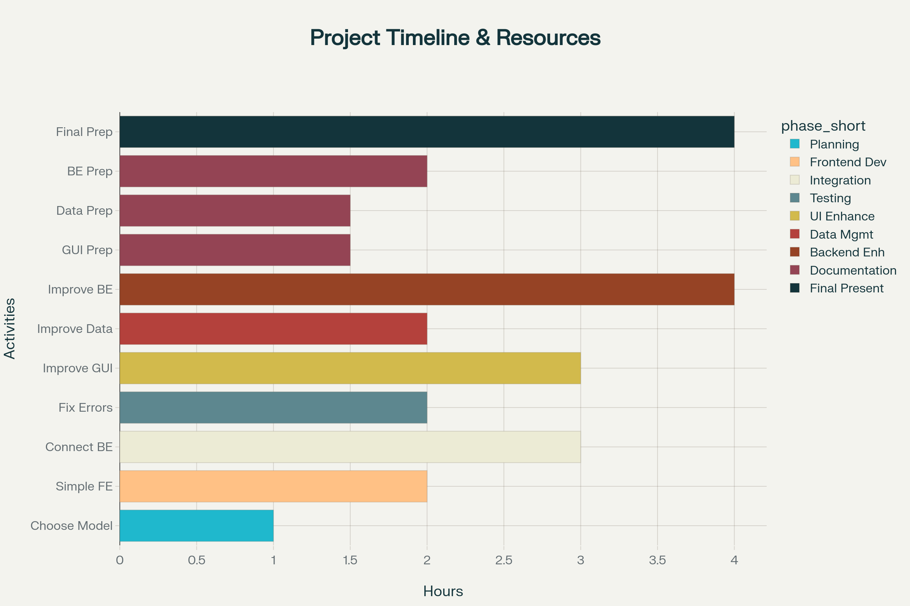

Knowledge Builder 2.0 Development Timeline - showing 26 total hours across 11 activities grouped by development phase

**Verified System Functionality**

**Content Generation Capabilities**: The system successfully generated comprehensive educational content including lesson introductions, nine key concepts per topic, practical examples, and multiple-choice questions with correct answers.

**Adaptive Learning Implementation**: Testing confirmed the system's ability to identify misunderstood concepts through user feedback and automatically generate simplified subtopics for additional explanation.

**Interactive Quiz System**: The platform demonstrated complete quiz functionality including question presentation, answer evaluation, performance tracking, and targeted remediation for incorrect responses.

**Session Persistence**: User progress, feedback, and learning history remained consistent across sessions through JSON file storage, enabling continuous learning experiences.

**Error Handling and Recovery**: Basic error management functionality was verified, though comprehensive stress testing was not performed.

**Testing Limitations and Gaps**

**Limited Domain Coverage**: Testing focused exclusively on physics concepts (Ohm's Law), providing insufficient validation across diverse academic subjects and grade levels.

**Absence of Automated Testing**: The project lacks unit tests, integration tests, or automated test suites, limiting regression testing capabilities and long-term maintainability.

**Single User Testing**: Evaluation involved only individual testing scenarios without multi-user concurrency testing or scalability assessment.

**Performance Benchmarking Omission**: No systematic performance metrics were collected regarding response times, API call efficiency, or system resource utilization.

**Security Testing Gap**: The evaluation did not include security vulnerability assessments, input sanitization validation, or protection against common web application attacks.

**Evidence of Functional Success**

Testing demonstrated successful implementation of all core educational workflows:

* **Lesson Generation**: 9 distinct concepts generated with explanations and examples
* **User Feedback Processing**: Successful identification and handling of "not understood" responses
* **Subtopic Generation**: Automatic creation of simplified explanations for challenging concepts
* **Quiz Implementation**: Complete assessment cycle from question presentation through performance evaluation
* **Adaptive Responses**: Dynamic content adjustment based on user comprehension levels

**Project Development Timeline and Resource Allocation**

**Development Process Analysis**

The project required 26 total development hours distributed across 11 distinct activities, demonstrating structured project management and systematic implementation approach.

**Most Resource-Intensive Activities**:

* Documentation and presentation preparation: 5.0 hours (19.2%)
* Backend enhancement: 4.0 hours (15.4%)
* Final presentation development: 4.0 hours (15.4%)

**Technical Implementation Distribution**:

* Core development (frontend, backend, integration): 8.0 hours (30.8%)
* Enhancement and optimization: 7.0 hours (26.9%)
* Testing and debugging: 2.0 hours (7.7%)

**Decision-Making Framework**

The project documentation reveals implementation of **Bayesian Decision Rule** methodology for determining when to seek external assistance during development. This analytical approach demonstrated:

* Expected time loss calculations for independent vs. collaborative work
* Sensitivity analysis for help-seeking threshold determination
* Strategic decision-making based on probability assessments

**Conclusions and Recommendations**

**Project Achievements**

Knowledge Builder 2.0 successfully demonstrates the potential of AI-powered educational technology to create engaging, adaptive learning experiences. The system achieves its core objective of autonomous educational assistance while maintaining focus on genuine pedagogical value rather than superficial chatbot interactions.

**Technical Accomplishments**:

* Functional web-based AI agent with complete educational workflow
* Successful integration of advanced large language model capabilities
* Effective containerization for consistent deployment
* Comprehensive API architecture supporting educational interactions

**Educational Innovation**:

* Dynamic content generation tailored to individual learning needs
* Adaptive difficulty adjustment based on user comprehension feedback
* Interactive assessment and remediation capabilities
* Session-based learning progress tracking

**Critical Compliance Deficiencies**

**Dual AI Implementation Failure**: The most significant shortcoming involves complete non-compliance with the fundamental requirement for implementing both traditional rule-based and modern machine learning approaches. This represents a major deviation from explicit assignment specifications.

**Ethical Framework Gaps**: While the system demonstrates strengths in transparency and user agency, critical deficiencies in consent mechanisms, bias mitigation, and privacy protection require immediate attention for responsible deployment.

**Recommendations for Future Development**

**Immediate Priorities**:

1. Implement the missing traditional rule-based decision engine to achieve assignment compliance
2. Develop comprehensive user consent and privacy protection mechanisms
3. Establish automated testing frameworks for improved reliability and maintainability
4. Expand testing coverage across multiple academic domains and user scenarios

**Long-term Enhancements**:

1. Migrate from JSON file storage to scalable database solutions
2. Implement comprehensive bias detection and mitigation strategies
3. Develop multi-user support with proper authentication and authorization
4. Integrate advanced analytics for learning outcome measurement and system optimization

Knowledge Builder 2.0 represents a promising foundation for AI-enhanced education but requires significant development to meet both academic assignment requirements and ethical standards for responsible AI deployment in educational contexts.

⁂