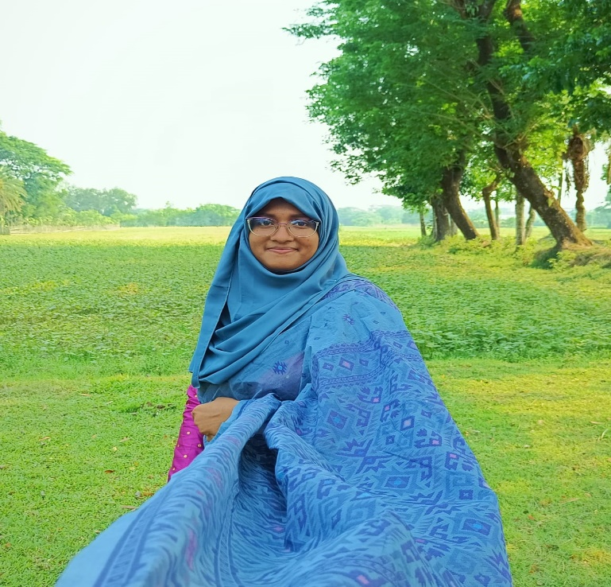**Moriam Binte Alam**

E-mail : [moriamsara@gmil.com](mailto:moriamsara@gmil.com)

**Personal information:**

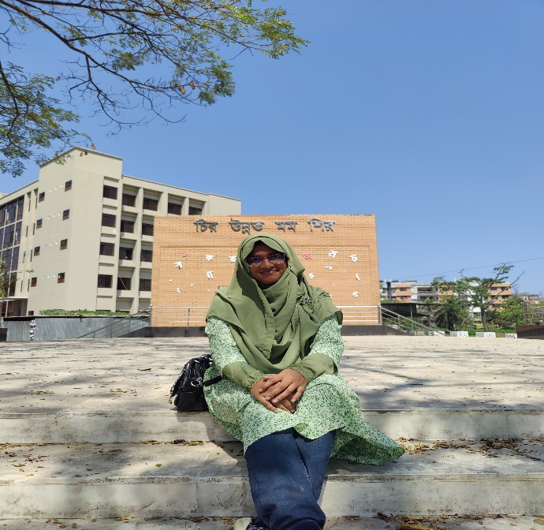Nickname : Sara

Date of birth: 18 September,1999

Height : 5 feet 5 inch

Weight : 68 KG

Skin colour : Brown

Blood group : B+

Merital status : Unmerried

Religion : Islam

Nationality : Bangladeshi

**Address** : Muslim para, College Branch Road, Barguna Sadar, Barguna

**Academic information :**

|  |  |  |
| --- | --- | --- |
| **CLASS** | **INSTITUTION** | **Passing Year** |
| **SSC** | Barguna Collegeiate Secondary School, Barguna. | 2016 |
| HSC | BAF Shaheen College, Tejgaon, Dhaka. | 2018 |
| Hons. | University of Barishal  Department of Mathematics | 3rd Year (running)  Session: 2019-20 |

**Family Introduction :**

Father: Late Md. Shah Alam (2020)

AGM, Sonali Bank PLC (Rtd)

Mother : Hasina Begum

Home maker.

Siblings:

1. Md Hasanul shaon, senior representative in NTV. Lives in Dhaka.

Spouse : Humaira khanom Moni (Home maker)

Child : One boy, Muhammad Safwan (7 year)

1. Salma Binte Alam Sumi, Home maker. Lives in Barguna.

Spouse : Sumon Khan, Businessman.

Child : One girl, Tasnim Moury (13 year)

One boy, Md Towsin Esa (7 year)

1. Sumaia Binte Alam, Student. Lives in Denmark.

Spouse : Md. Lelin Bhuiya, Student.

**About myself :**

I’m the youngest child of my parents. I always try to follow the basic islam . I love to travel , specially in hills. I’m a foodie person. I also love to read story books, watch movies or series, spend time with friends and family.

**Expected life partner :**

Well educated , honest , non-smoker, pray 5 time in a day, love to travel, has the mentality to be understanding.