No supervisory information is indicated on the DMI except the train speed. Train data has to be entered in order not to have to stop a train at a level transition to ERTMS/ETCS equipped area and to supervise maximum train speed.
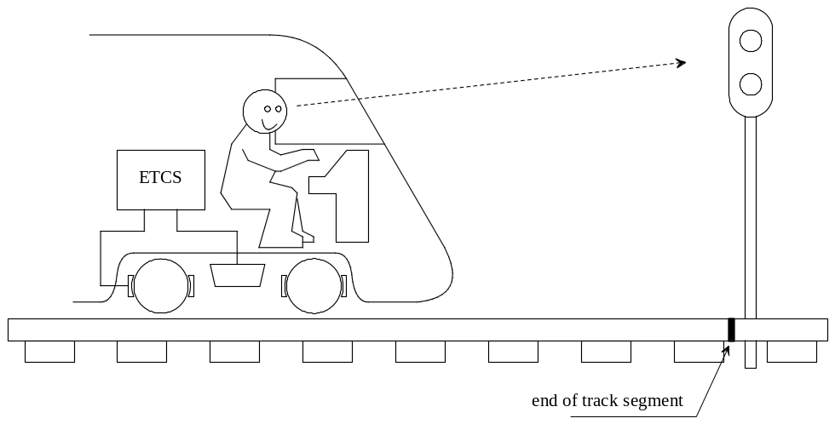
Figure 1: ERTMS/ETCS Application Level 0

