The trackside radio block centre which provides the information to the trains knows each ERTMS/ETCS controlled train individually by the ERTMS/ETCS identity of its leading ERTMS/ETCS on-board equipment.

Note: Lineside signals can be suppressed in Level 2.
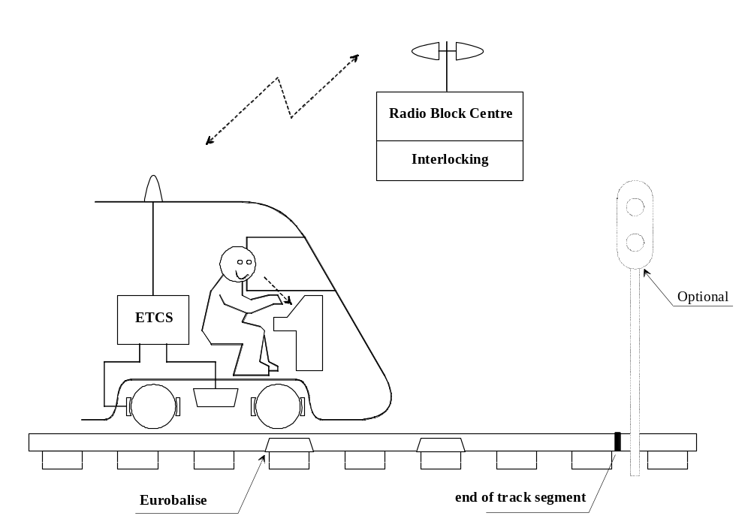
Figure 1: ERTMS/ETCS Application Level 2

Summary of characteristics of Application Level 2

