Revocation condition # | Estimated speed | Train front end position (estimated and max safe) | TI Command revoked | Supervision status revoked
r0 | Standstill |  | EB | Intervention status
r1 | 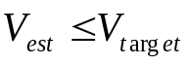 | Not relevant | TCO  SB  EB (in case V_target ≠ 0, only if allowed by National Value) | Indication status  Overspeed status  Warning status  Intervention status (in case of EB command and V_target ≠ 0, only if allowed by National Value)
r2 | 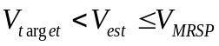 | 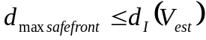if 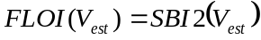  OR 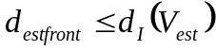if 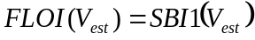 | TCO  SB  EB (only if allowed by National Value) | Indication status (only in case of change of displayed target)  Overspeed status  Warning status  Intervention status (in case of EB command and V_target ≠ 0, only if allowed by National Value)
r3 |  | 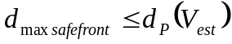 if  OR 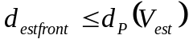 if | TCO  SB  EB (only if allowed by National Value) | Overspeed status  Warning status  Intervention status (in case of EB command, only if allowed by National Value)

